4.1 (b) To conduct a qualitative test for fat
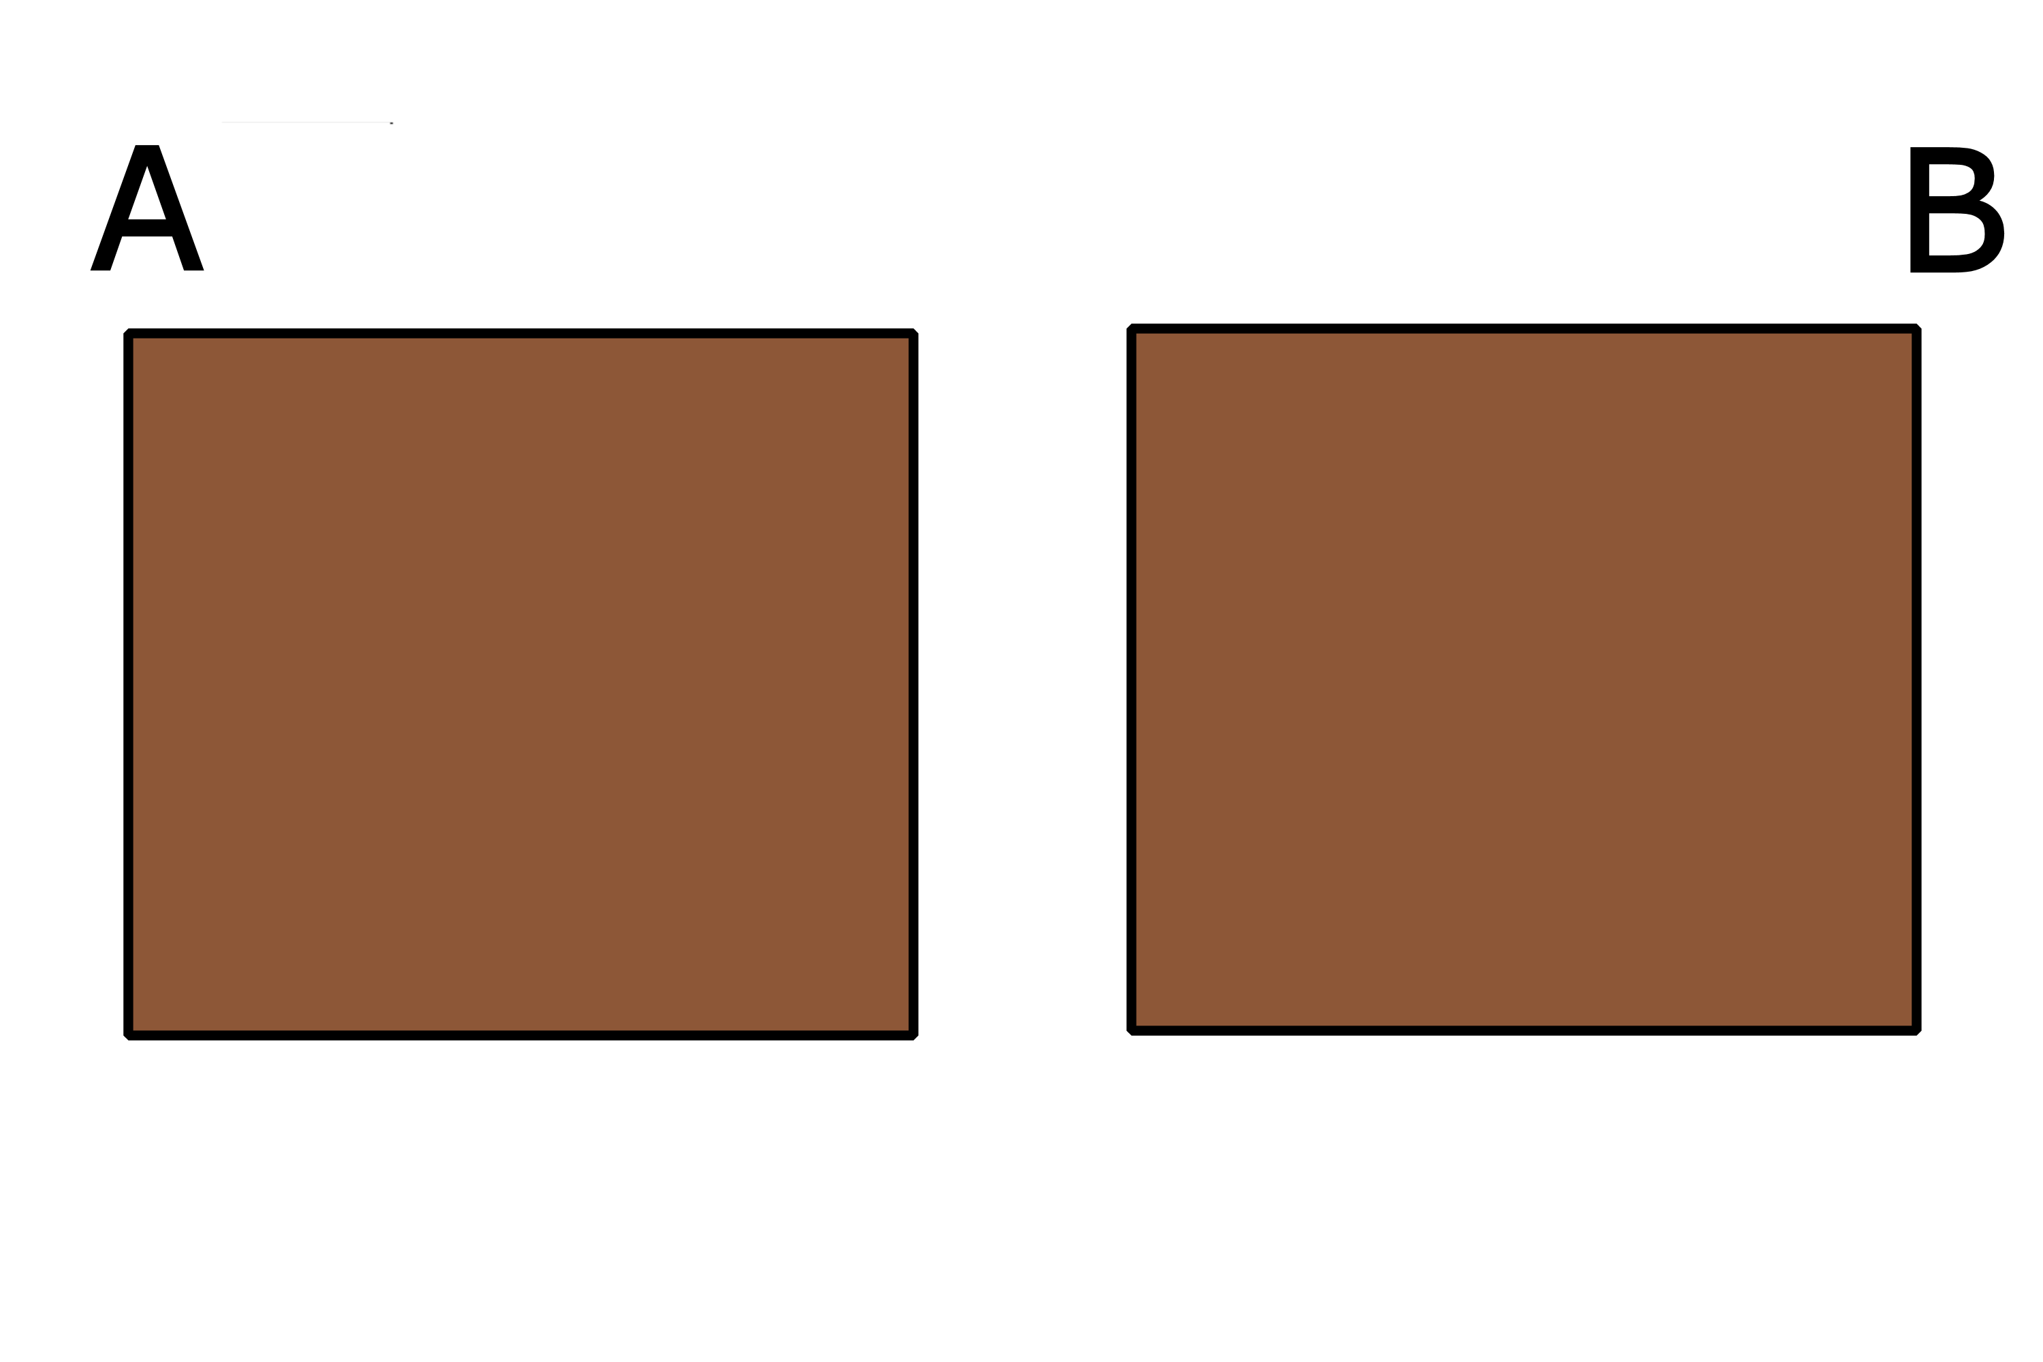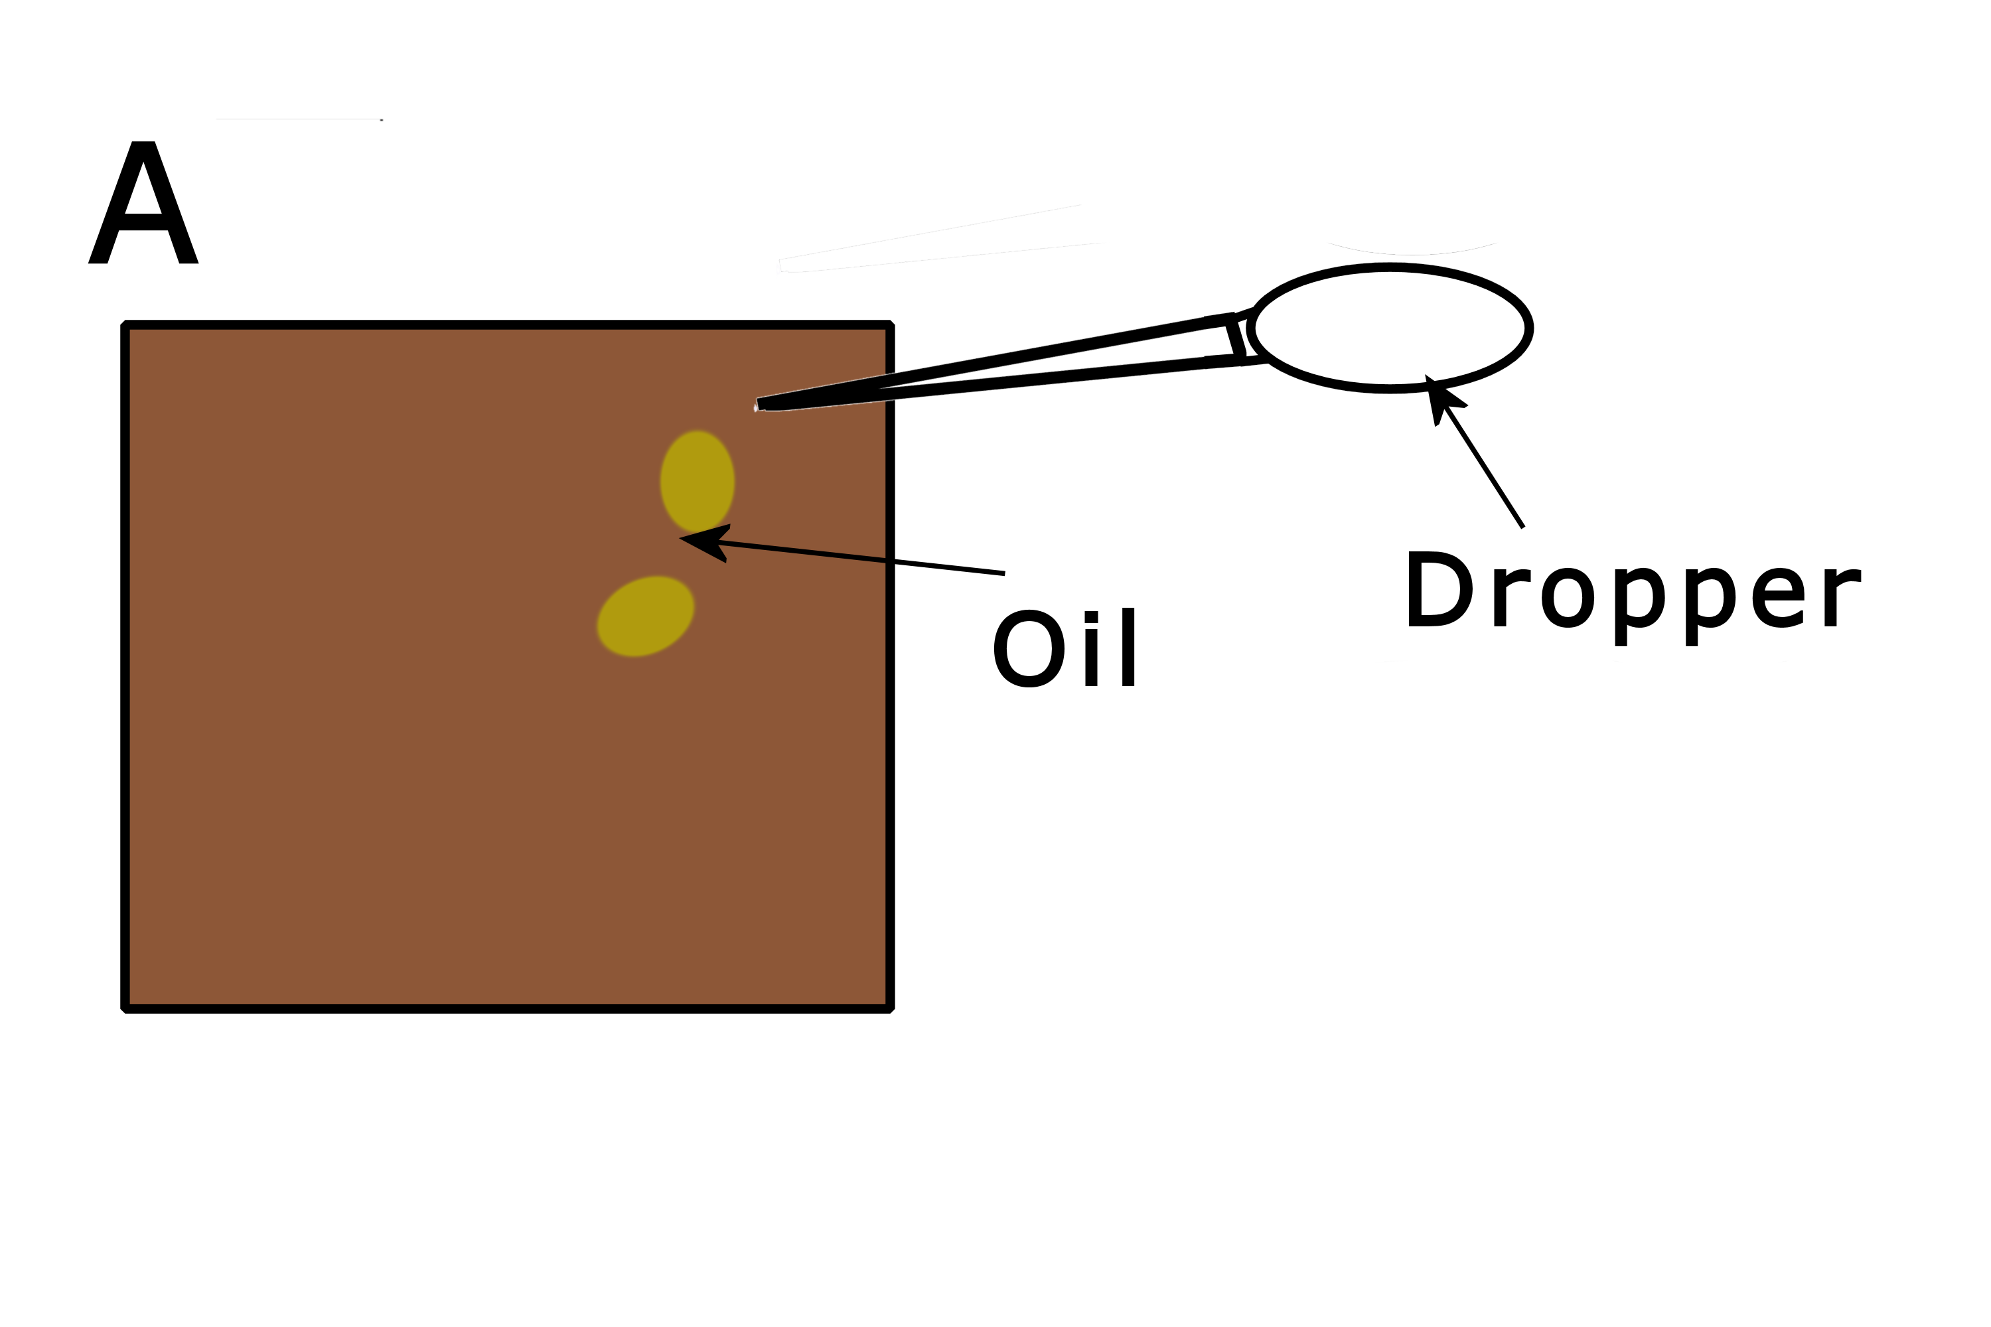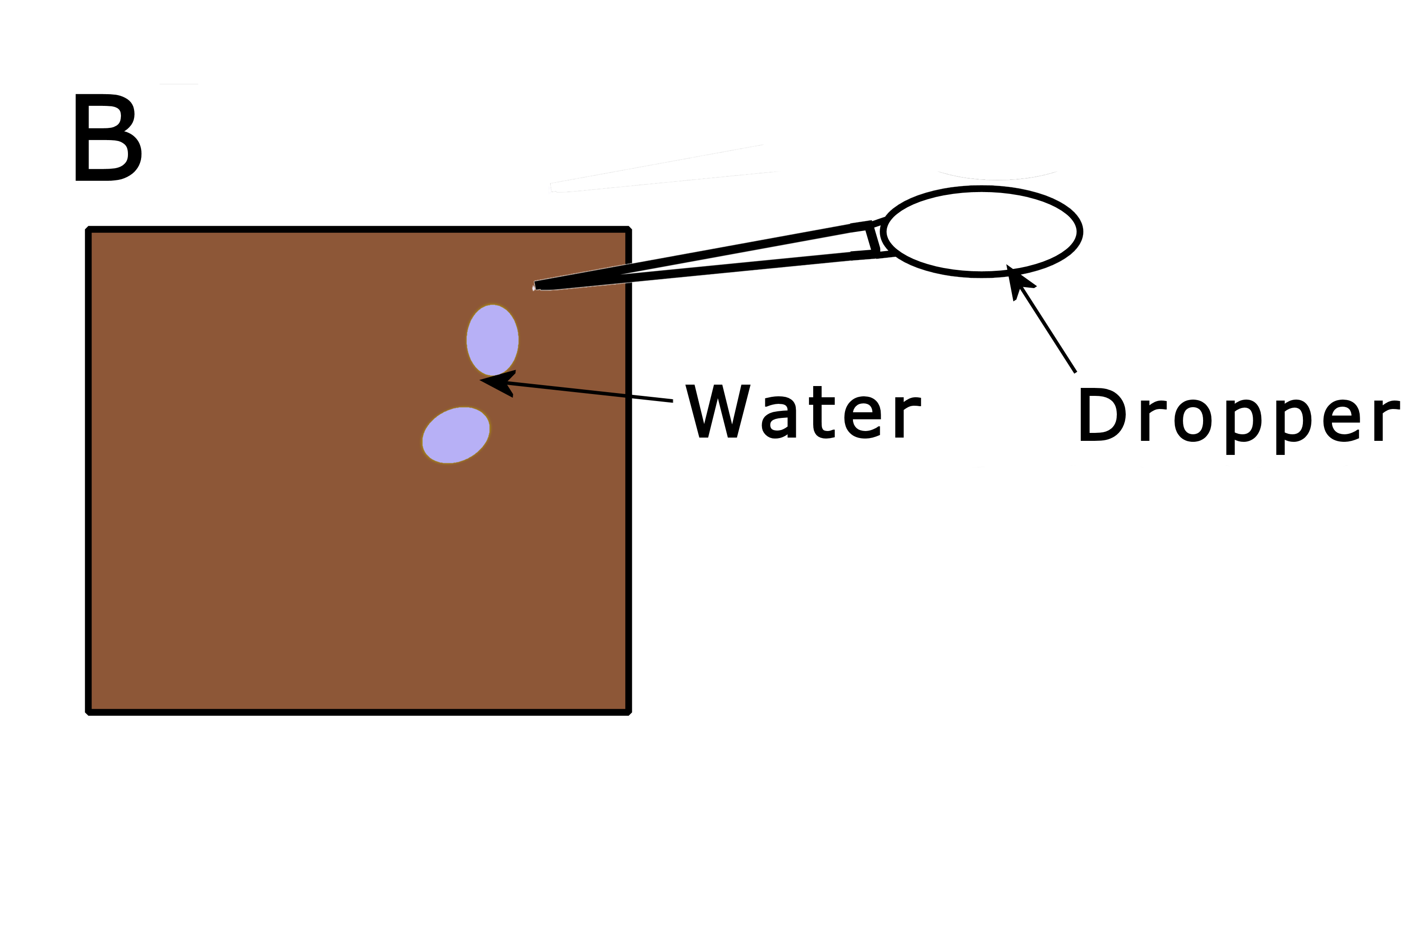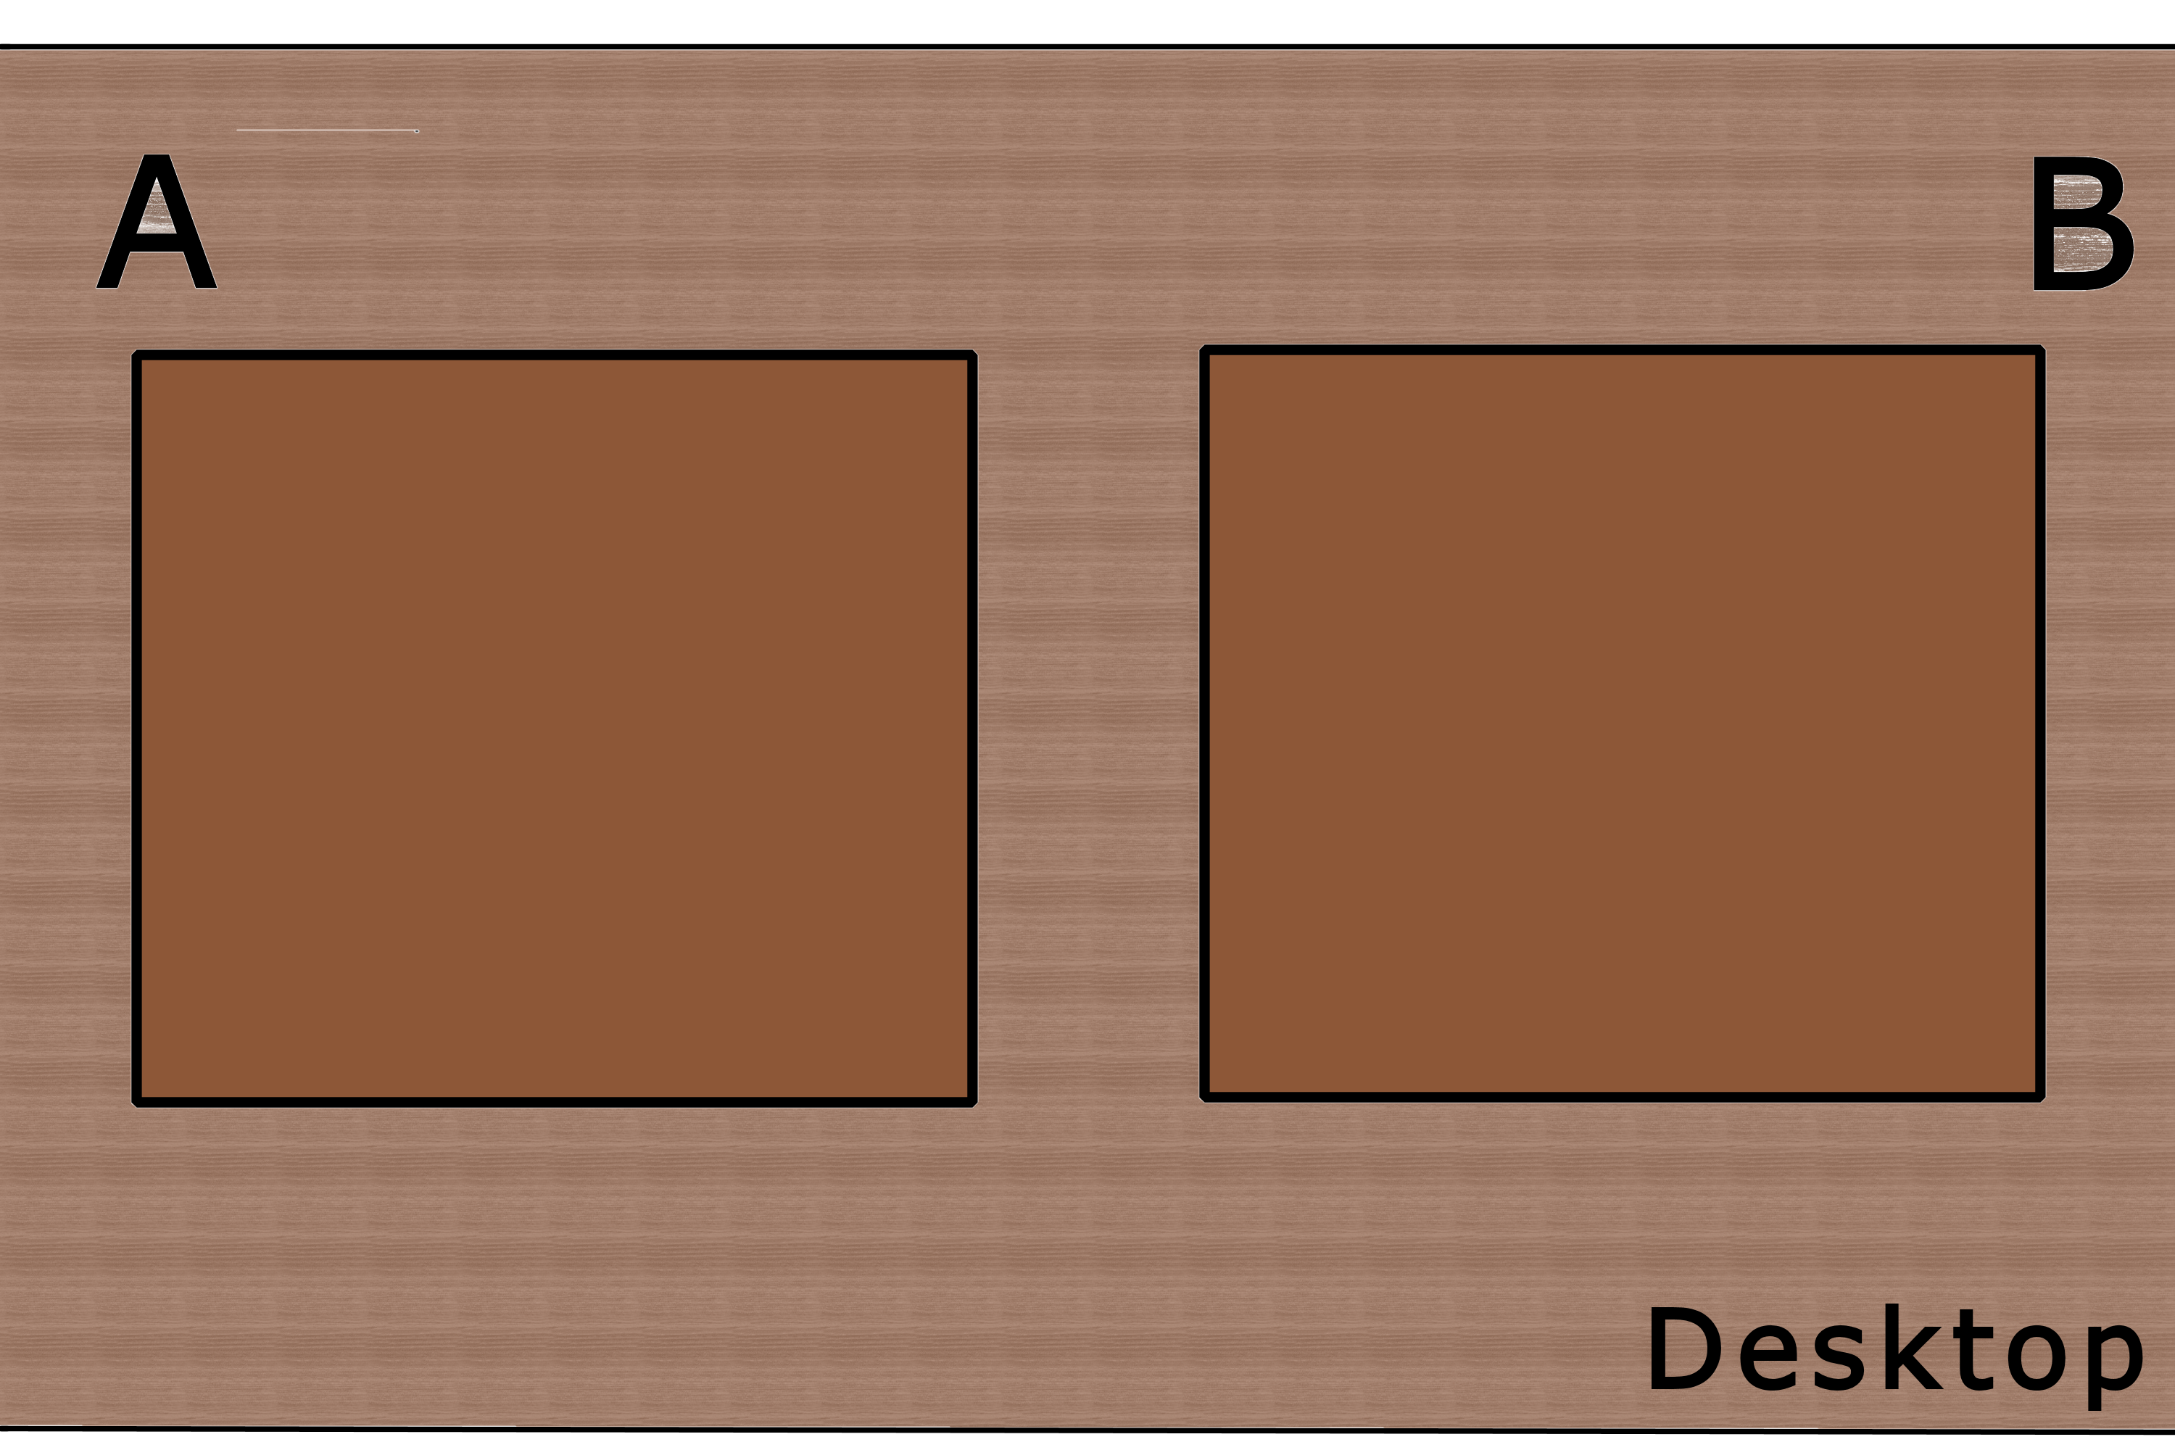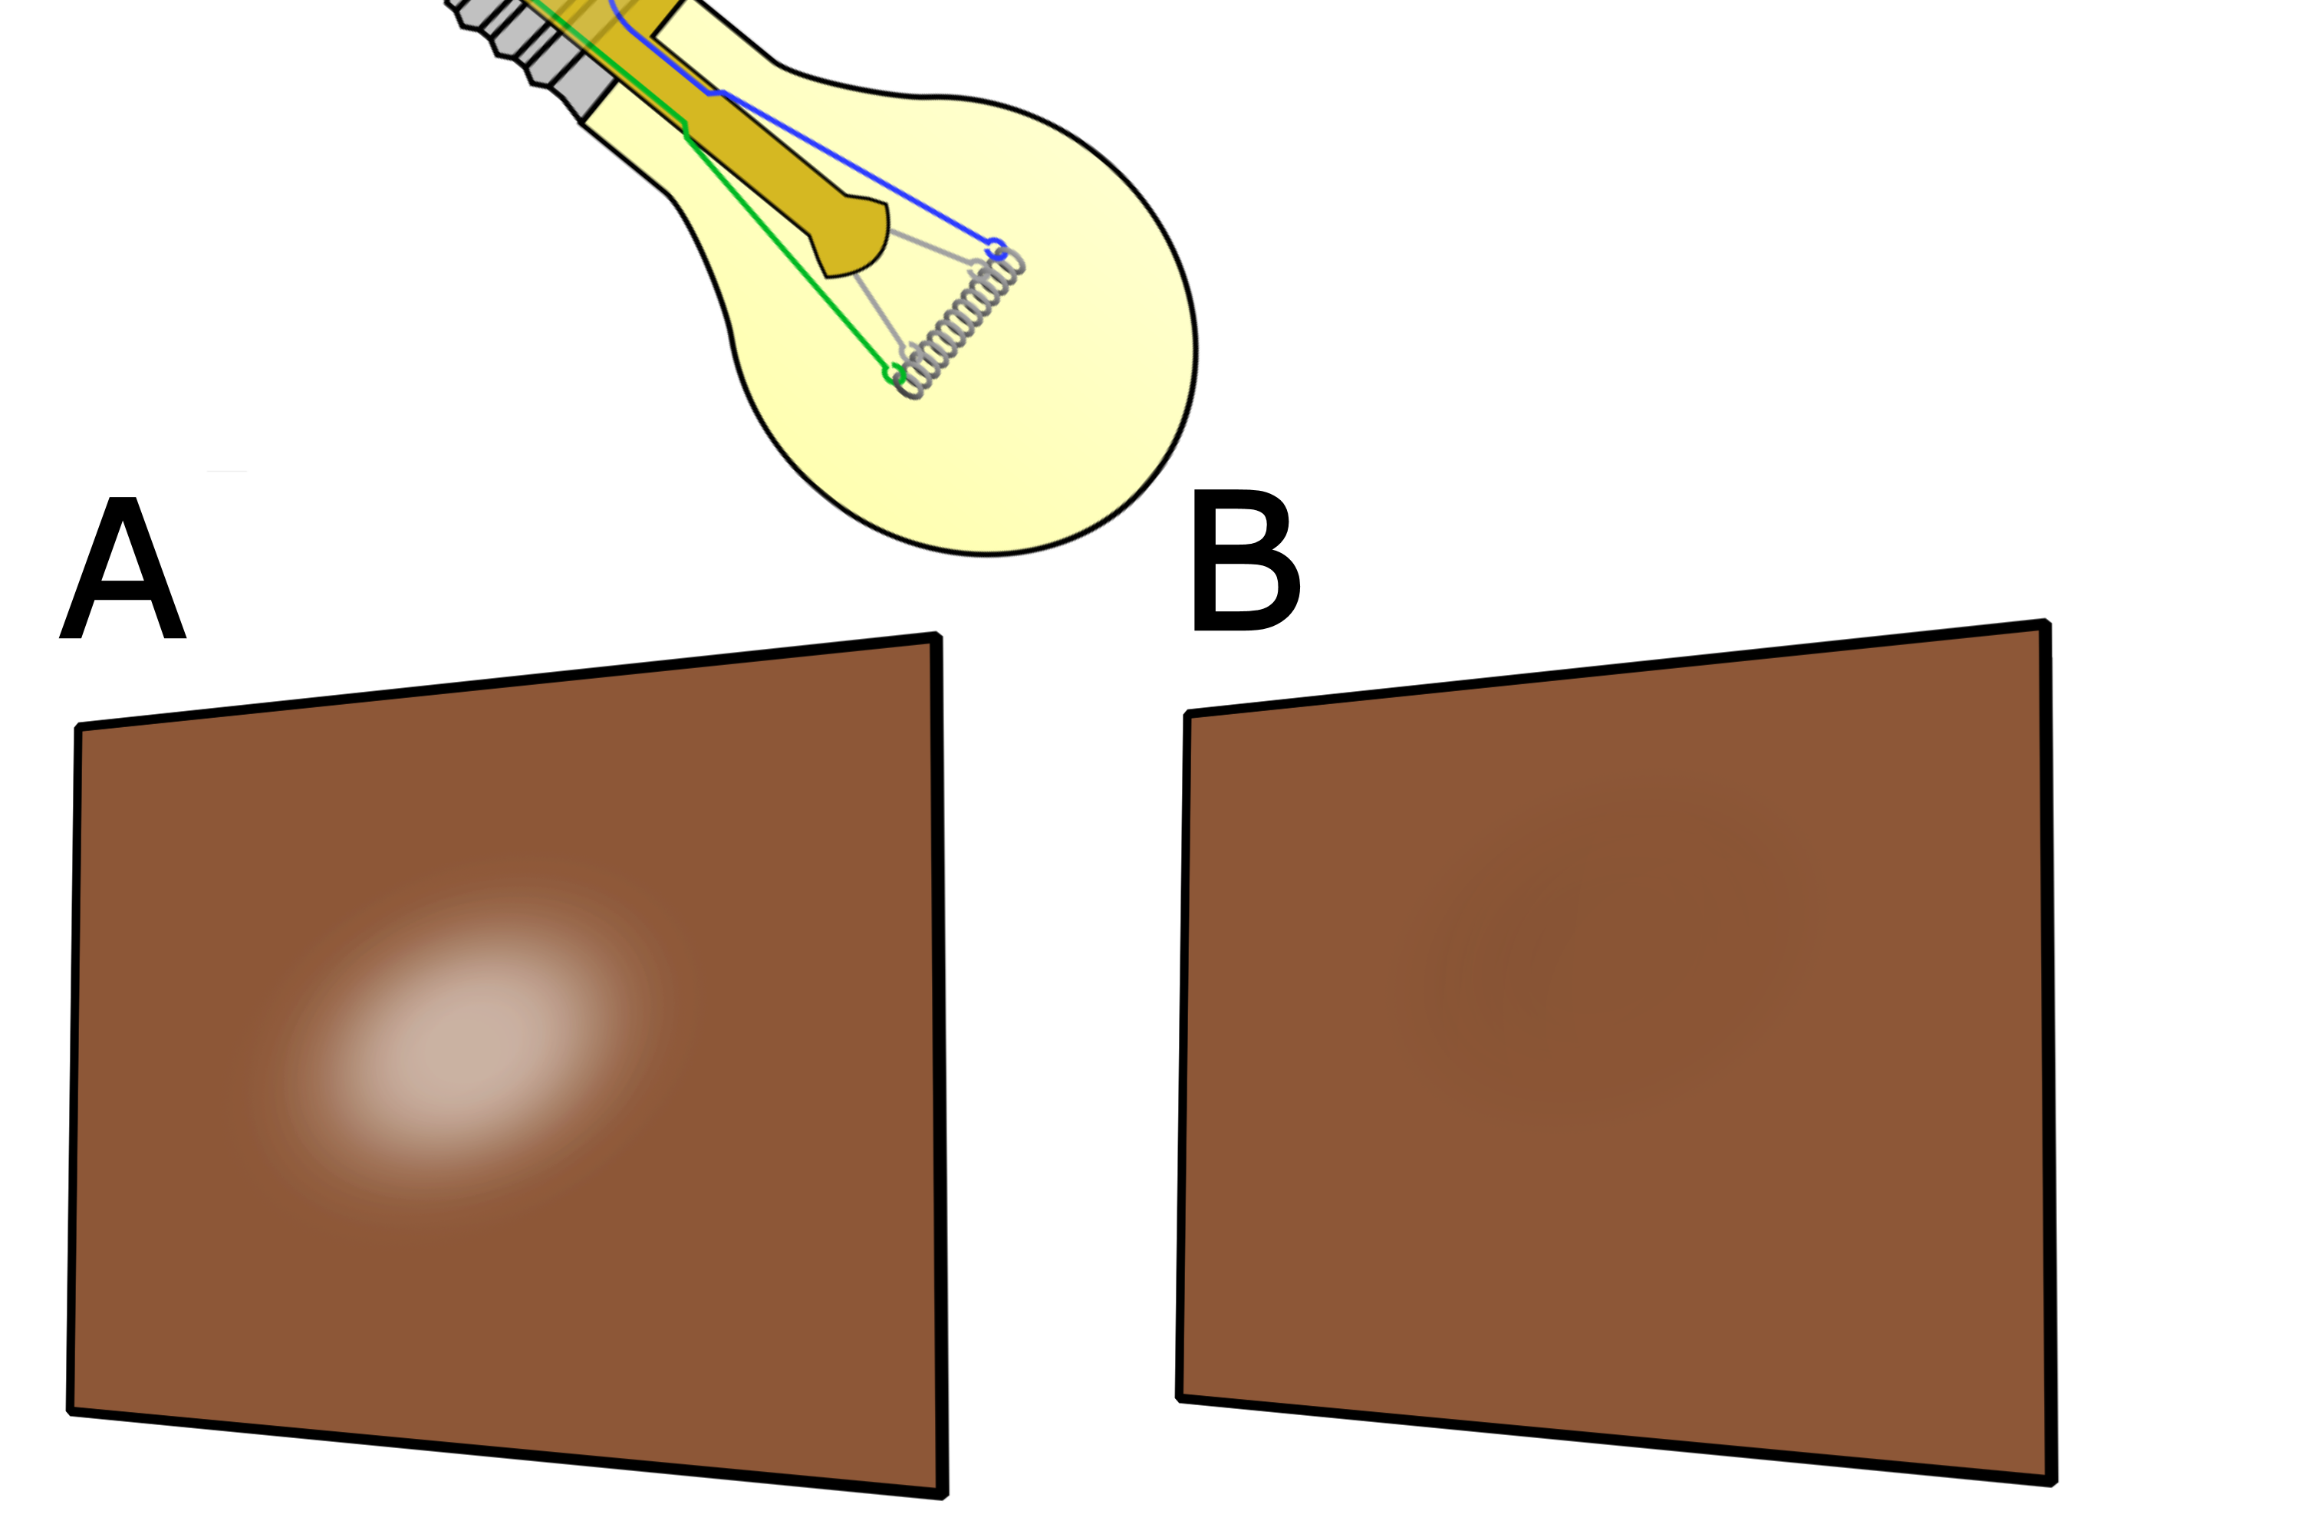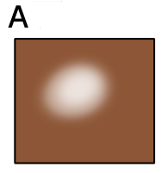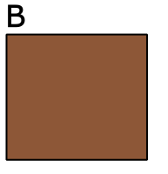
1.
2.
3.
4.
5.

Always remember – Leave time to tidy up
This page can be printed in colour from the accompanying CD
Cut two pieces of brown paper to similar size.
Place 2-3 drops of oil on paper A.
Place 2-3 drops of water on paper B.
Leave both pieces of paper to dry.
Hold both pieces up to the light when dry.

Expected Result
Positive: translucent spot
Negative: no translucent spot
Table of Results:
Sample | Translucent spot
Sample | Before drying | After drying
Oil
Water

Always remember – Leave time to tidy up
This page can be printed in colour from the accompanying CD

