4.2 (a) To be familiar with and use the light microscope
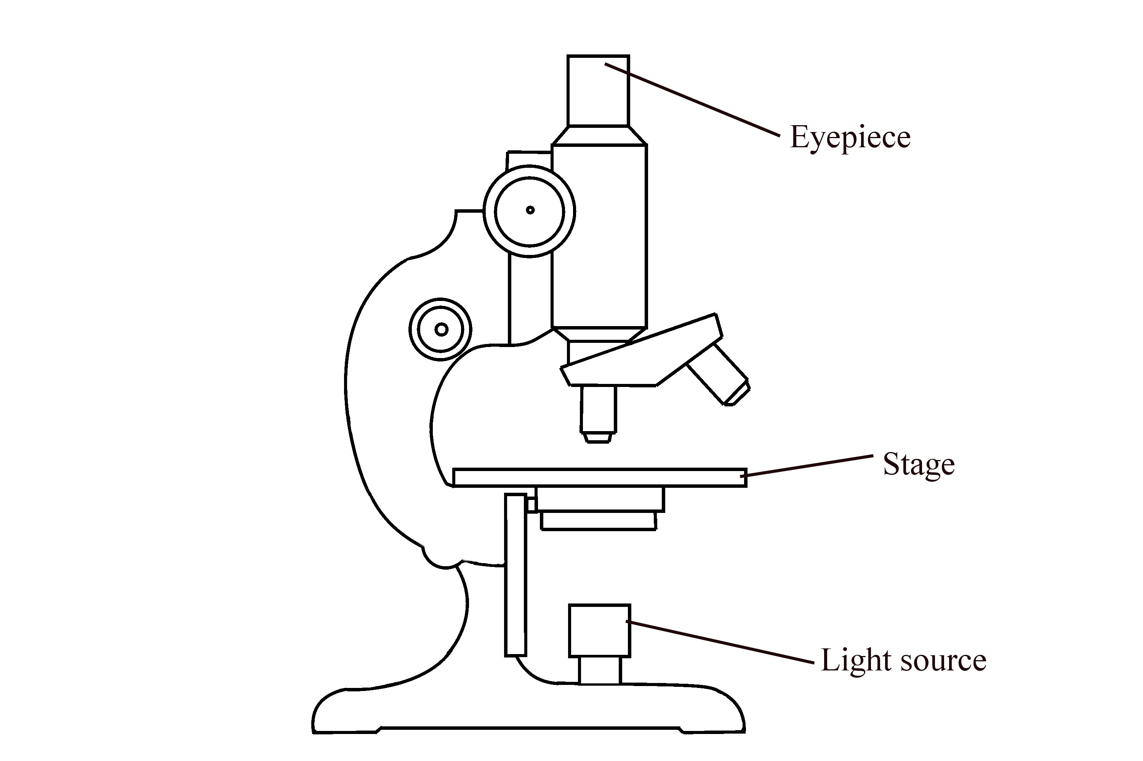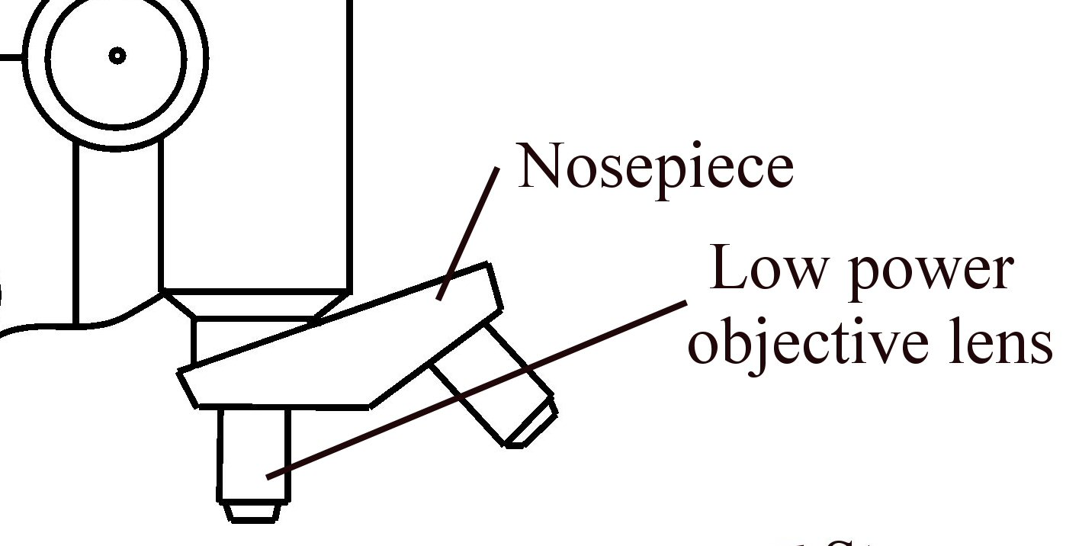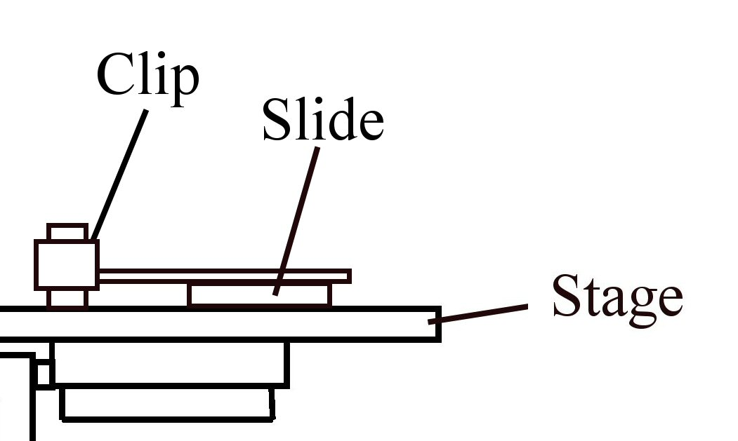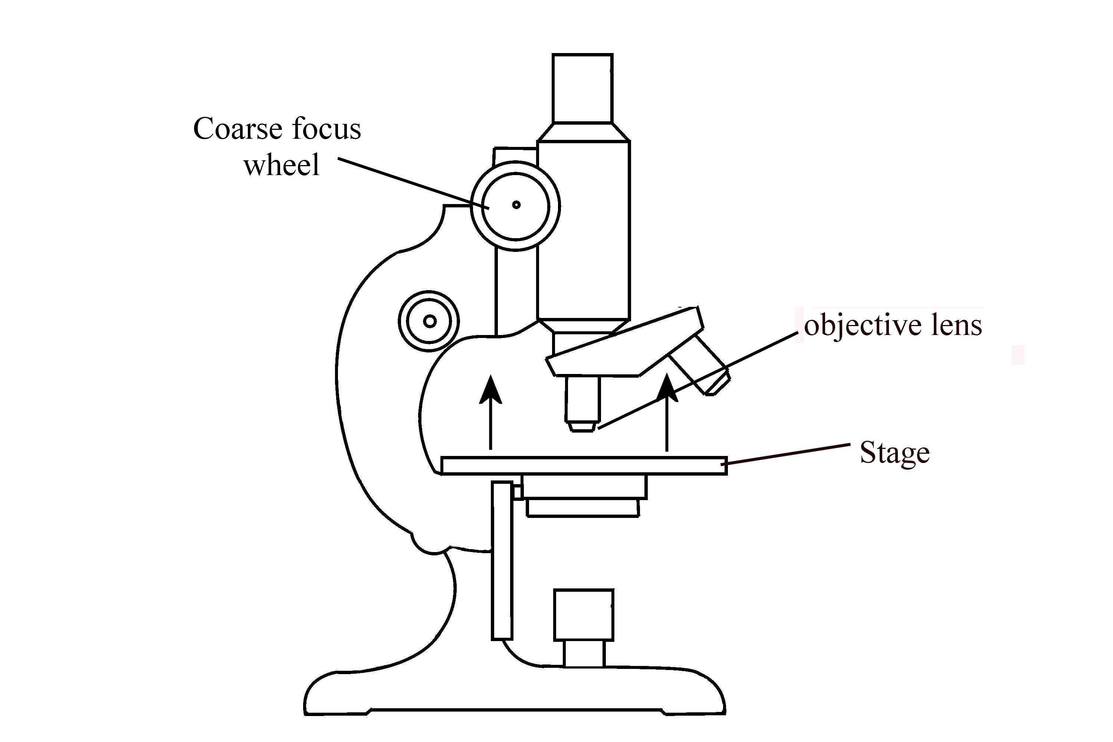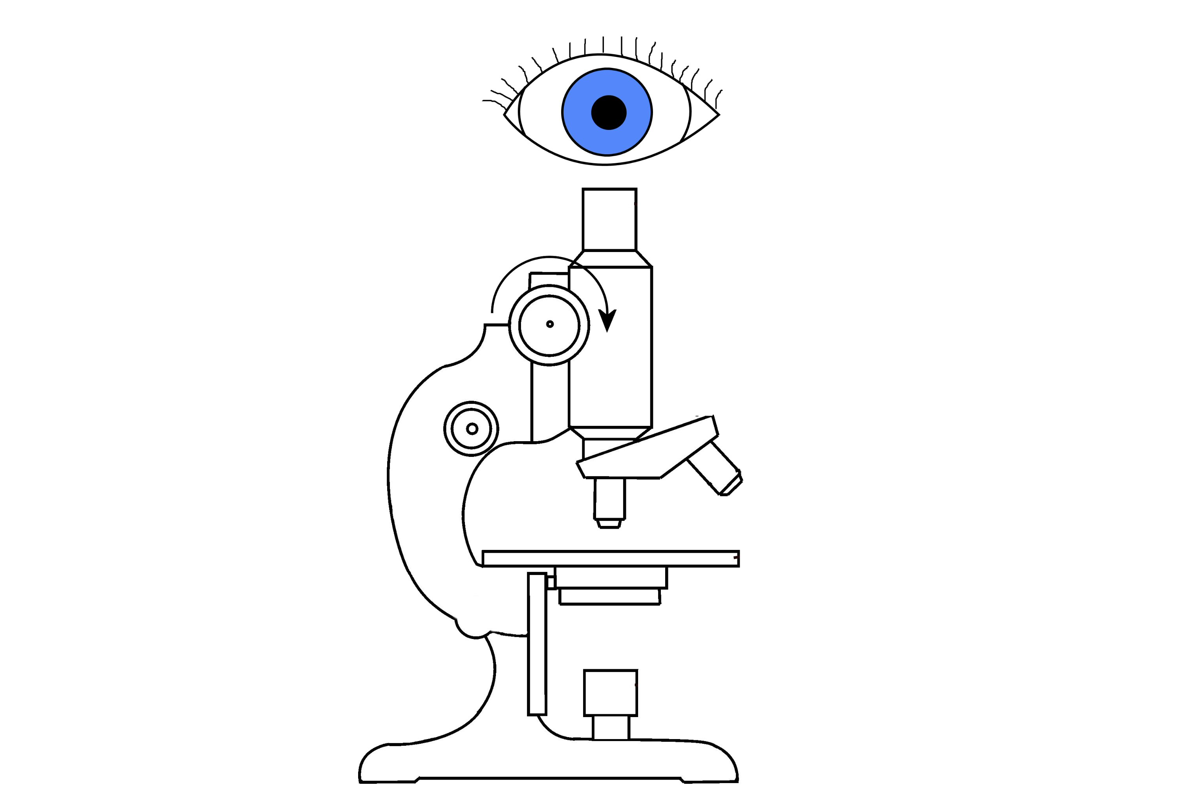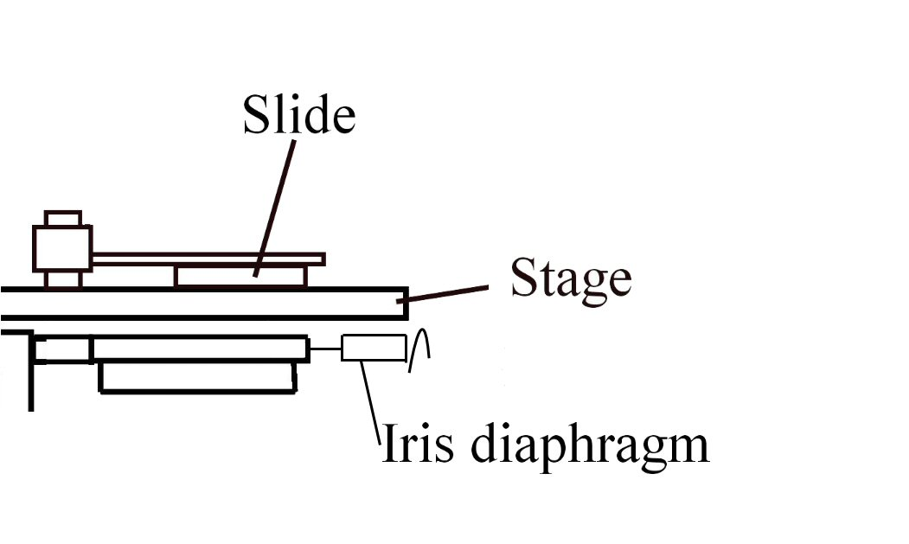
1.
2.
3.
5.

Always remember – Leave time to tidy up
This page can be printed in colour from the accompanying CD
Switch on the light source and remove the eyepiece cover, if present.
Rotate the nosepiece so that the low power objective lens is in use.
Put a prepared slide above the hole in the stage. Secure with the clips.
4.
Using the coarse focus wheel, ensure that the low power objective lens is as close as possible to the slide.
Adjust the iris diaphragm if the light is too bright.

6.
While looking through the eyepiece, use the coarse focus wheel to focus on the slide.
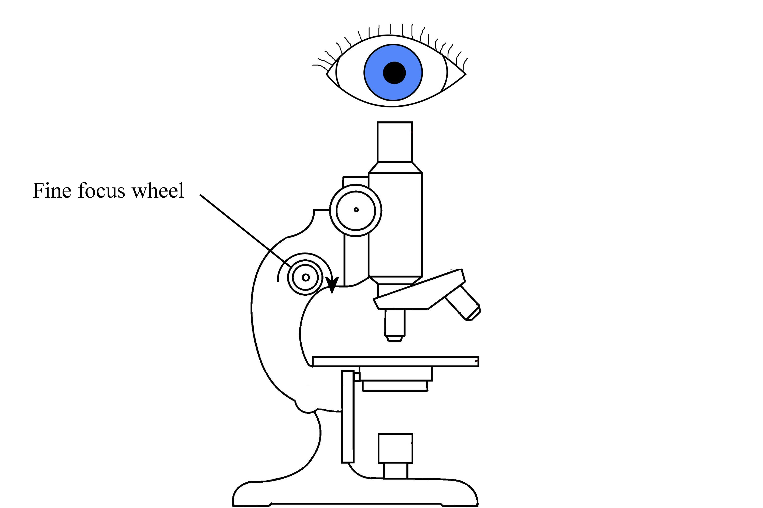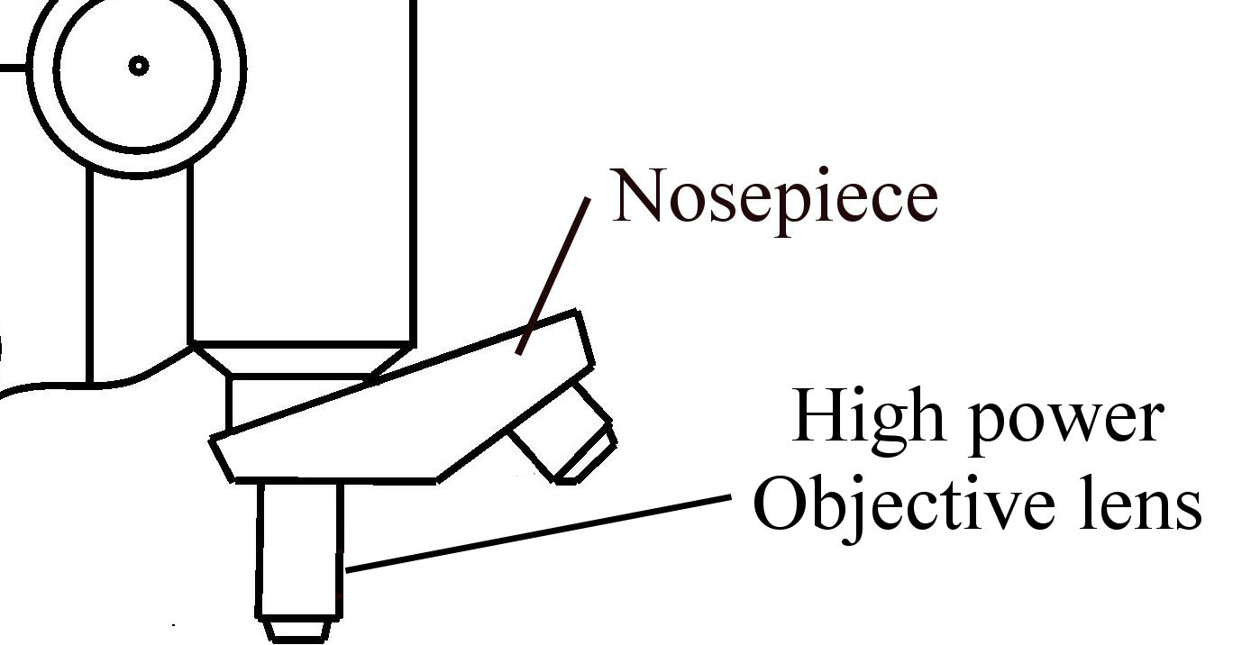
7.
8.
9.

Always remember – Leave time to tidy up
This page can be printed in colour from the accompanying CD
Still looking through the eyepiece, use the fine focus wheel to sharpen the focus.
Rotate the nosepiece to the next highest power objective lens.
Re-focus using the fine focus wheel. Repeat steps 8 and 9 to view the slide under high power.
10.
Results

Draw labelled diagrams of your observations under low power and under high power.

