4.2 (b) To prepare and examine one animal cell, stained and unstained, using the light microscope
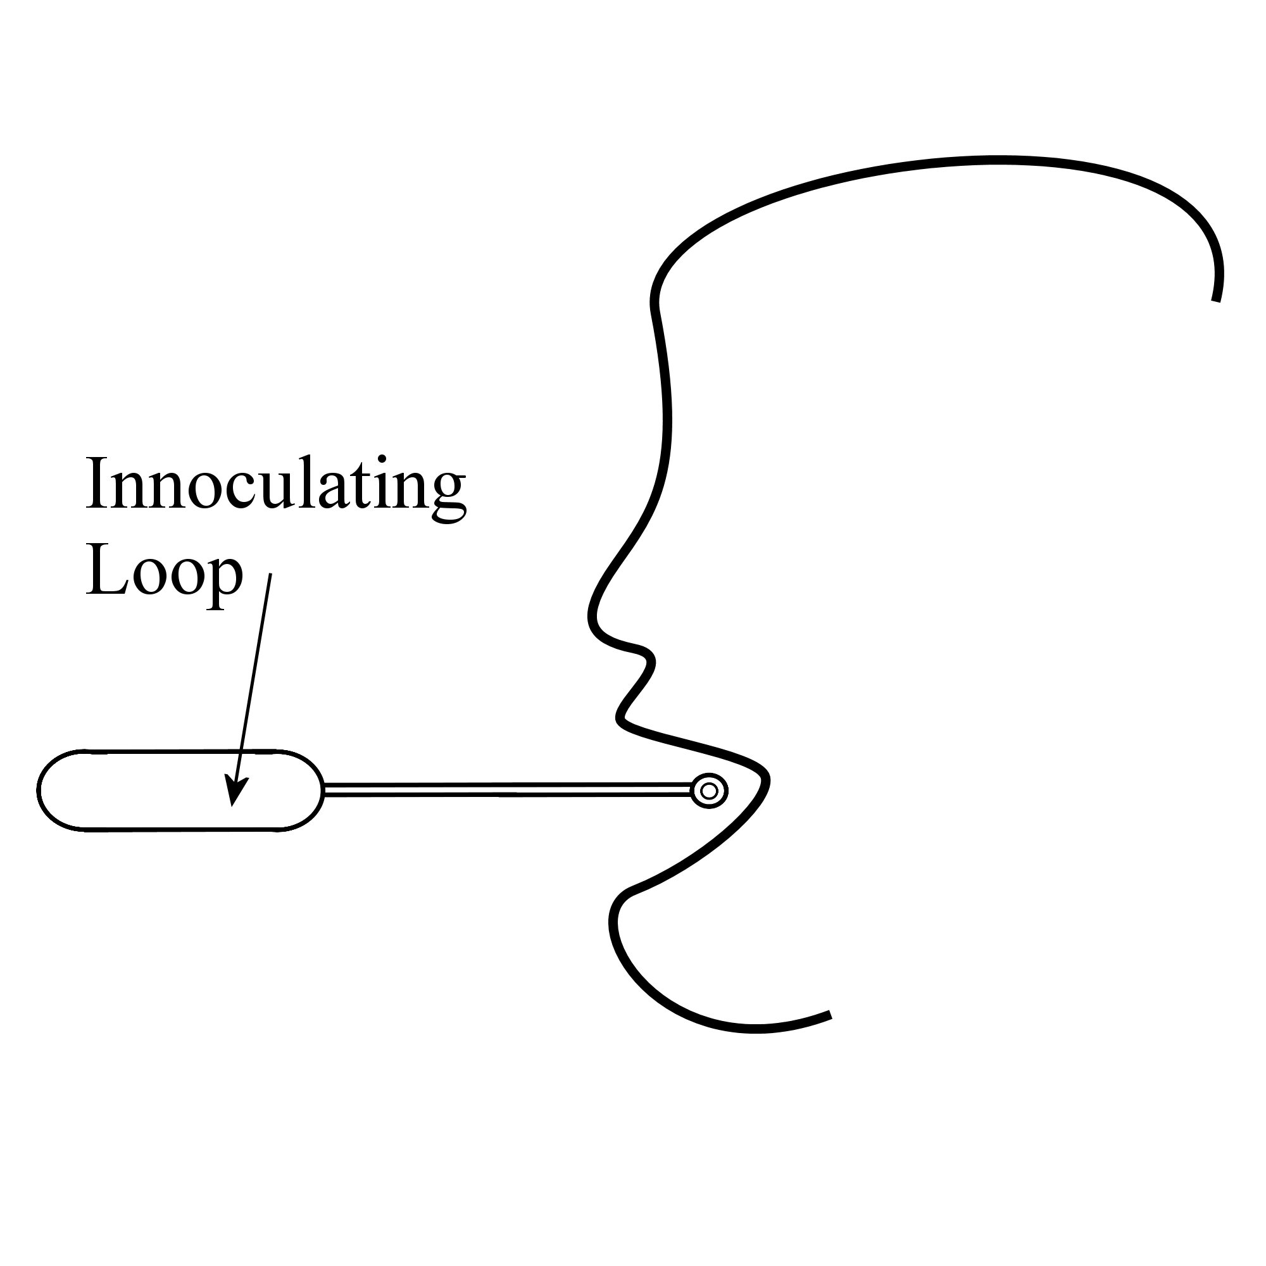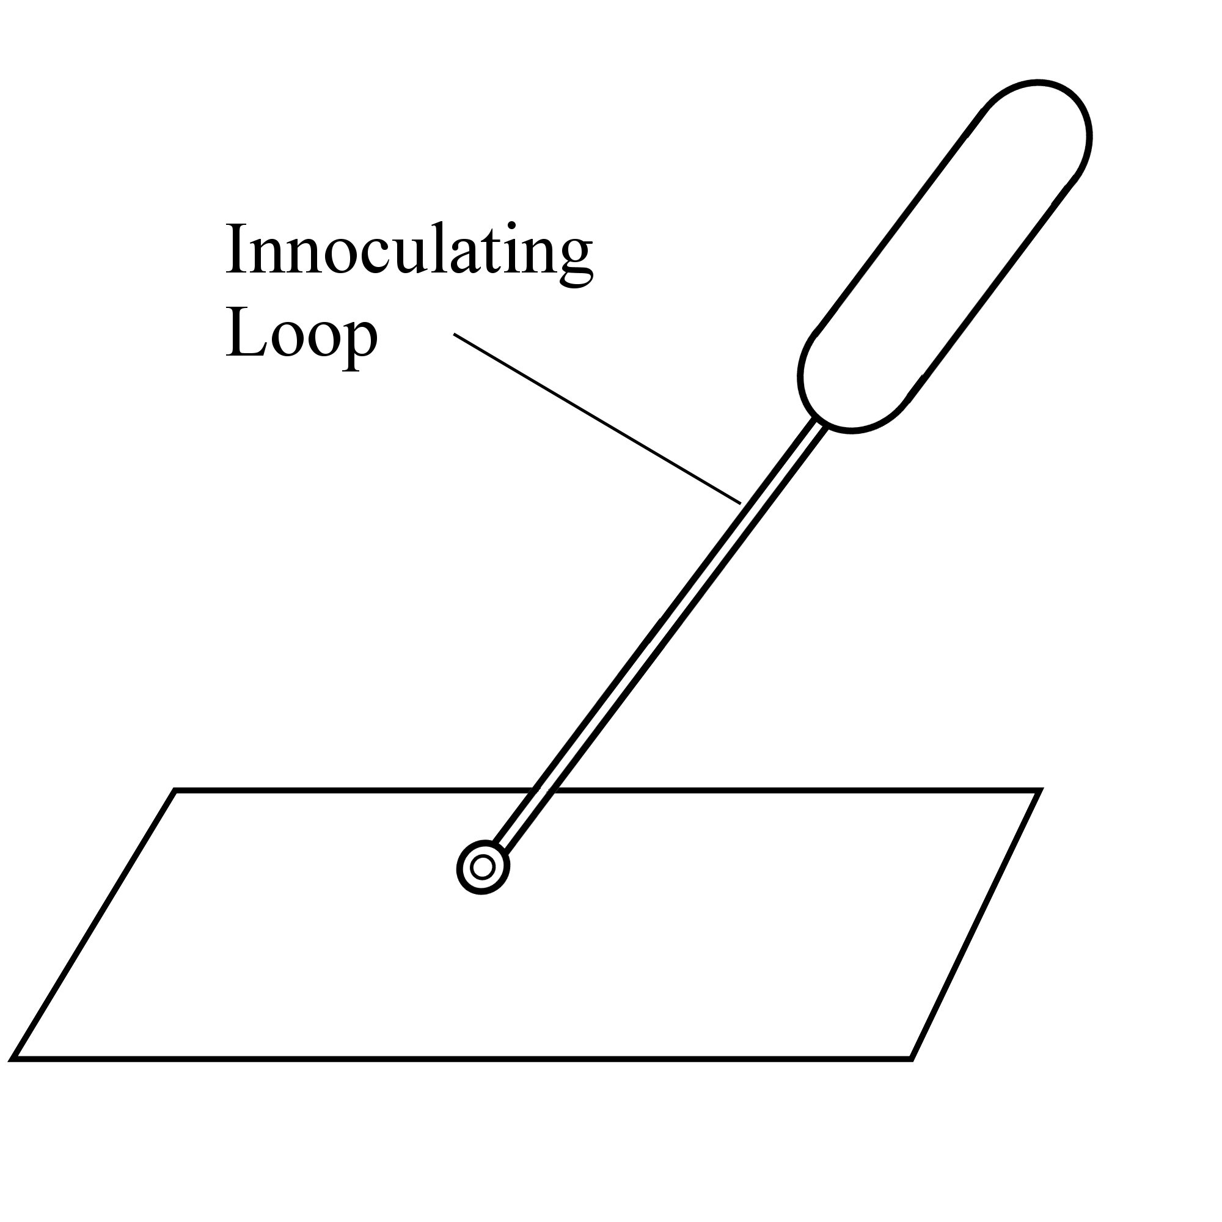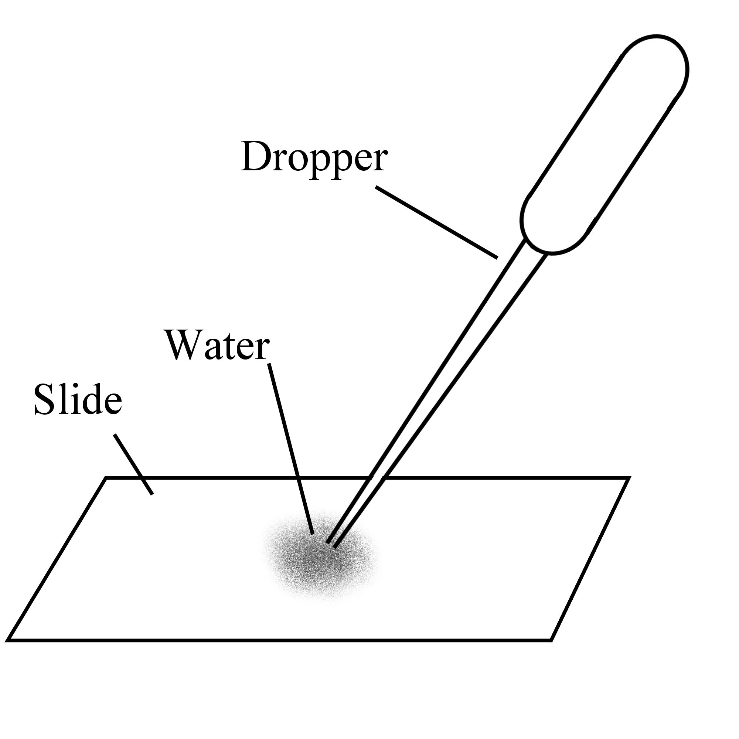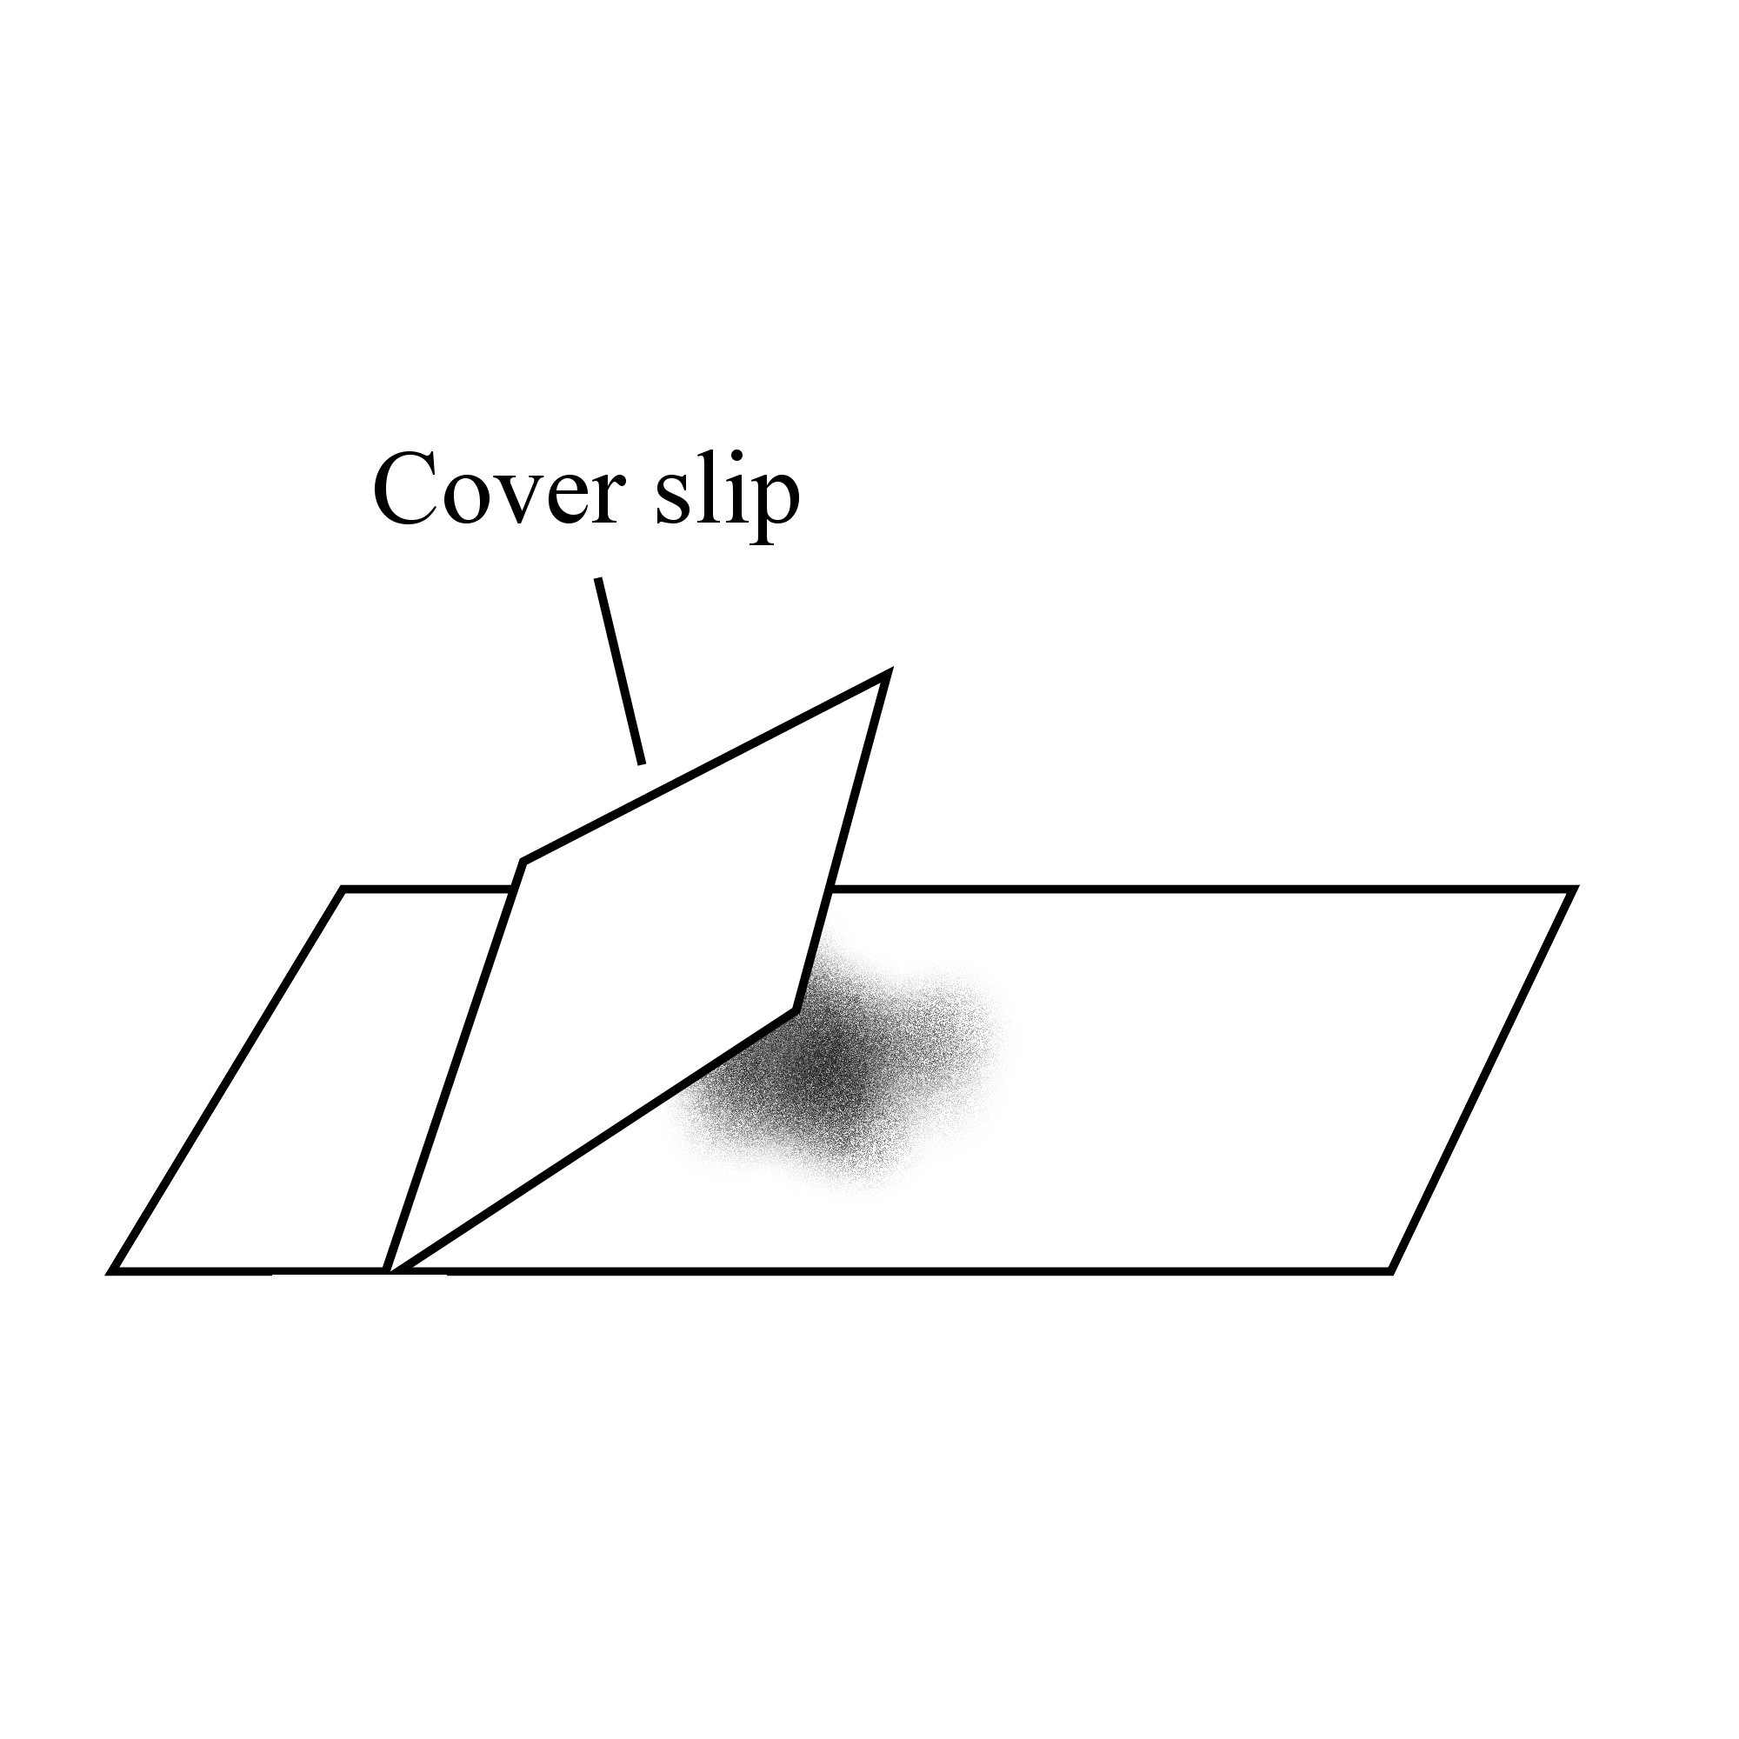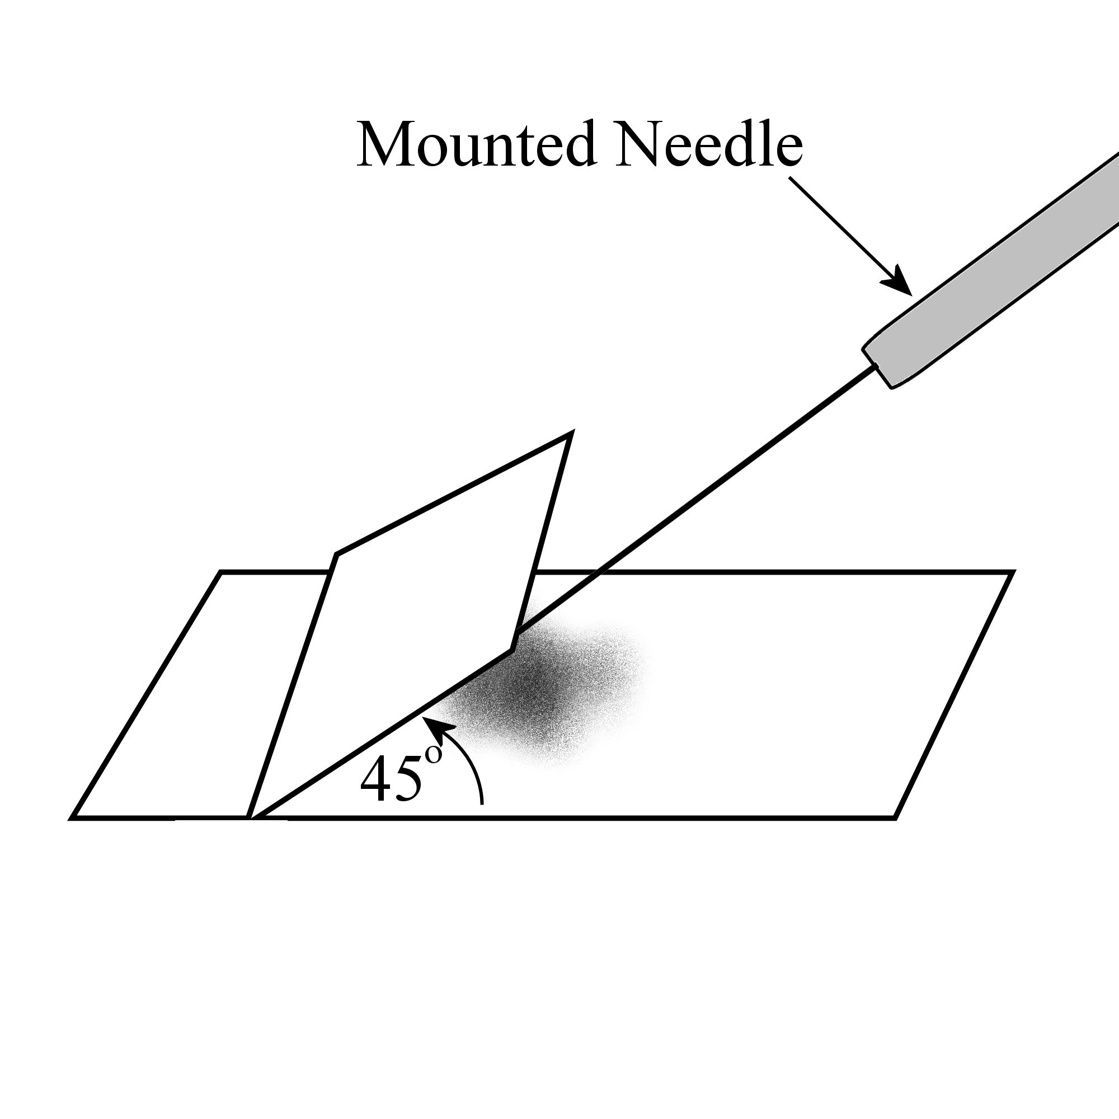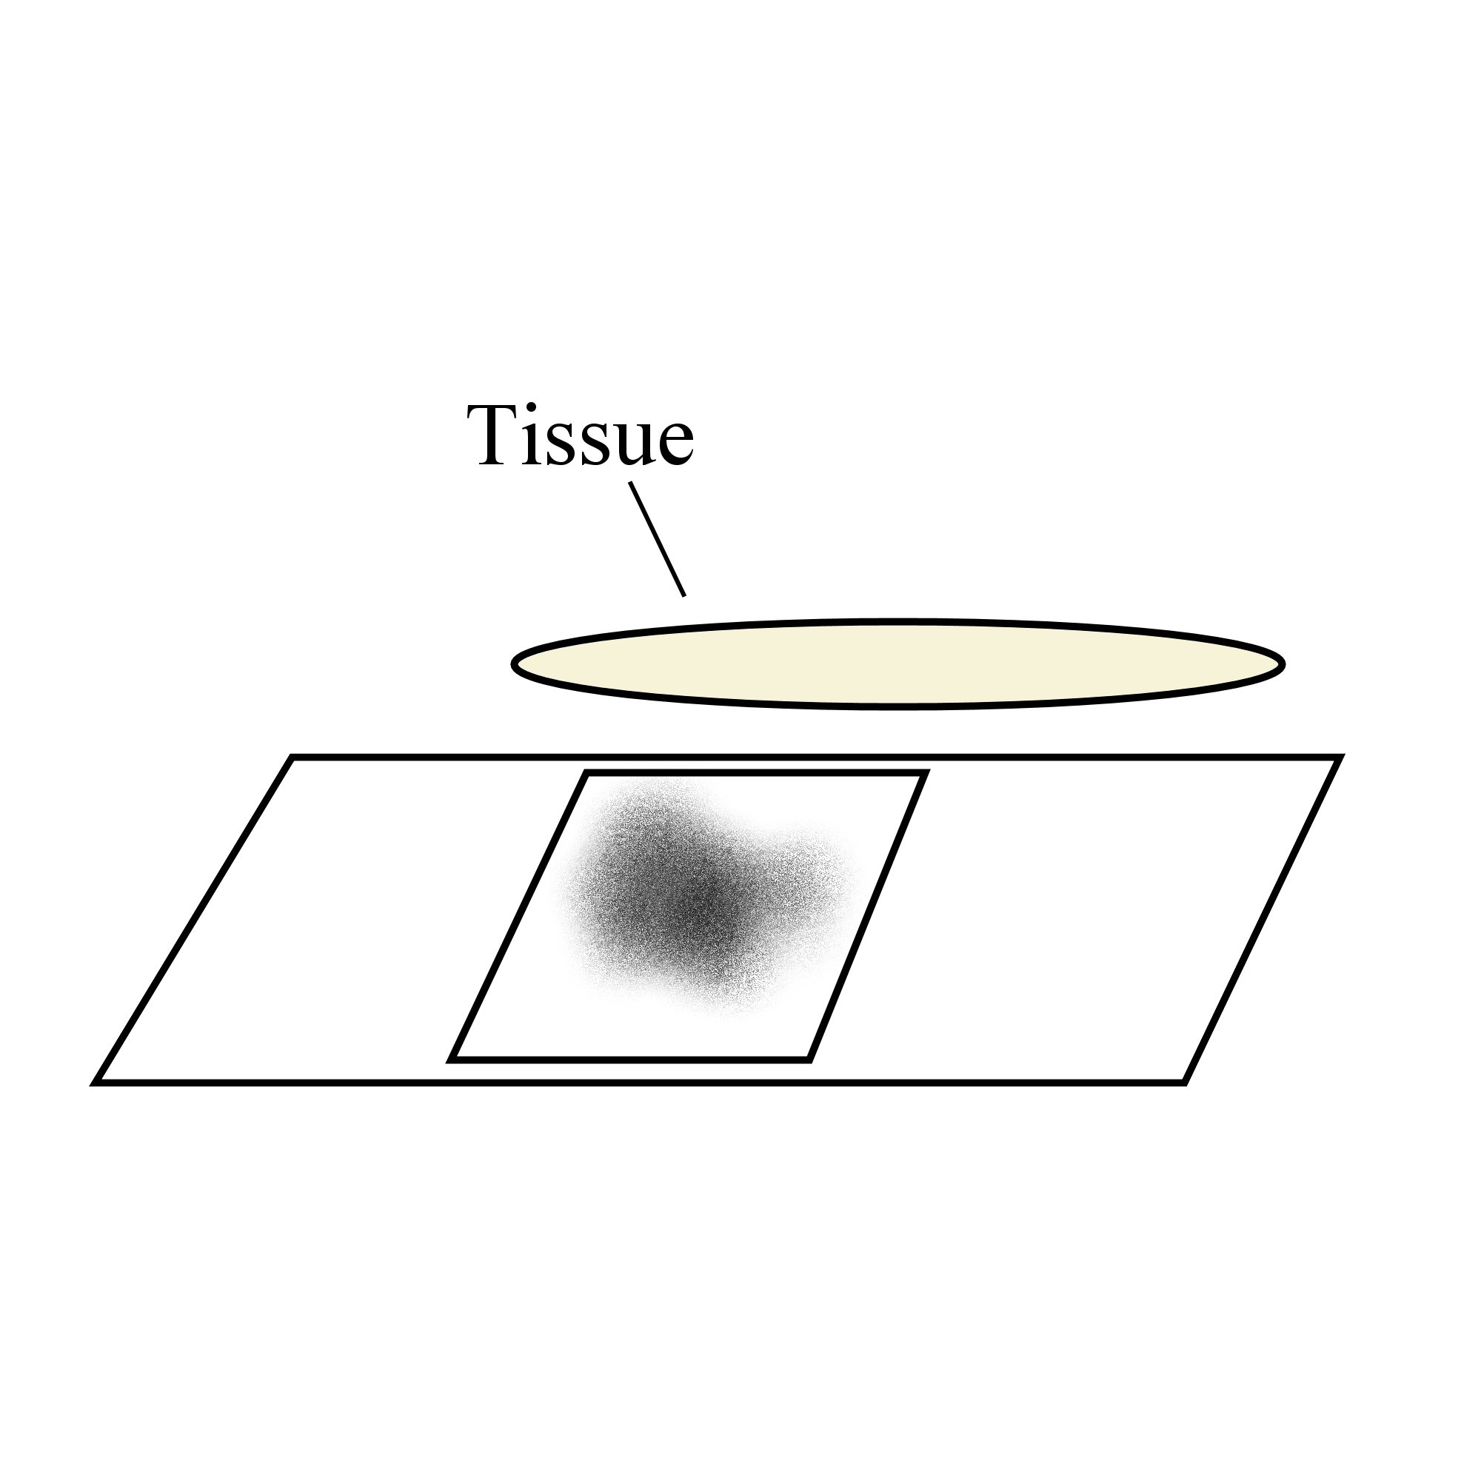
1.
2.
3.

Always remember – Leave time to tidy up
This page can be printed in colour from the accompanying CD
Swab the inside of the cheek.
Transfer the sample to a slide.
Cover the sample with a drop of water.
5.
4.
Place the cover slip at the edge of the water at a 45^{O} angle.
Slowly lower the cover slip onto the water
using the mounted needle.

6.
Dry the slide if necessary.
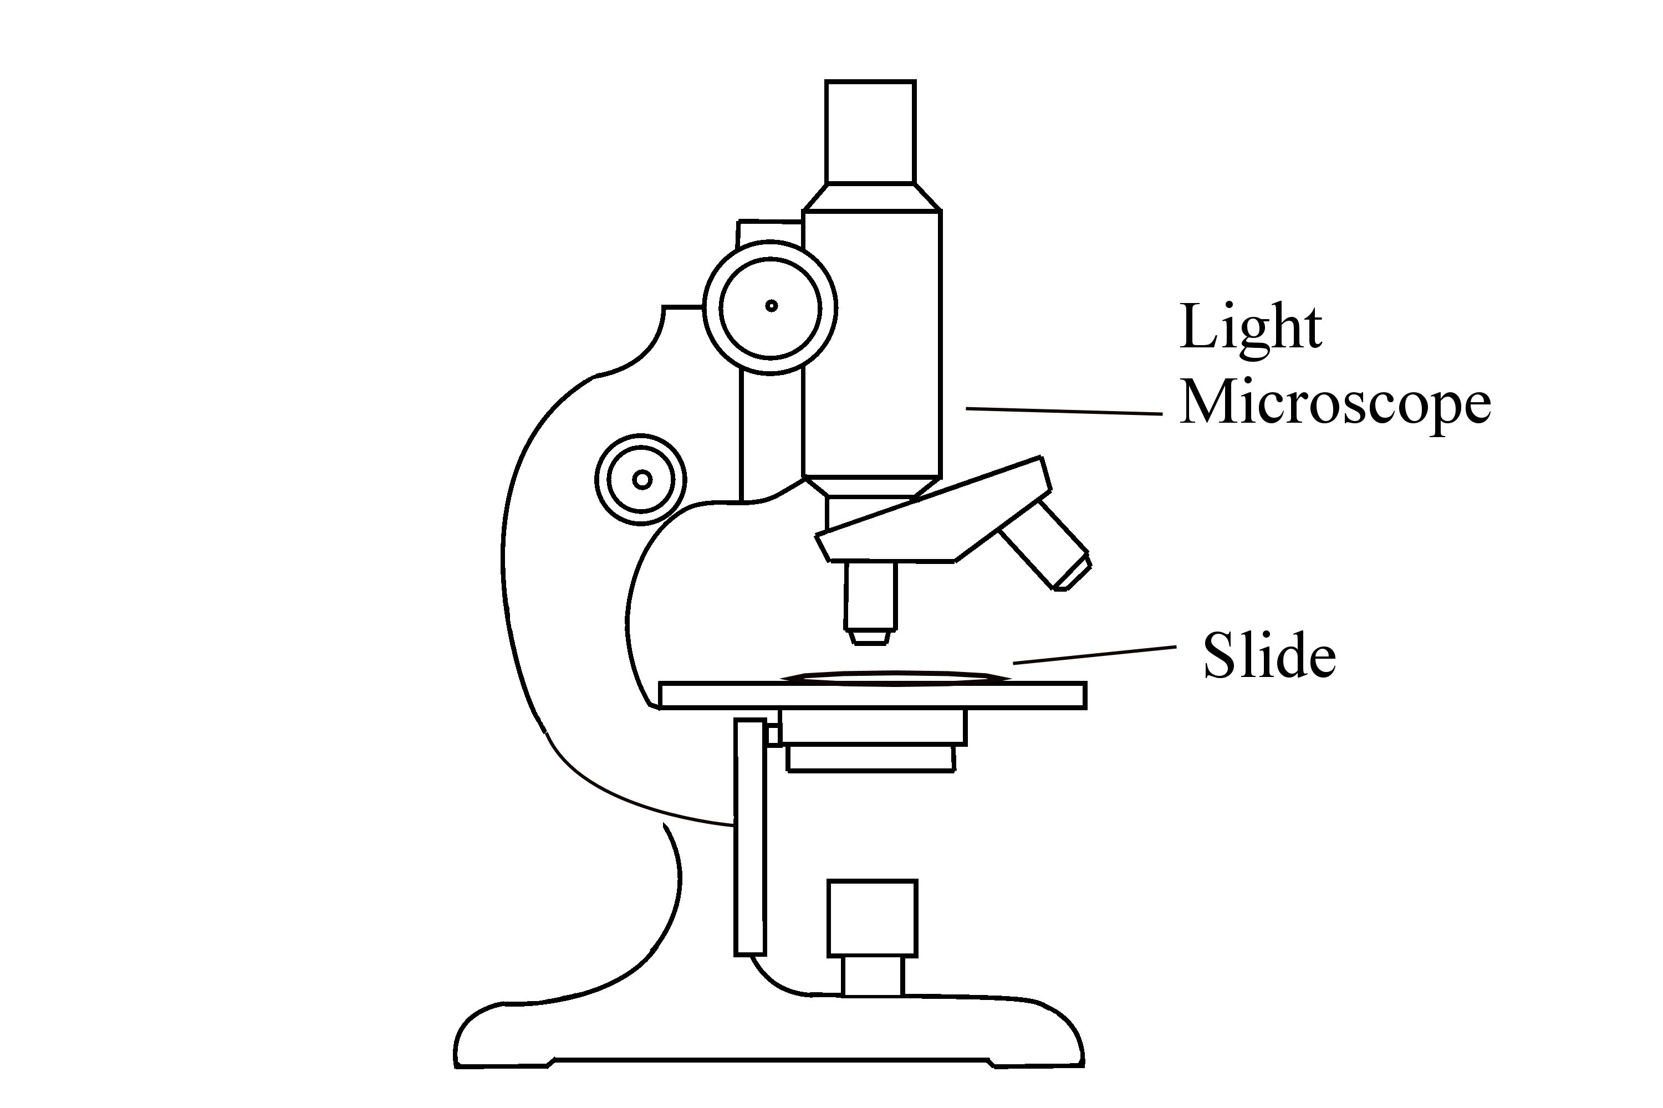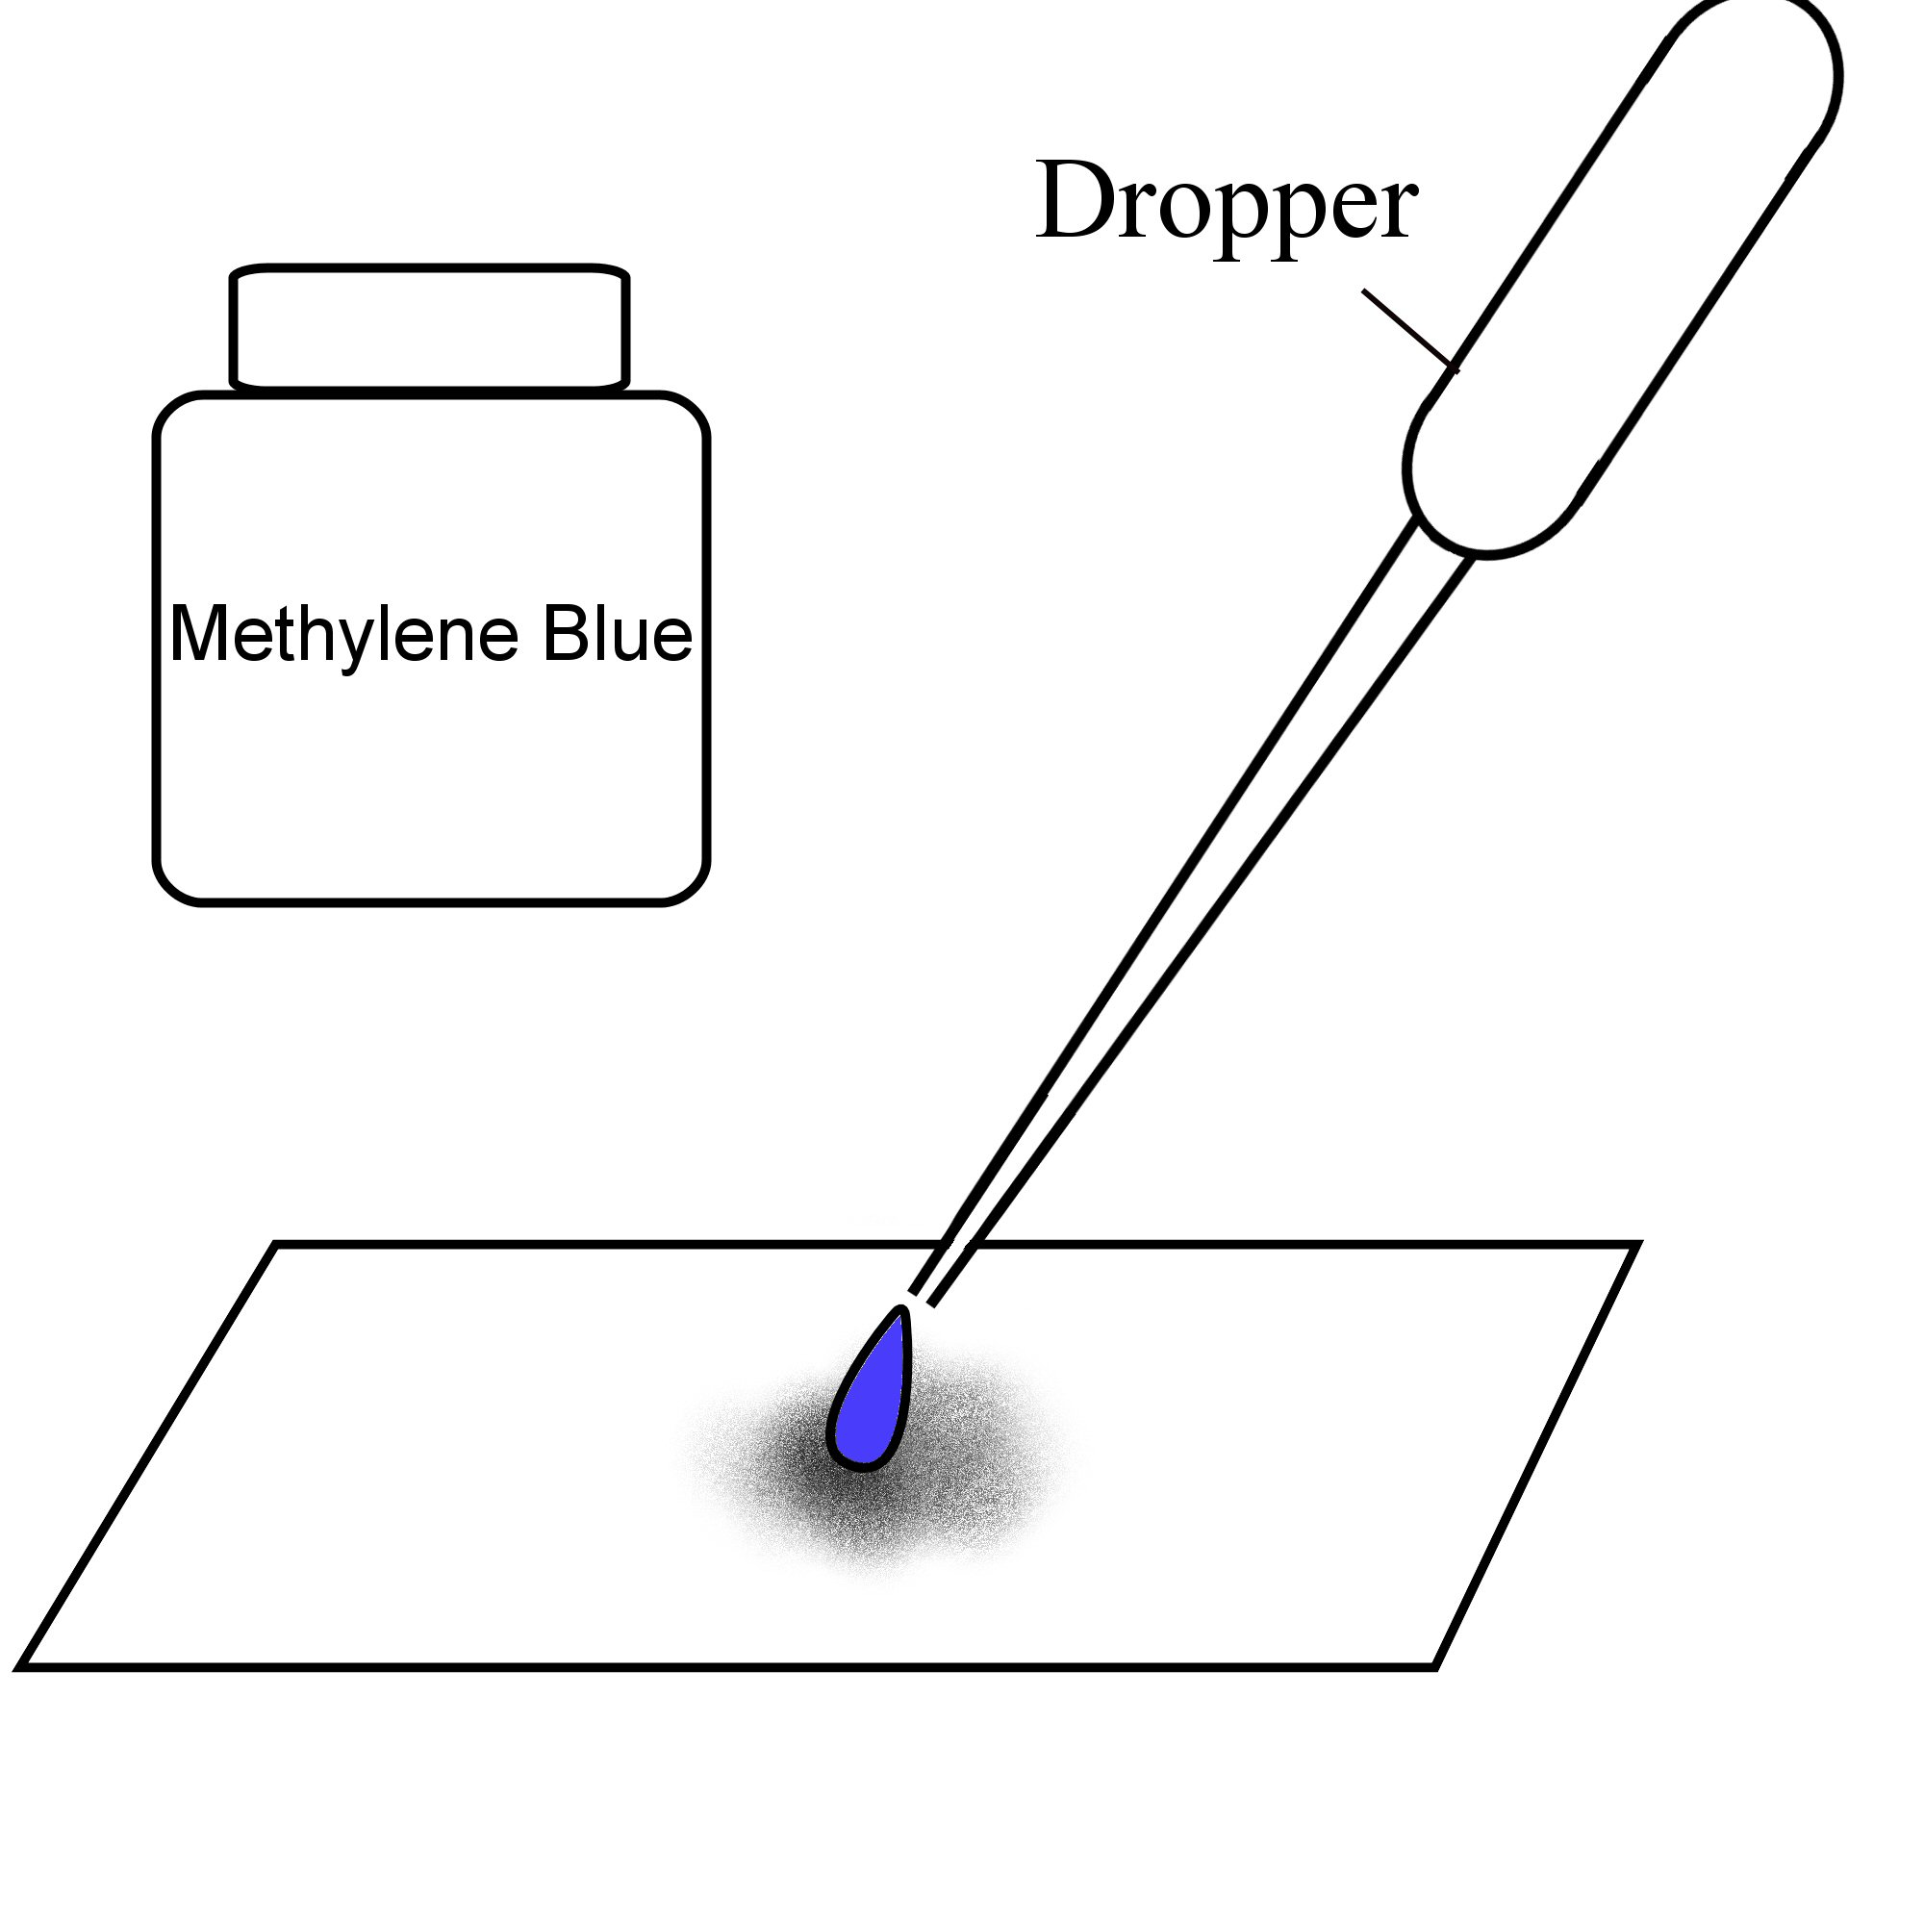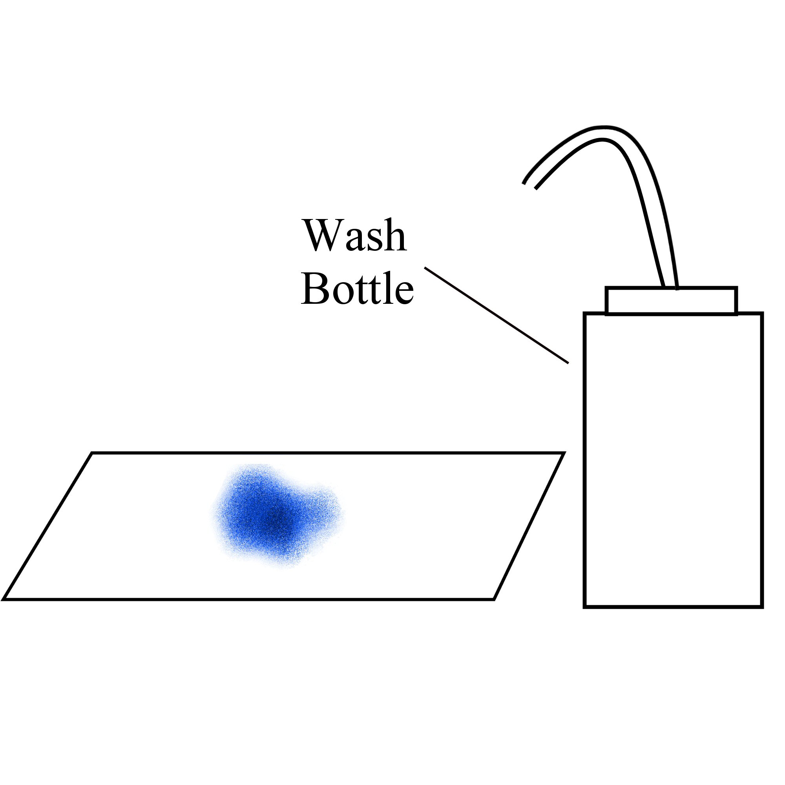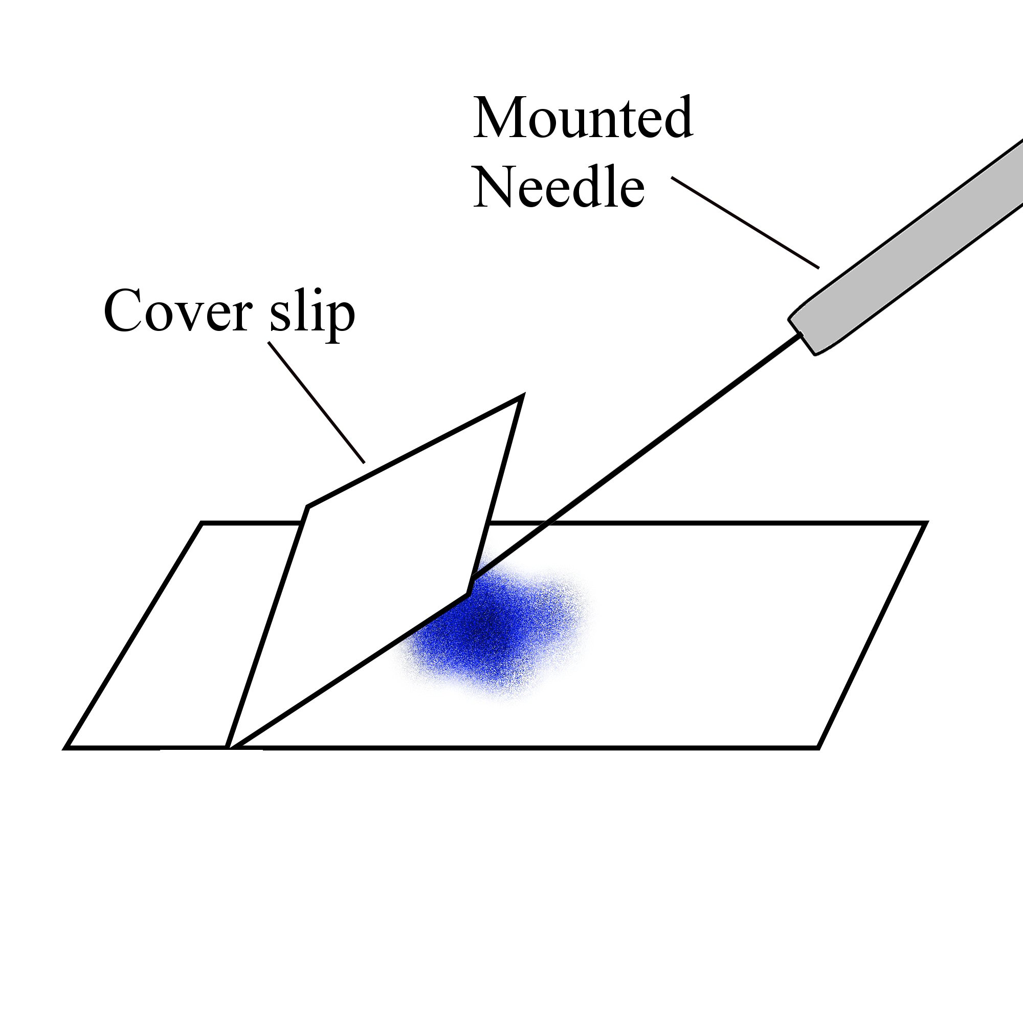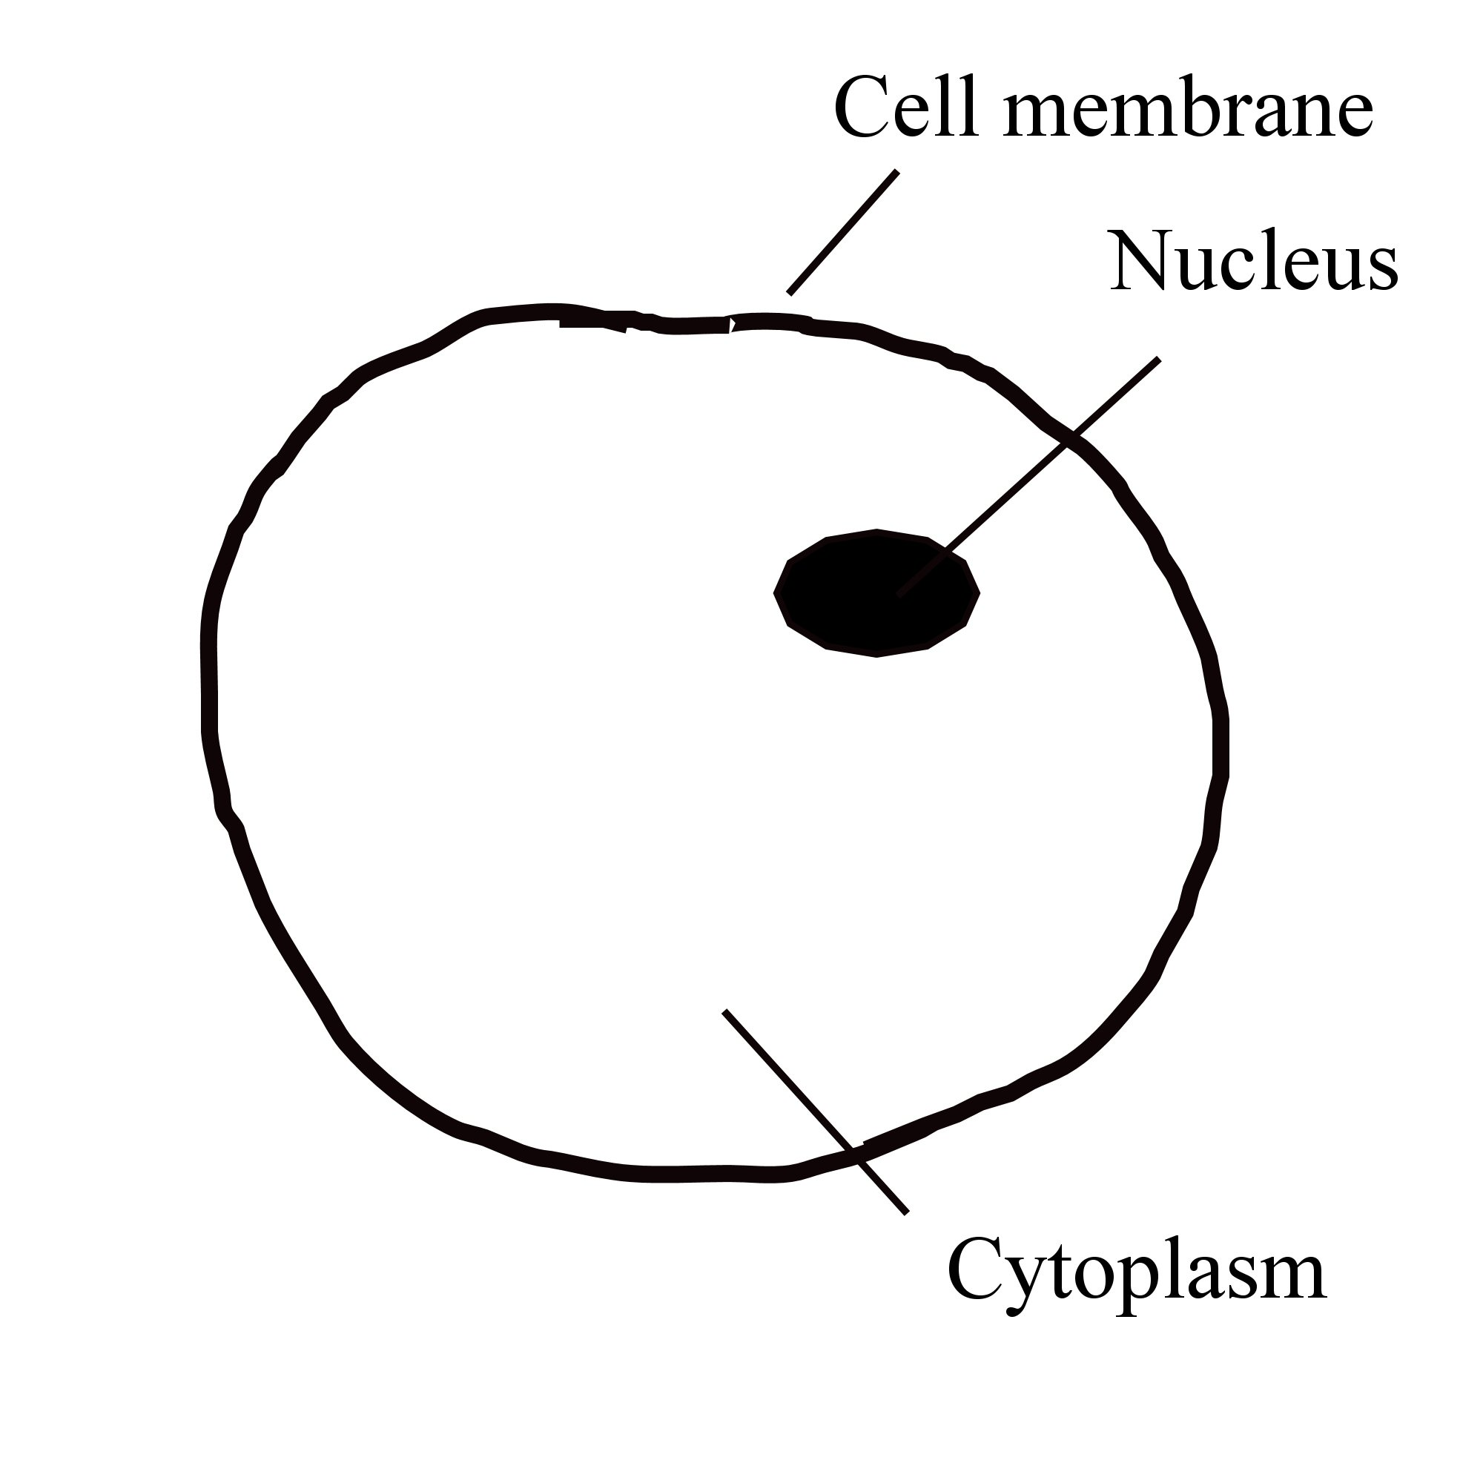
7.
8.
9.
11.

Always remember – Leave time to tidy up
This page can be printed in colour from the accompanying CD
Examine the slide under the microscope
using the usual procedure.
To stain:
Cover the sample with one drop of
methylene blue stain.
10.
Gently wash excess stain from the slide
using a wash bottle.
Apply the cover slip as previously done.

12.
Expected result
Prepare as for
steps 1 and 2 previously

