4.3 (a) To investigate the effect of pH on amylase activity
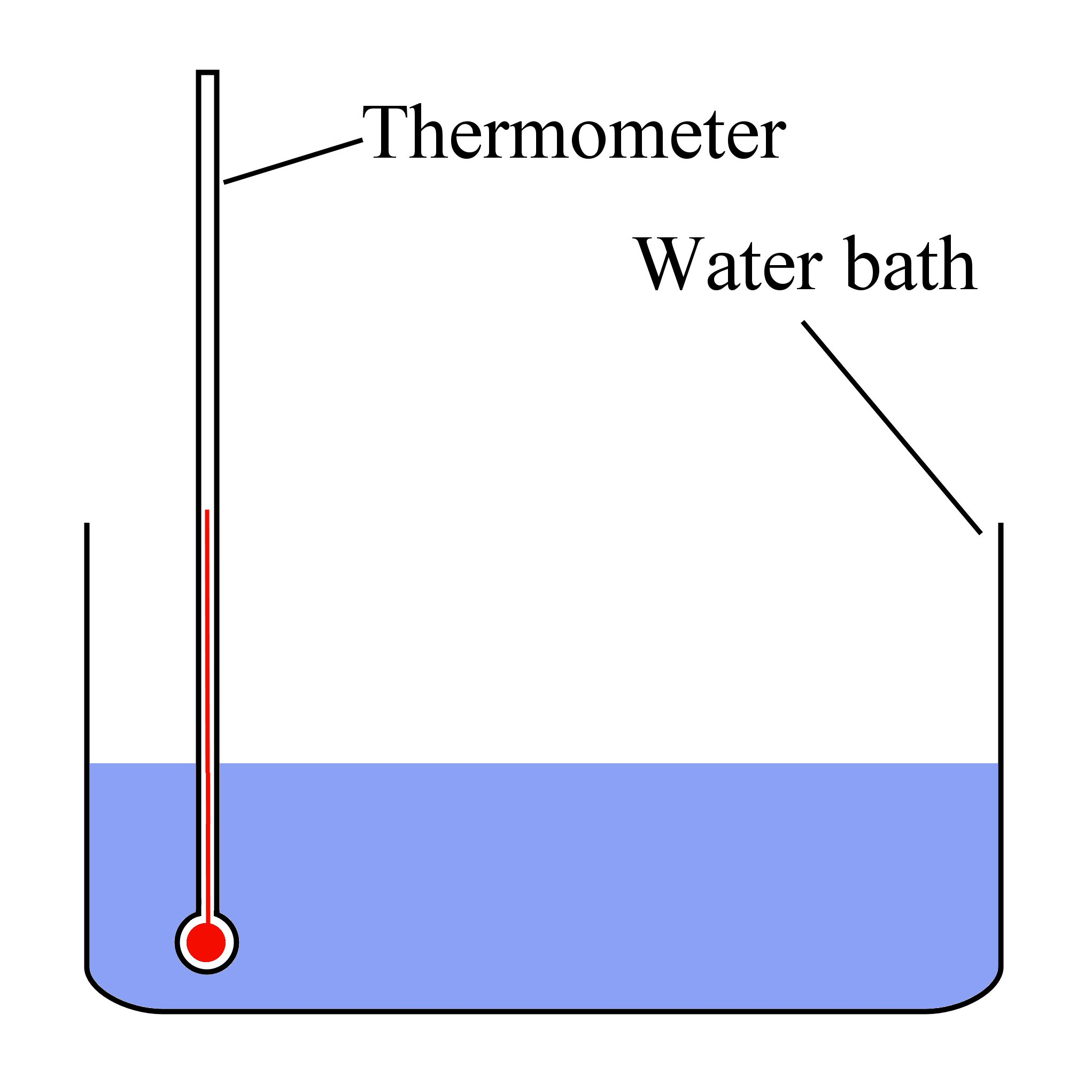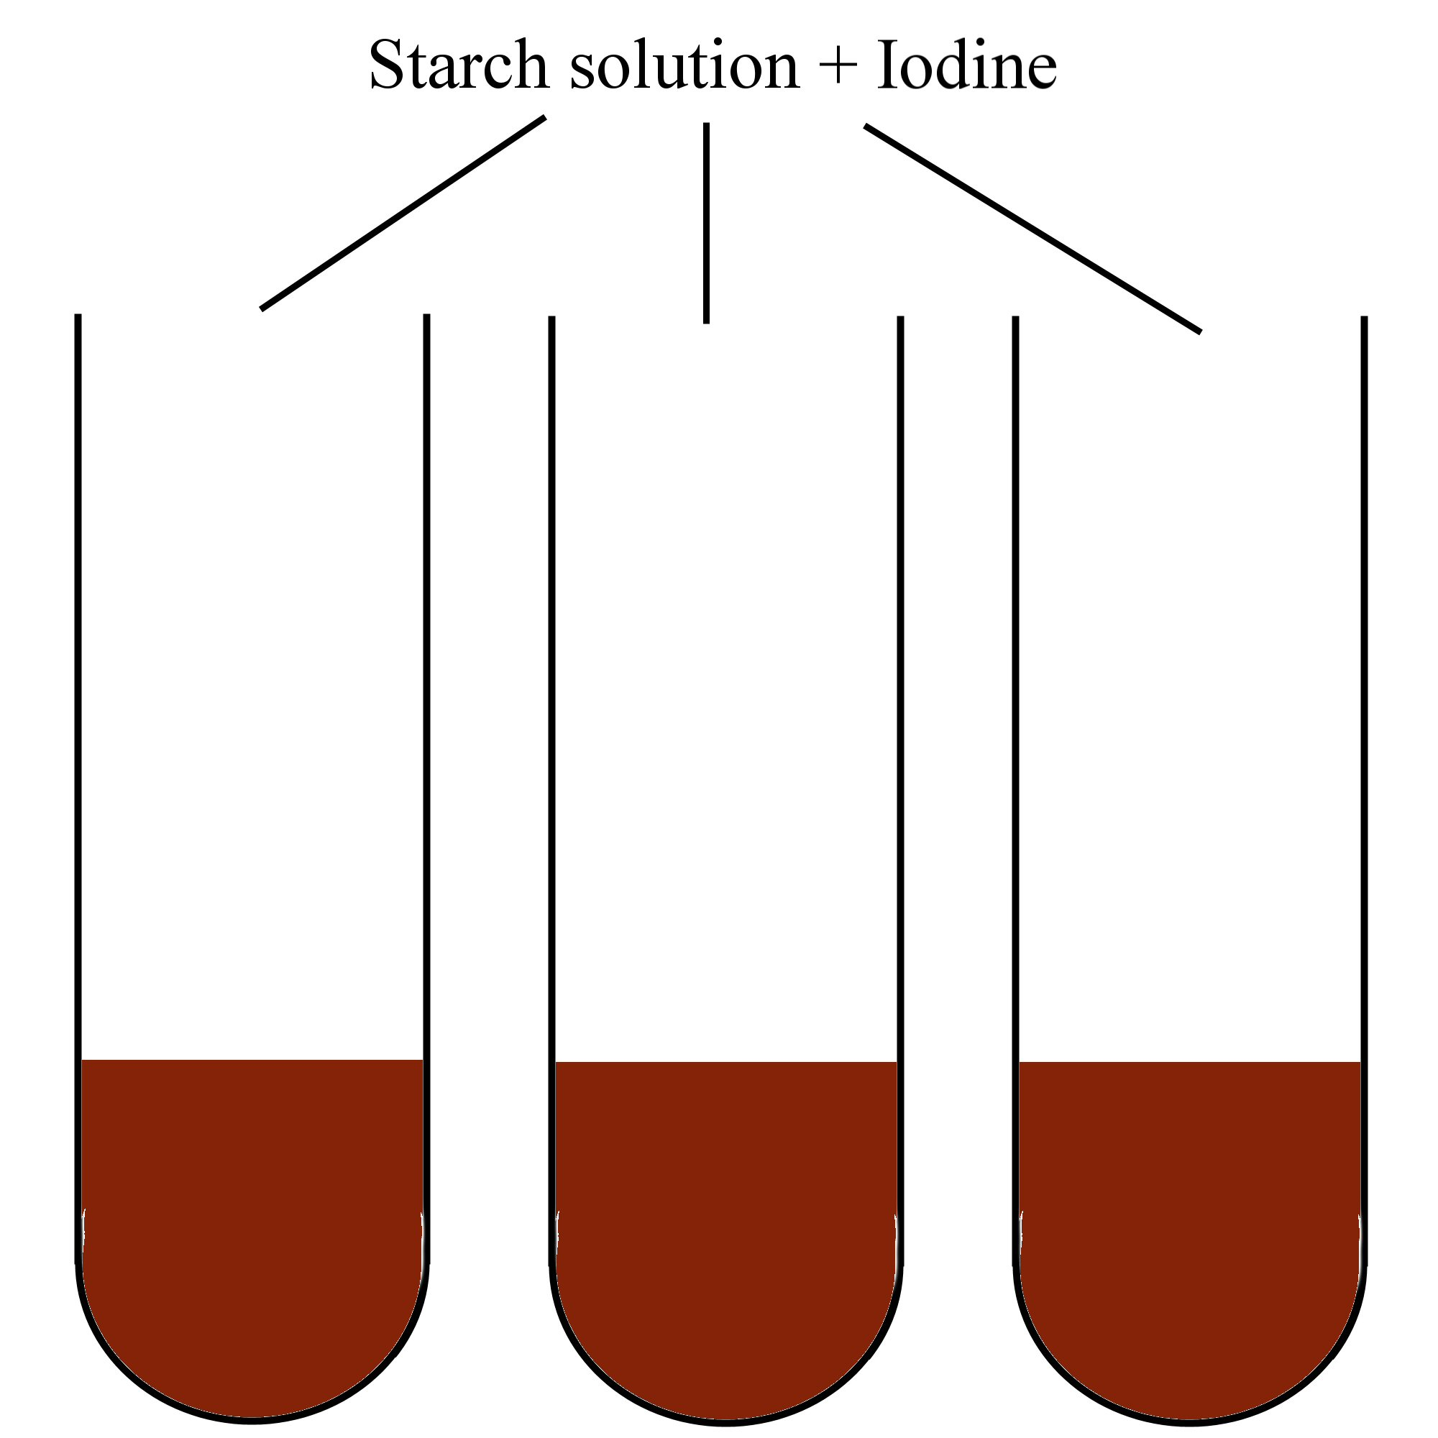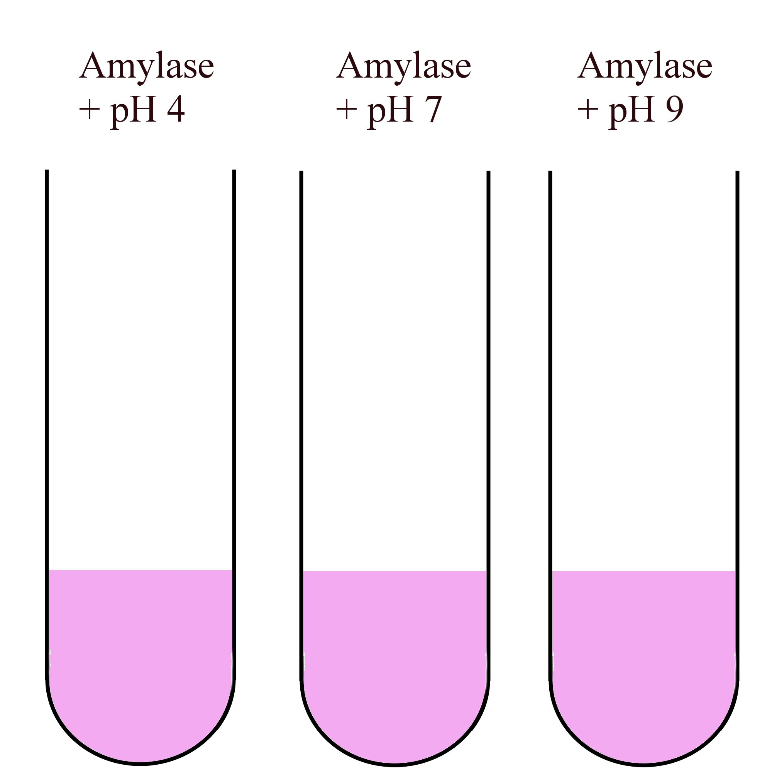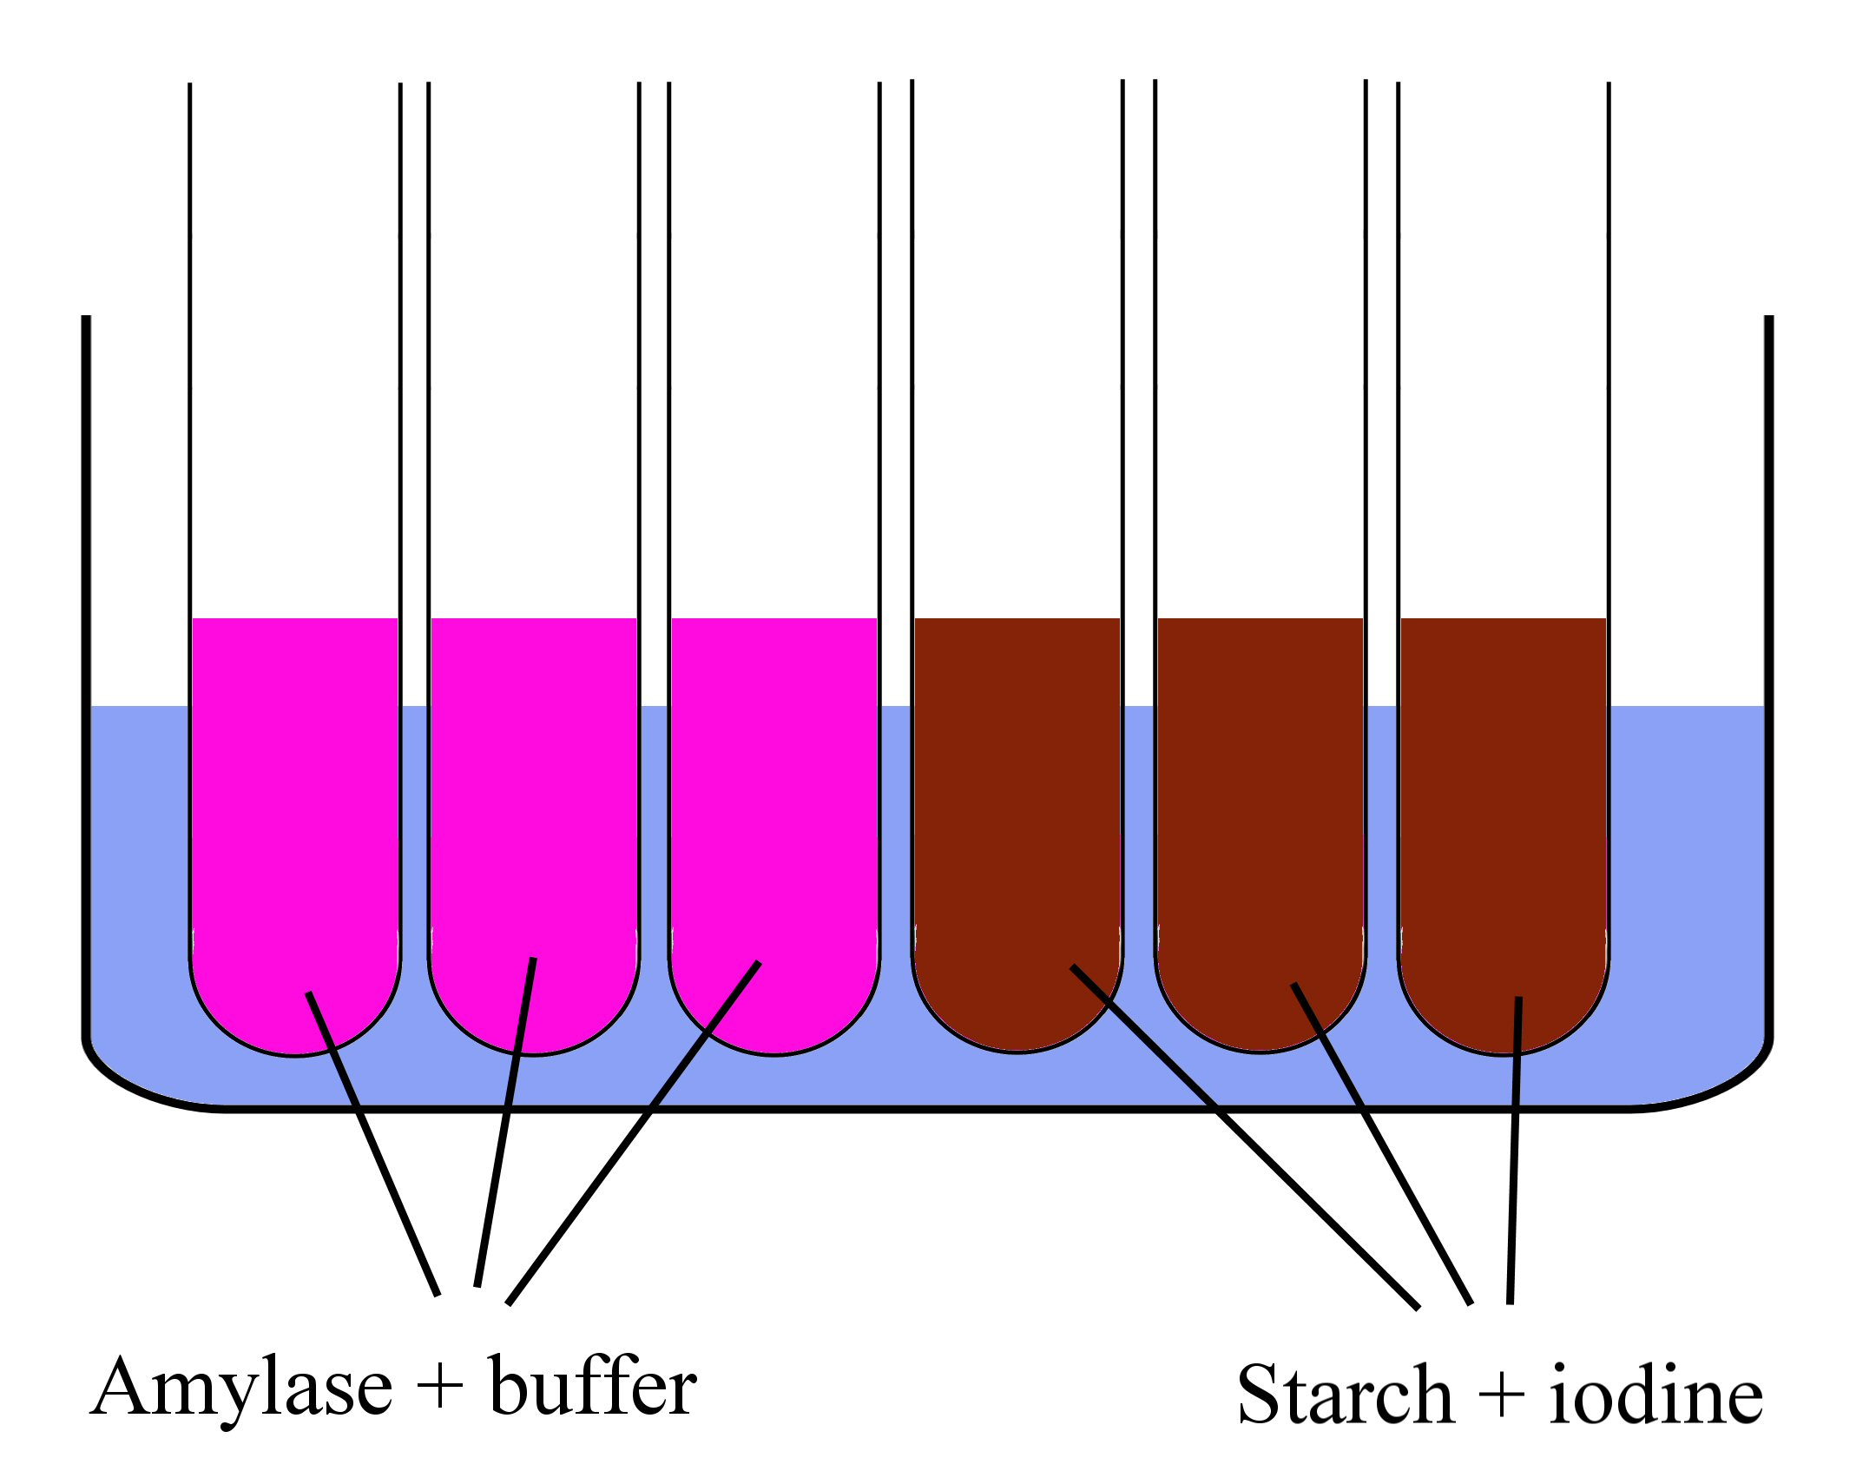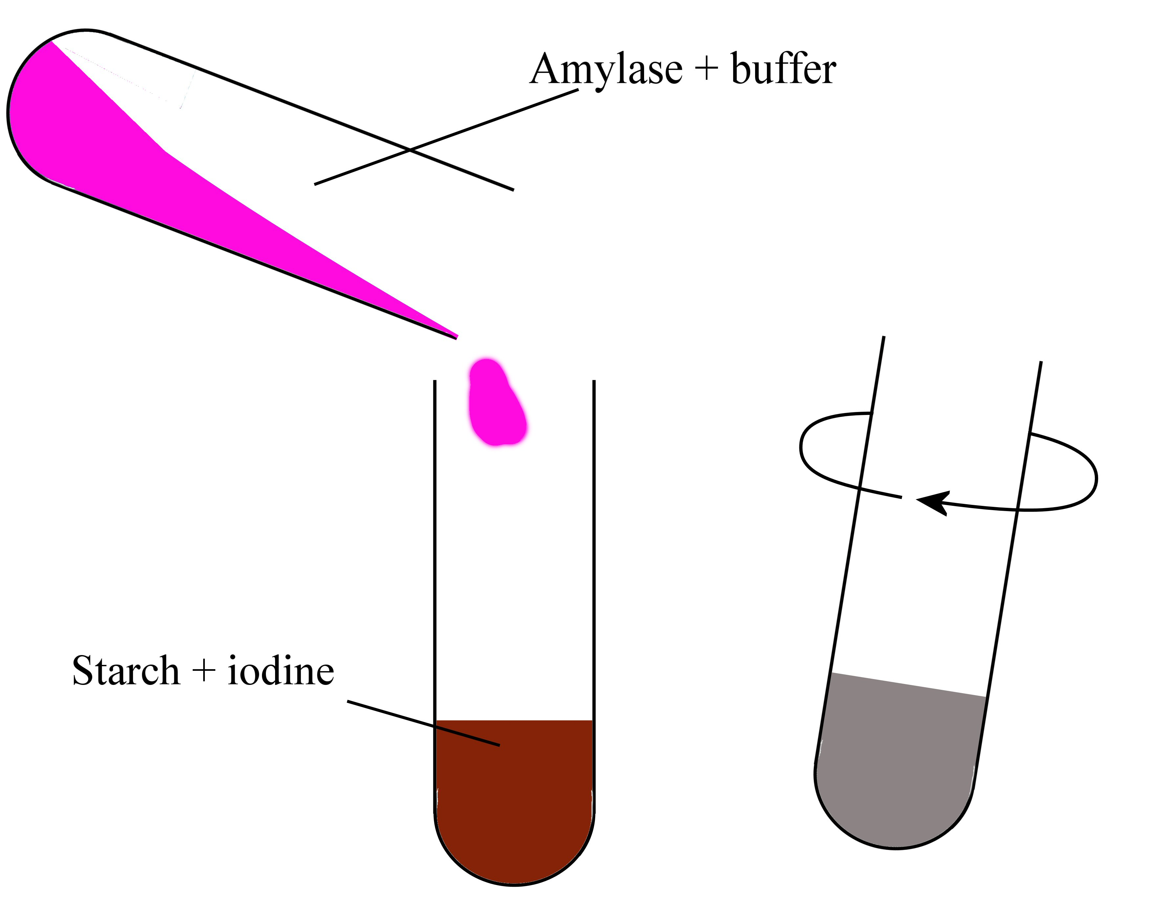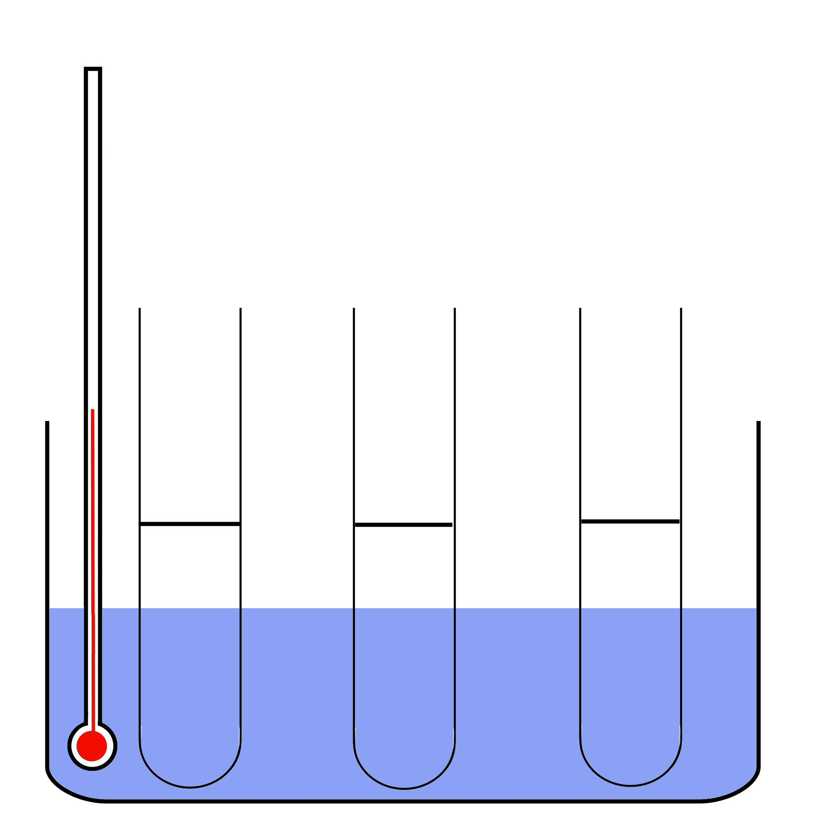
1.
2.
3.

Always remember – Leave time to tidy up
This page can be printed in colour from the accompanying CD
Set up a water bath at 37^{O}C.
Place 5 ml starch solution and 3 drops of
iodine solution into 3 boiling tubes.
Put 2 ml amylase solution and
5 ml buffer (4, 7, 9) into three other tubes.
5.
4.
Place all tubes into a water bath at 37^{O}C and leave for 5 minutes.
Pour one of the amylase tubes into one of the starch tubes. Gently shake.
Repeat for each pH.

6.
Replace the tubes in the water bath and measure the time taken for the blue/black colour to disappear.
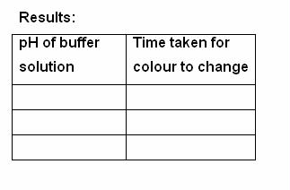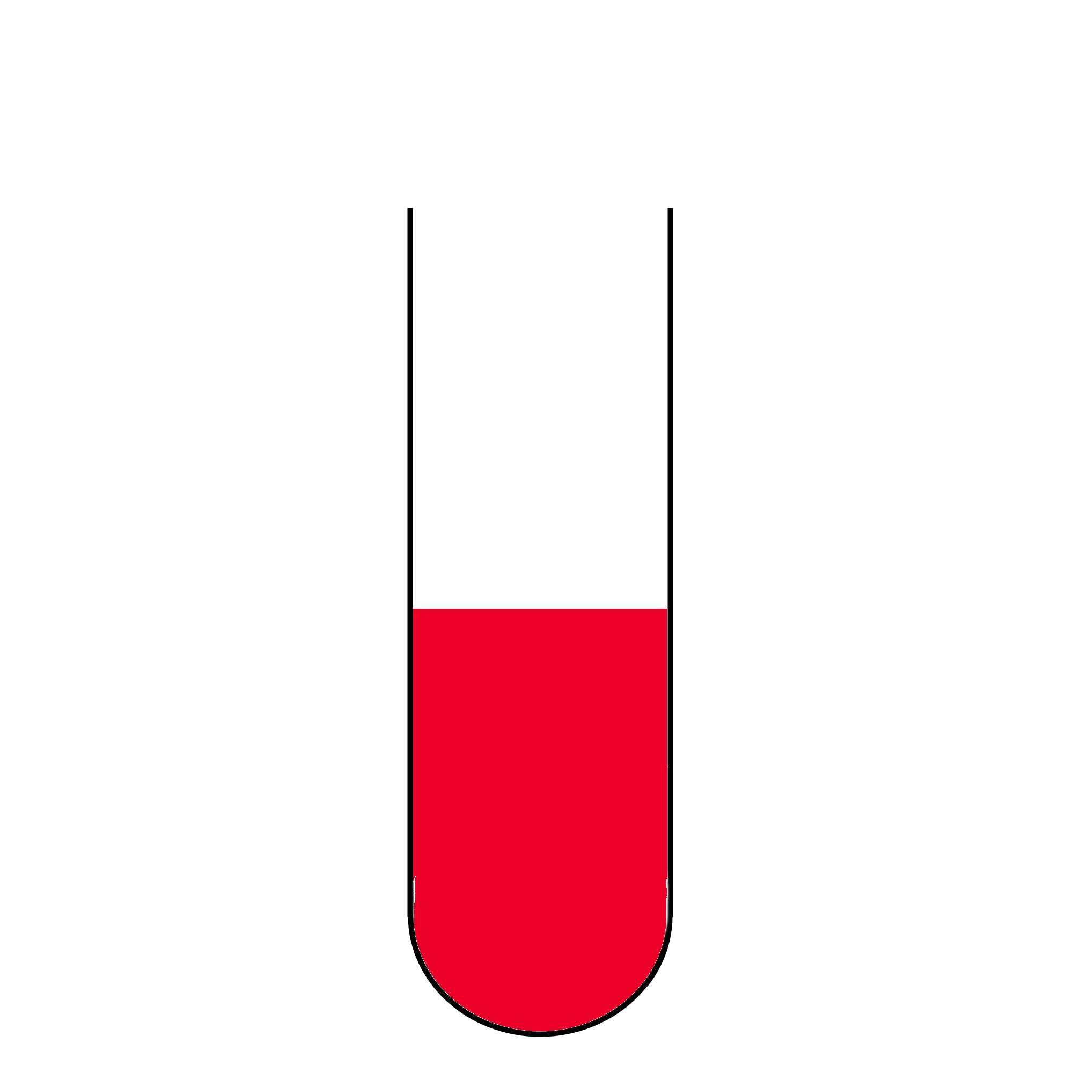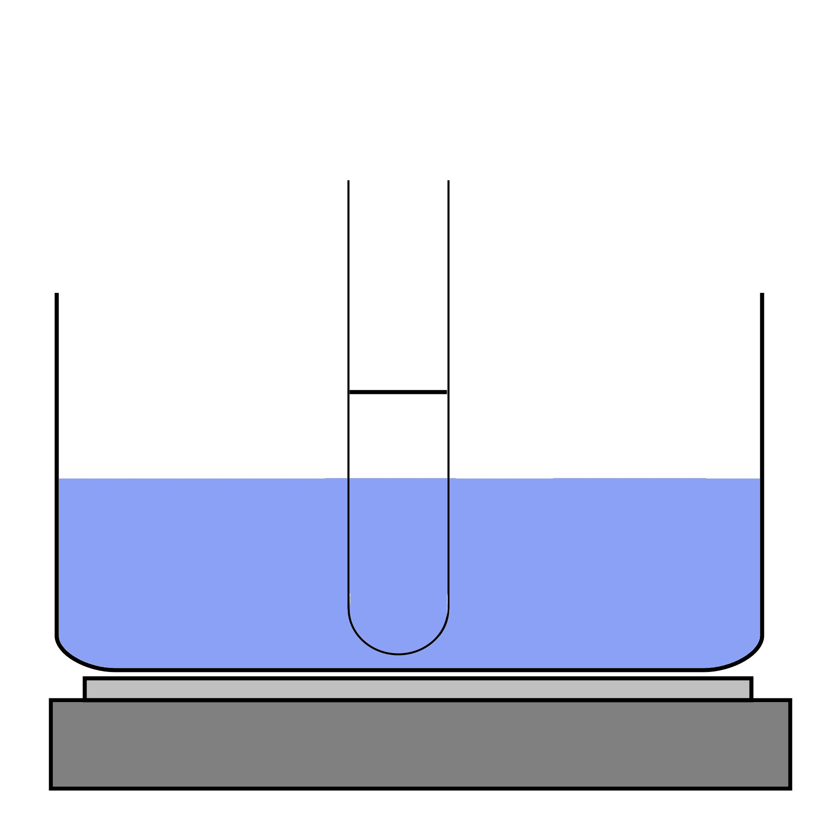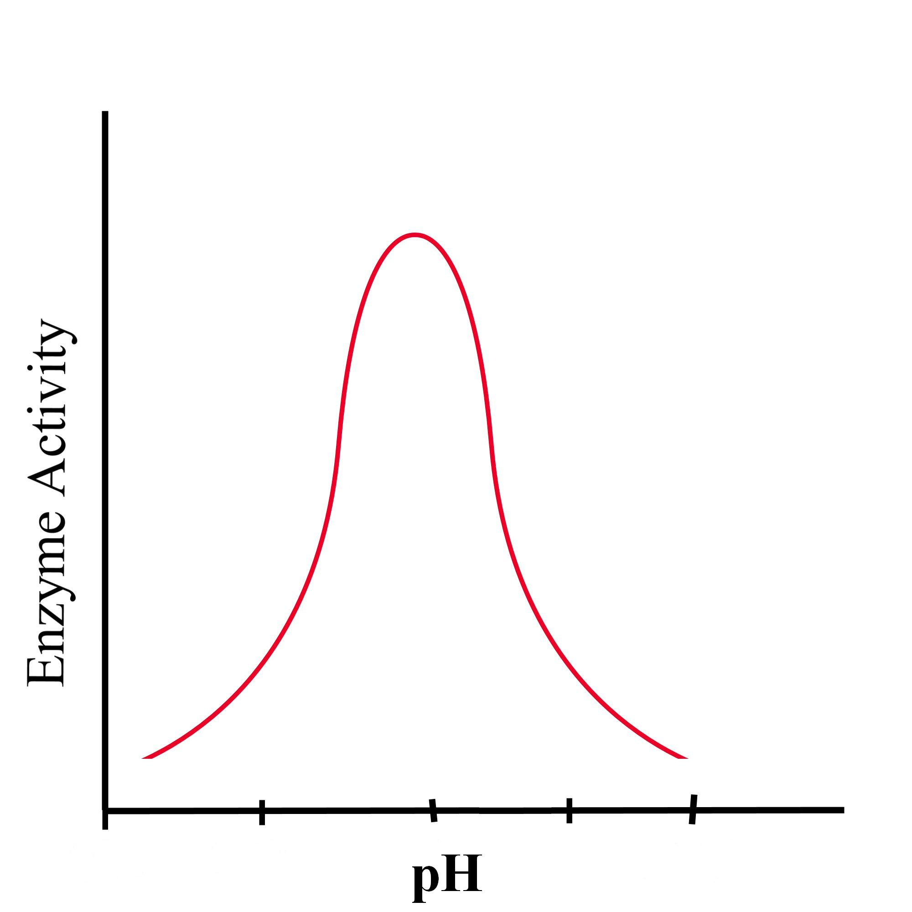
7.
8.
9.

Always remember – Leave time to tidy up
Graph your results
Test for sugar: add 1ml Benedict’s solution to each boiling tube and heat for 5 minutes.
A brick red colour indicates a reducing sugar is present.
10.
Repeat the whole experiment with boiled amylase as a control.
Prepare as for
steps 1 and 2 previously
11.
Expected result

The enzyme works best at a pH of 7.
The blue / black colour faded and Benedicts resulted in a
positive test.
This page can be printed in colour from the accompanying CD

