4.4 (a) To investigate the effect of temperature on amylase activity
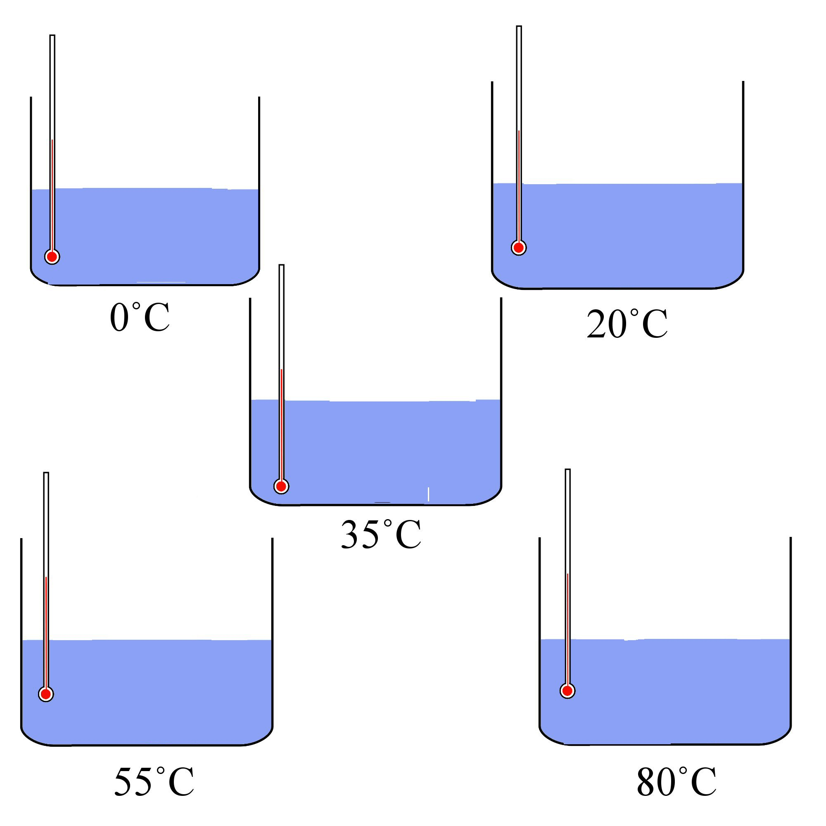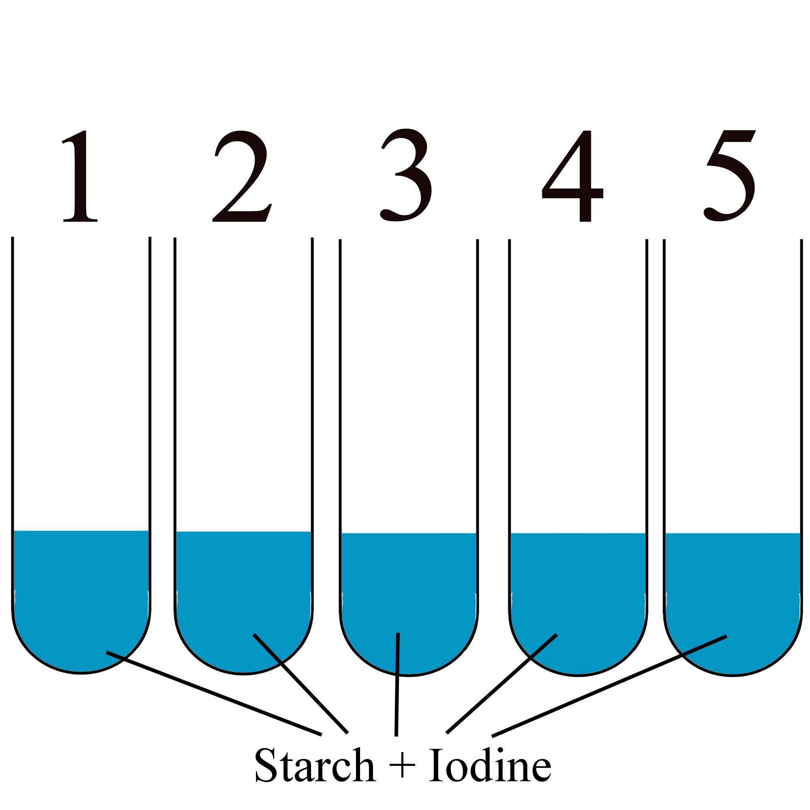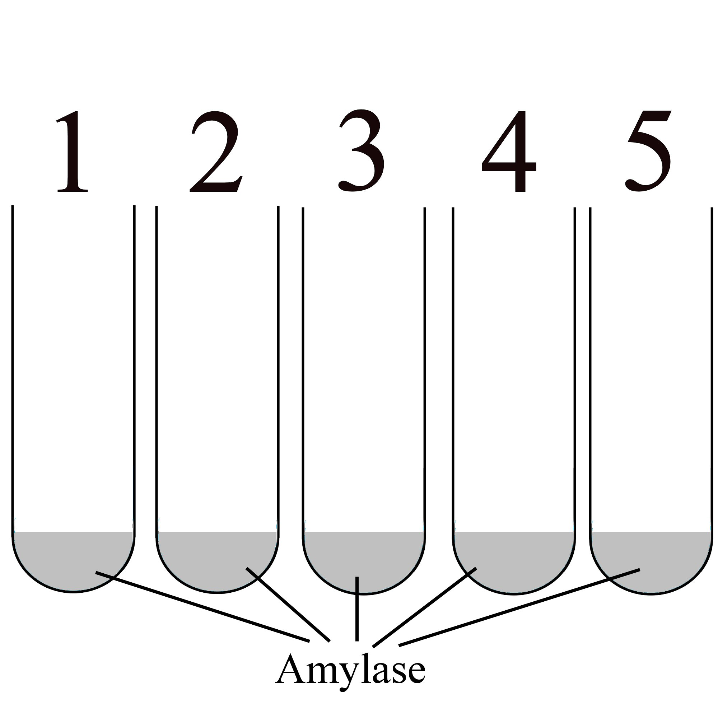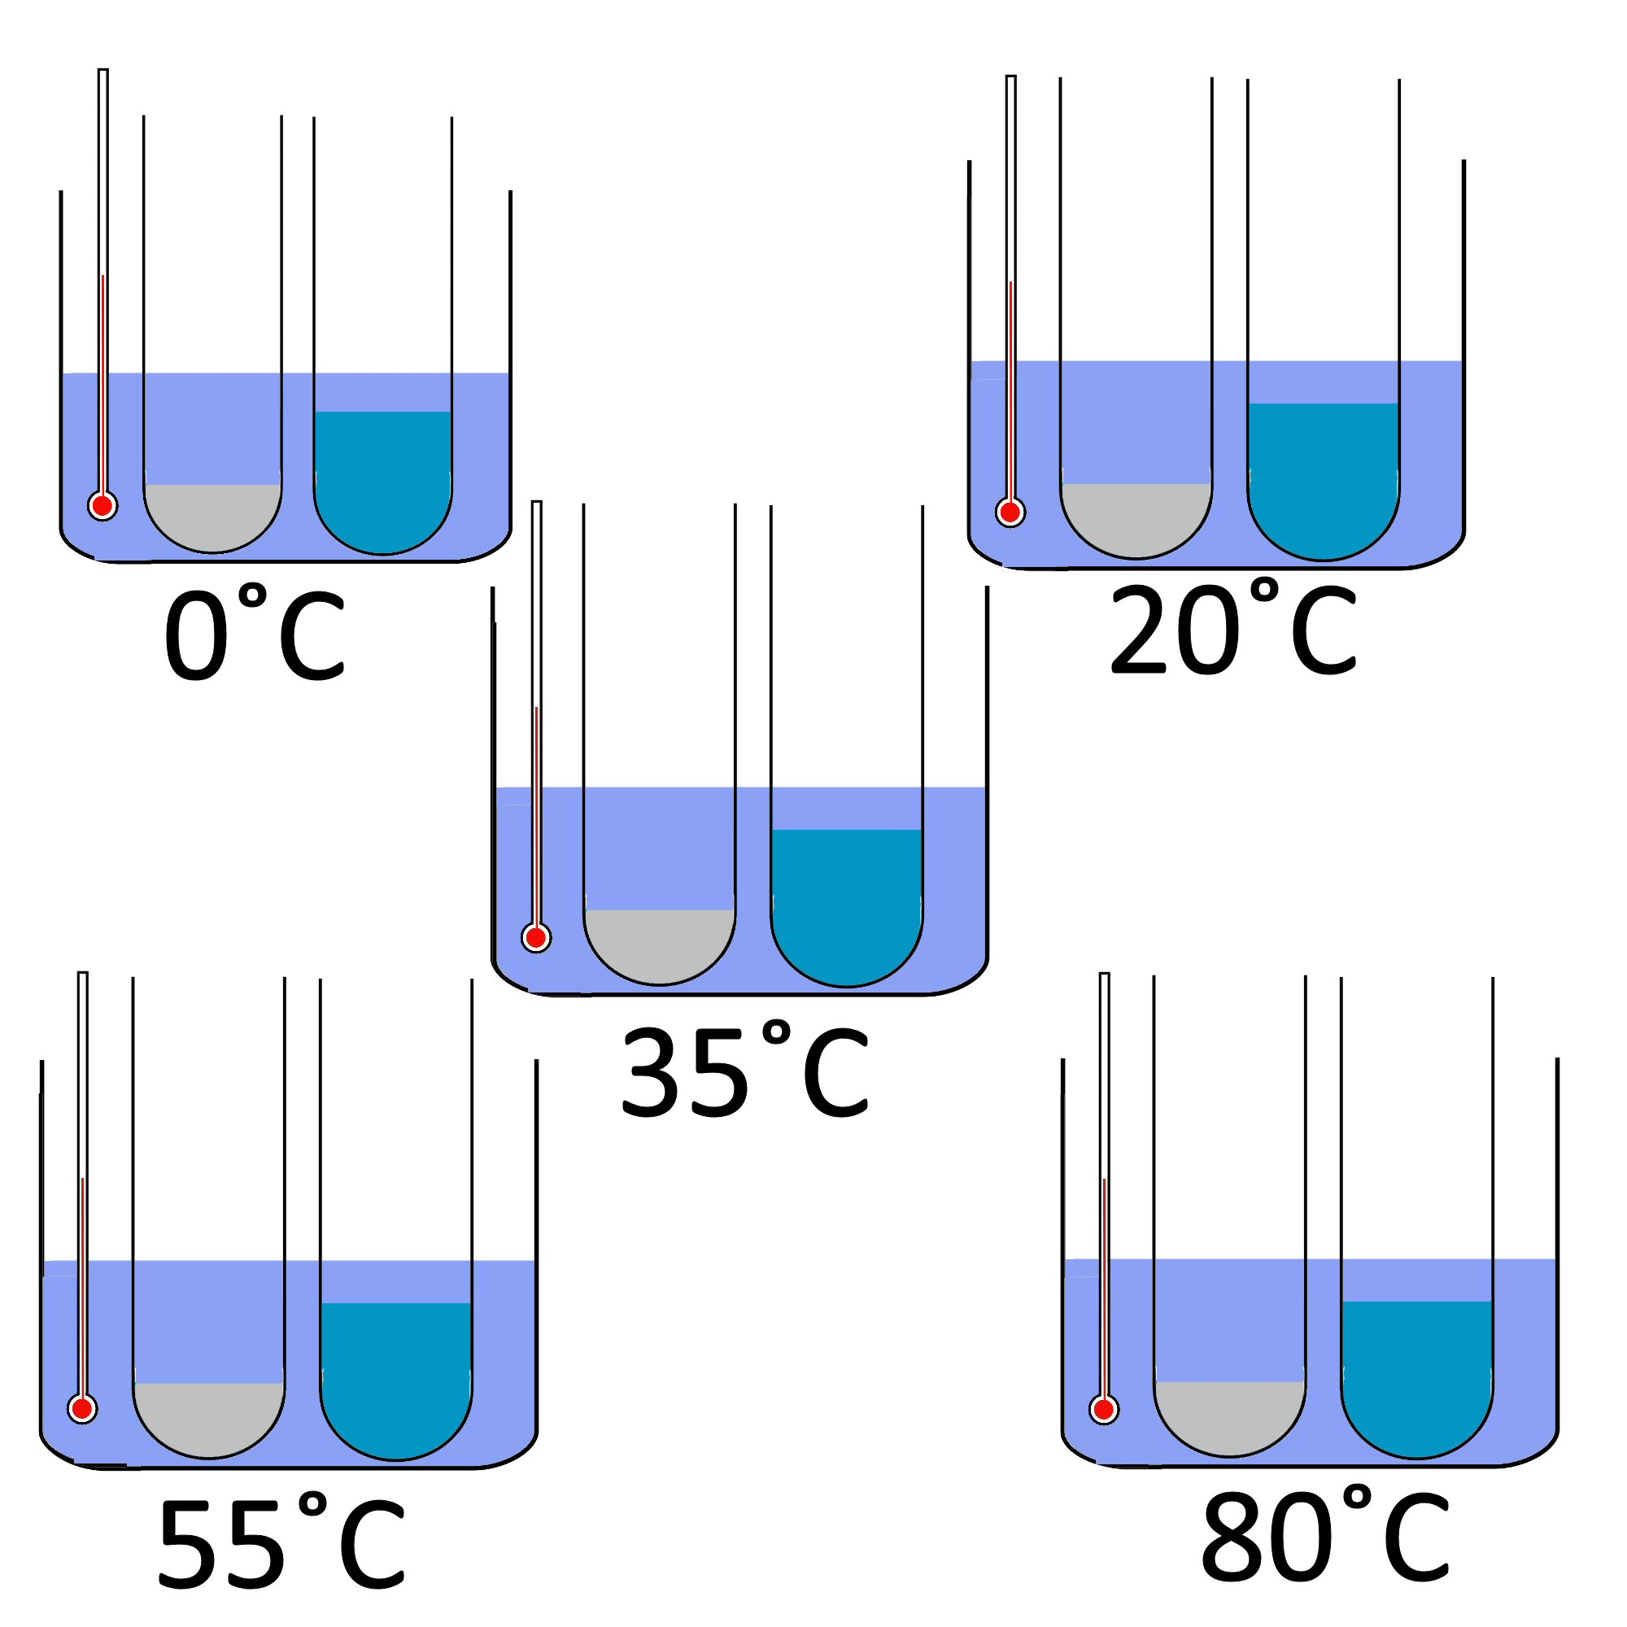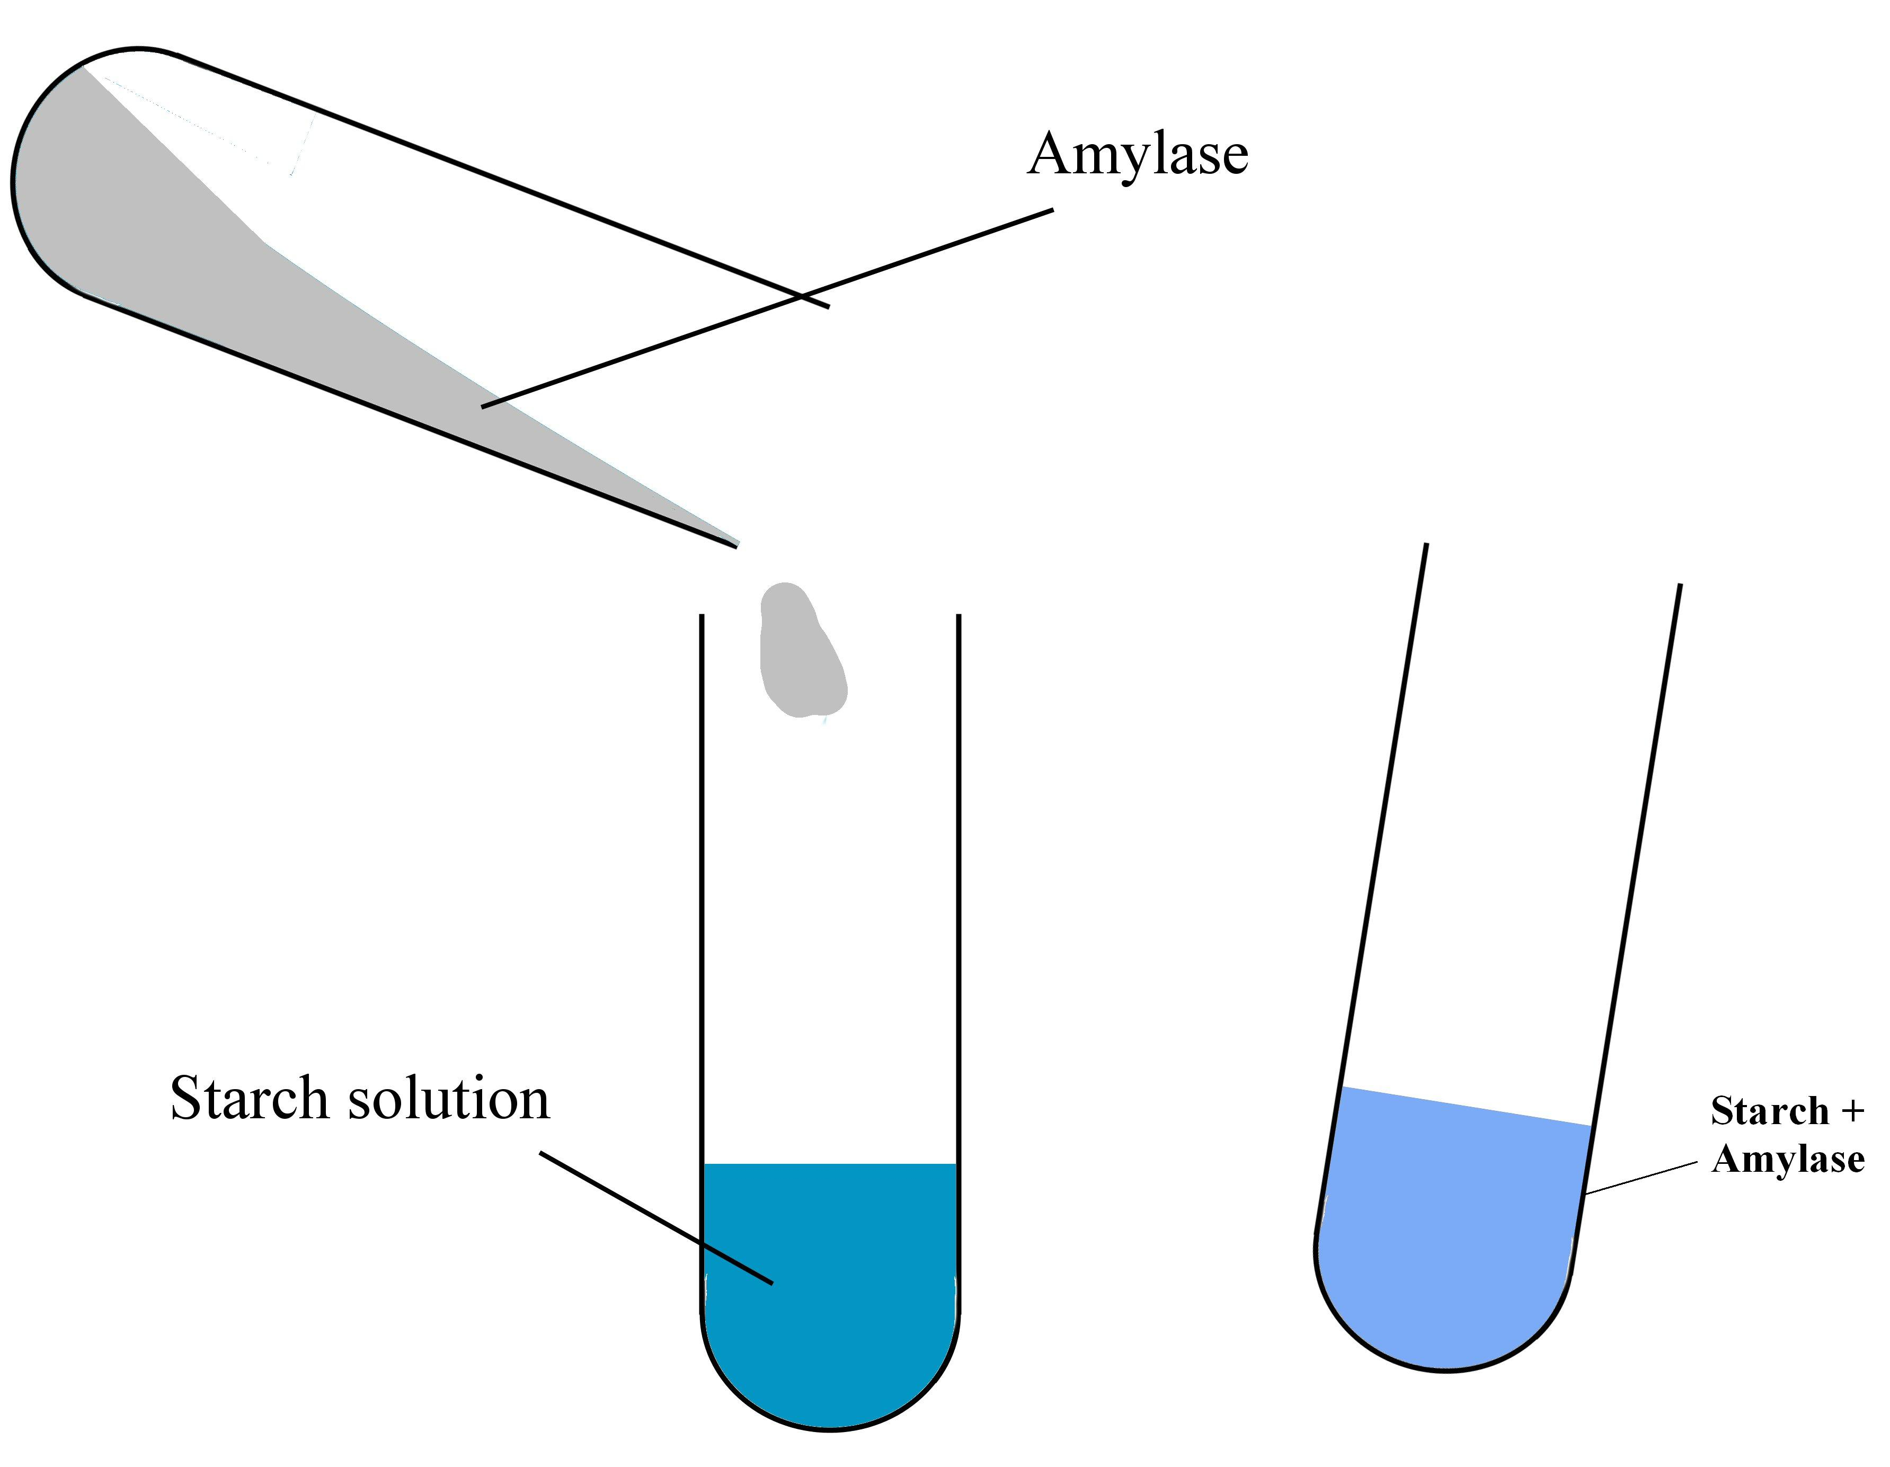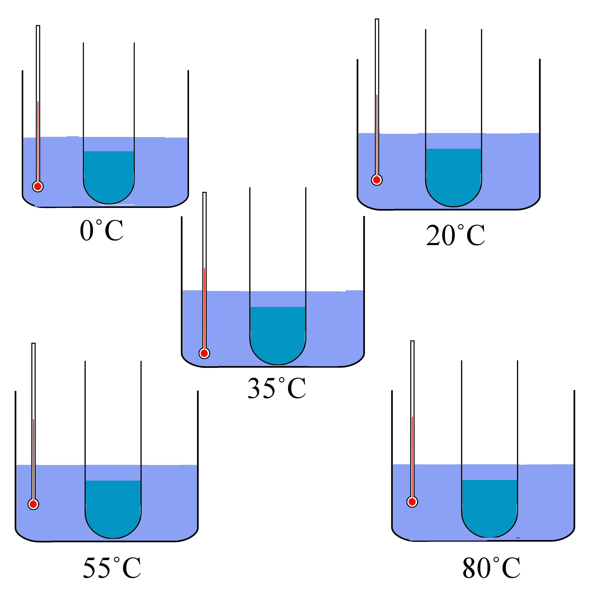
1.
2.
3.

Always remember – Leave time to tidy up
This page can be printed in colour from the accompanying CD
Set up five water baths at different temperatures – 0°C, 20°C, 35°C, 55°C, 80°C.
Into each of five boiling tubes put 5 ml starch solution and 3 drops iodine solution.
Into each of five more boiling tubes put
2 ml amylase solution.
5.
4.
Place a pair of boiling tubes into each water bath and leave for 5 minutes.
Pour the amylase into the tube of starch solution and gently shake. Repeat for each temperature.

6.
Replace the tubes in the water bath and measure the time taken for the blue/black colour to disappear.
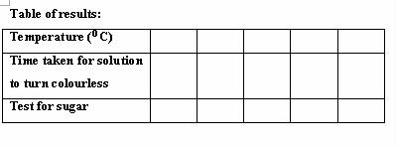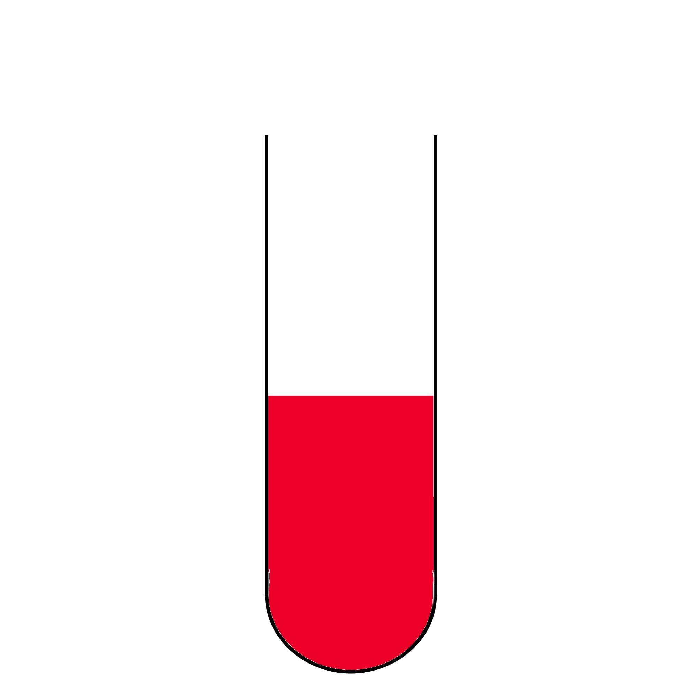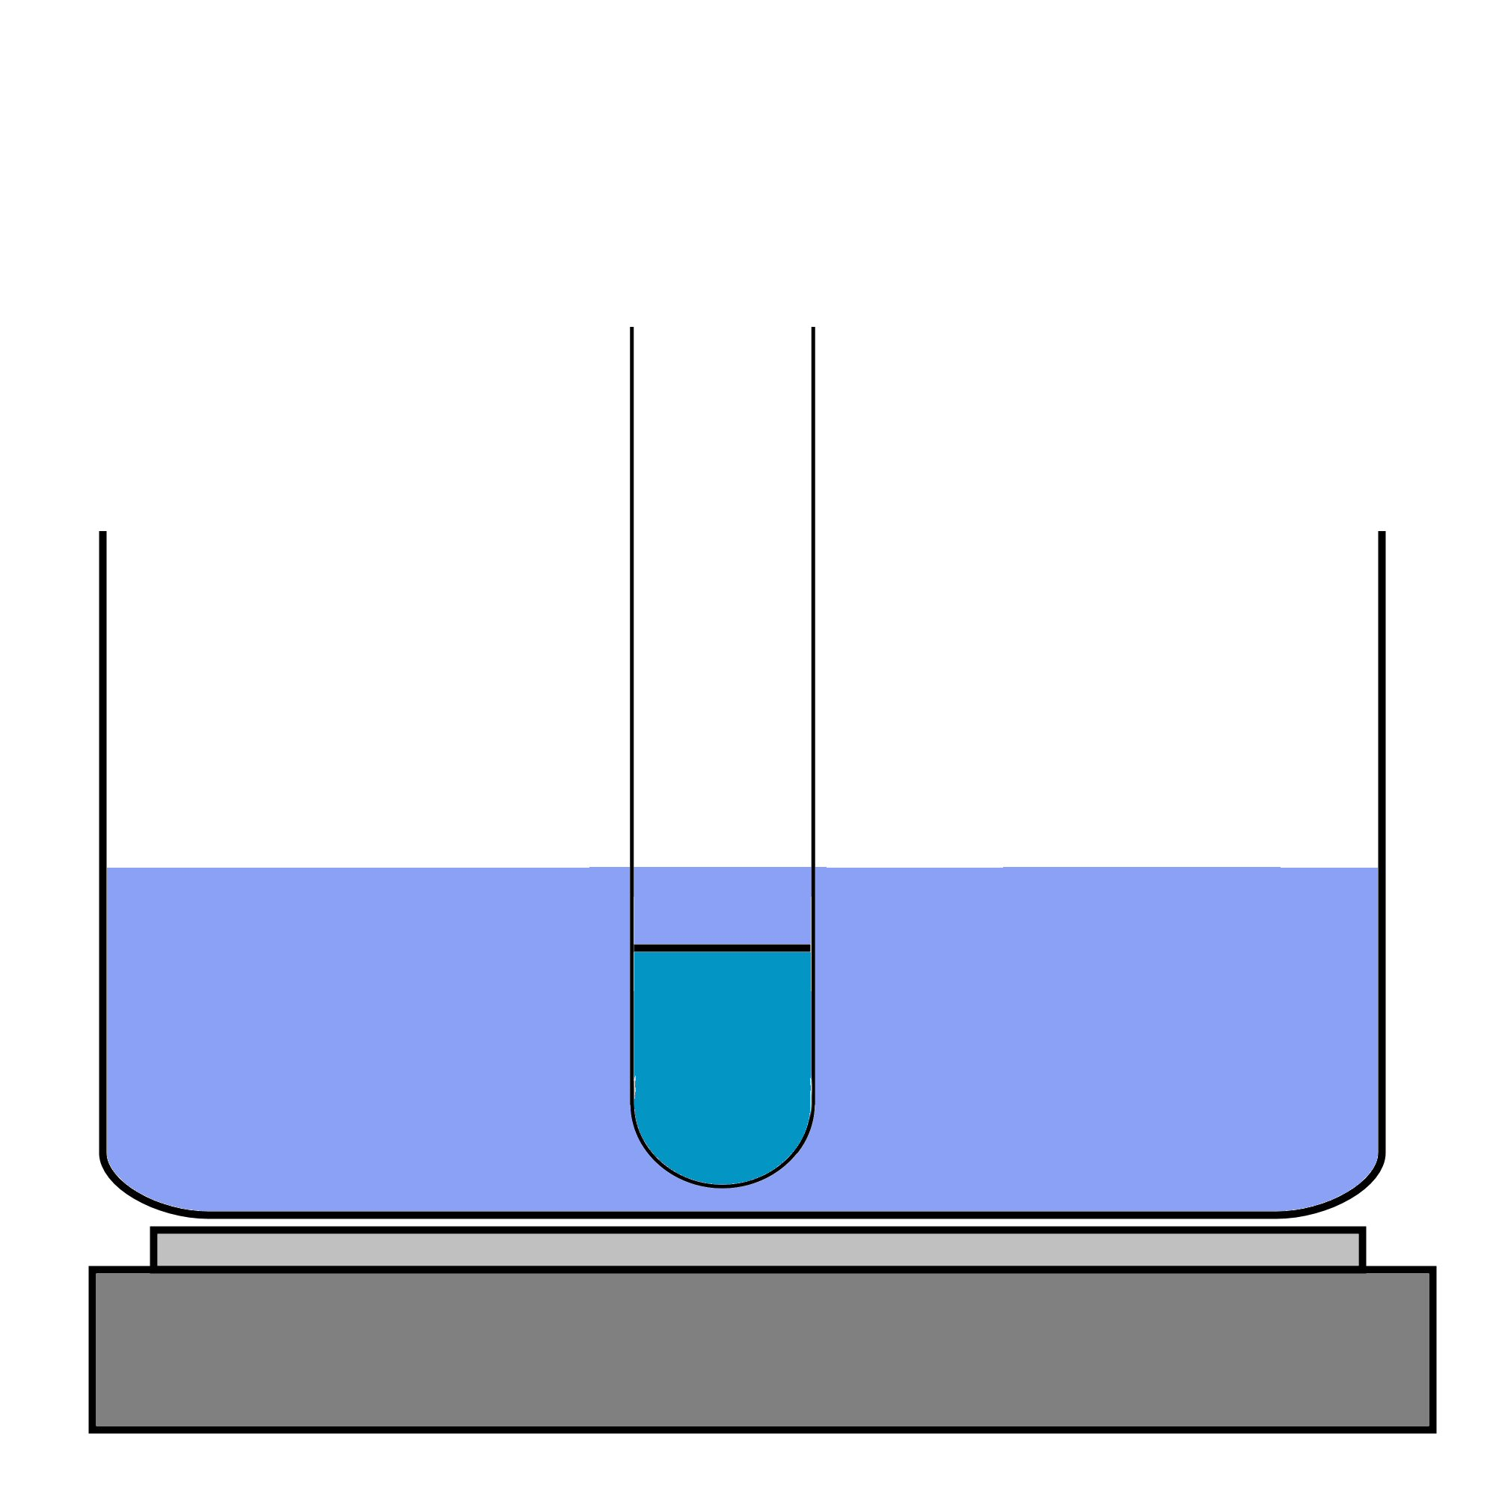
7.
8.
9.

Always remember – Leave time to tidy up
Test for sugar: add 1ml Benedict’s solution to each boiling tube and heat for 5 minutes.
A brick red colour indicates a reducing sugar is present.
10.
Repeat the whole experiment with boiled amylase as a control.
Expected result

The enzyme works best at 37^{O}C.
The blue / black colour faded and Benedict’s resulted in a
positive test.
This page can be printed in colour from the accompanying CD
Prepare as for
steps 1 and 2 previously

