4.3 (b) To investigate the effect of pH on catalase activity
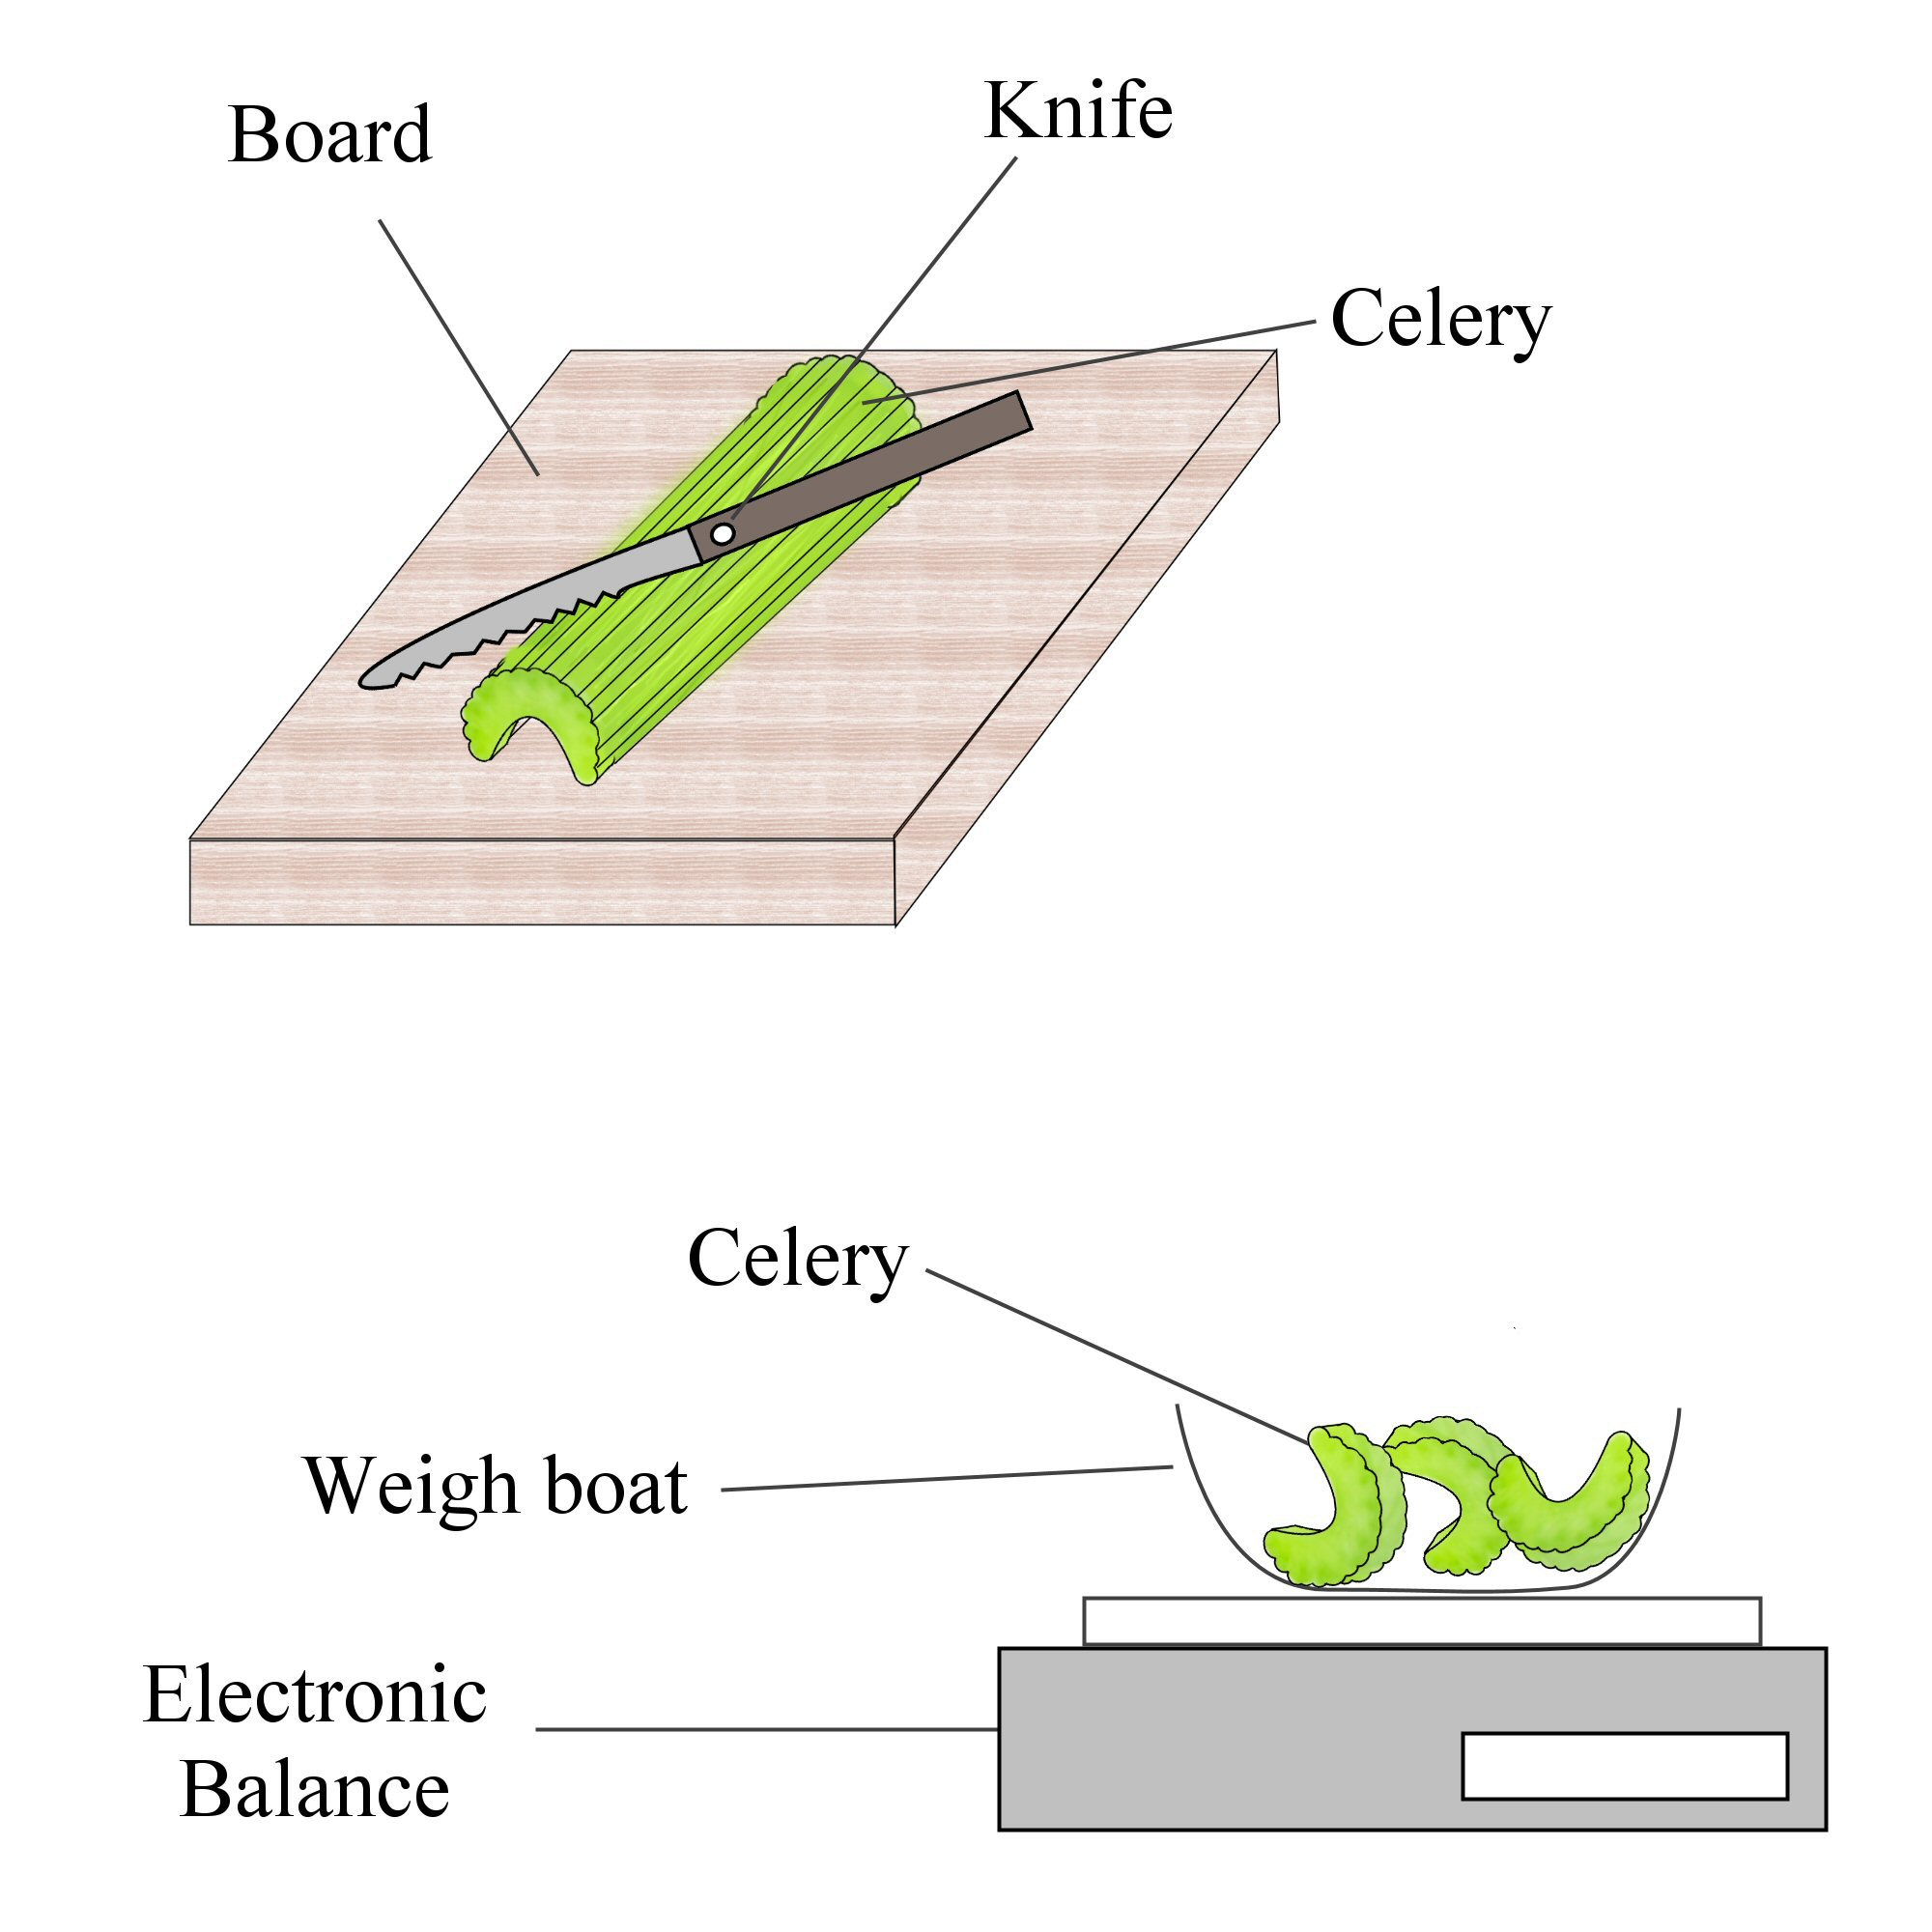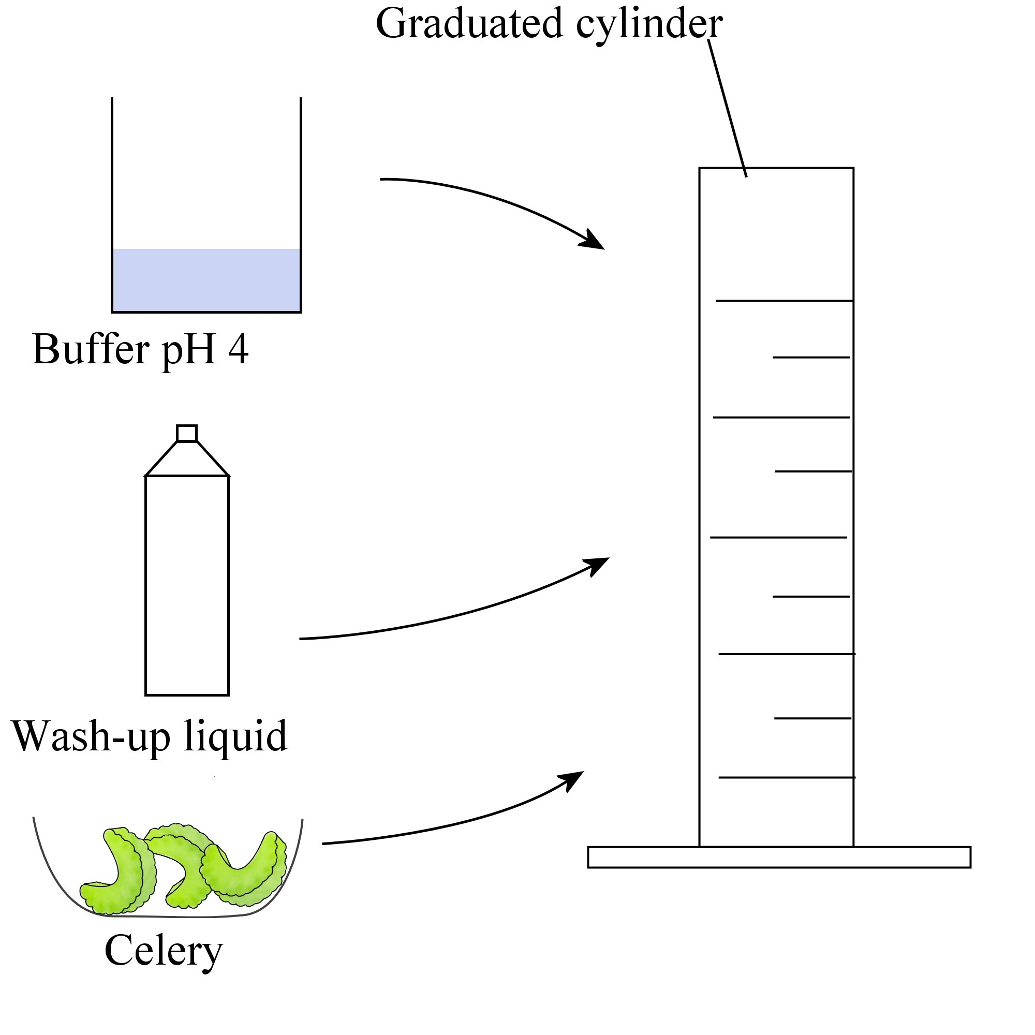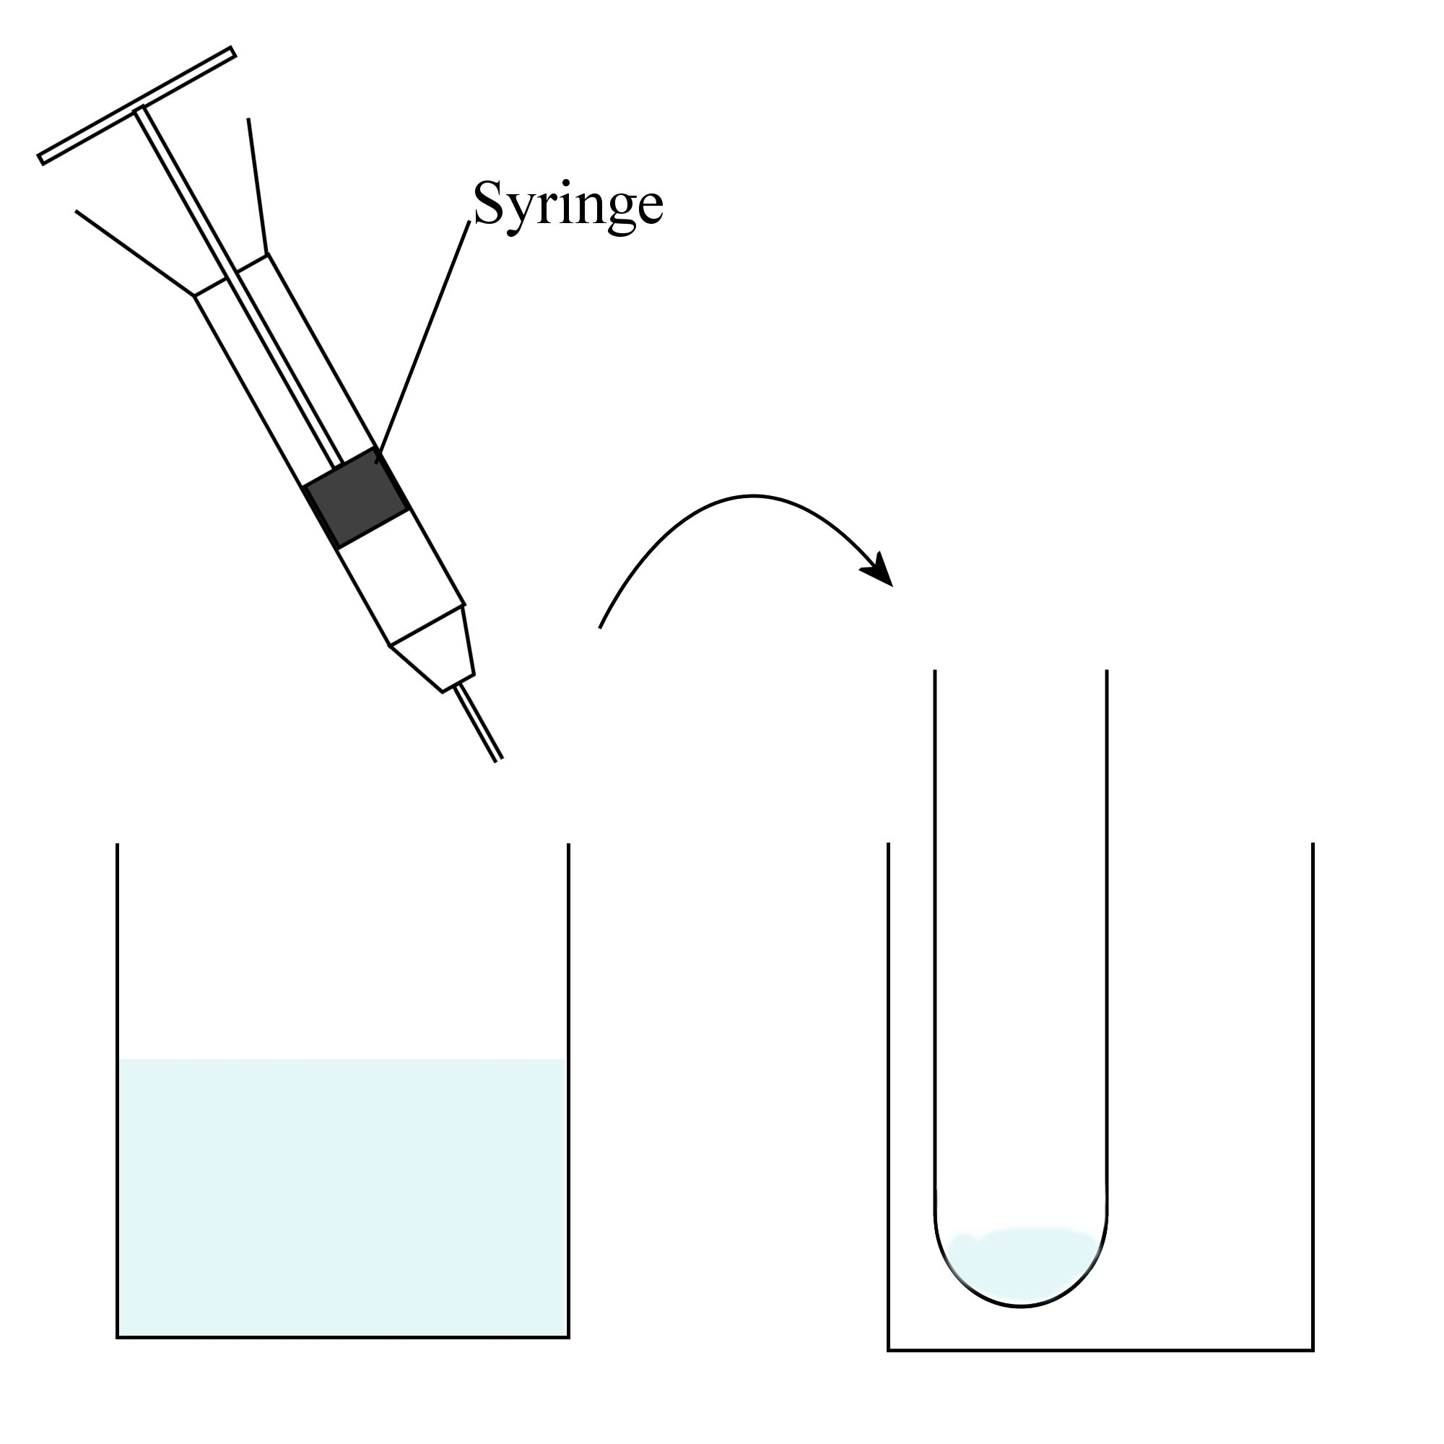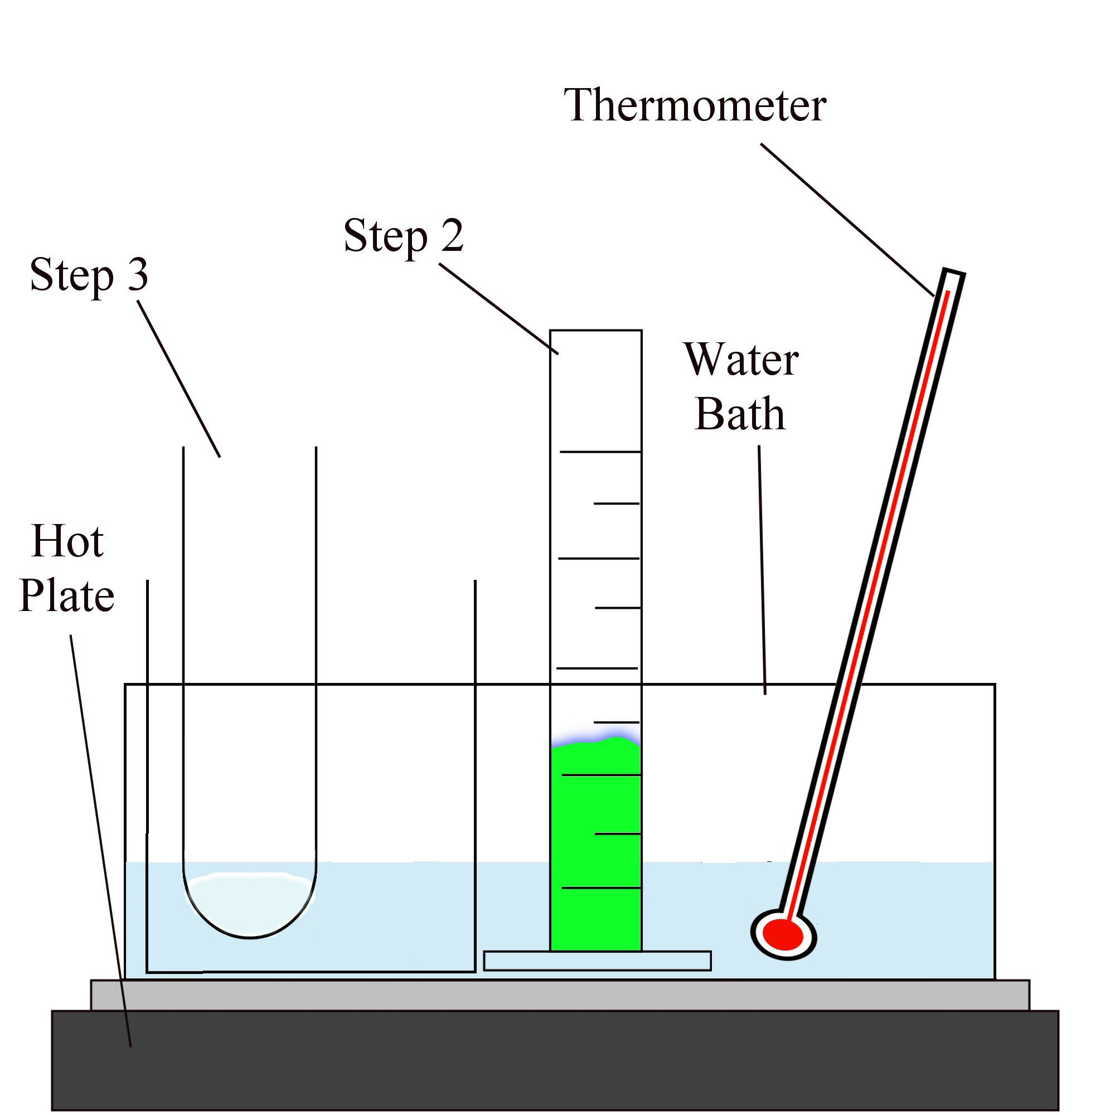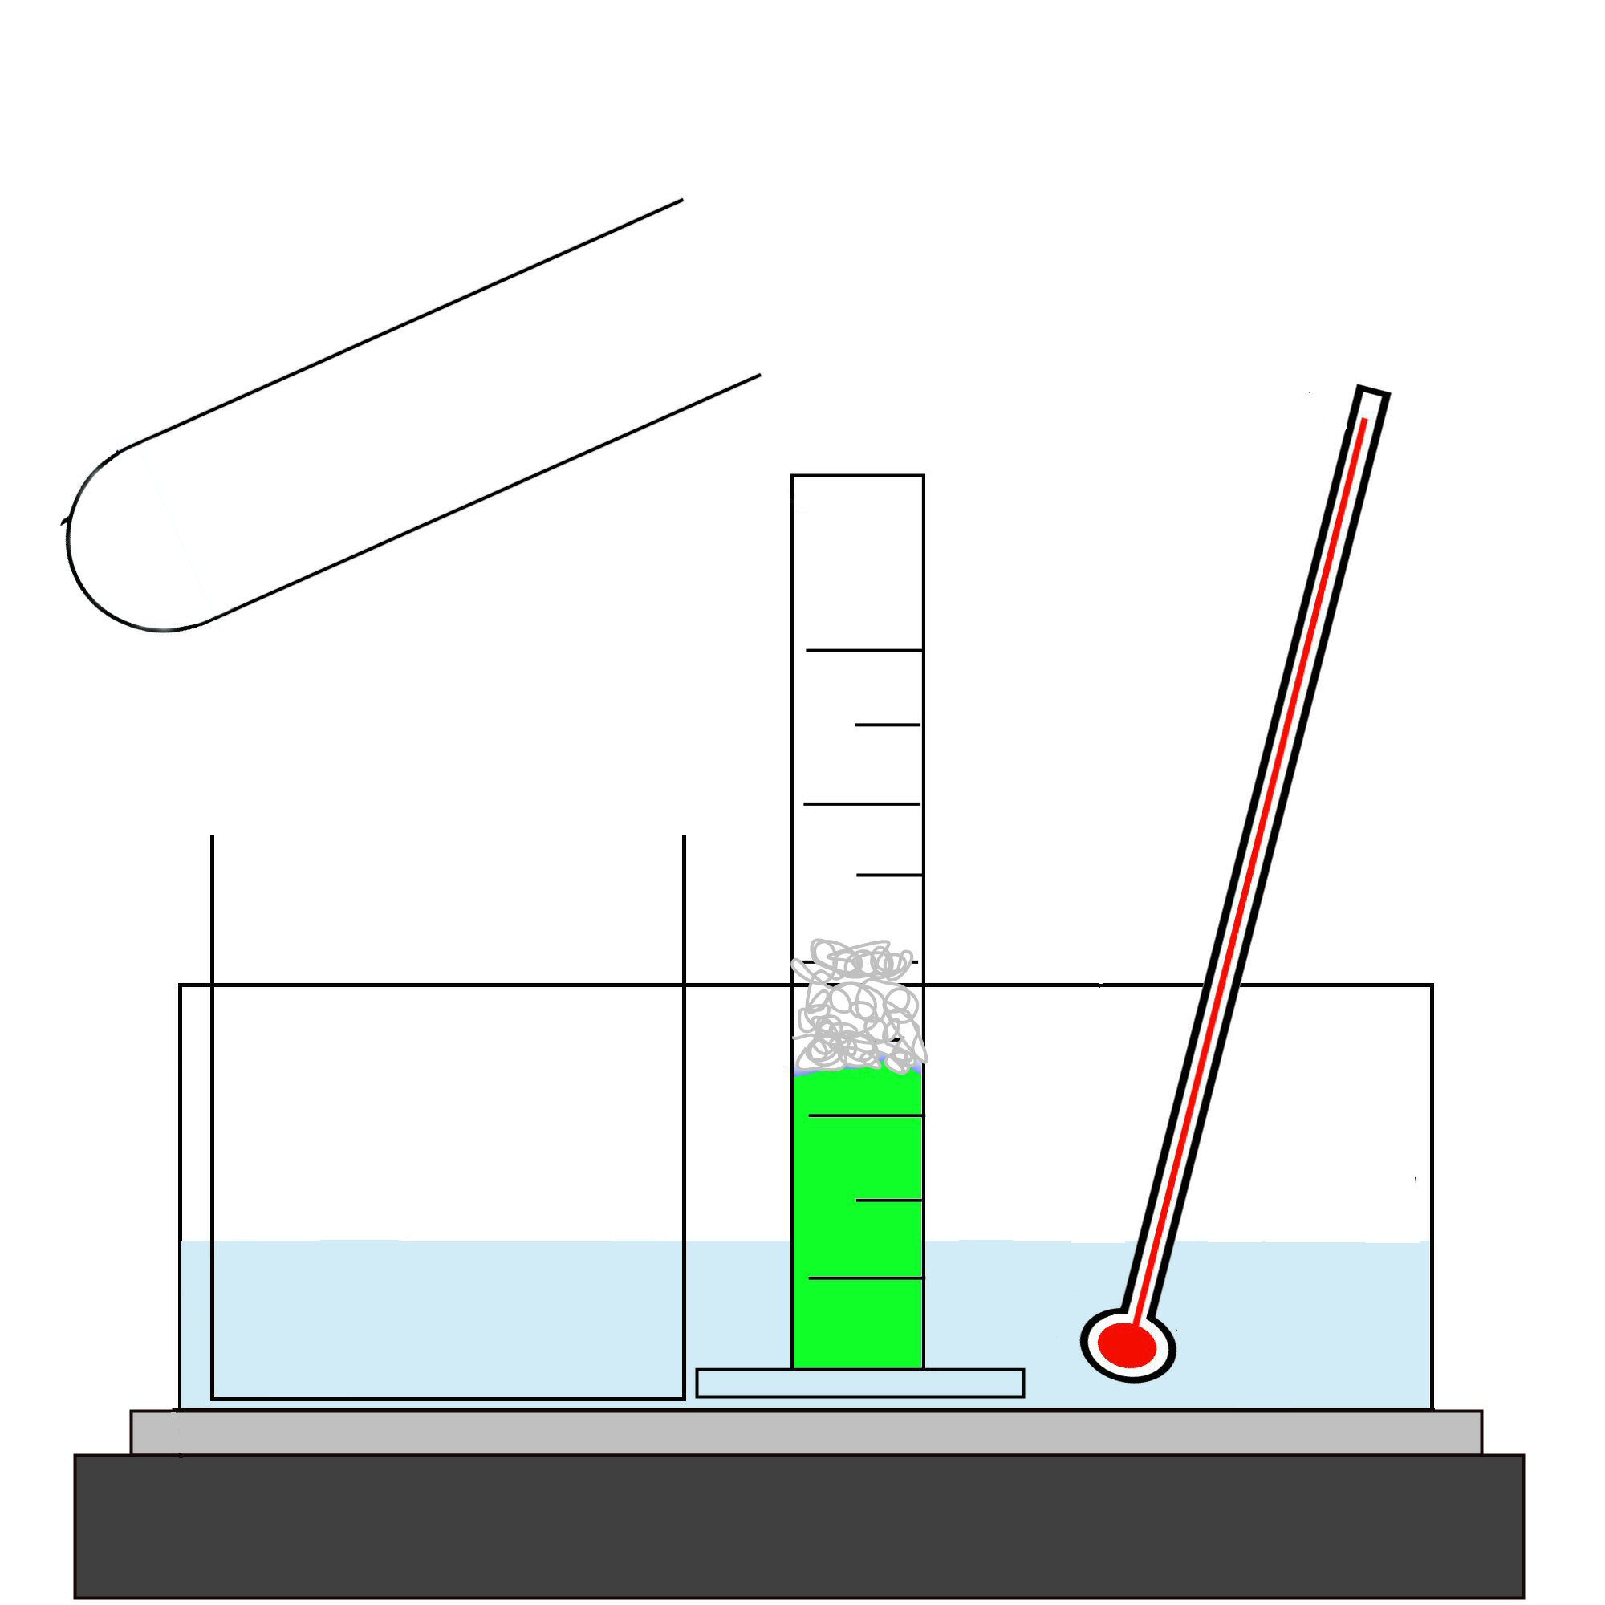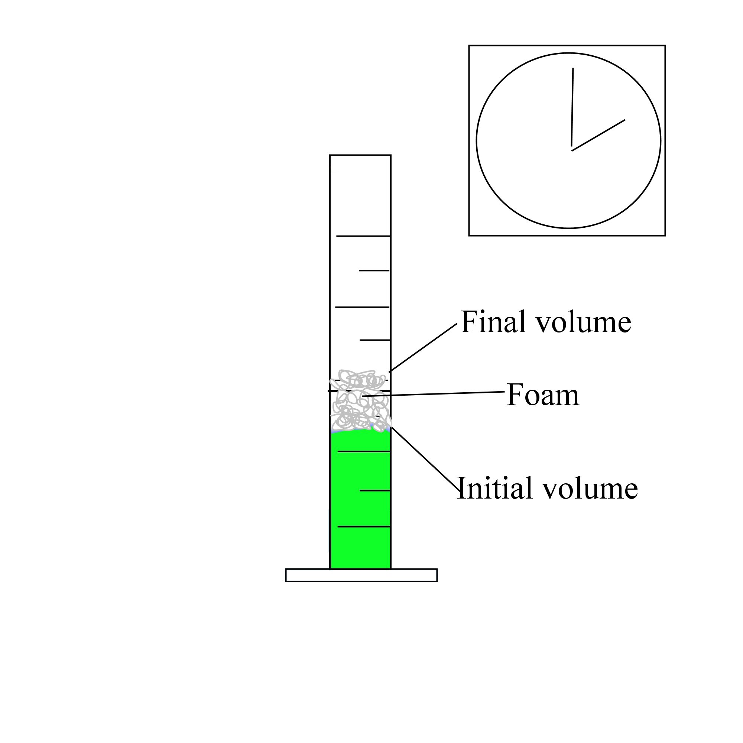
1.
2.
3.

Always remember – Leave time to tidy up
This page can be printed in colour from the accompanying CD
Finely chop the celery.
Weigh 5 g of the chopped celery.
Add 20 ml of buffer pH 4, one drop of washing-up liquid and 5 g of celery into a graduated cylinder.
Add 2 ml of hydrogen peroxide to a boiling tube.
5.
4.
Place the graduated cylinder and the boiling tube in a water bath at 25°C.
Add the hydrogen peroxide into the graduated cylinder and record the volume immediately.

6.
Time for 2 minutes and record the final volume.
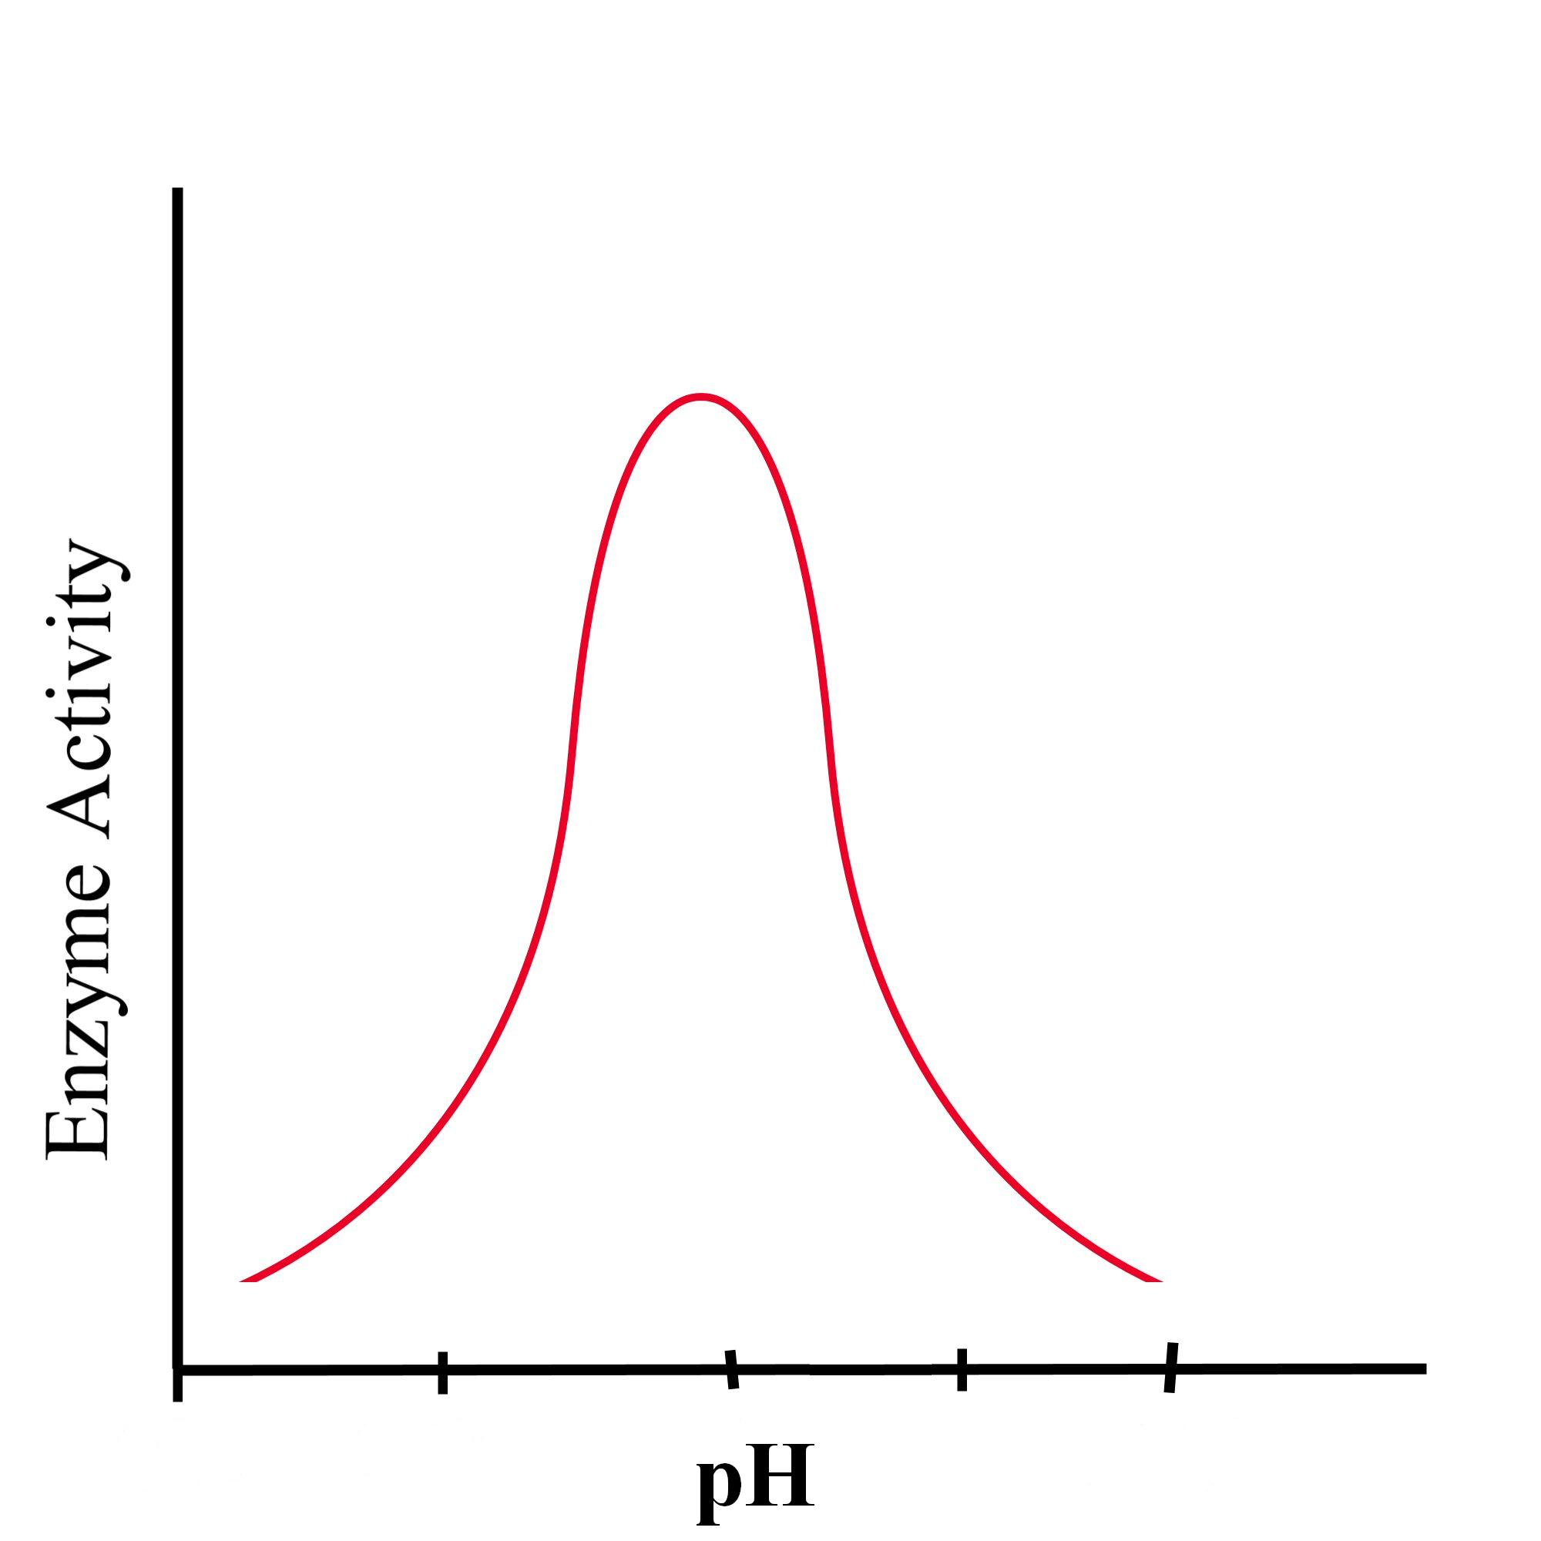
7.
8.
Expected result

Repeat the steps for
different pH buffer solutions e.g. 6, 7, 9, 10.
Table of results:
pH of buffer | Initial volume  (ml) | Final volume  (ml) | Volume of foam produced (ml)

Always remember – Leave time to tidy up
This page can be printed in colour from the accompanying CD

