4.4 (b) To investigate the effect of temperature on catalase activity
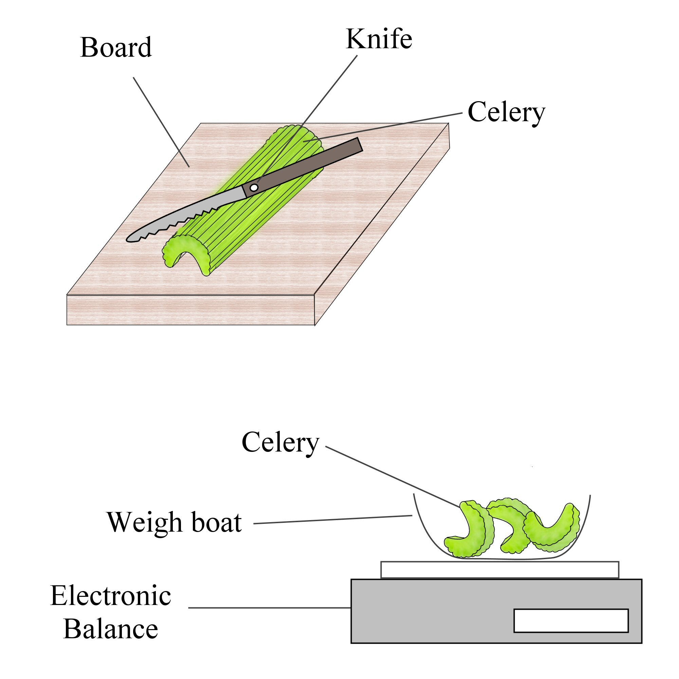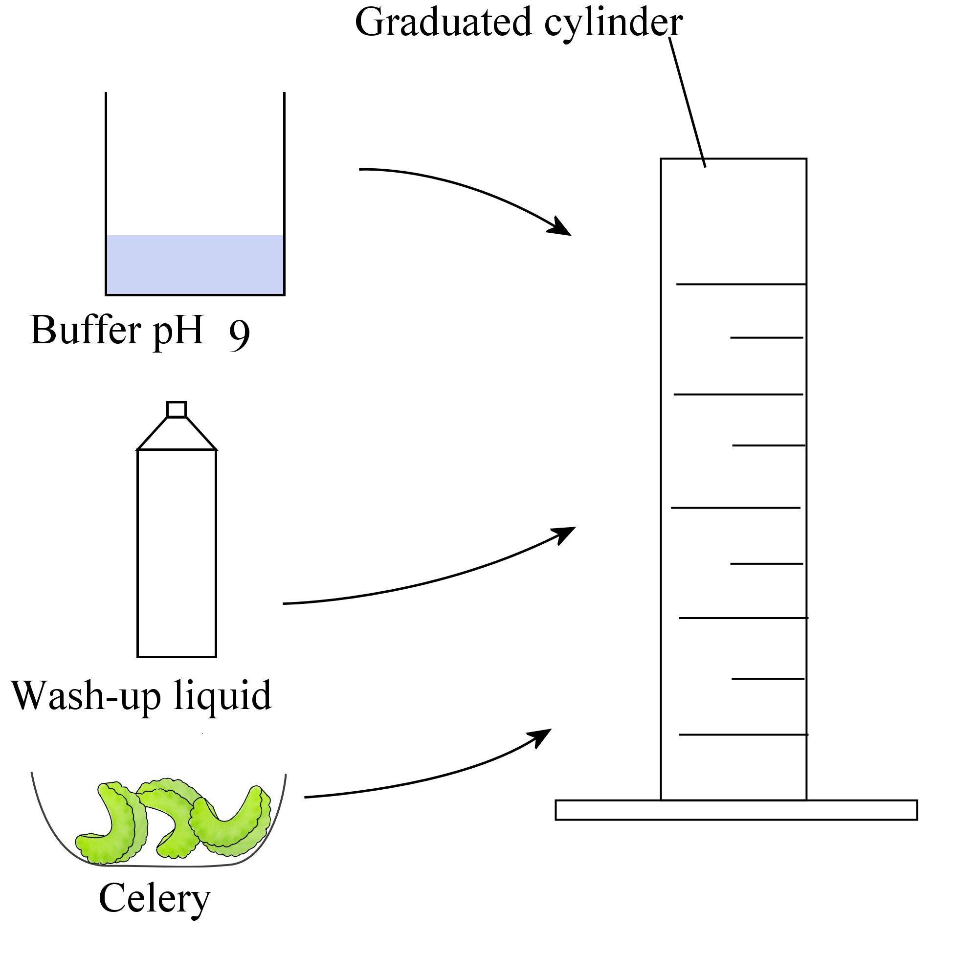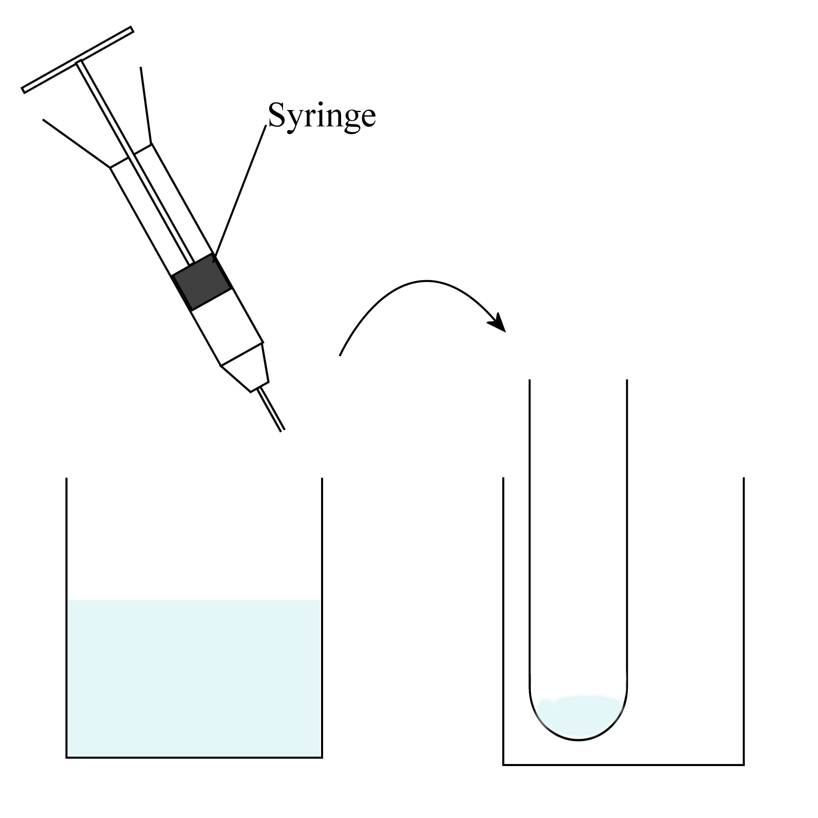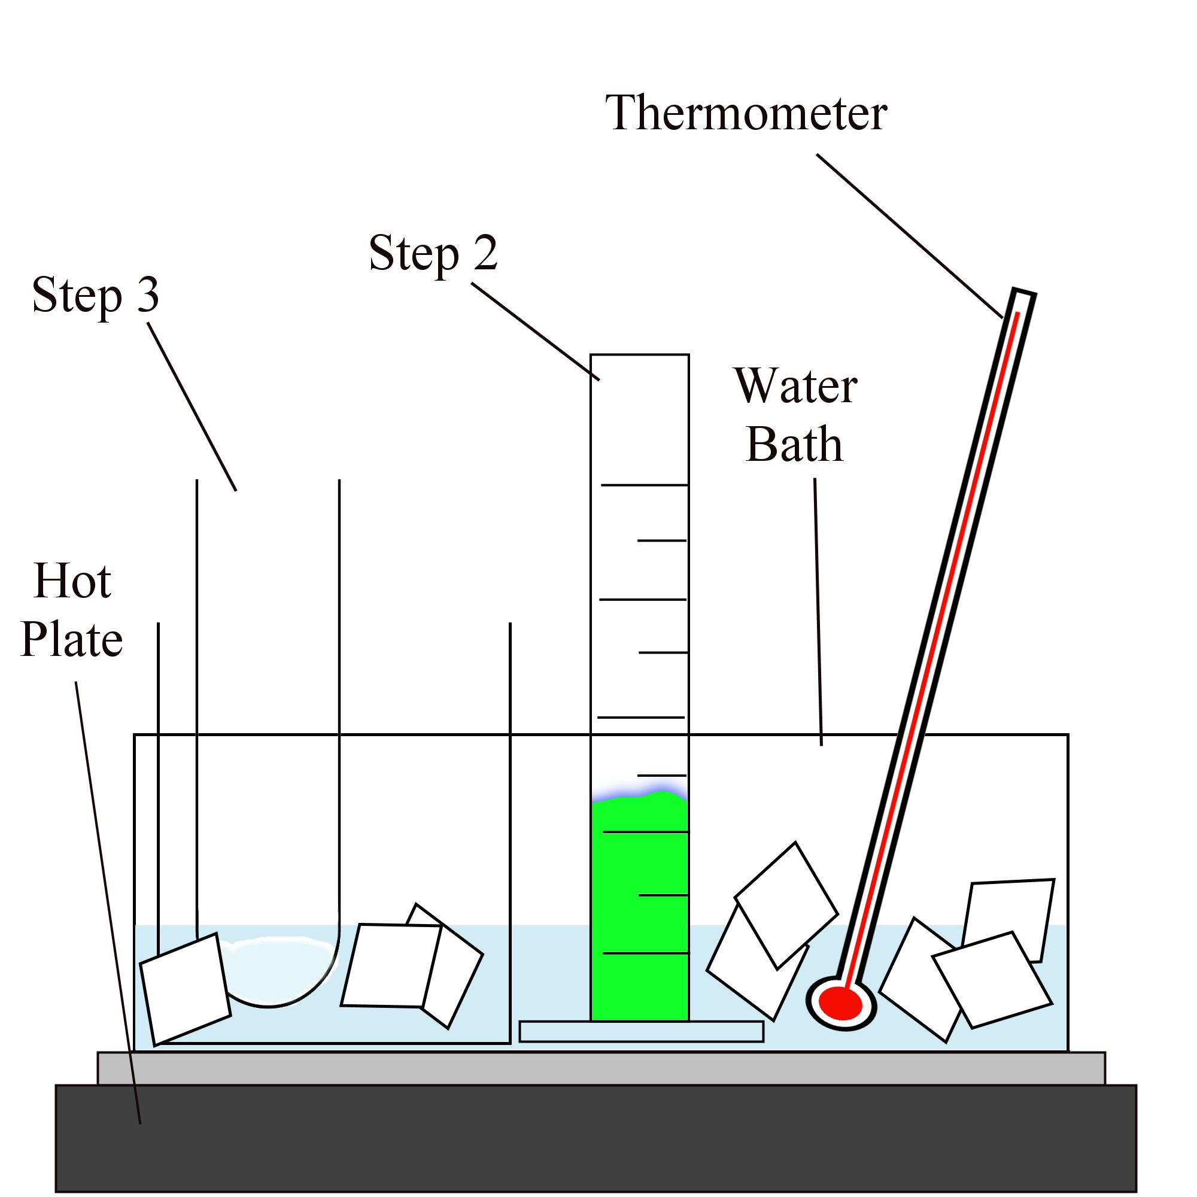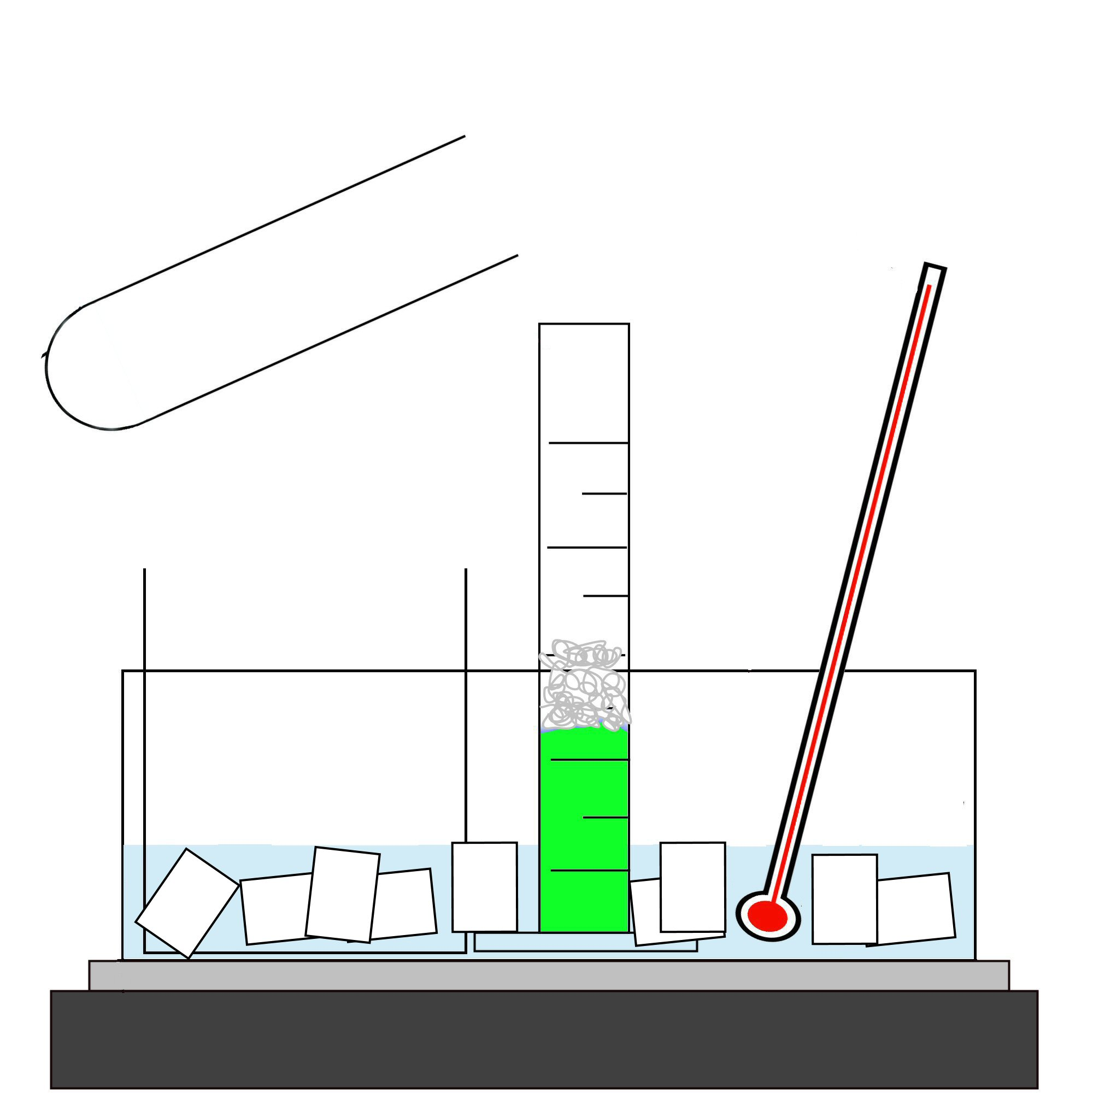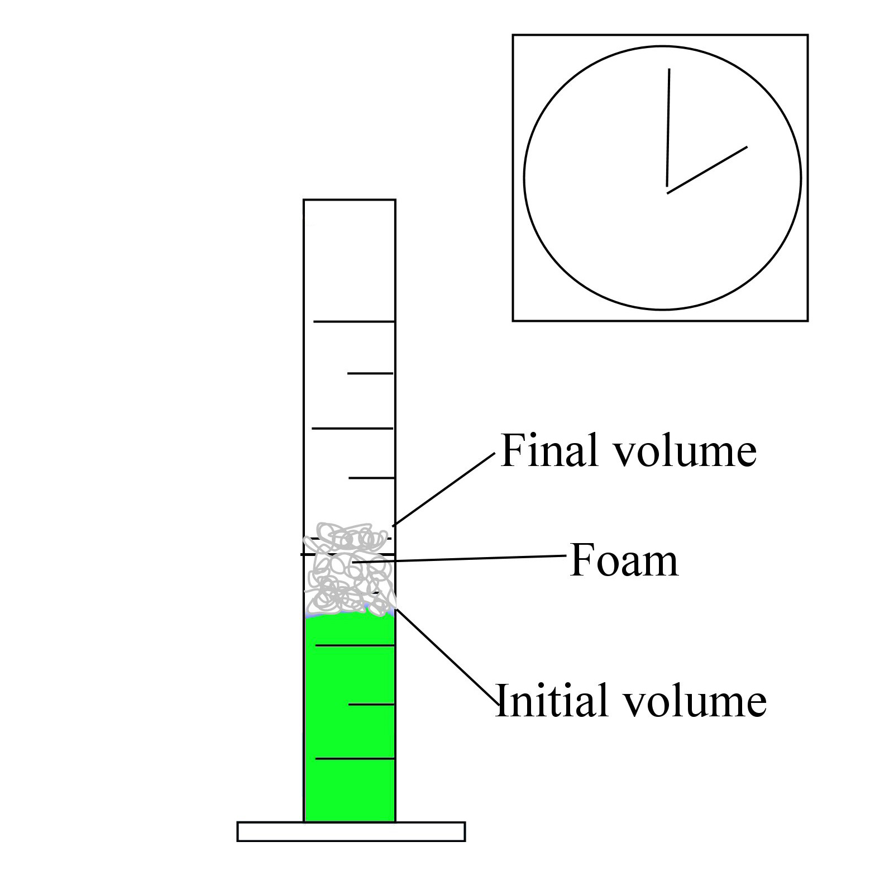
1.
2.
3.
5.

Always remember – Leave time to tidy up
This page can be printed in colour from the accompanying CD
Finely chop the celery.
Weigh 5 g of the chopped celery.
Add 20 ml of buffer pH 9, one drop of washing-up liquid and 5 g of celery into a graduated cylinder.
Add 2 ml of hydrogen peroxide to a boiling tube.
4.
Place the graduated cylinder and the boiling tube in an ice bath. Leave until the desired temperature of 4^{O}C is reached.
Add the hydrogen peroxide into the graduated cylinder and record the volume immediately.

6.
Time for 2 minutes and record the final volume.
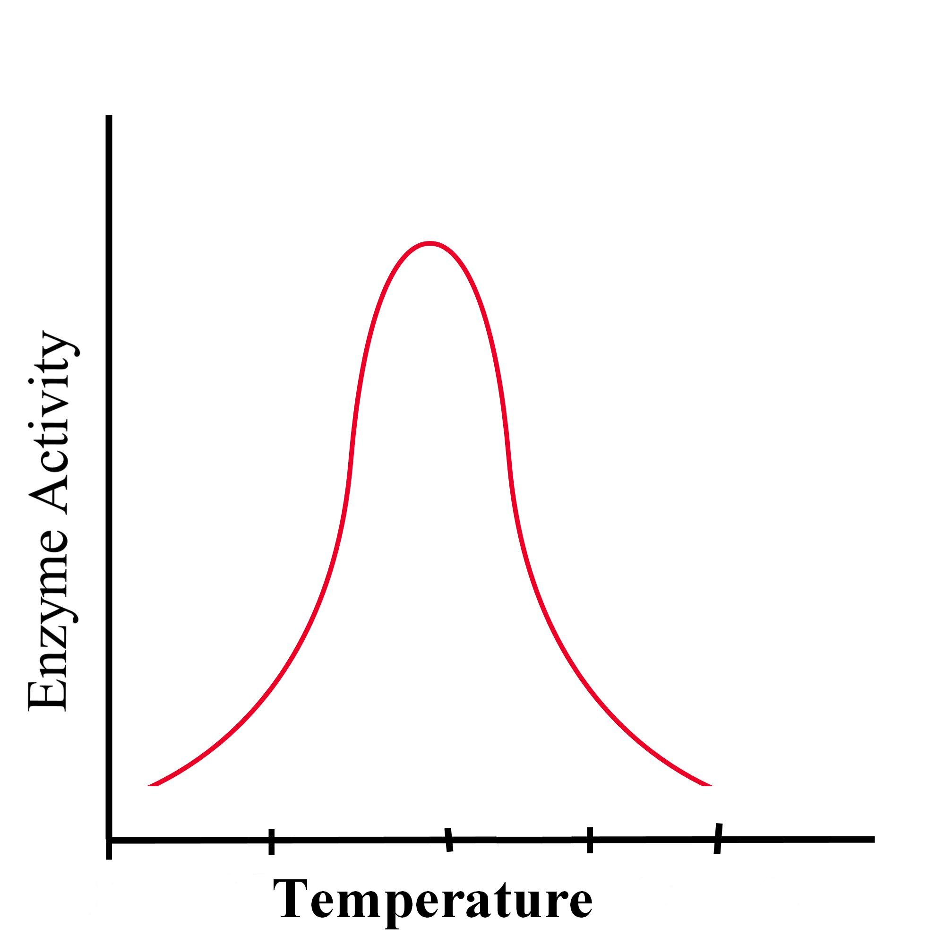
7.
8.
Repeat the steps for
water baths at different temperatures
e.g. 20^{O}C, 30^{O}C, 45^{O}C, 60^{O}C,
Expected result
Table of results:
Temperature (^{O}C)
Initial volume (ml)
Final volume (ml)
Volume of foam produced (ml)

Always remember – Leave time to tidy up
This page can be printed in colour from the accompanying CD

