4.7 (b) To investigate the influence of carbon dioxide concentration on the rate of photosynthesis
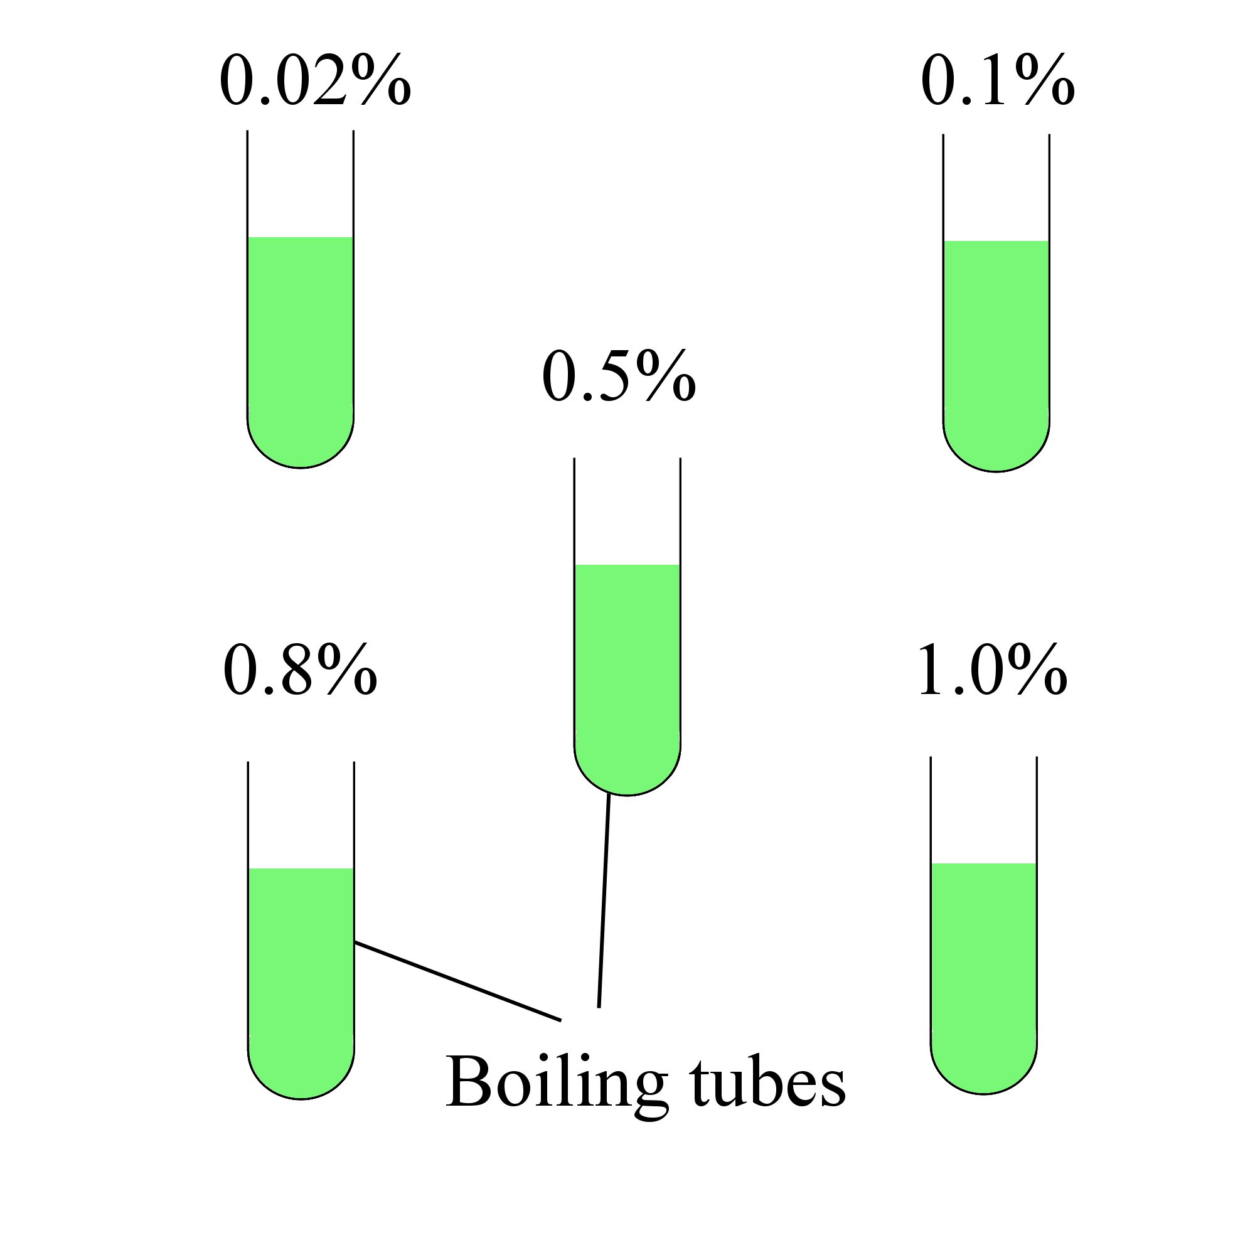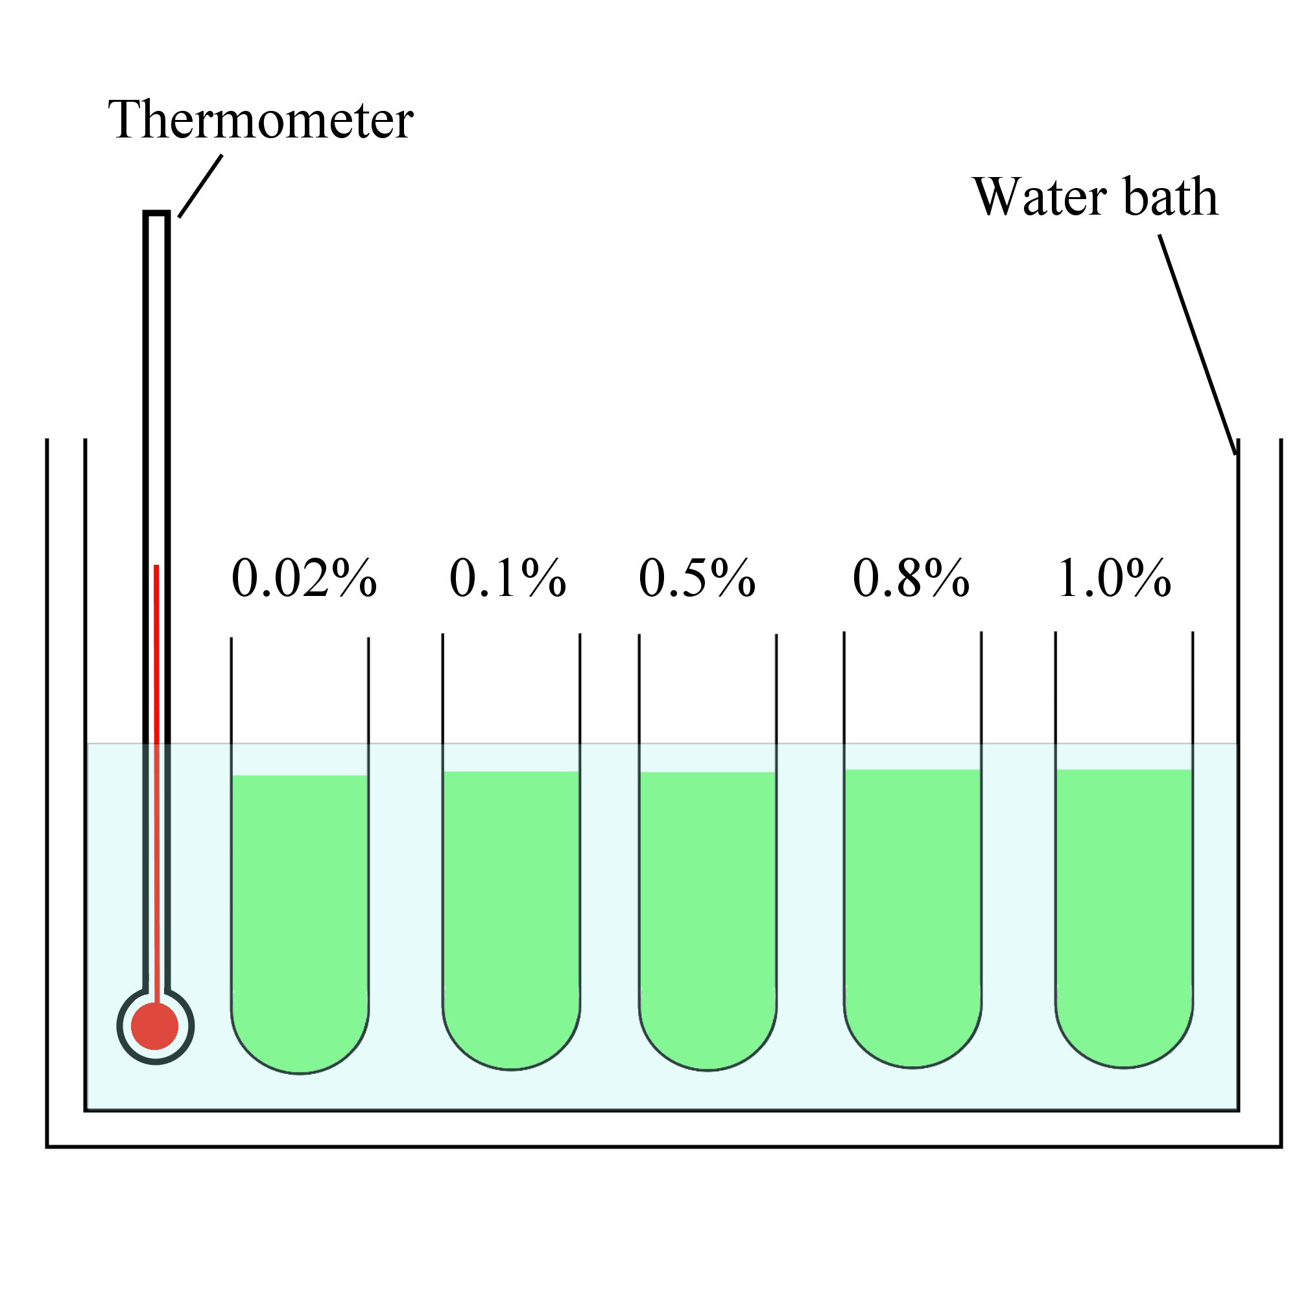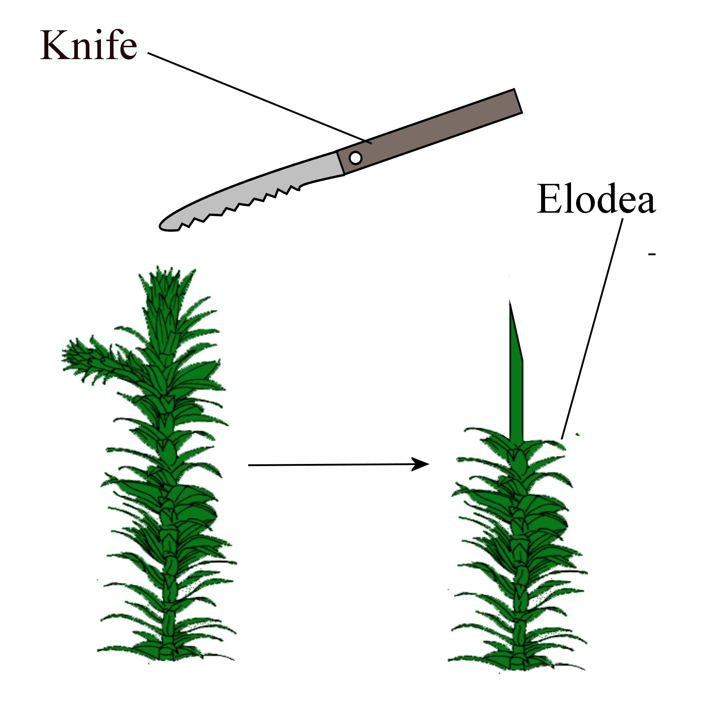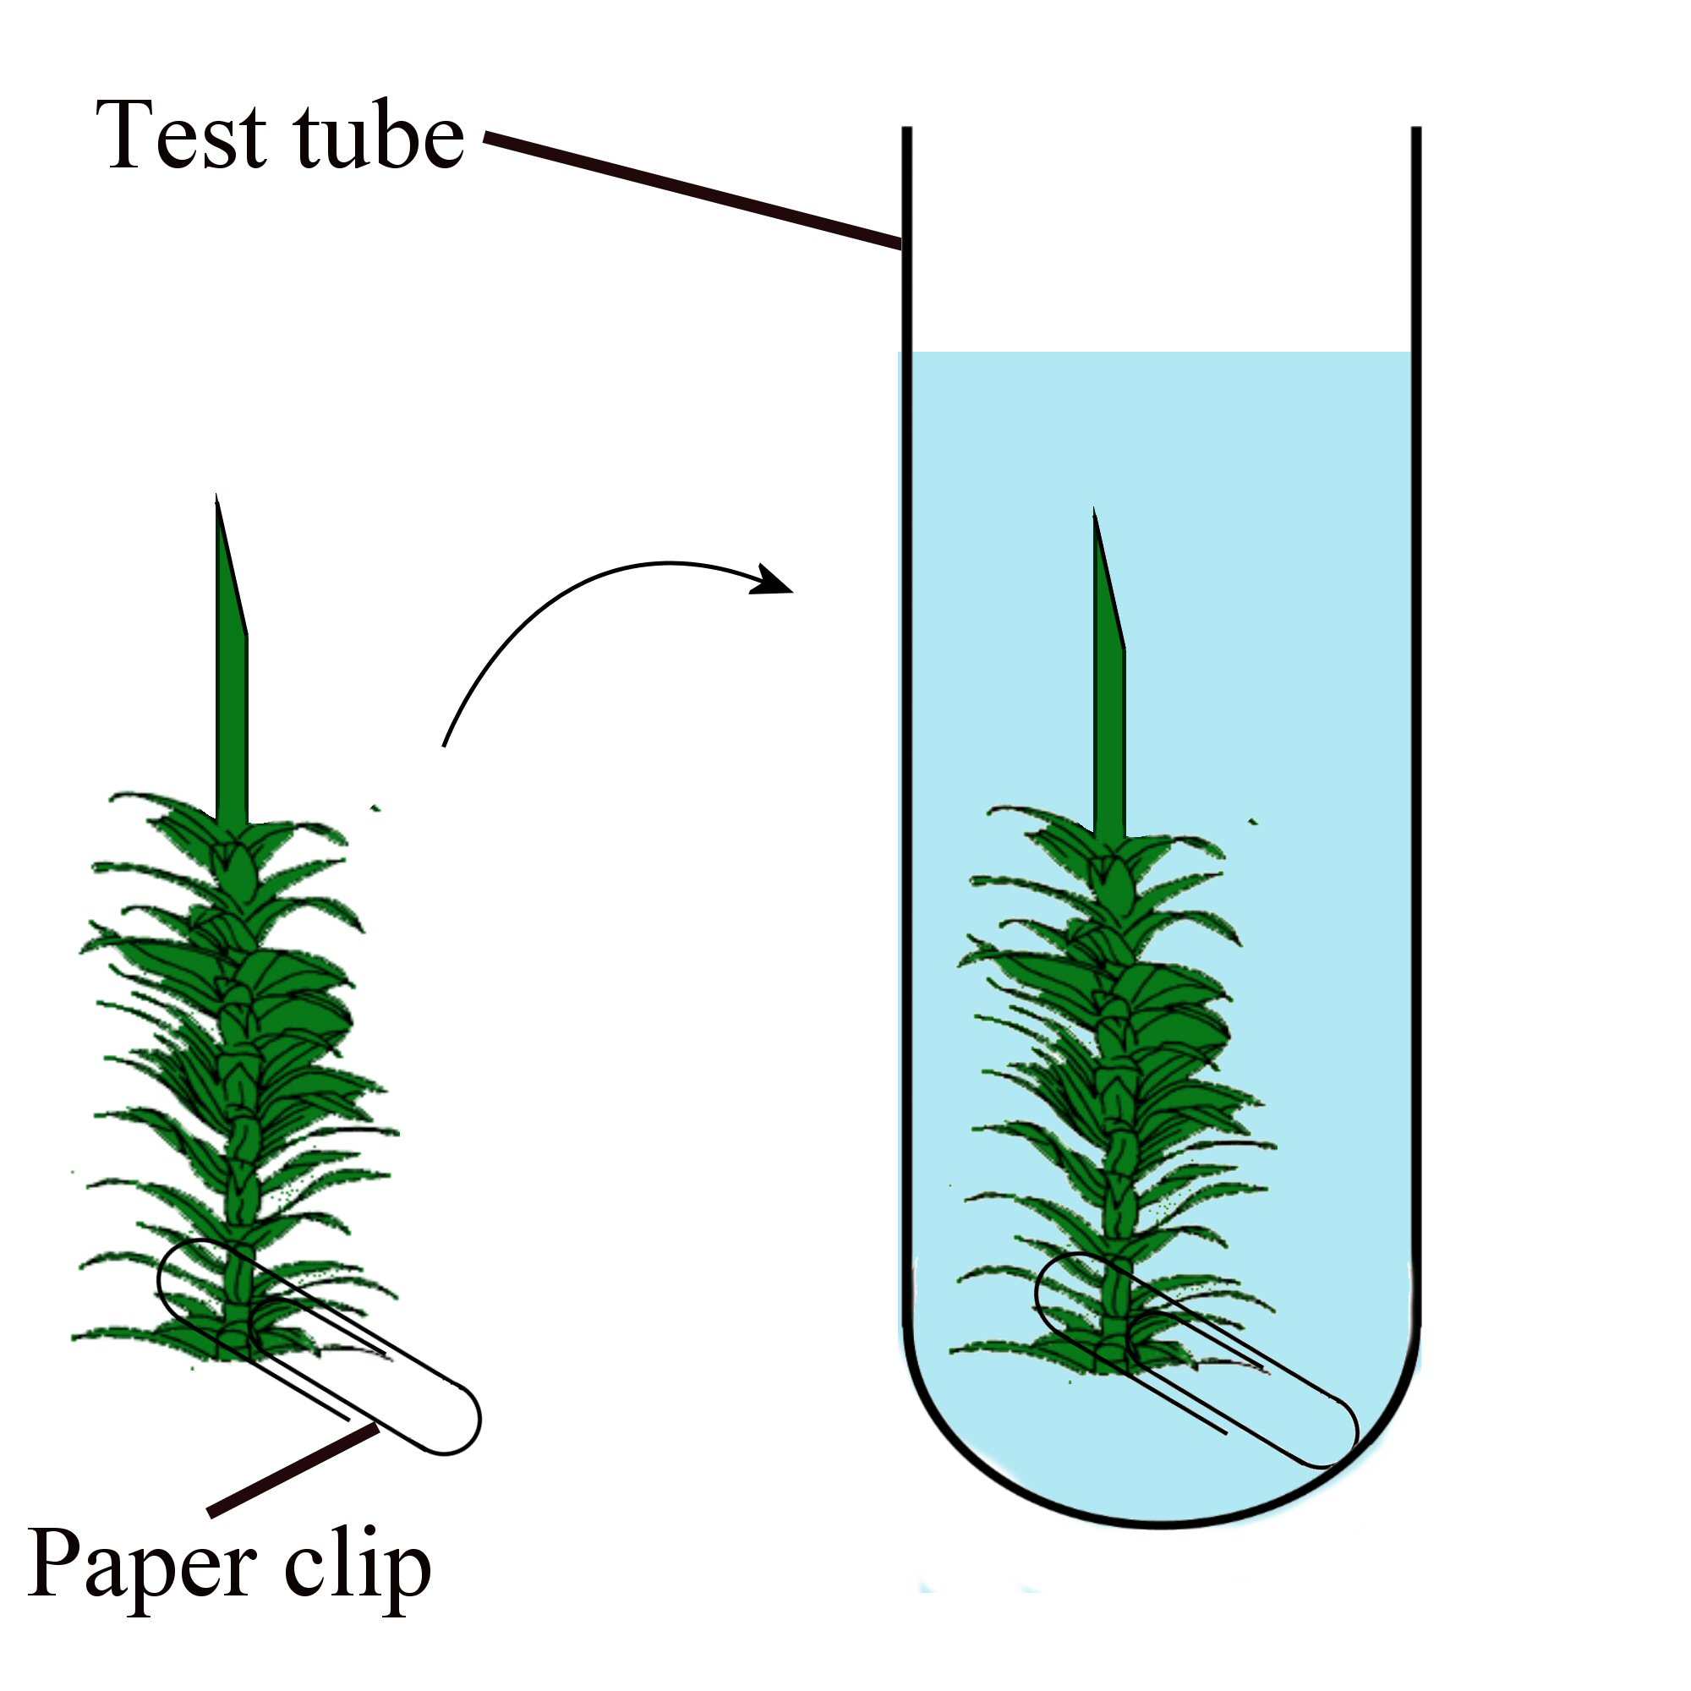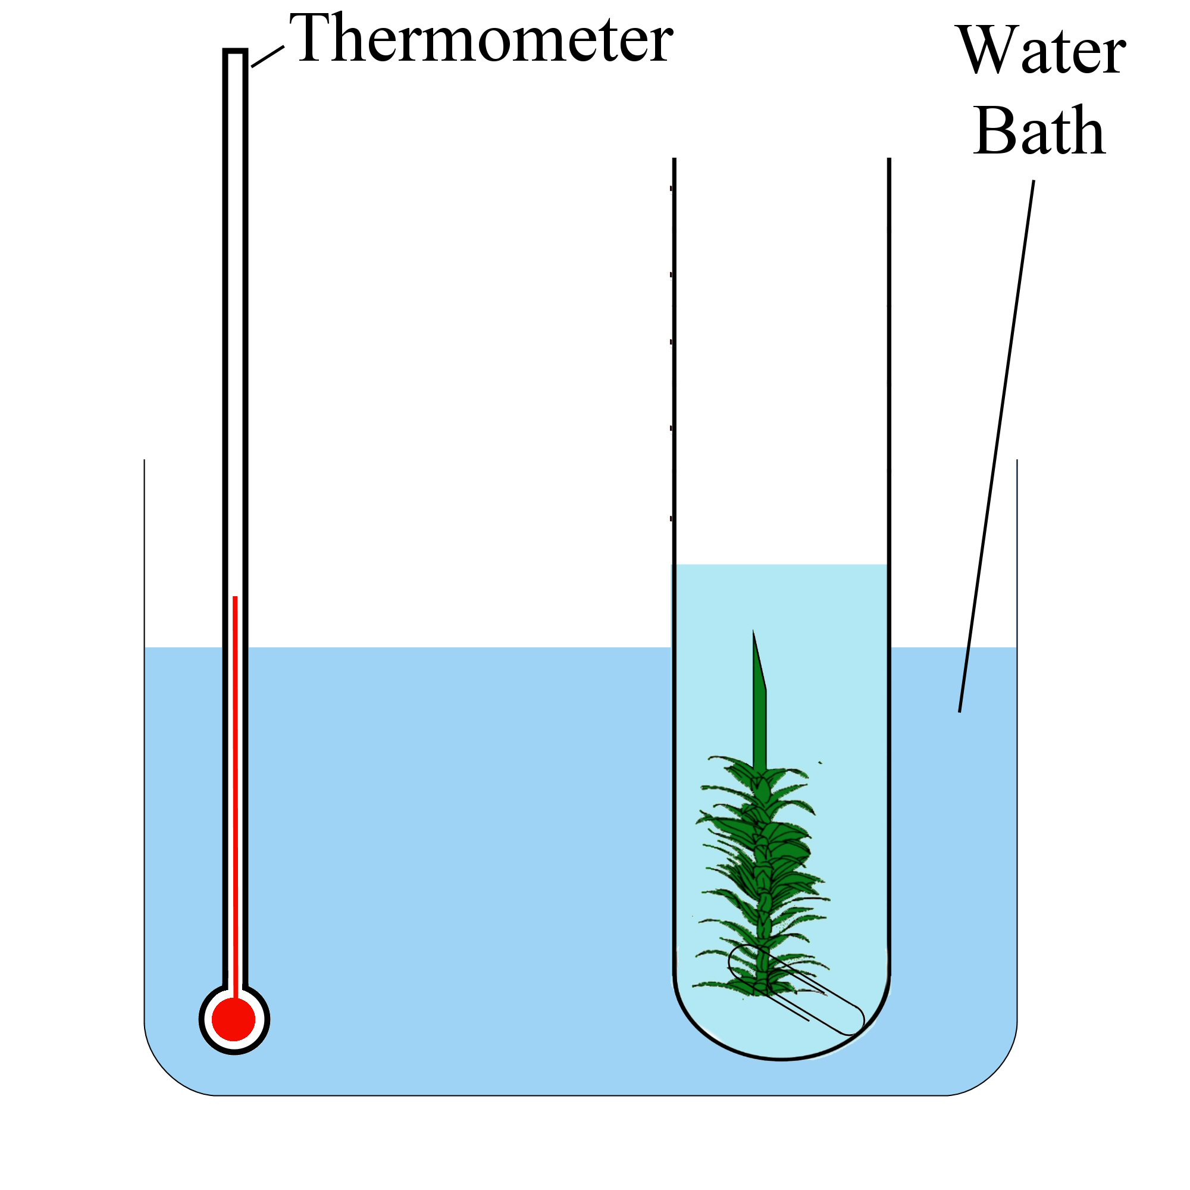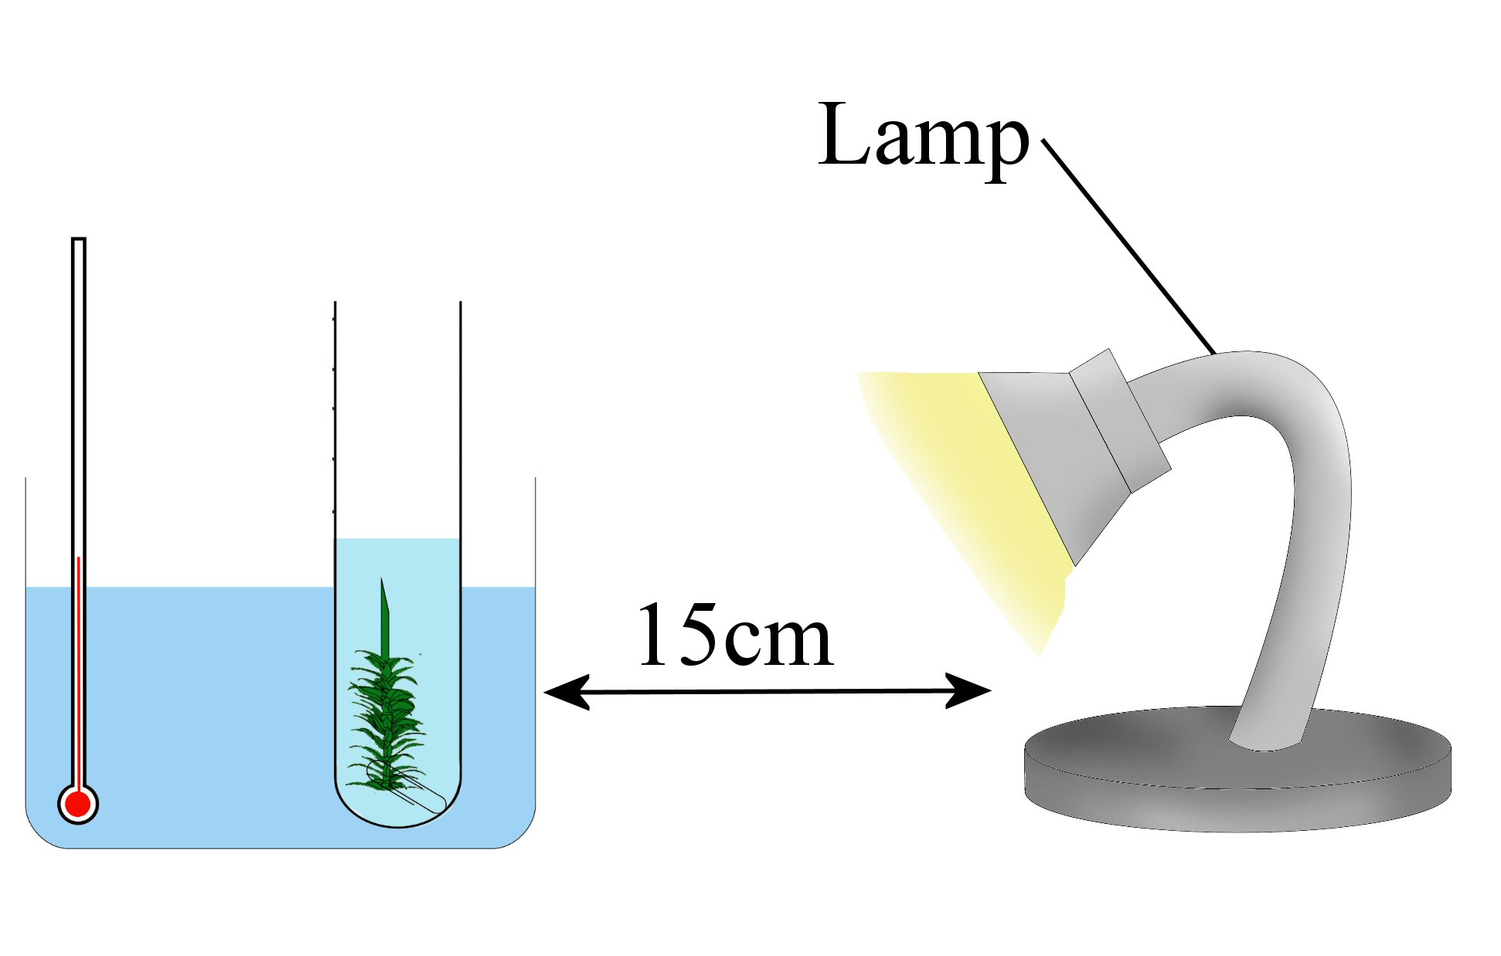
1.
2.
3.

Always remember – Leave time to tidy up
This page can be printed in colour from the accompanying CD
Fill each boiling tube with a different concentration sodium hydrogencarbonate solution and label.
Put the boiling tubes in a water bath at 25^{O}C until they reach this temperature.
Cut the stem of the elodea at an angle. Remove several leaves from the cut end of the stem.
5.
4.
Hook a paper clip onto the end of the elodea. Drop the elodea, stem up, into the boiling tube containing the 0.02% solution.
Place the boiling tube containing the elodea into a water bath at 25^{O}C.

6.
Switch on the light source and place the water bath containing the elodea 15 cm from the lamp. Wait for 5 minutes.
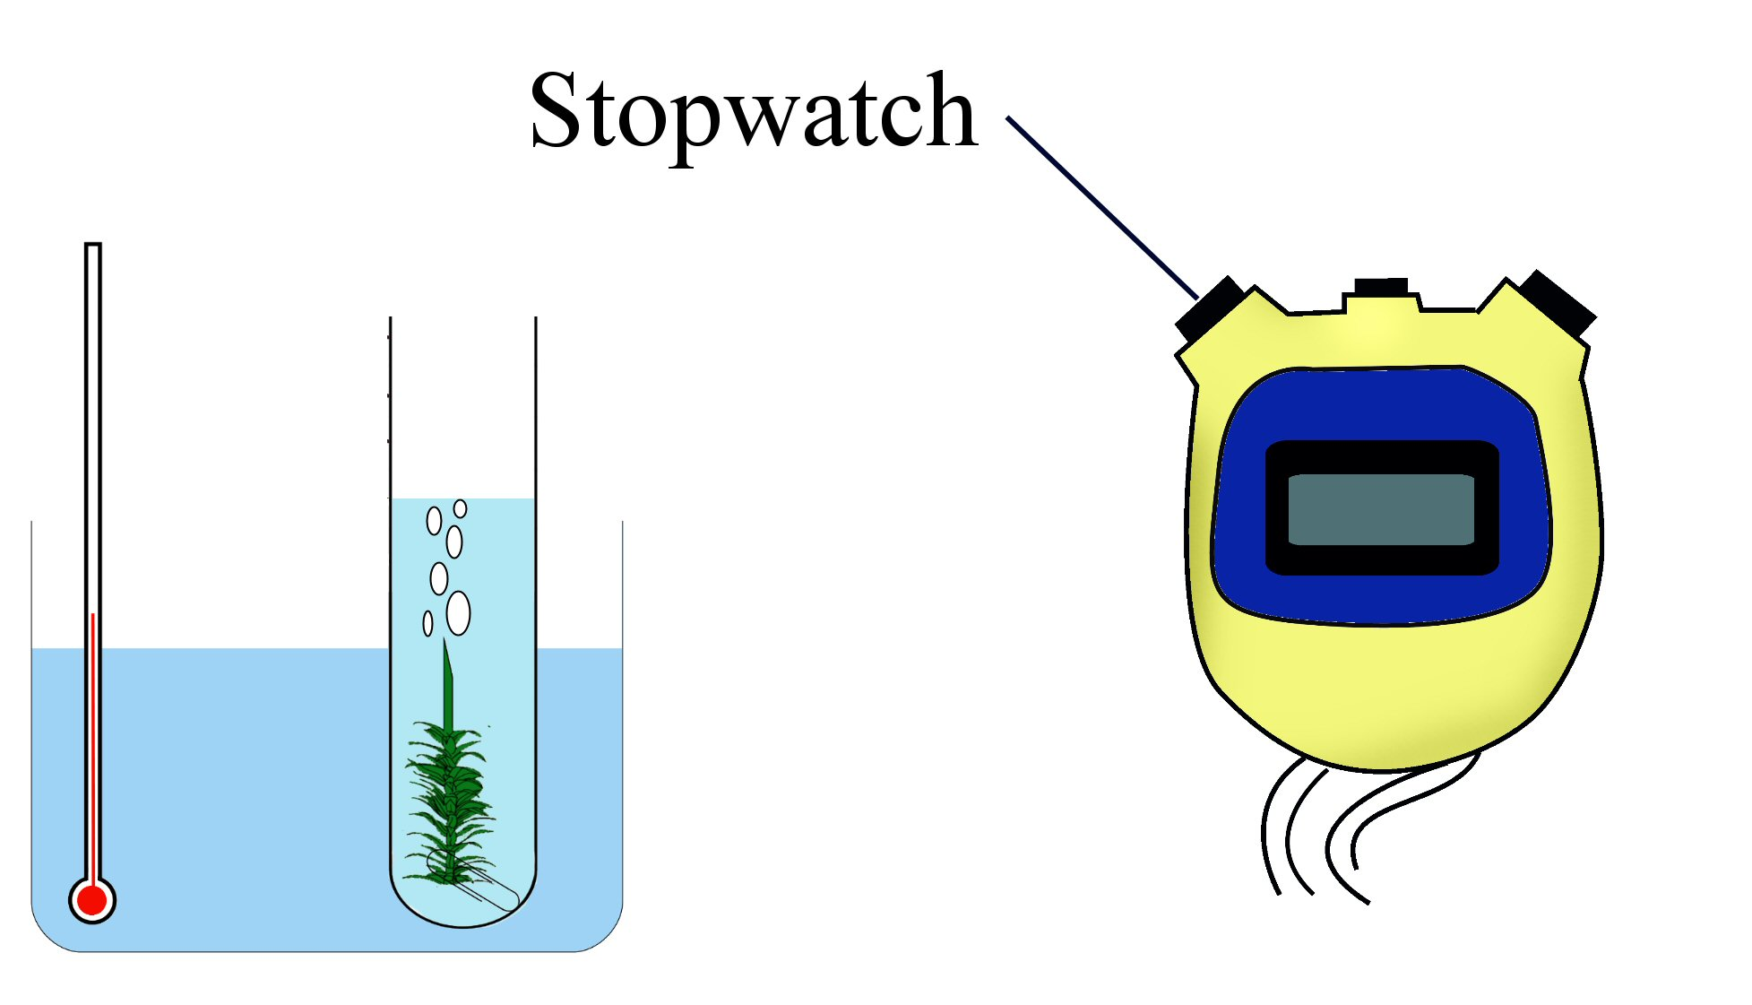
7.
Observe bubbles being released from the cut end of the stem. Count and record the number of bubbles released per minute.
Repeat twice and get an average.
8.
9.
Expected result

Repeat the experiment using
the different concentrations
of sodium hydrogencarbonate solution.

Rate of Photosynthesis
Carbon dioxide concentration

Table of results:
NaHCO₃ concentration | Trial 1  (No. of bubbles / min) | Trial 2  (No. of bubbles / min) | Trial 3  (No. of bubbles / min) | Average  (No. of bubbles / min)

Always remember – Leave time to tidy up

Always remember – Leave time to tidy up
This page can be printed in colour from the accompanying CD
This page can be printed in colour from the accompanying CD

