4.8 To prepare and show the production of alcohol by yeast
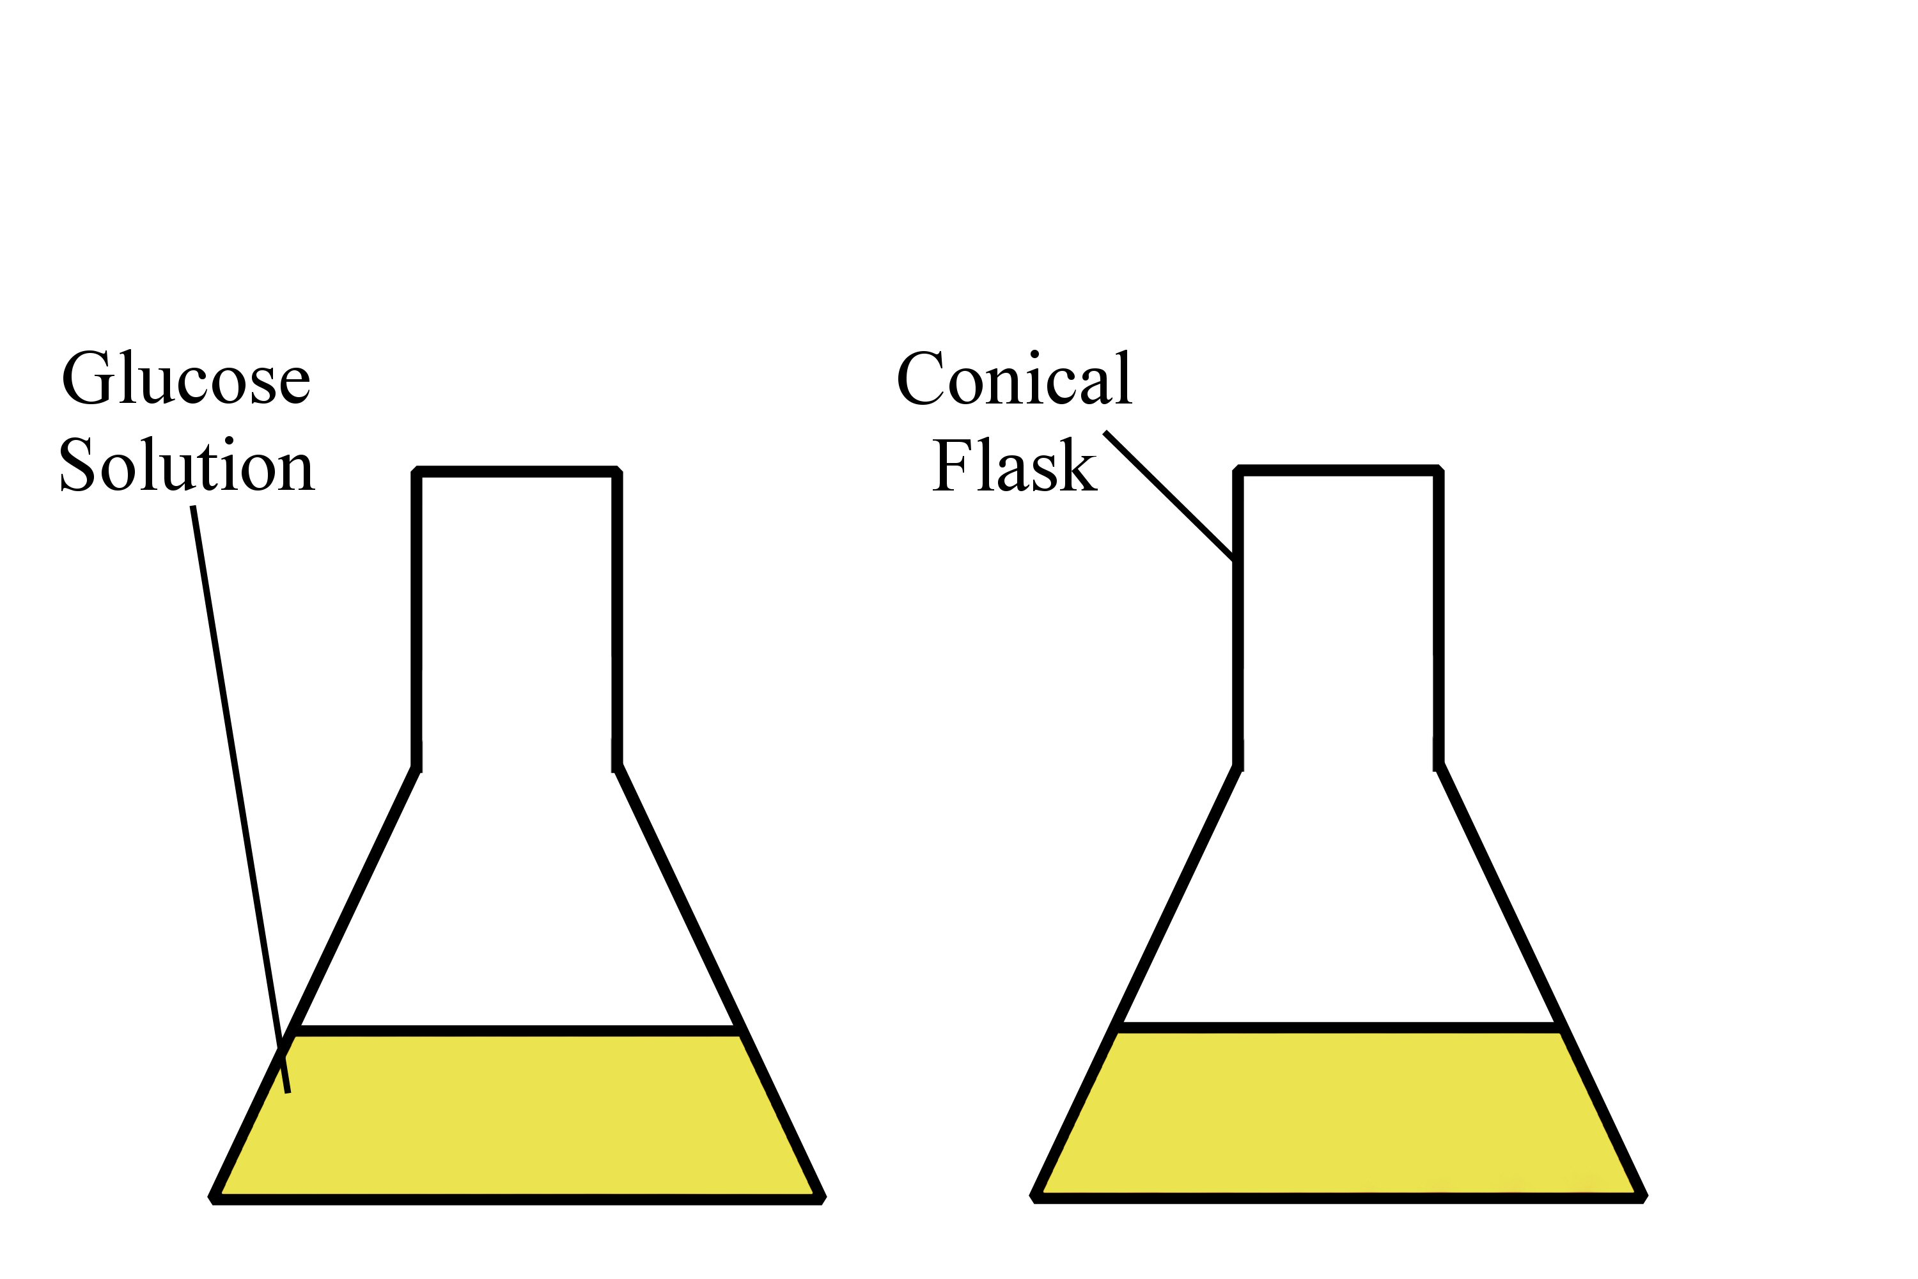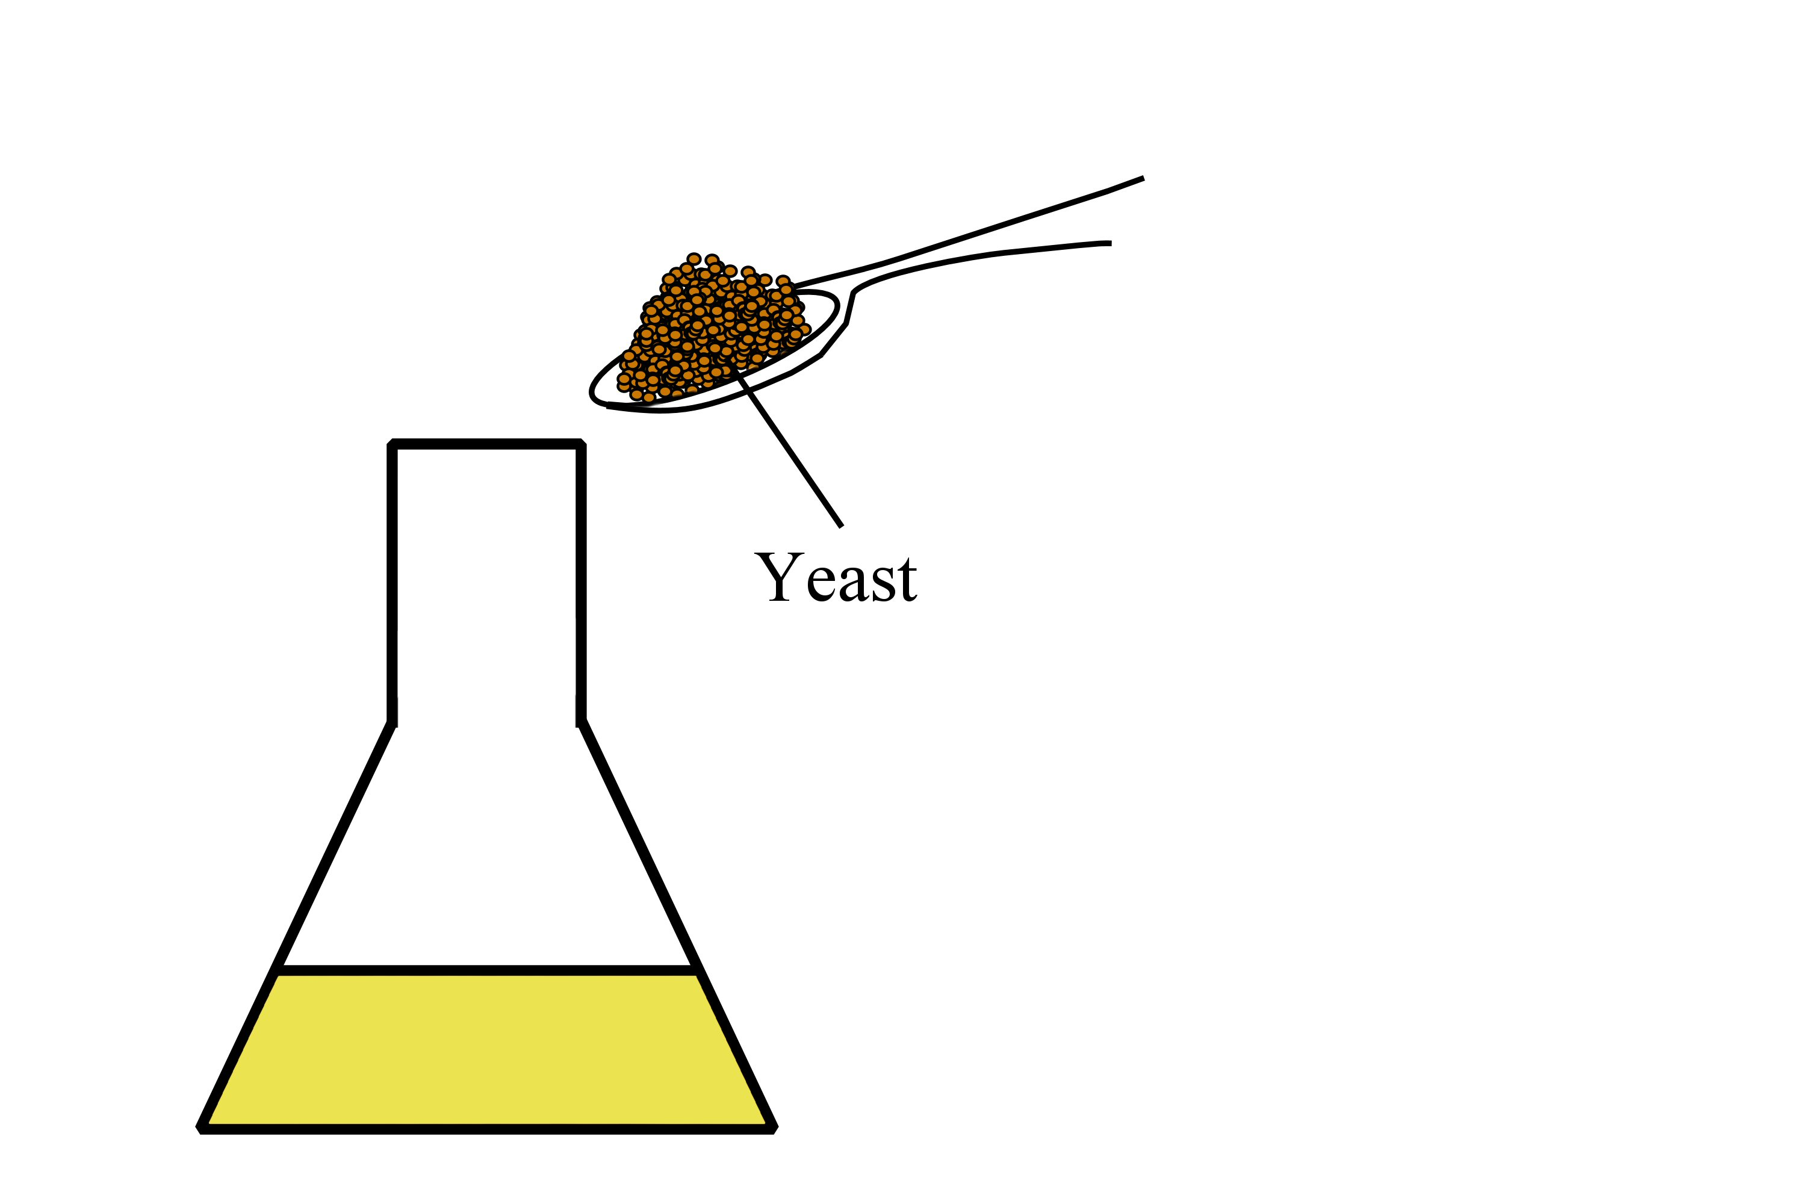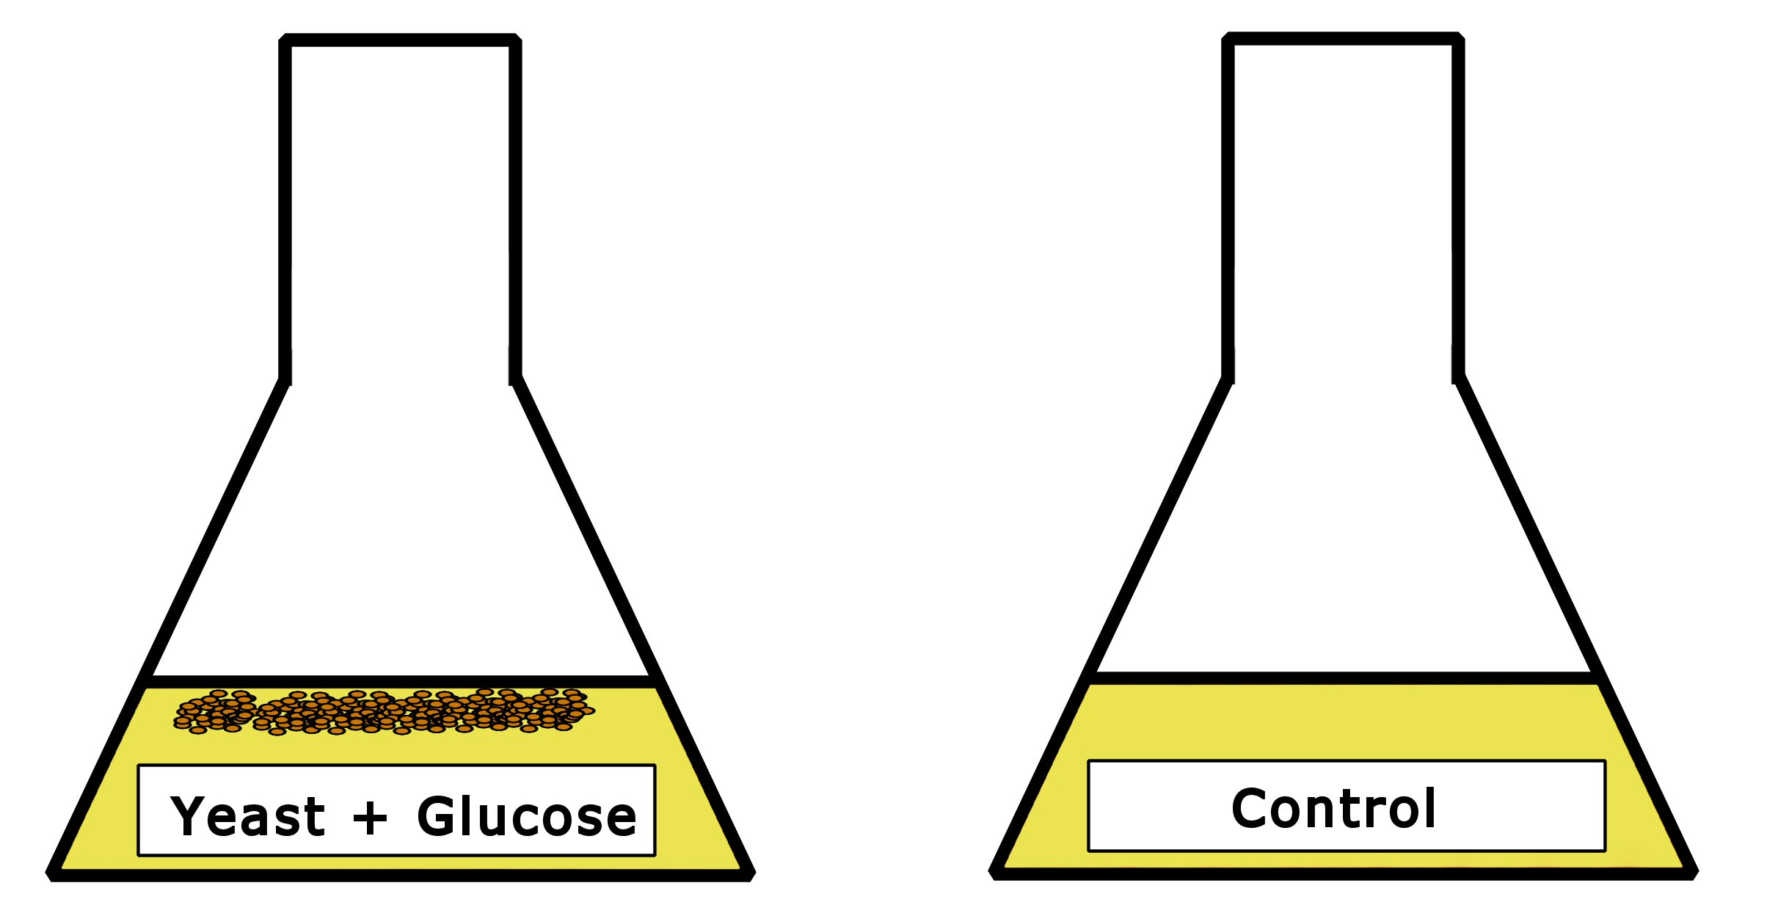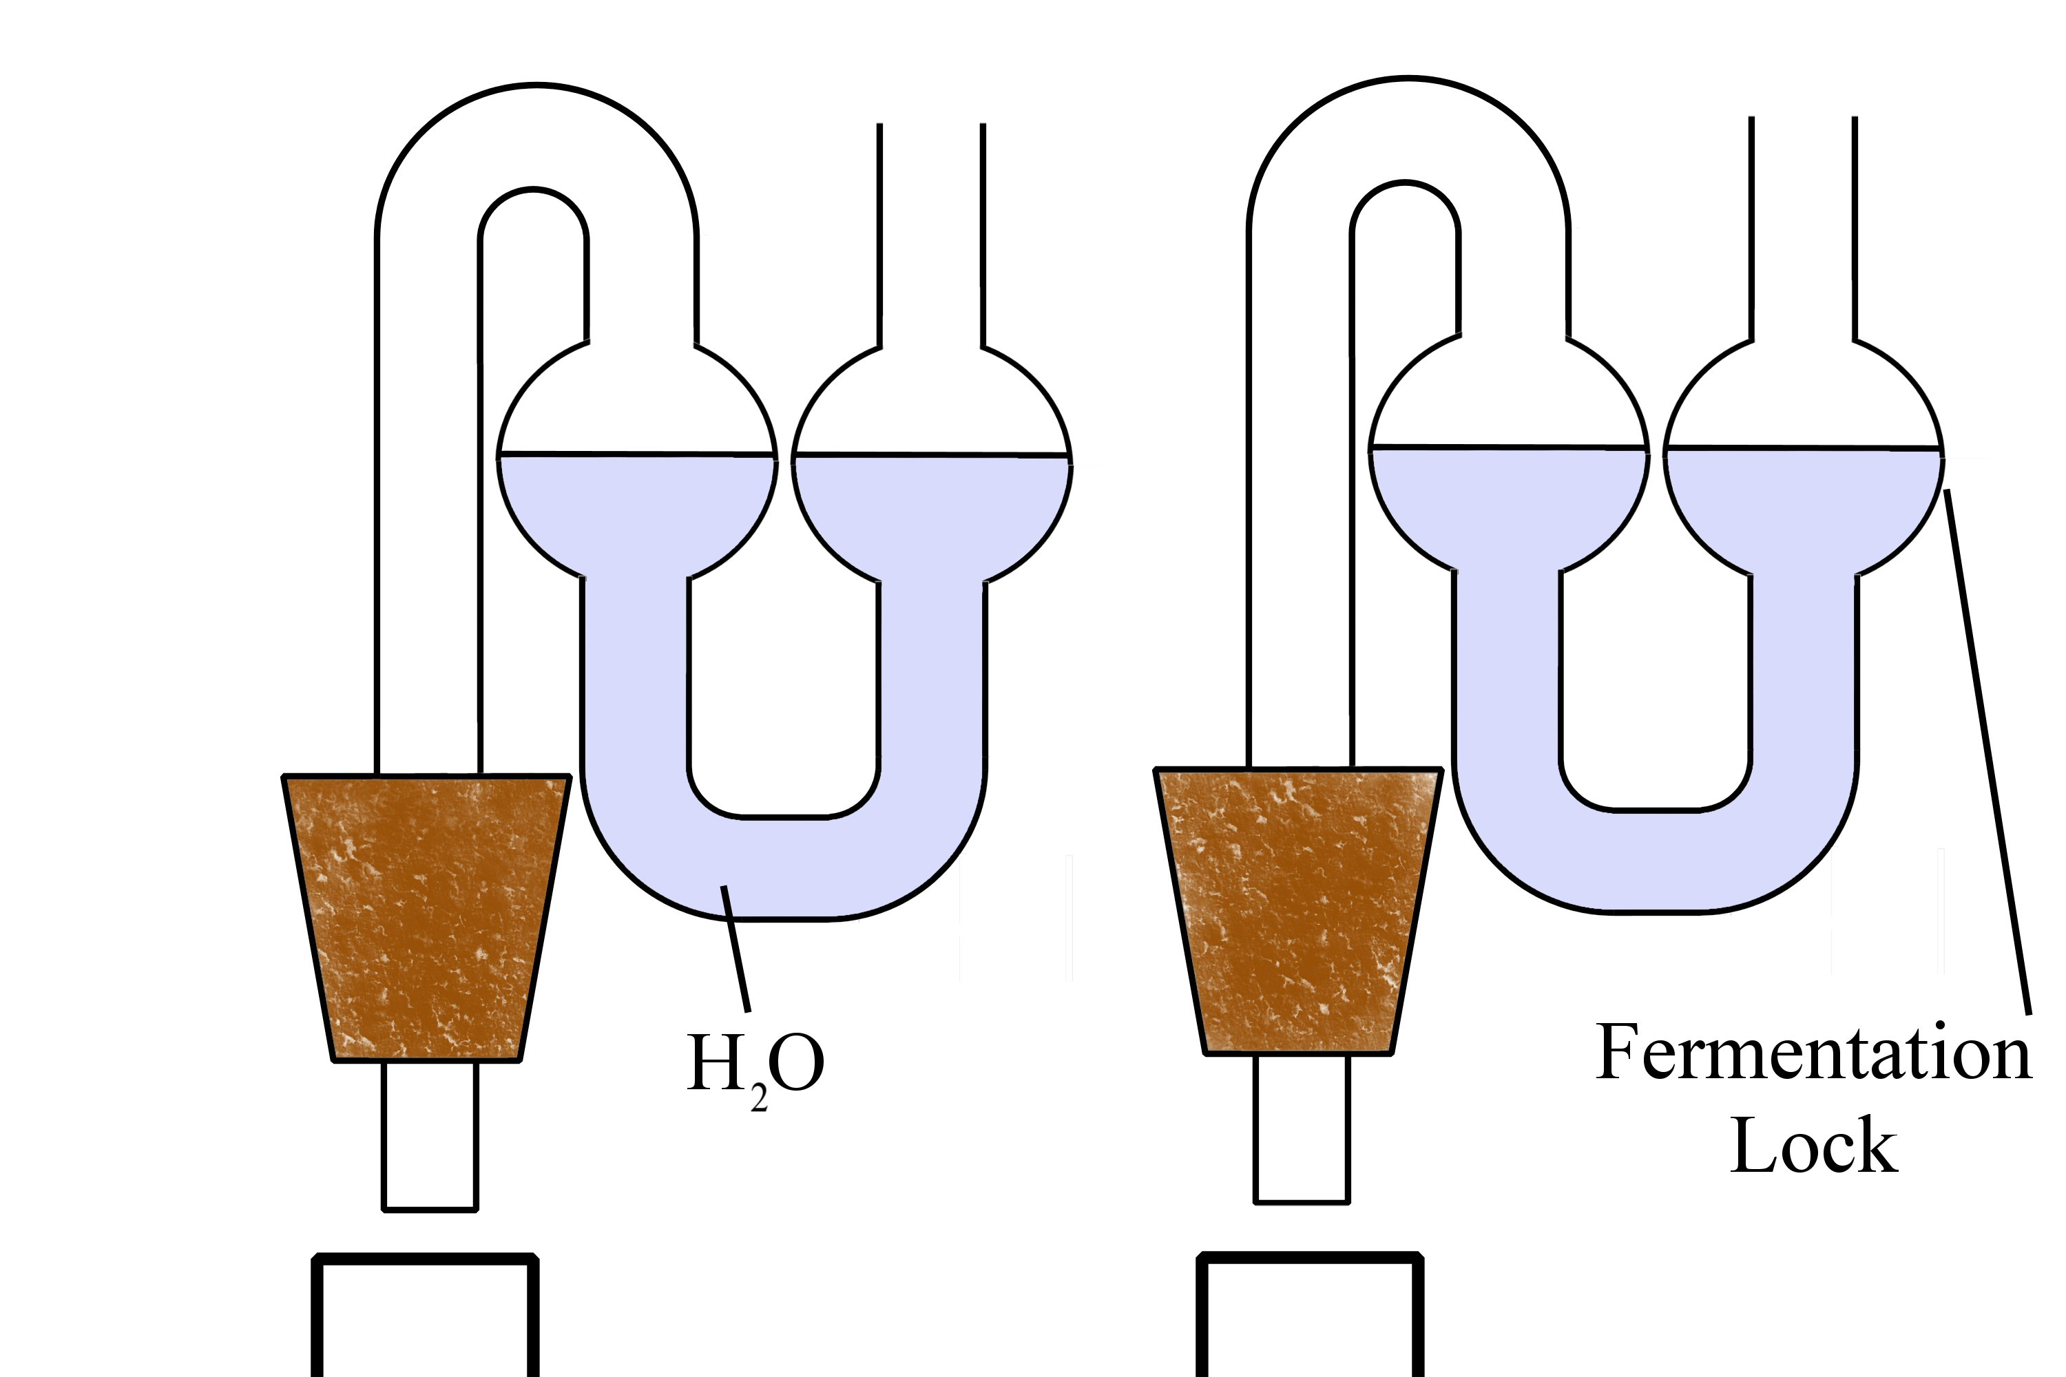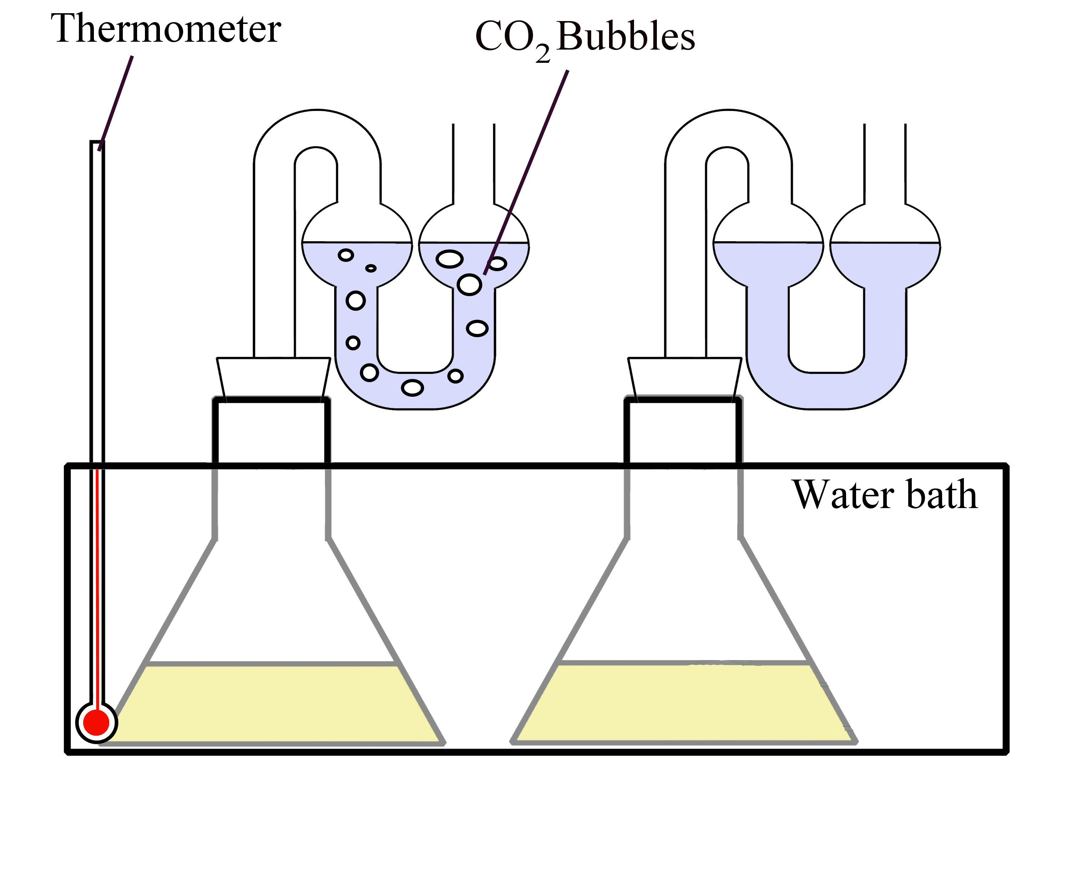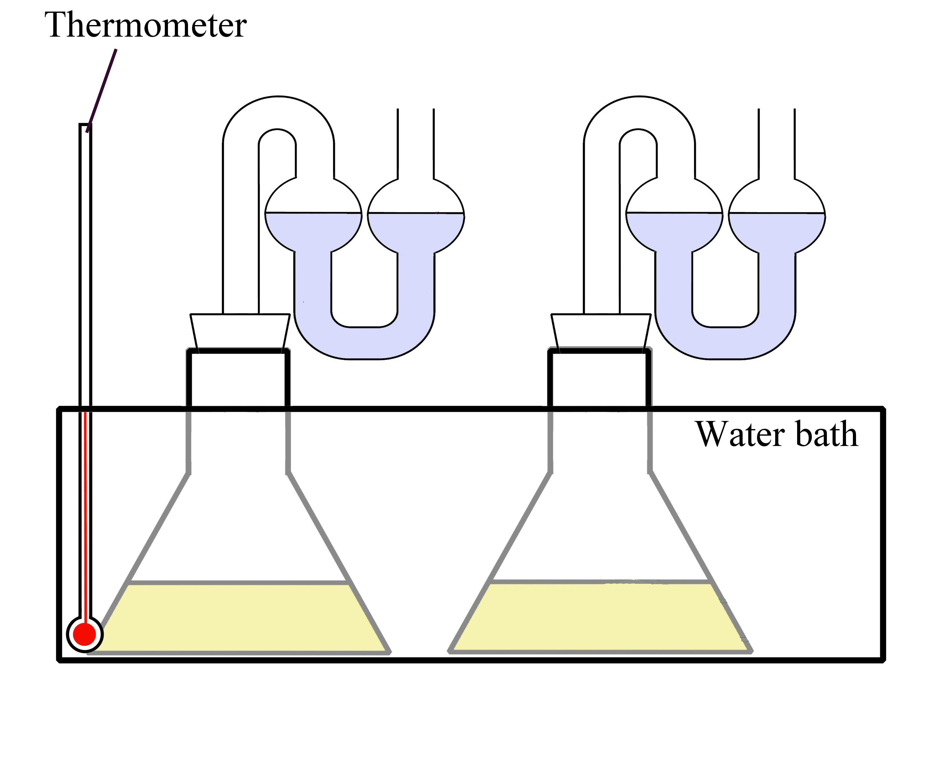
1.
2.
3.

Always remember – Leave time to tidy up
This page can be printed in colour from the accompanying CD
Add 200 ml glucose solution to each of two conical flasks.
Add 5 g of yeast to one flask. The second flask contains no yeast – this acts as a control.
Label the flasks:
‘Yeast + Glucose’ and ‘Control’
5.
4.
Half fill the fermentation locks with water and put one on each flask.
Stand the flasks in a water bath at 30^{O}C
for 24 hours.

6.
Result: Fermentation is complete when the bubbles stop.
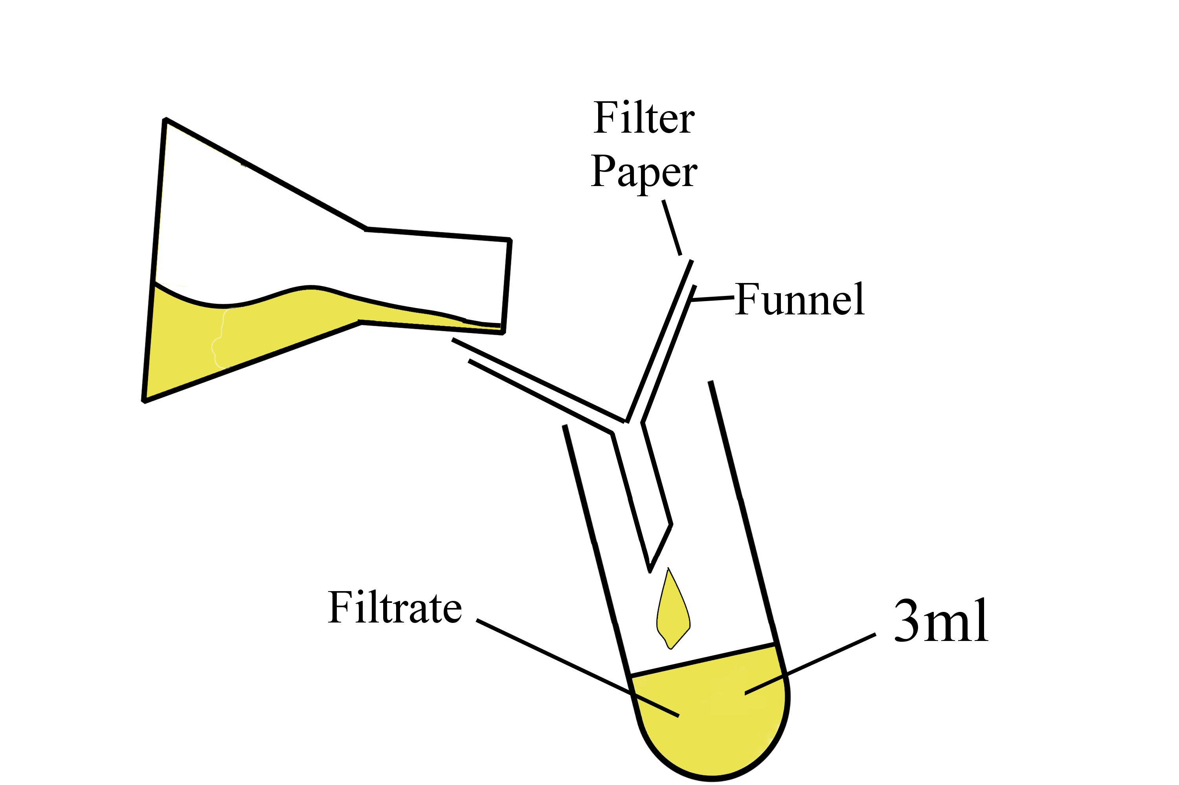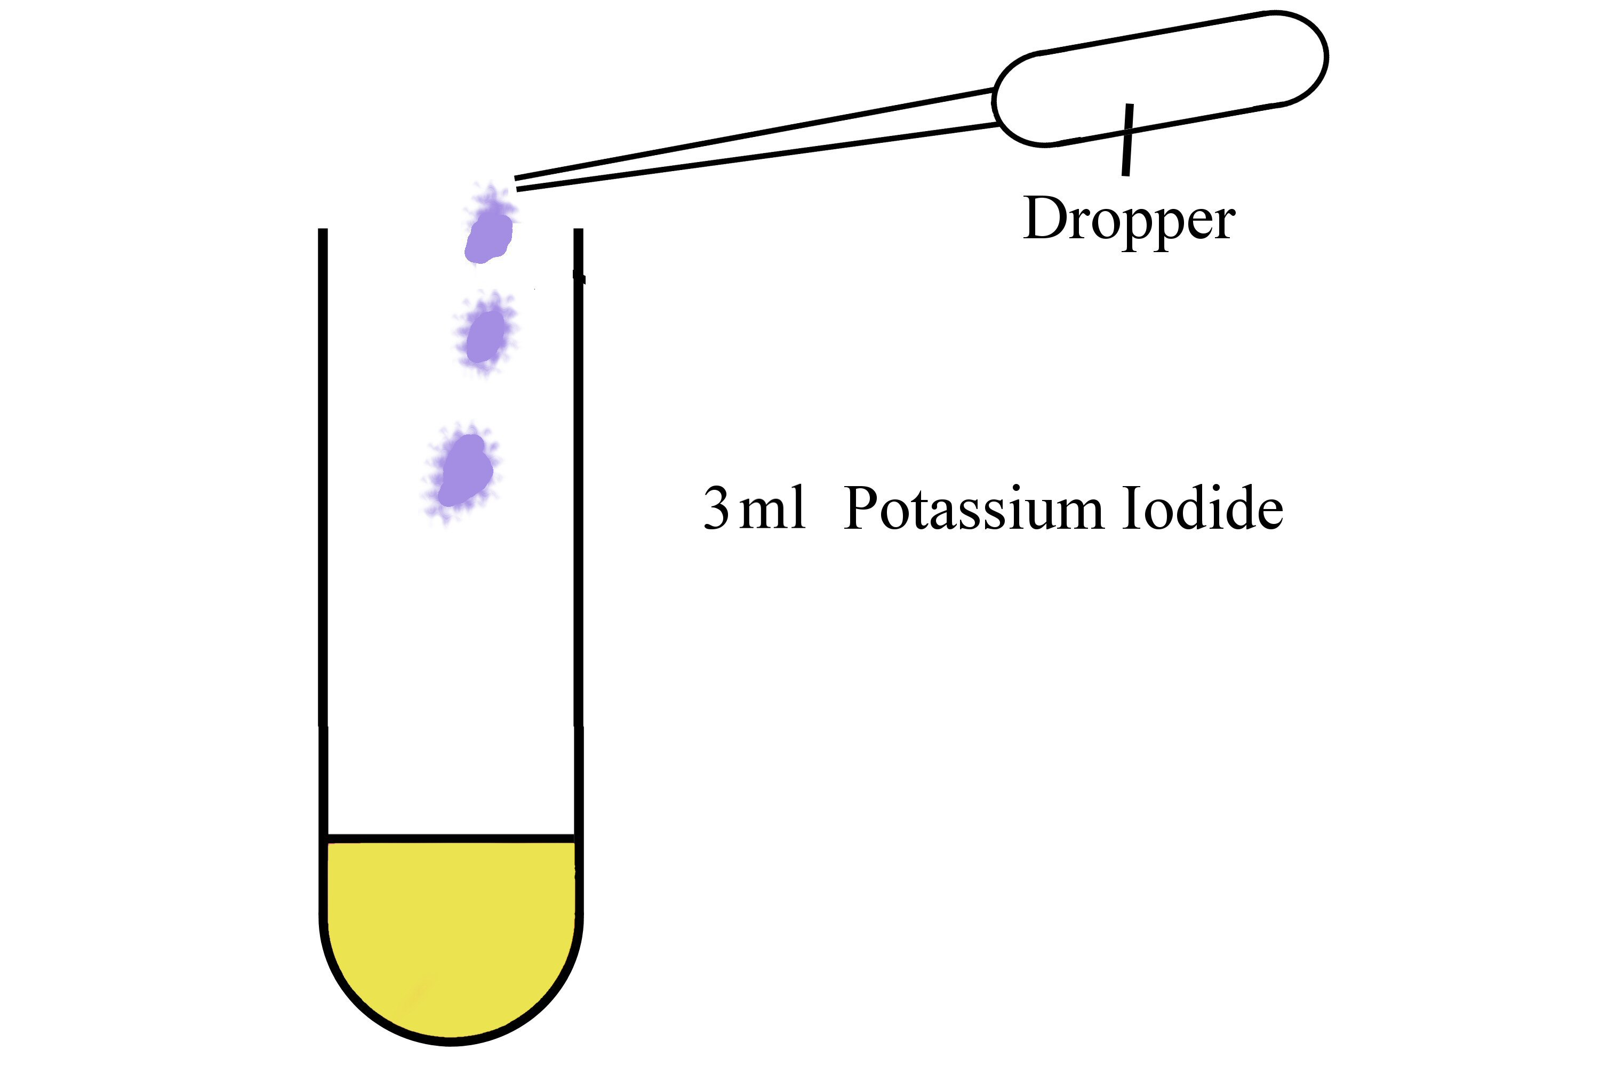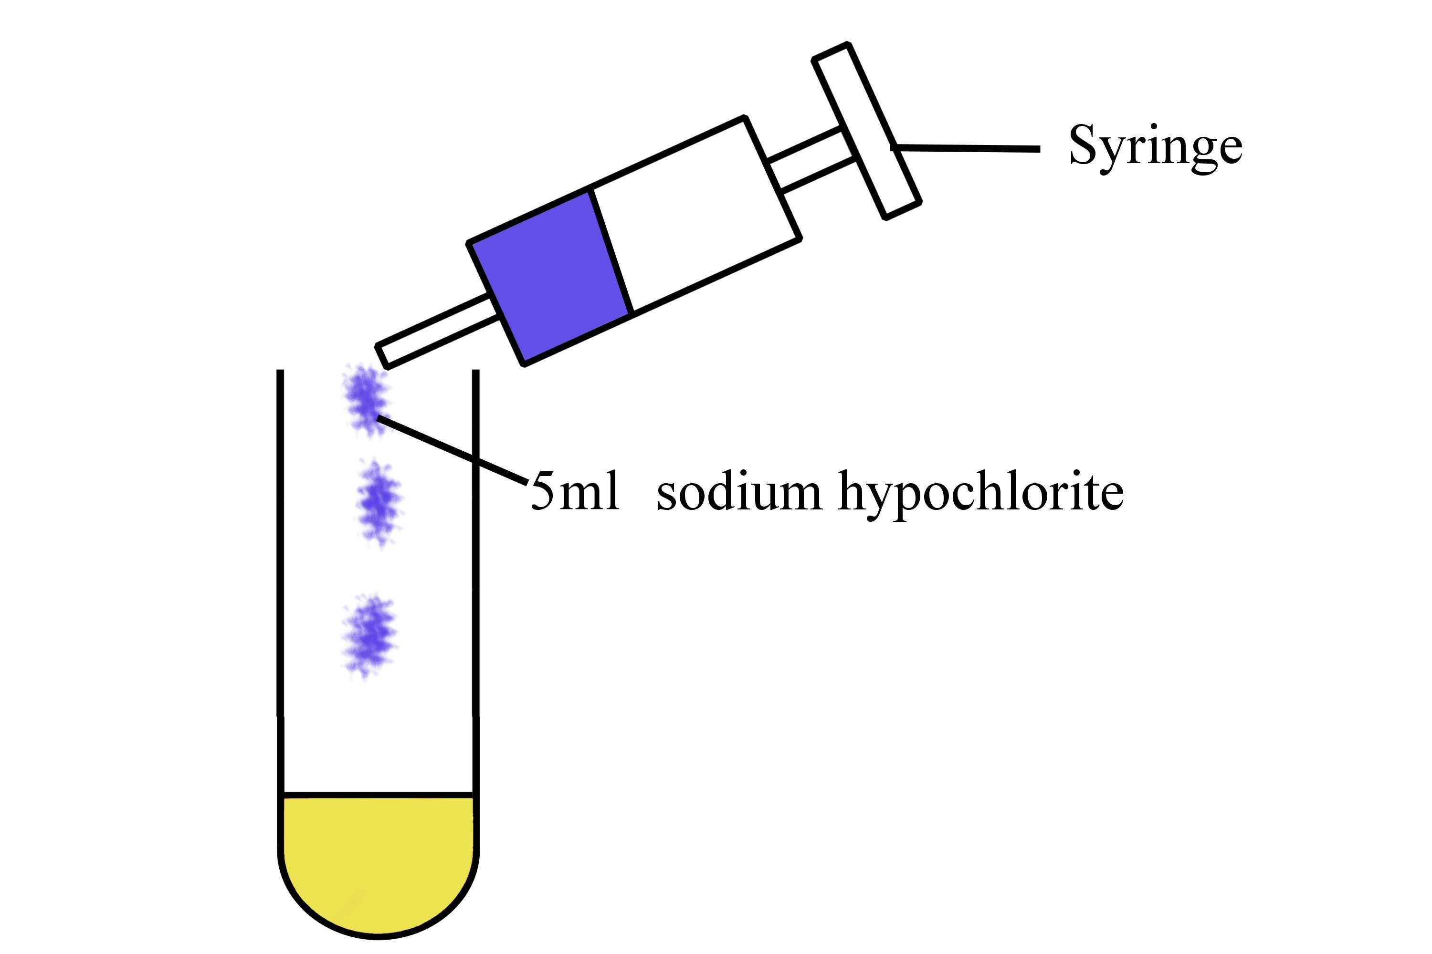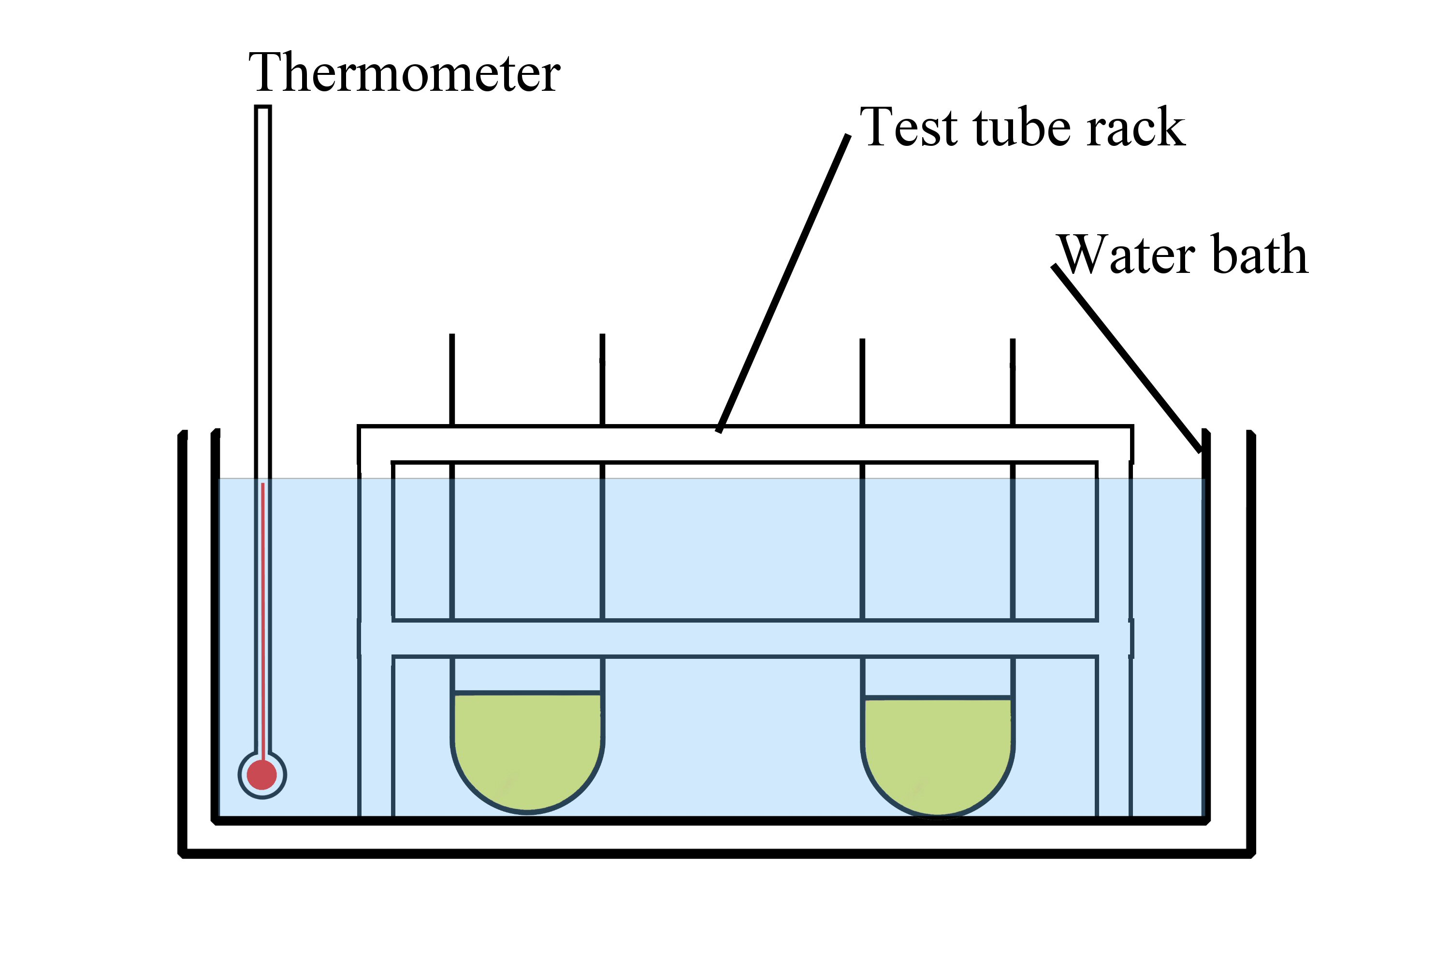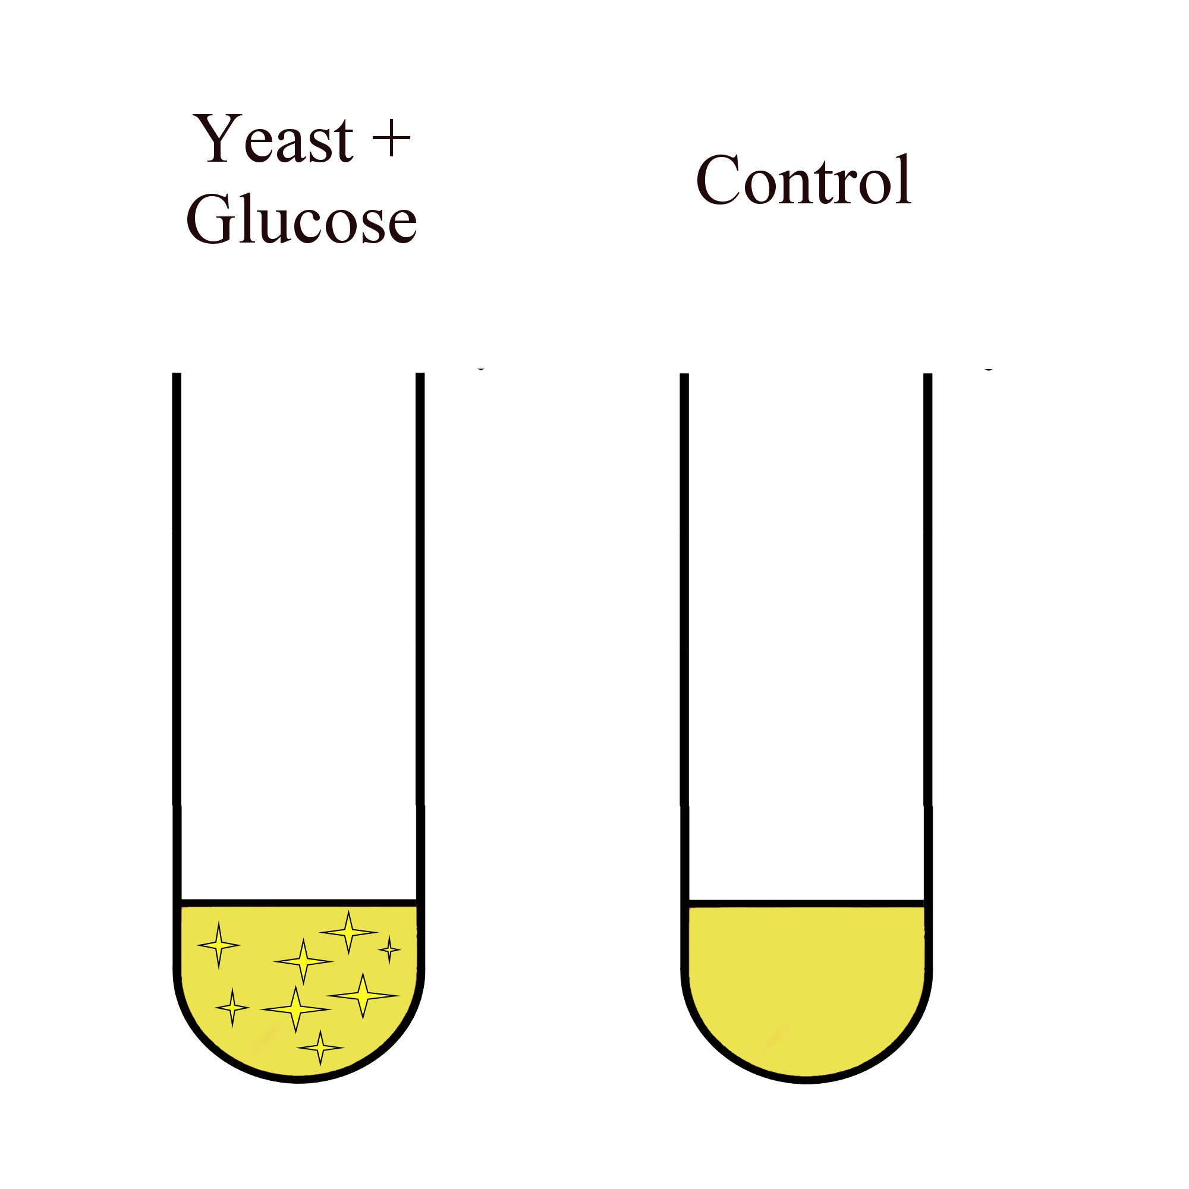
7.
8.
9.
11.

Always remember – Leave time to tidy up
This page can be printed in colour from the accompanying CD
Filter the contents of each flask into separate boiling tubes.

Add 3 ml potassium iodide to each boiling tube.

Add 5 ml sodium hypochlorite to each
boiling tube.

10.
Place boiling tubes in a water bath at 60^{O}C for 4-5 minutes.

Expected result

Table of results
Flask | Original colour of filtrate | Final colour of filtrate | Other changes
Yeast + Glucose solution

Control (no yeast)

Always remember – Leave time to tidy up
This page can be printed in colour from the accompanying CD

