4.11 To investigate the growth of leaf yeast using agar plates and controls
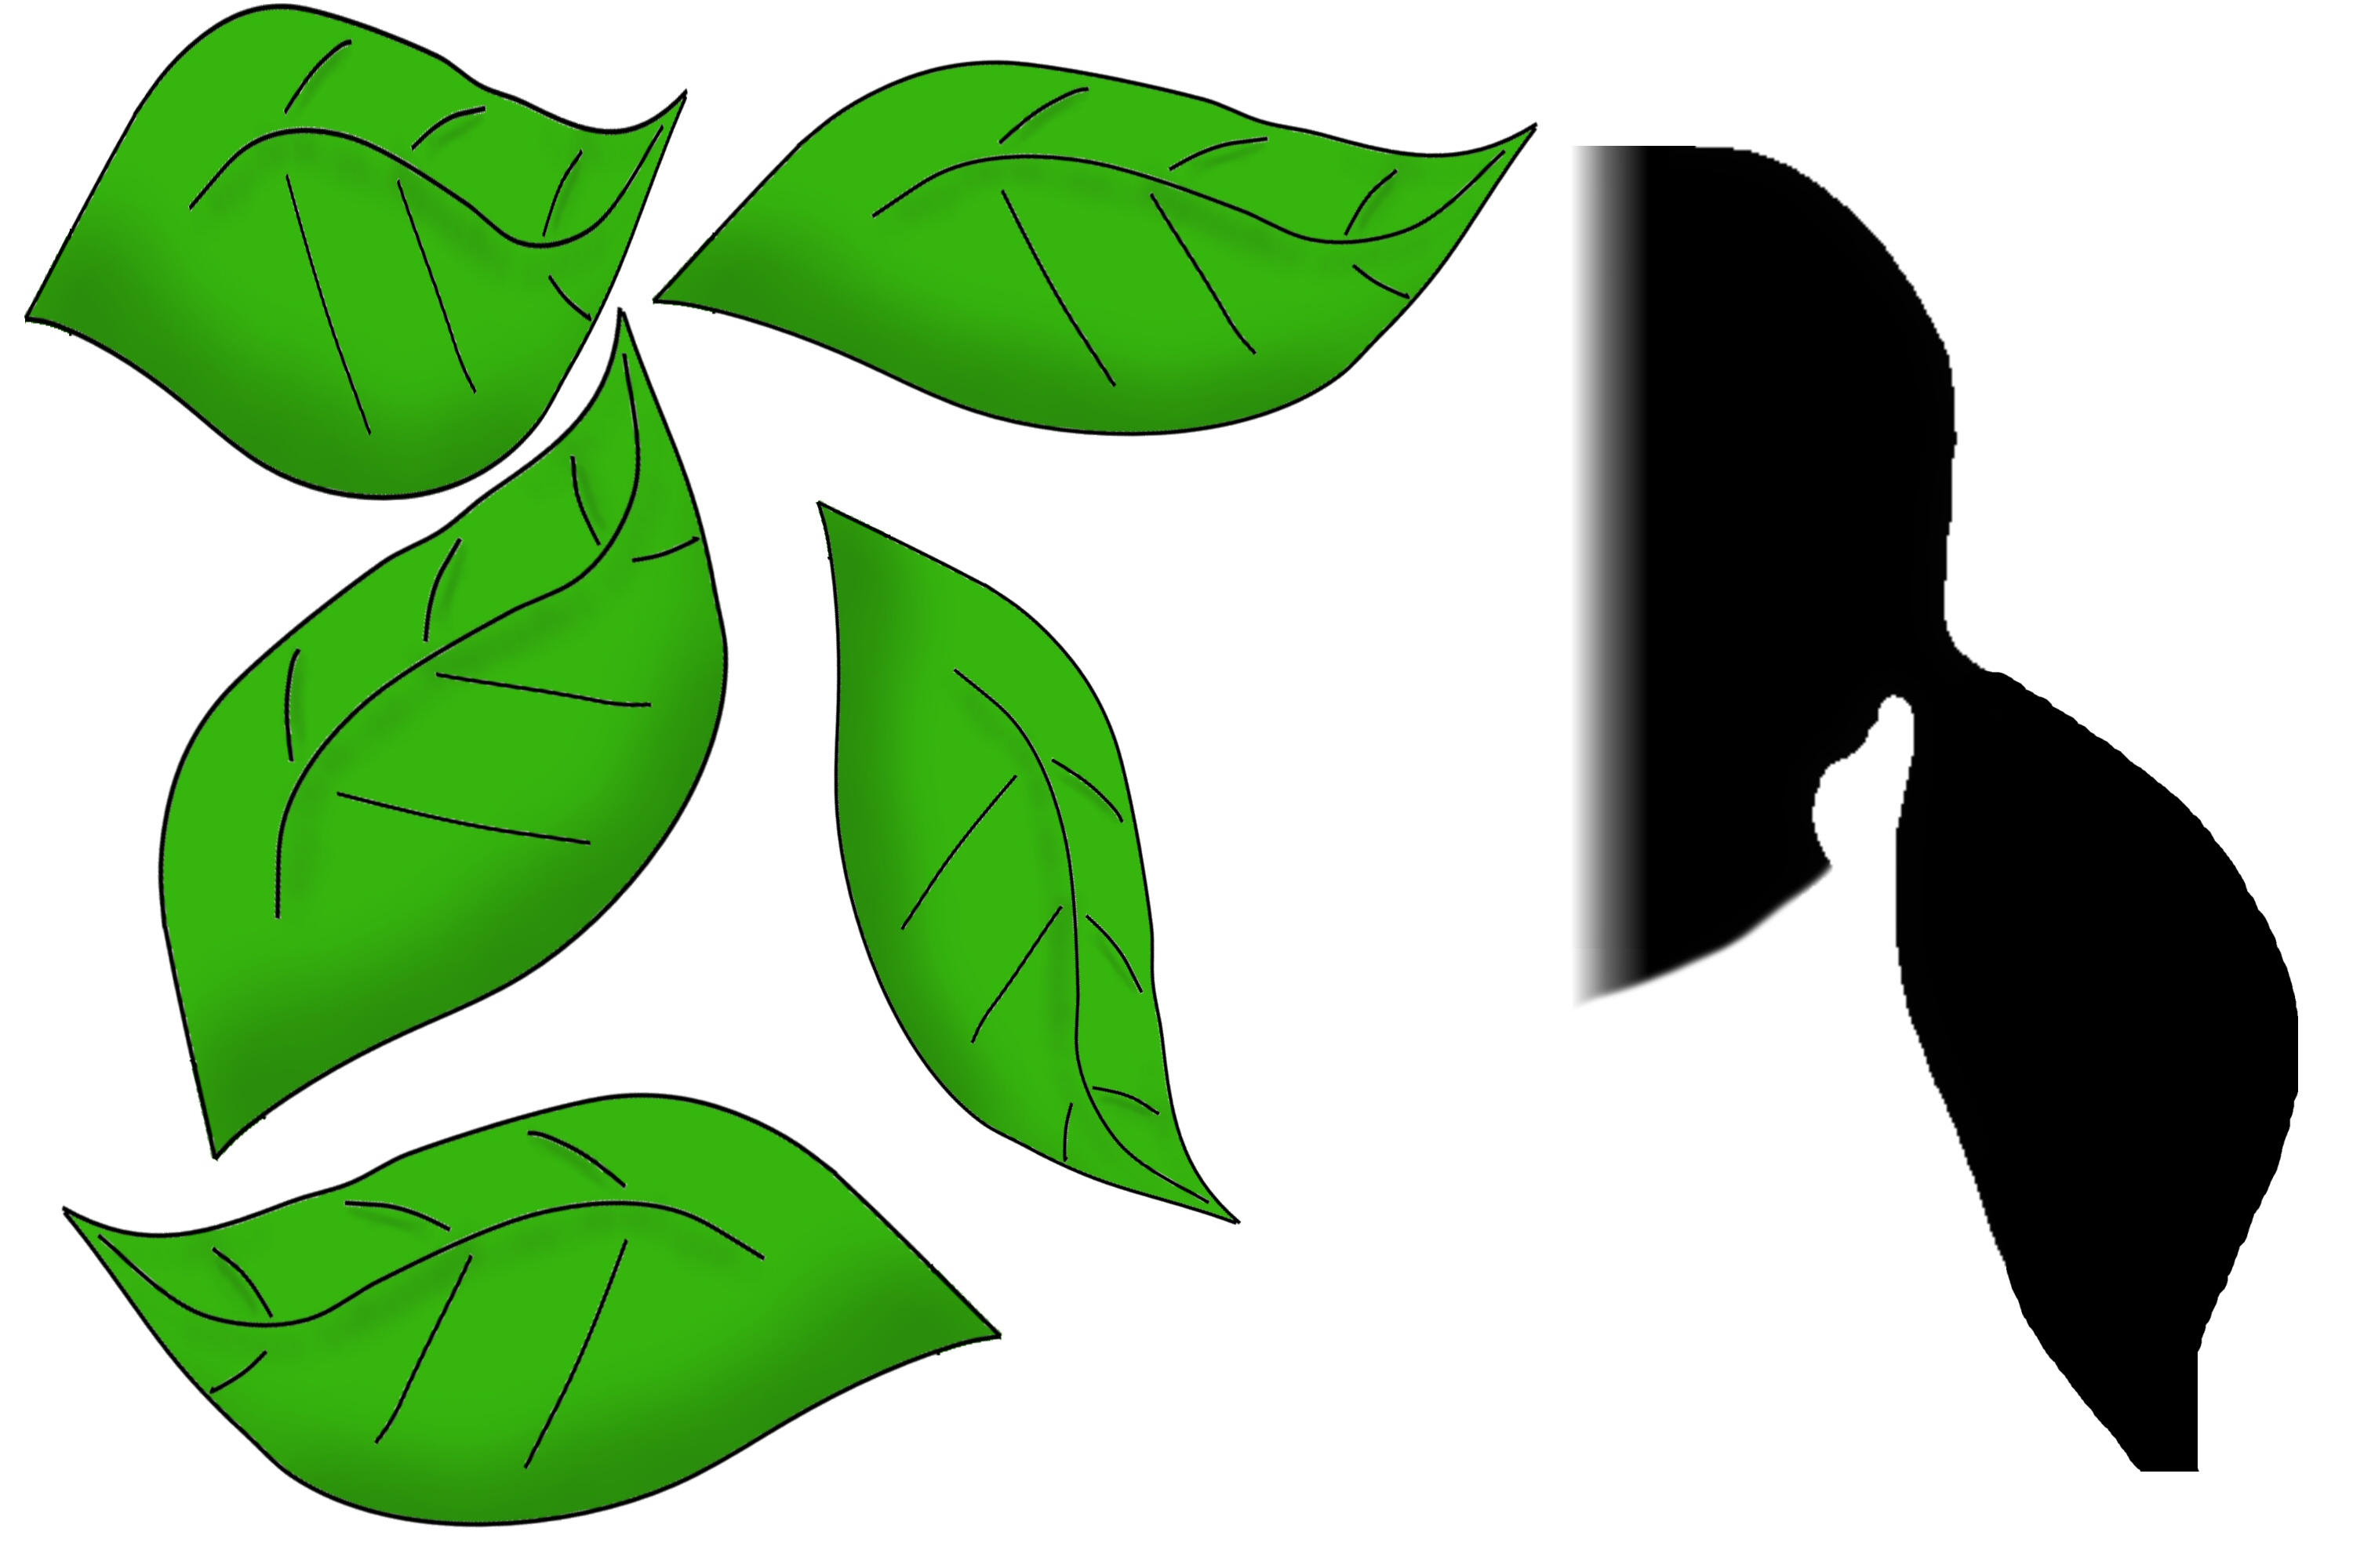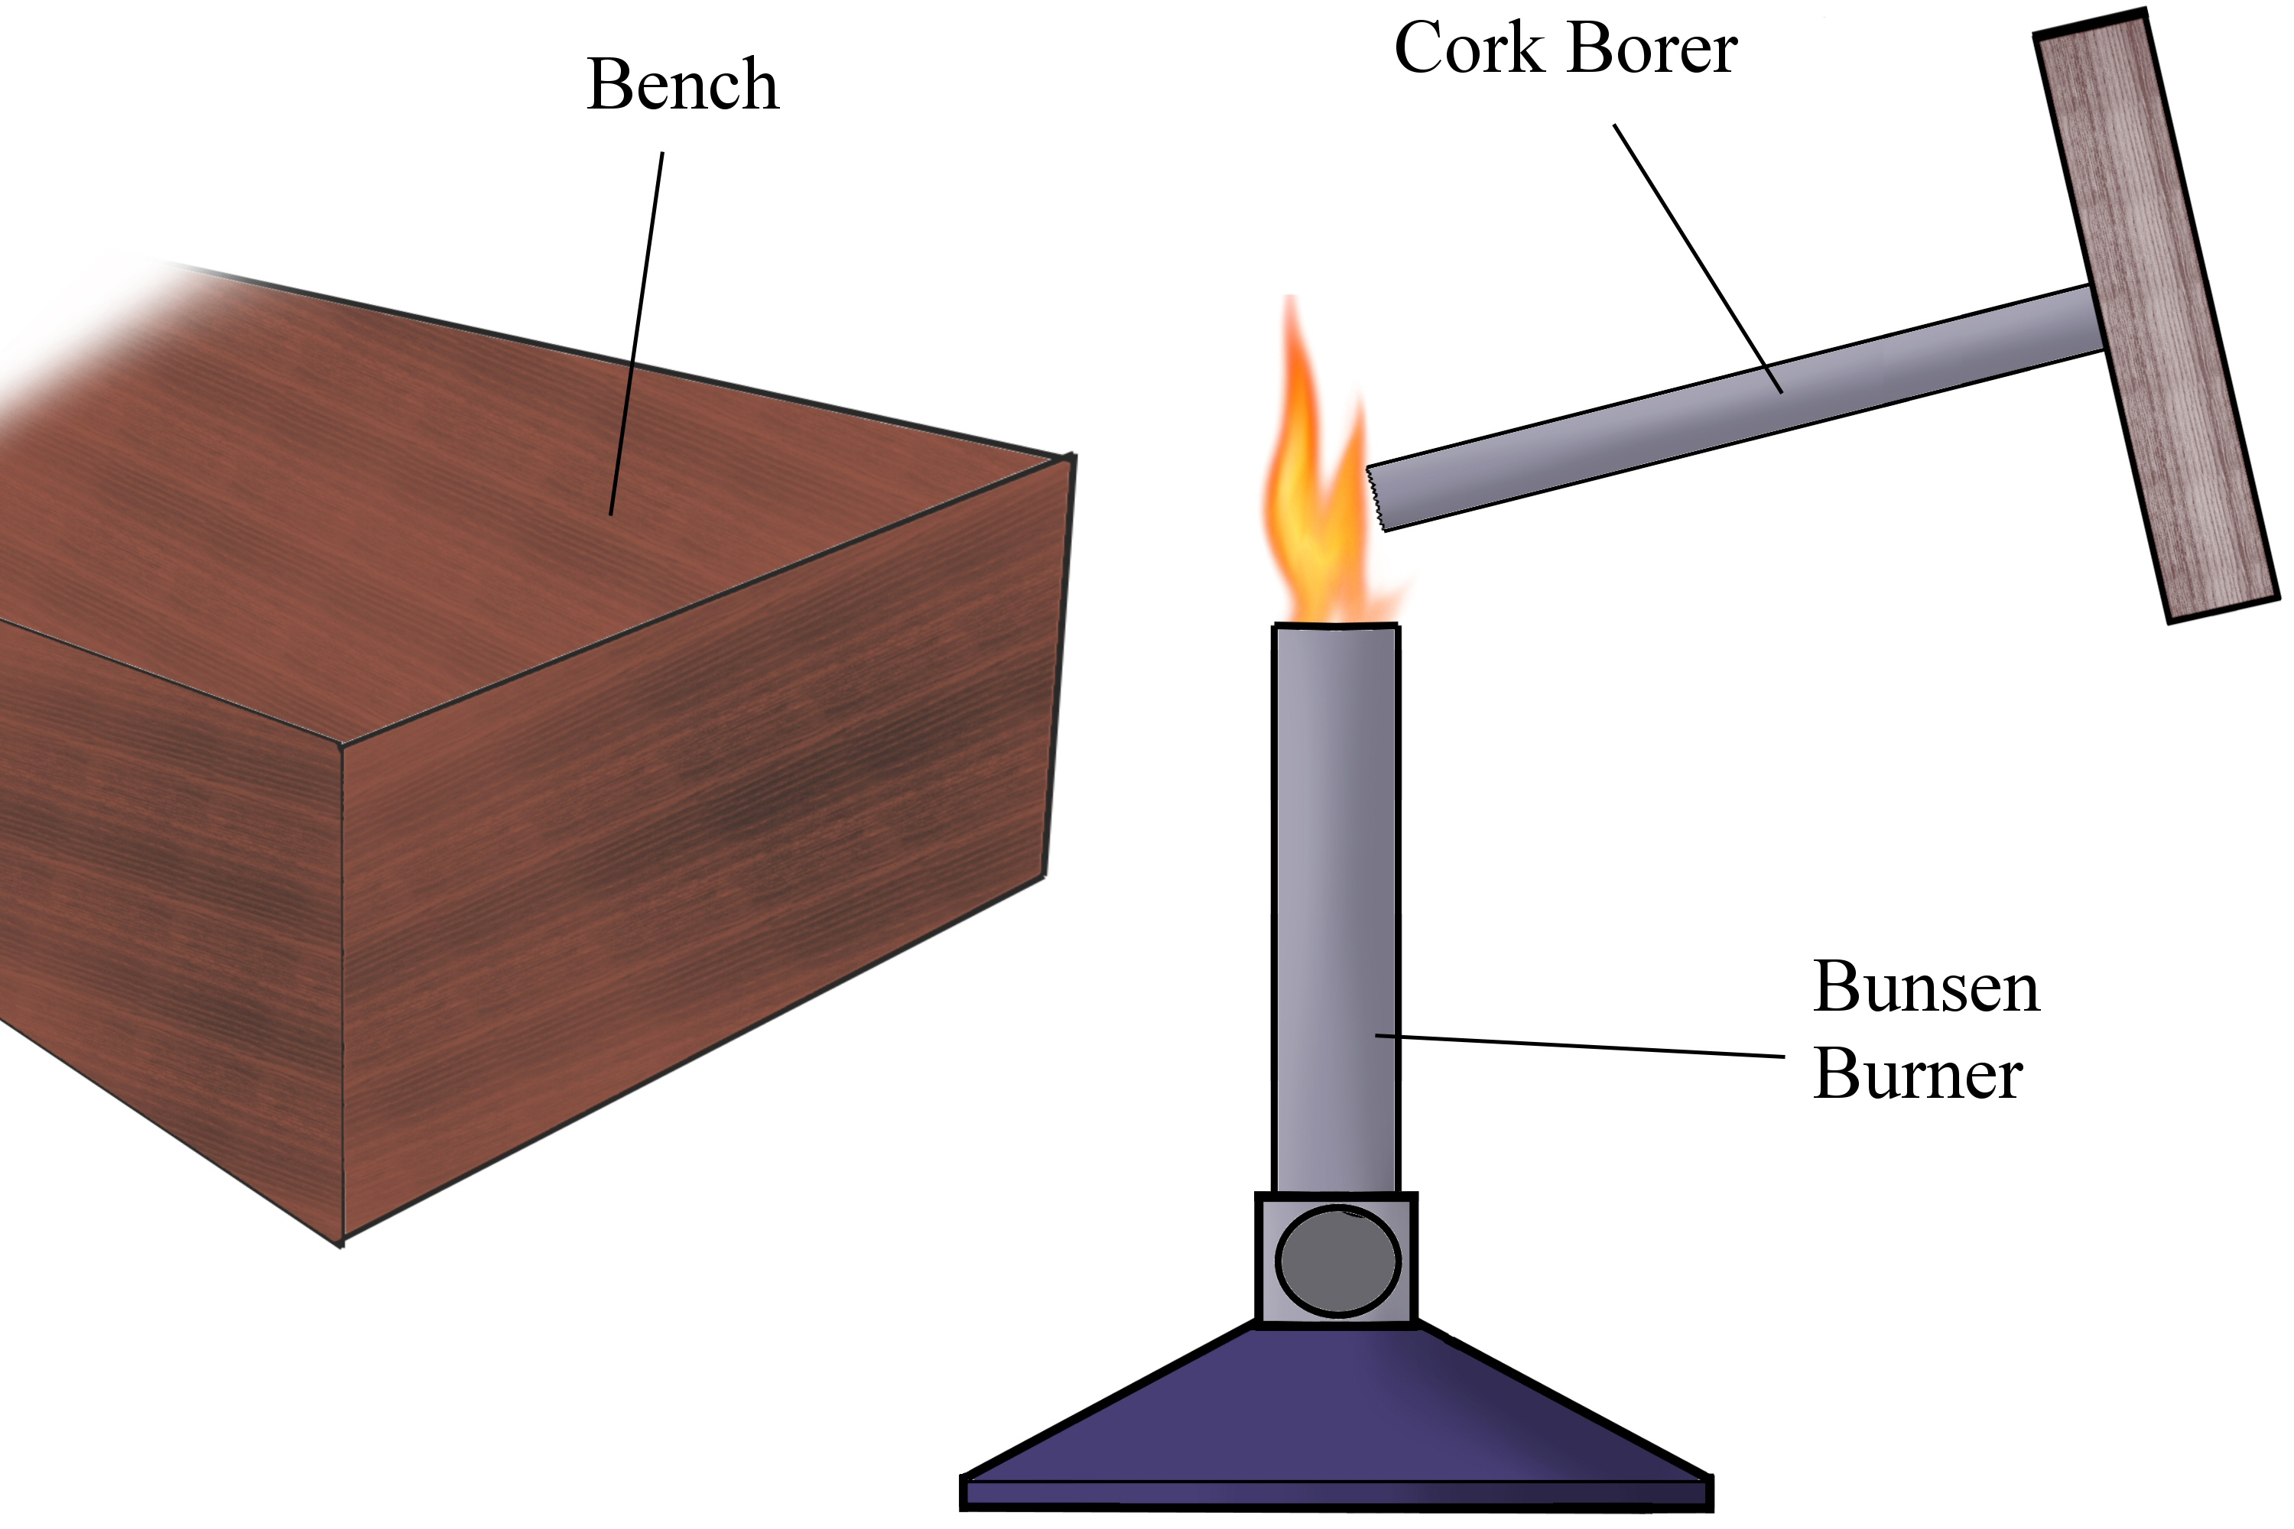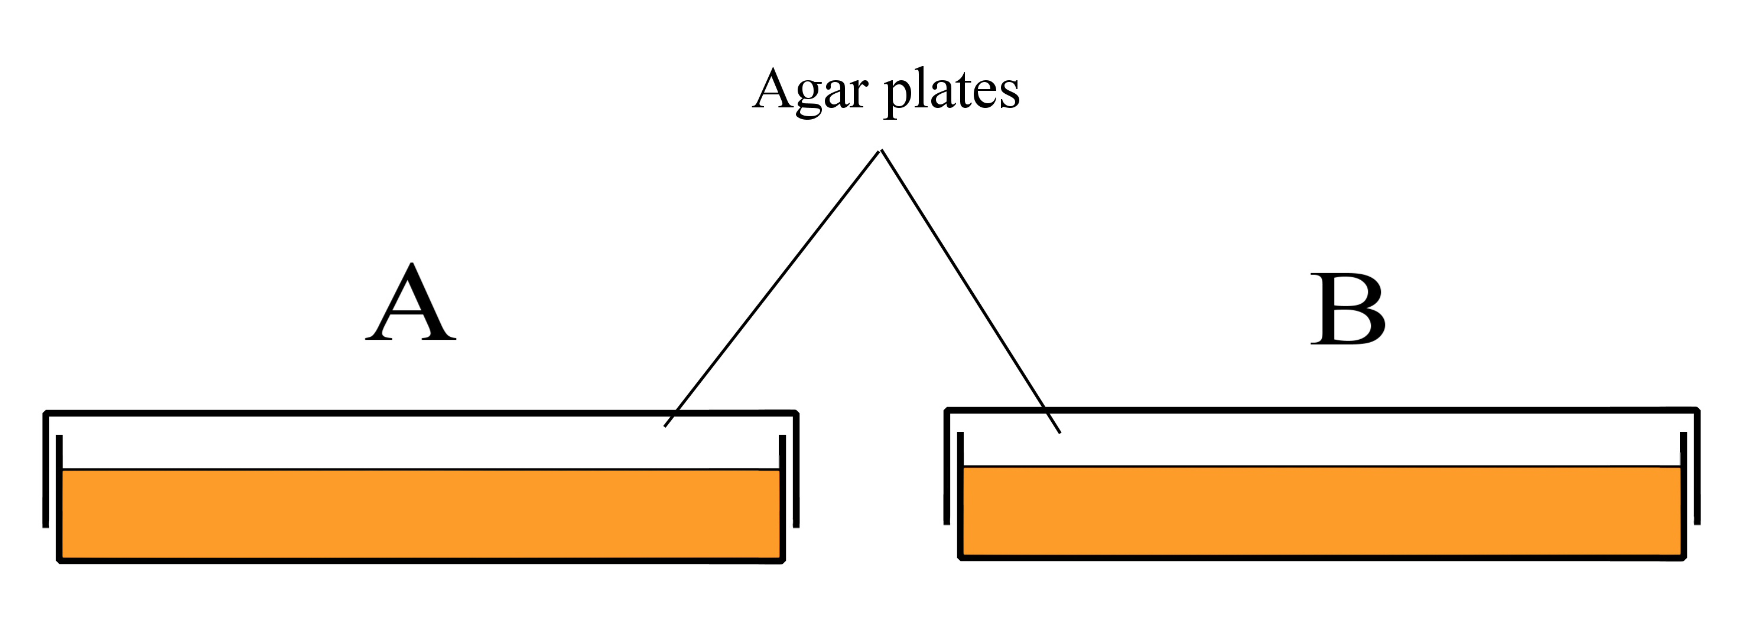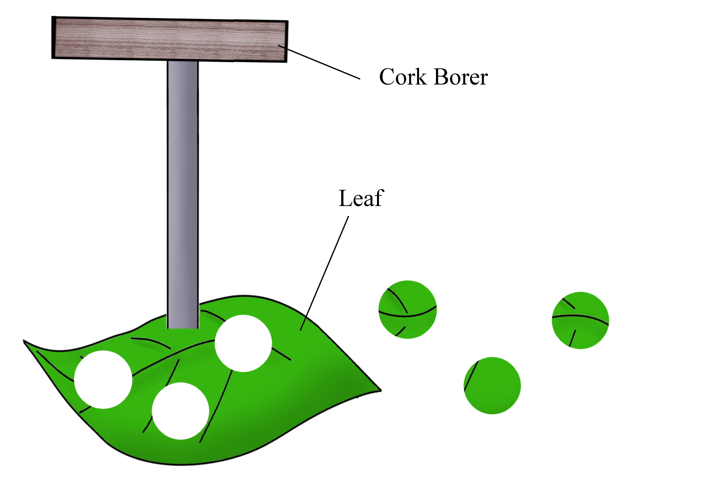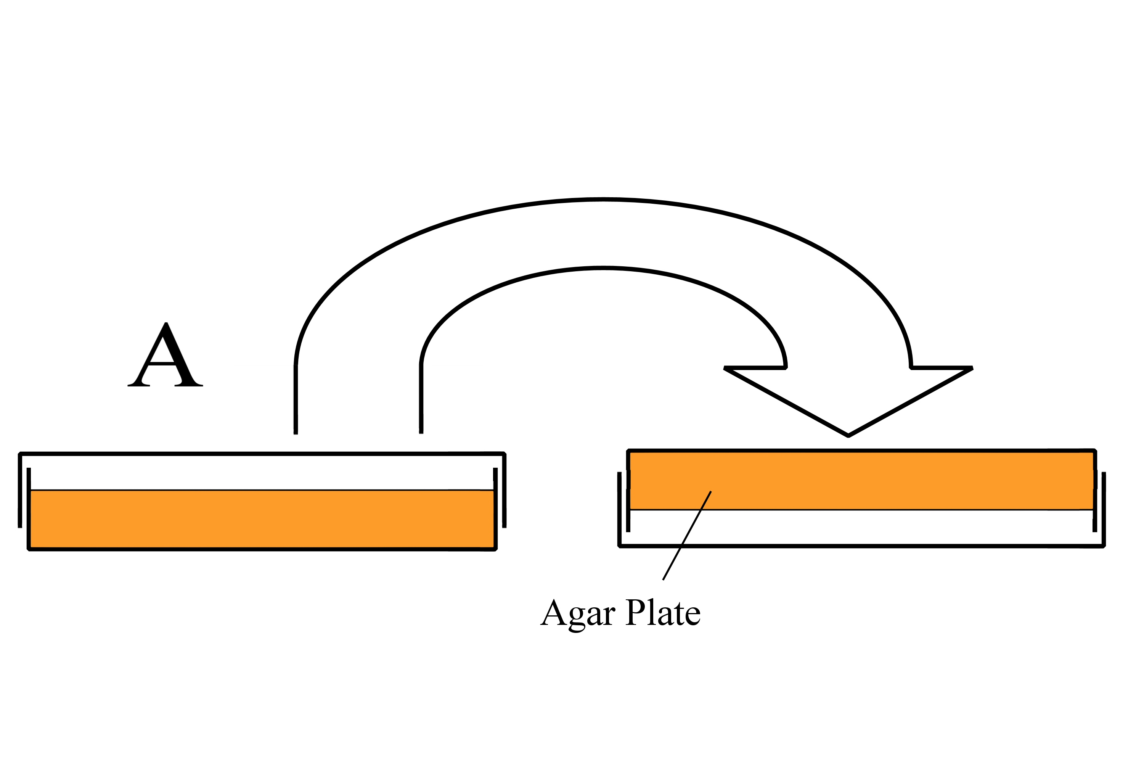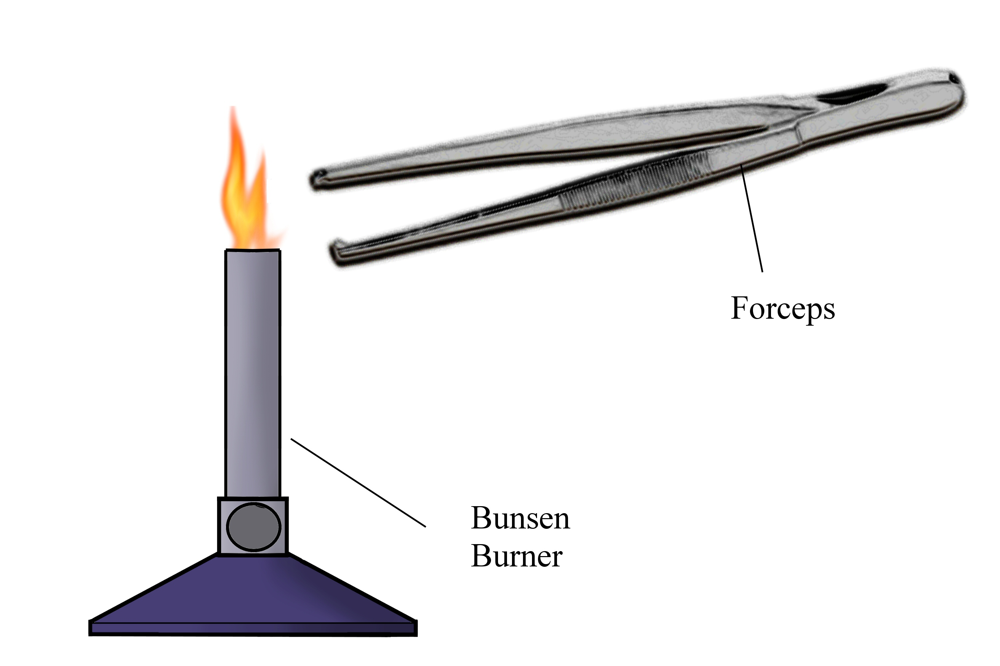
1.
2.
3.
5.

Always remember – Leave time to tidy up

This page can be printed in colour from the accompanying CD
Collect leaves. Tie back hair and wash hands.
Wash and disinfect the bench. Flame the cork borer to sterilise.
Place two agar plates on the bench. Label ‘A’ and ‘B’.
4.
Cut as many discs as possible from the leaf using the cork borer.
Place plate ‘A’ upside-down on the bench.

6.
Flame the forceps and allow it to cool.
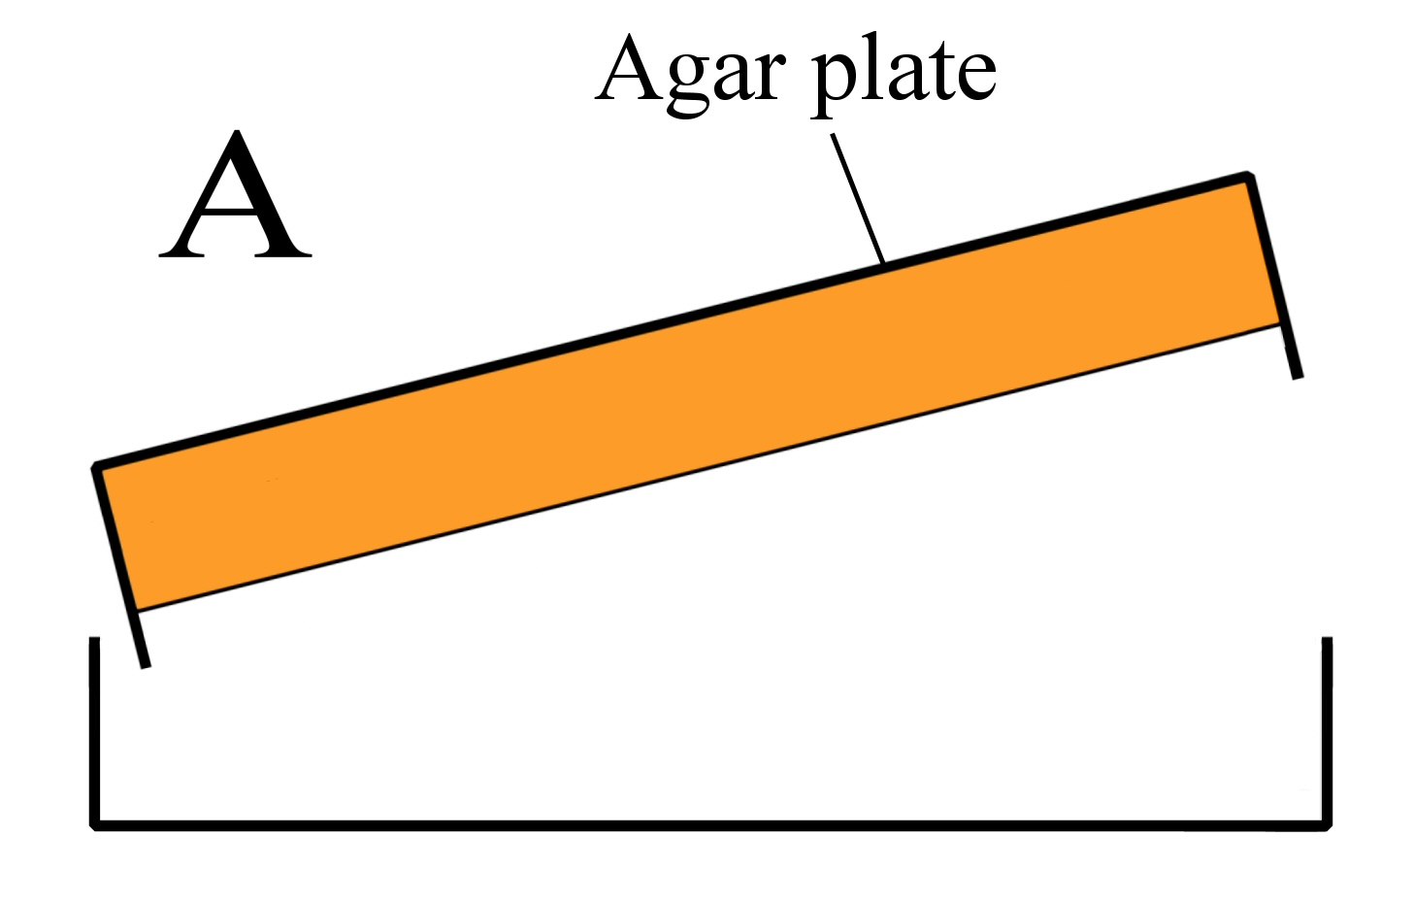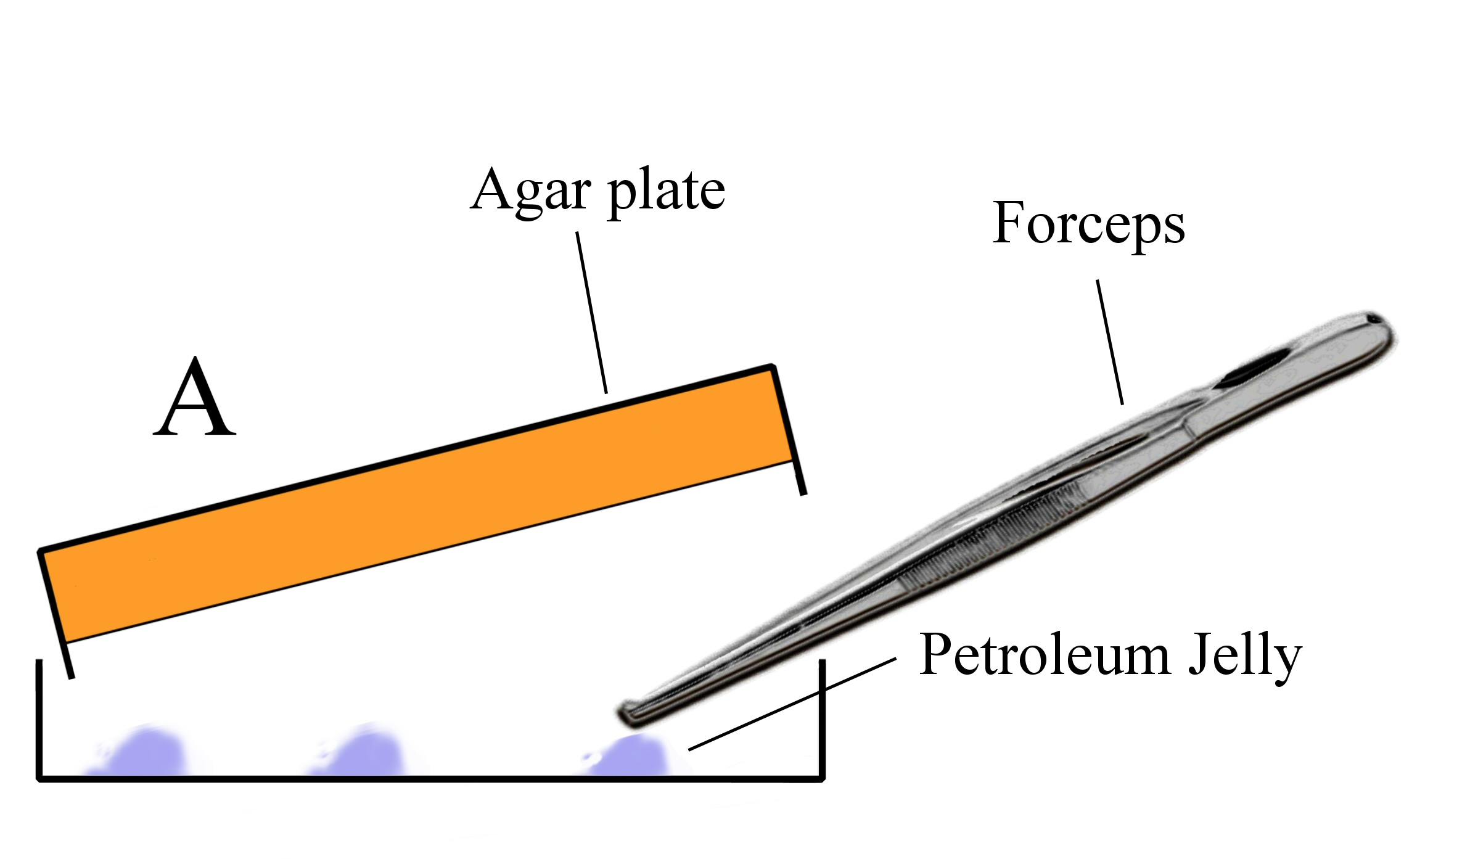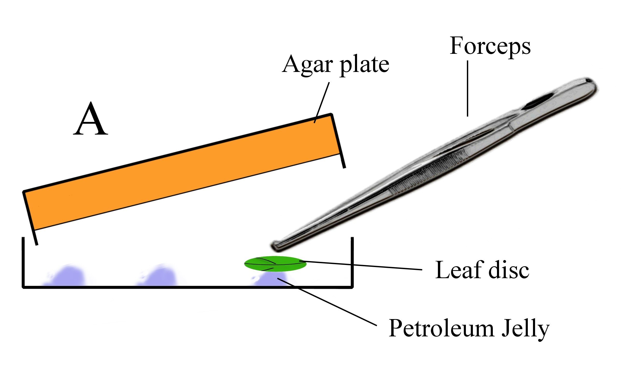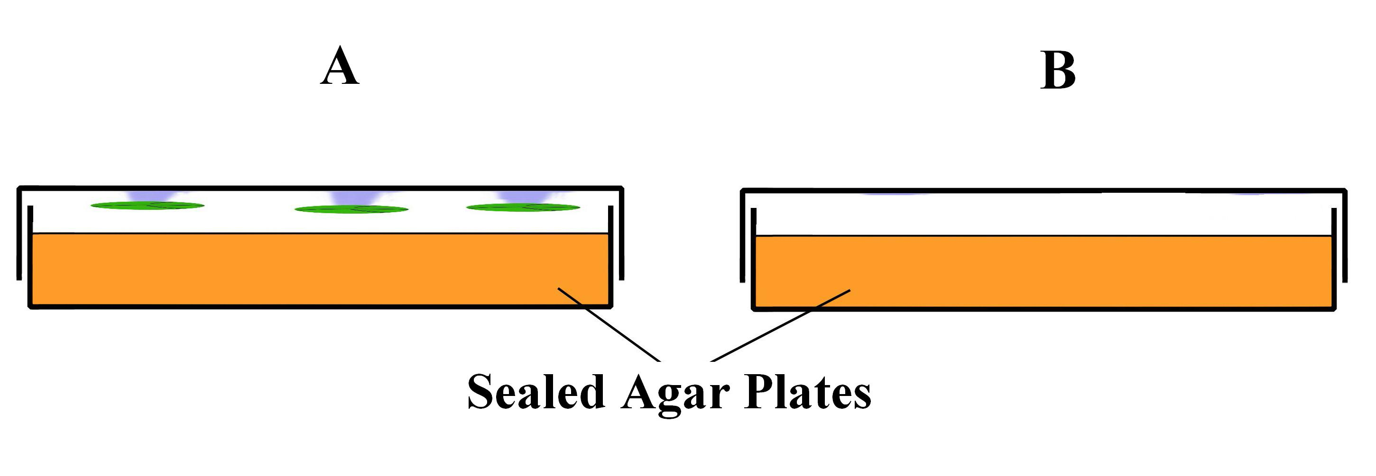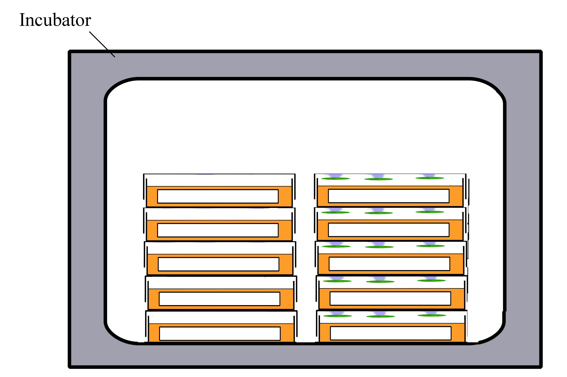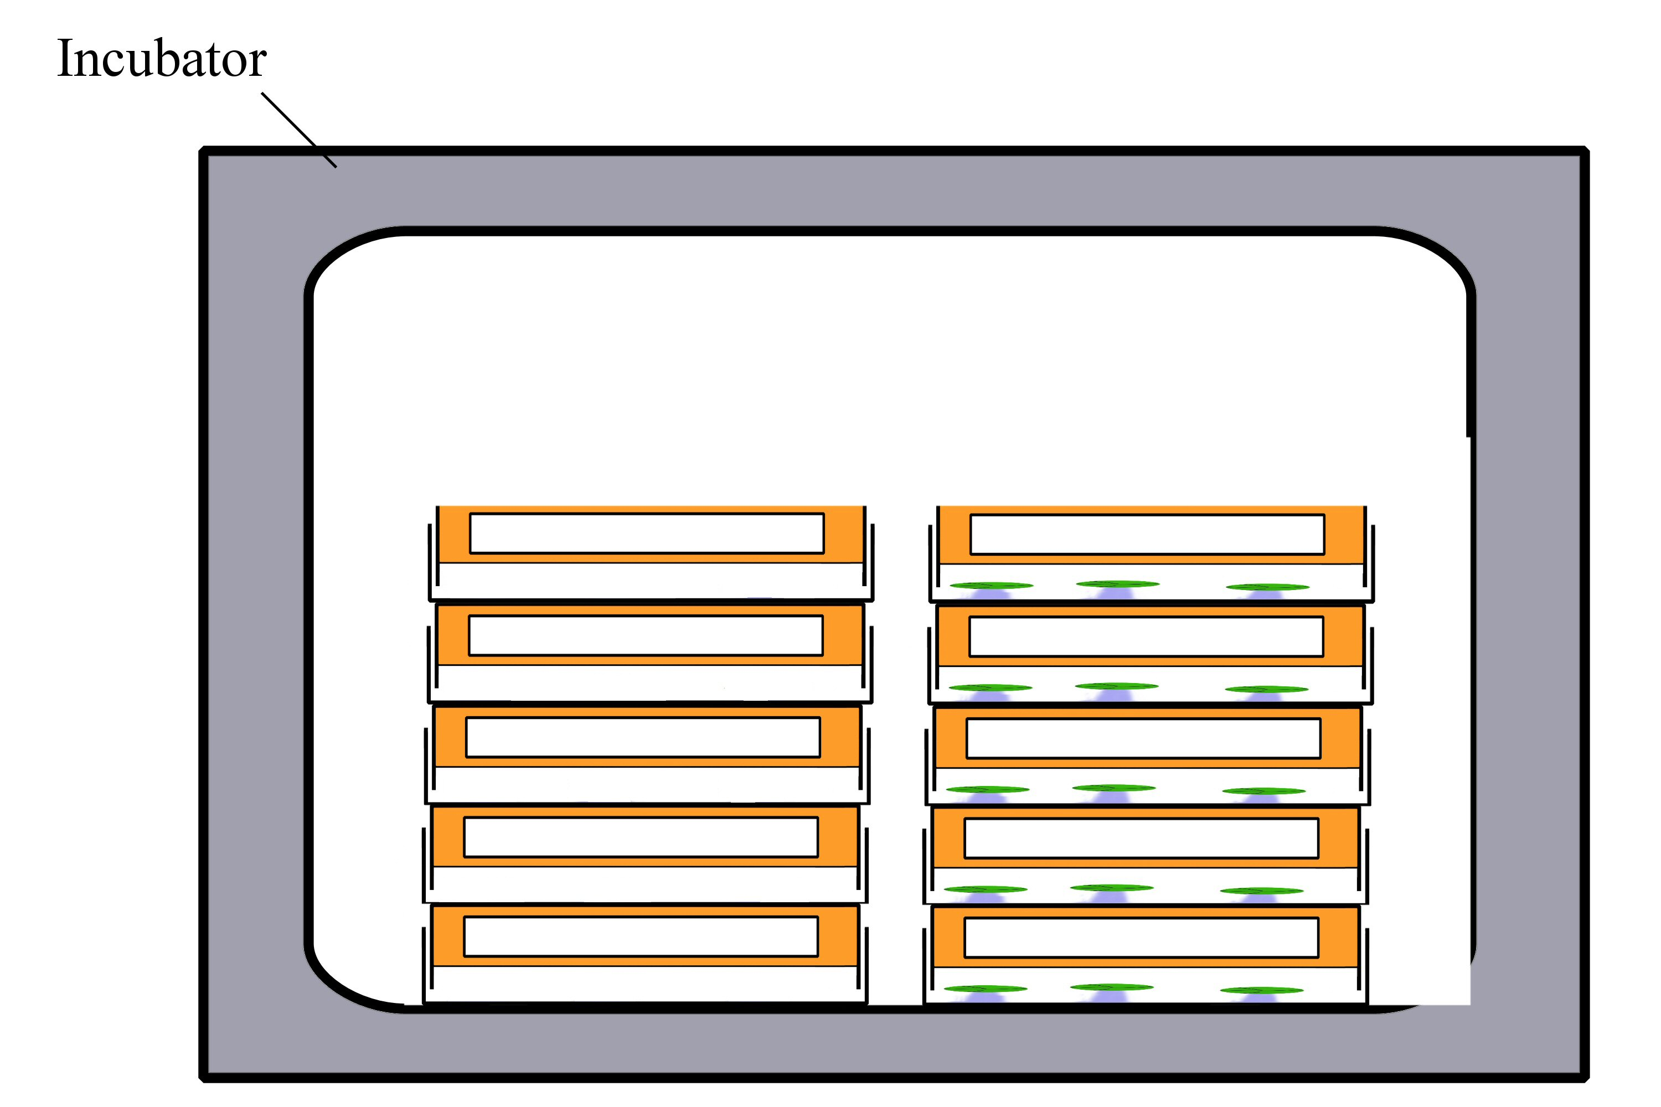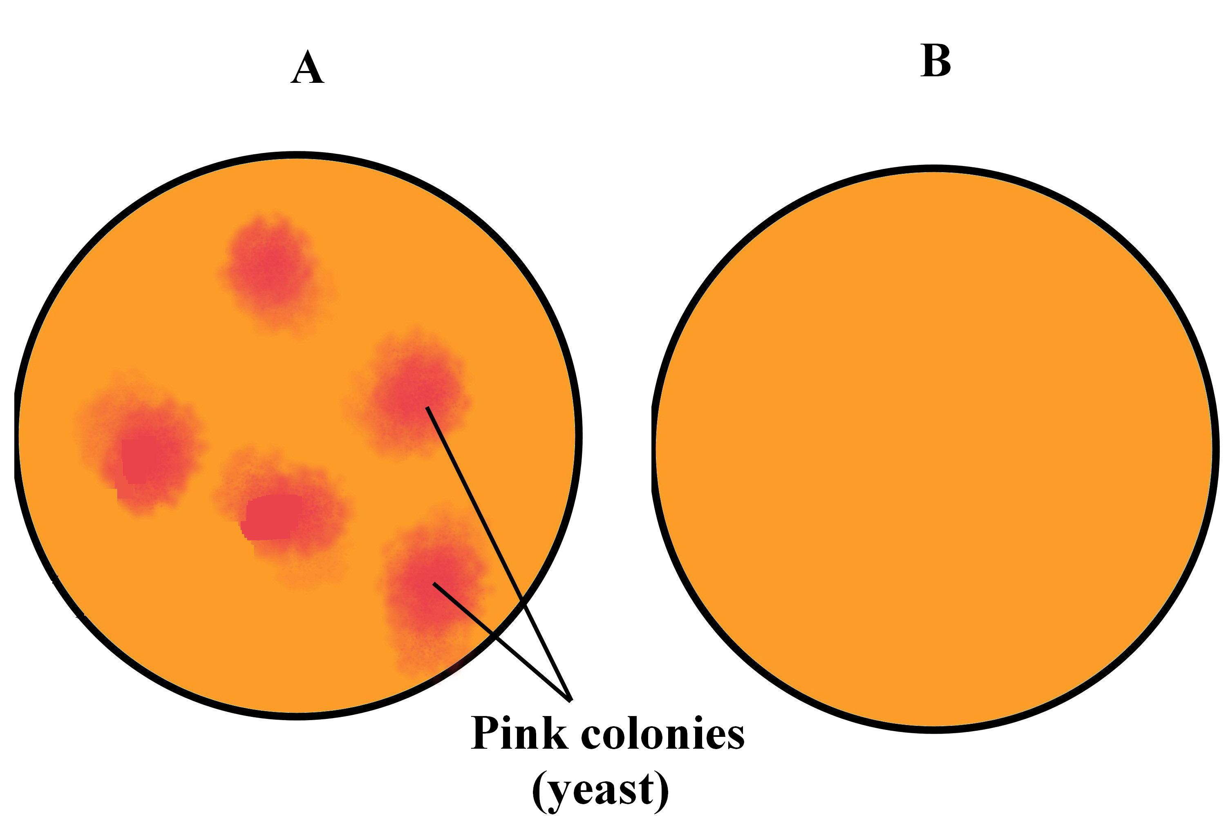
7.
8.
9.

Always remember – leave time to tidy up
This page can be printed in colour from the accompanying CD
Carefully raise the base of the petri dish just enough to work with.
Using the forceps, smear dots of petroleum jelly onto the inside of the lid.
Use the forceps to attach a leaf disc to each blob of jelly. Re-flame the forceps.
10.
Seal the plate with parafilm. Seal plate ‘B’ with parafilm. Label and date both plates.
11.
Store all petri dishes right way up in an incubator at 20^{O}C for 24 hours.

12.
Turn the petri dishes upside down and incubate at 20^{O}C for 3 days.
13.
Expected result.
Table of results
Agar plate | Appearance of colonies
A - Experiment
B - Control

This page can be printed in colour from the accompanying CD

Always remember – Leave time to tidy up

Always remember – leave time to tidy up
This page can be printed in colour from the accompanying CD

