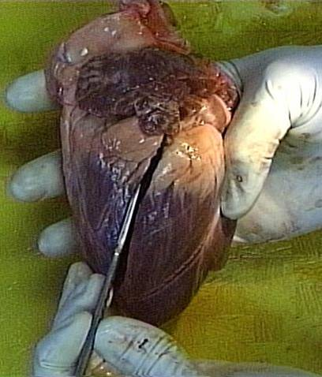
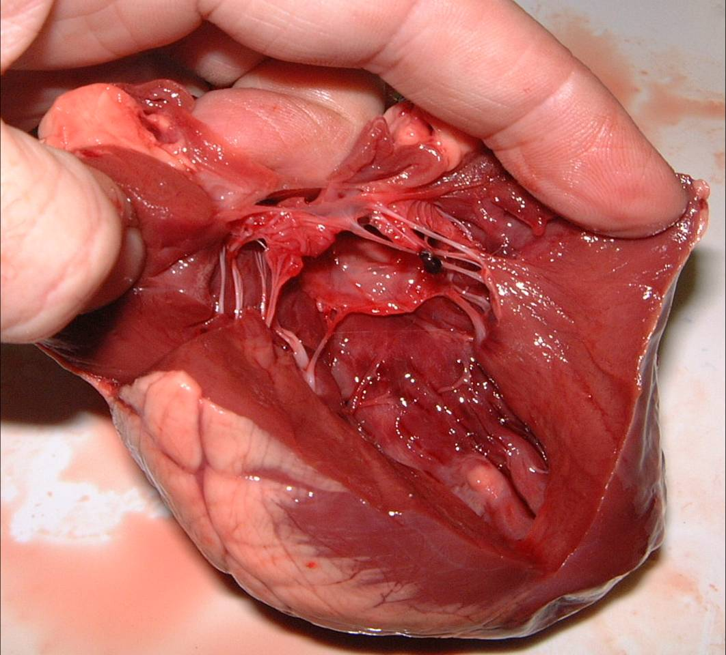
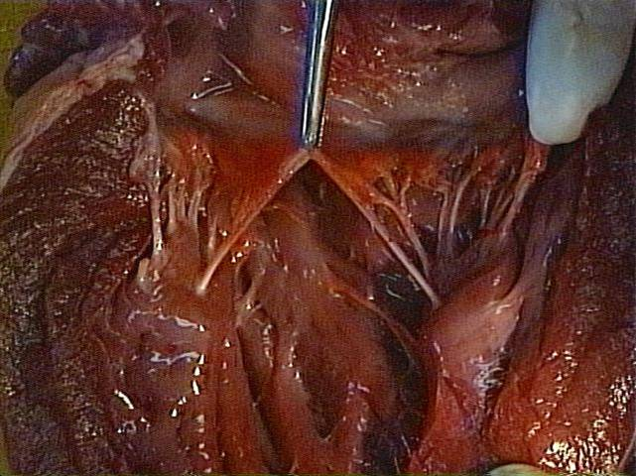
4.12 To dissect, display and identify an ox’s or sheep’s heart
4.
Make a shallow cut in the left ventricle and the left atrium.
Push open the chambers and examine the internal structure.

5.
Locate the bicuspid valve and note the chordae tendinae – . anchoring the cusps of the valve

6.

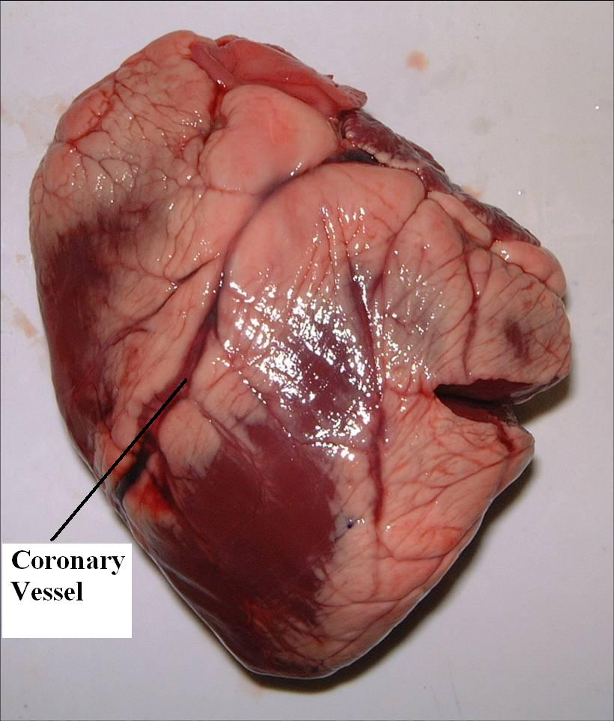
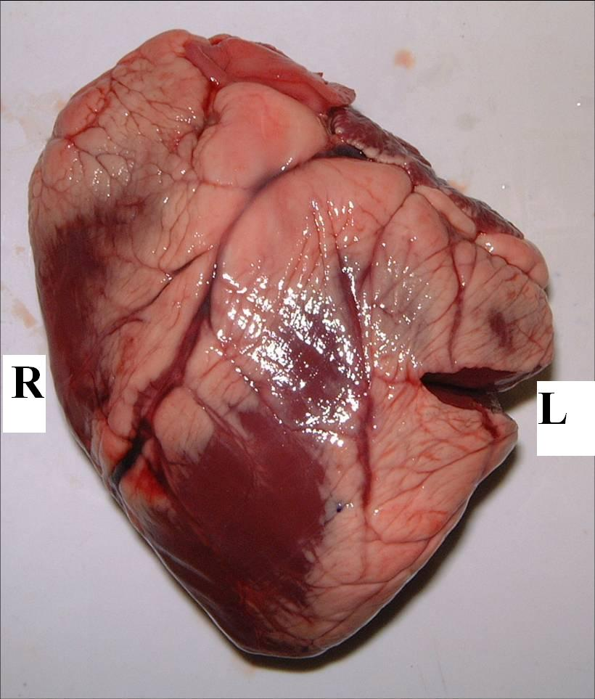
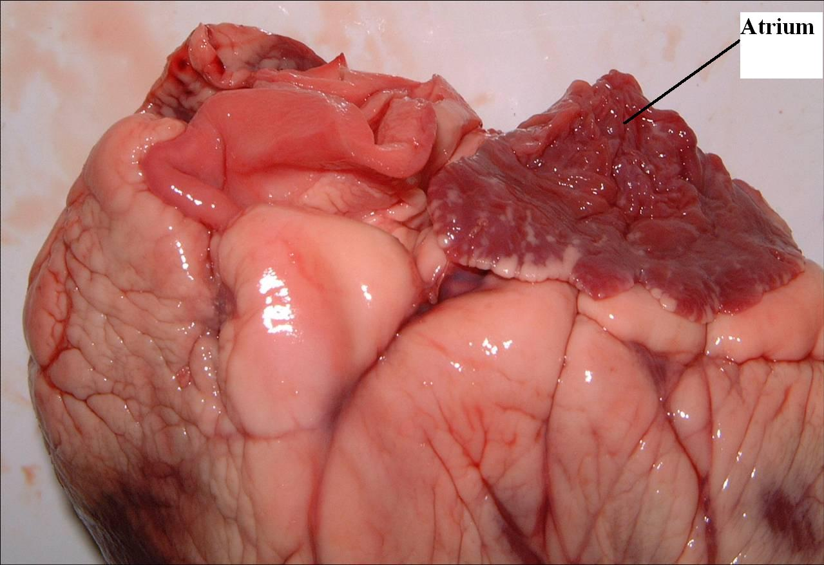
1.
Feel / pinch the left and right side of the heart to distinguish between them.
2.
Identify the blood vessels: aorta, pulmonary artery, vena cava and pulmonary vein.
3.

Identify the front of the heart by locating the position of the coronary artery. Place this side facing up on the dissecting board.

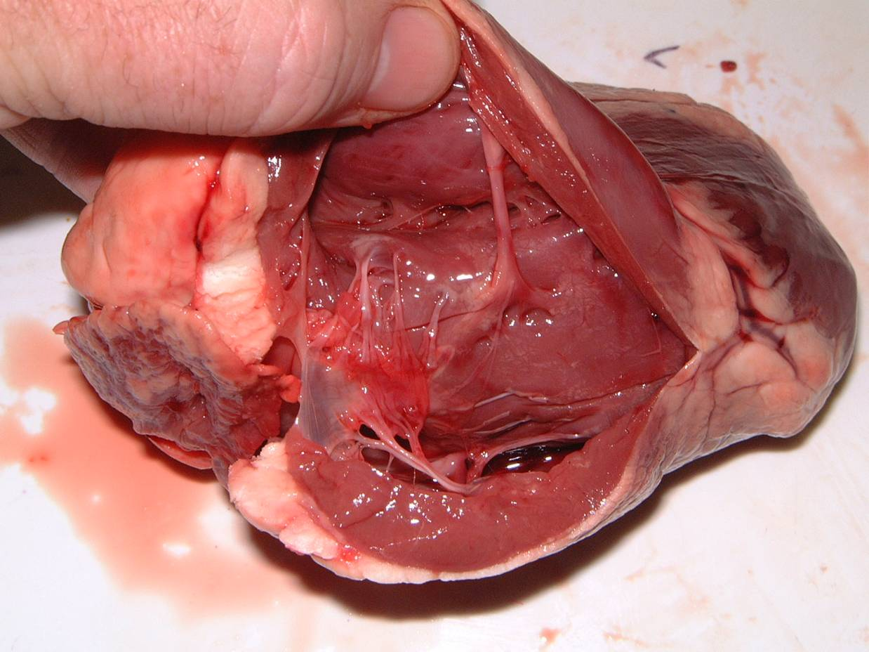
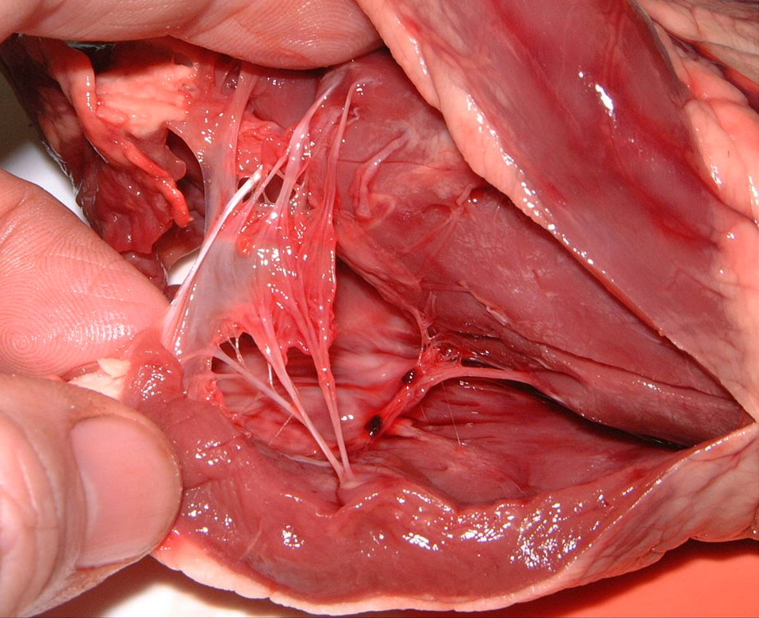
9.
Observe

Note the difference between the walls of the left ventricle and the right ventricle.
7.
Repeat the previous steps for the right side of the heart.
8.
Locate the tricuspid valve and note the chordae tendinae anchoring the cusps.

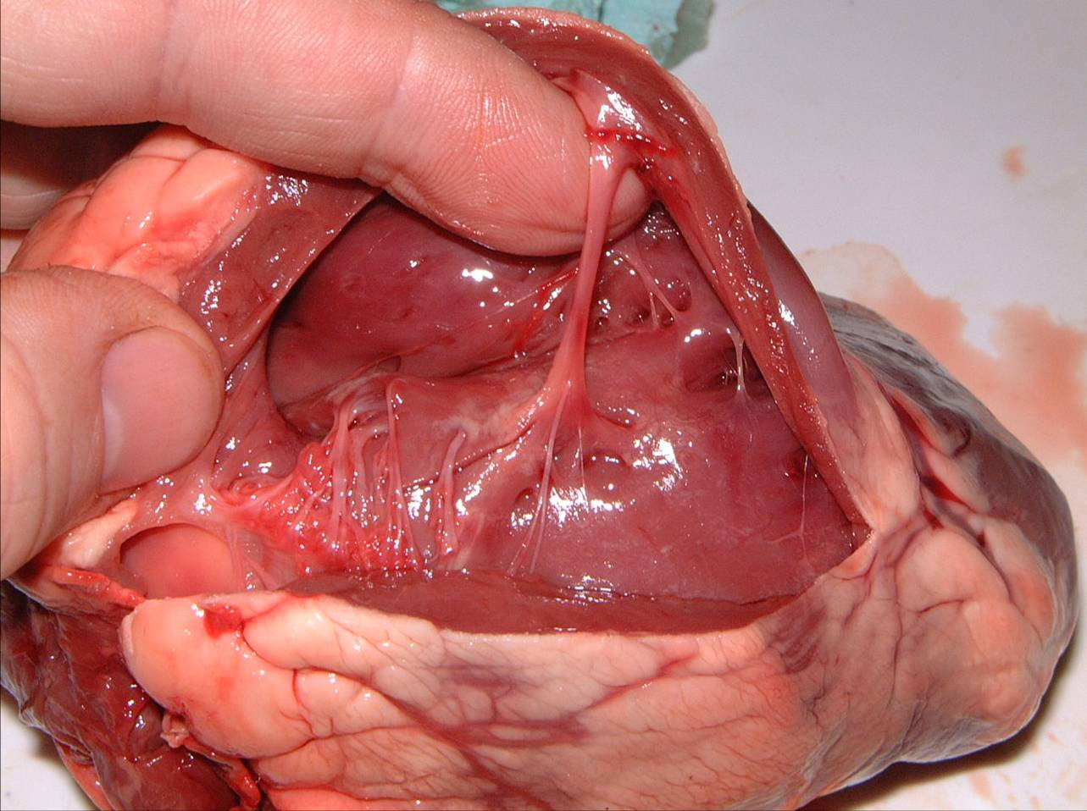
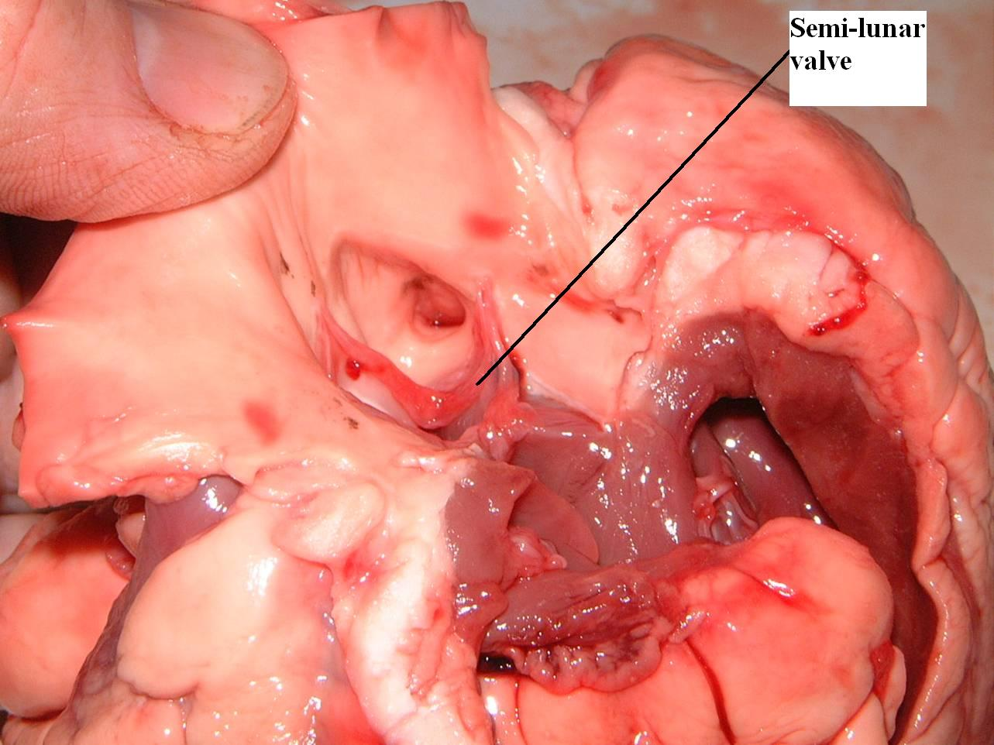
Insert a forceps under the moderator band in the right ventricle

11.
Identify the opening at the base of the aorta, above the semi-lunar valves, leading to the coronary arteries
12.
10
Observe

Locate the septum separating the left from the right side of the heart.

14
Flag label each of the structures that you have identified.
Septum
13

To highlight the
coronary arteries

Using a dropper, pump air into the opening at the base of the aorta

Observations

Chamber | Size: small/large | Wall: thin/thick
Left atrium
Right atrium
Left ventricle
Right ventricle

Valve | Shape/Number of Flaps
Bicuspid
Tricuspid
Semi-lunar

