4.13 (b) To investigate the effect of exercise on the pulse rate of a human
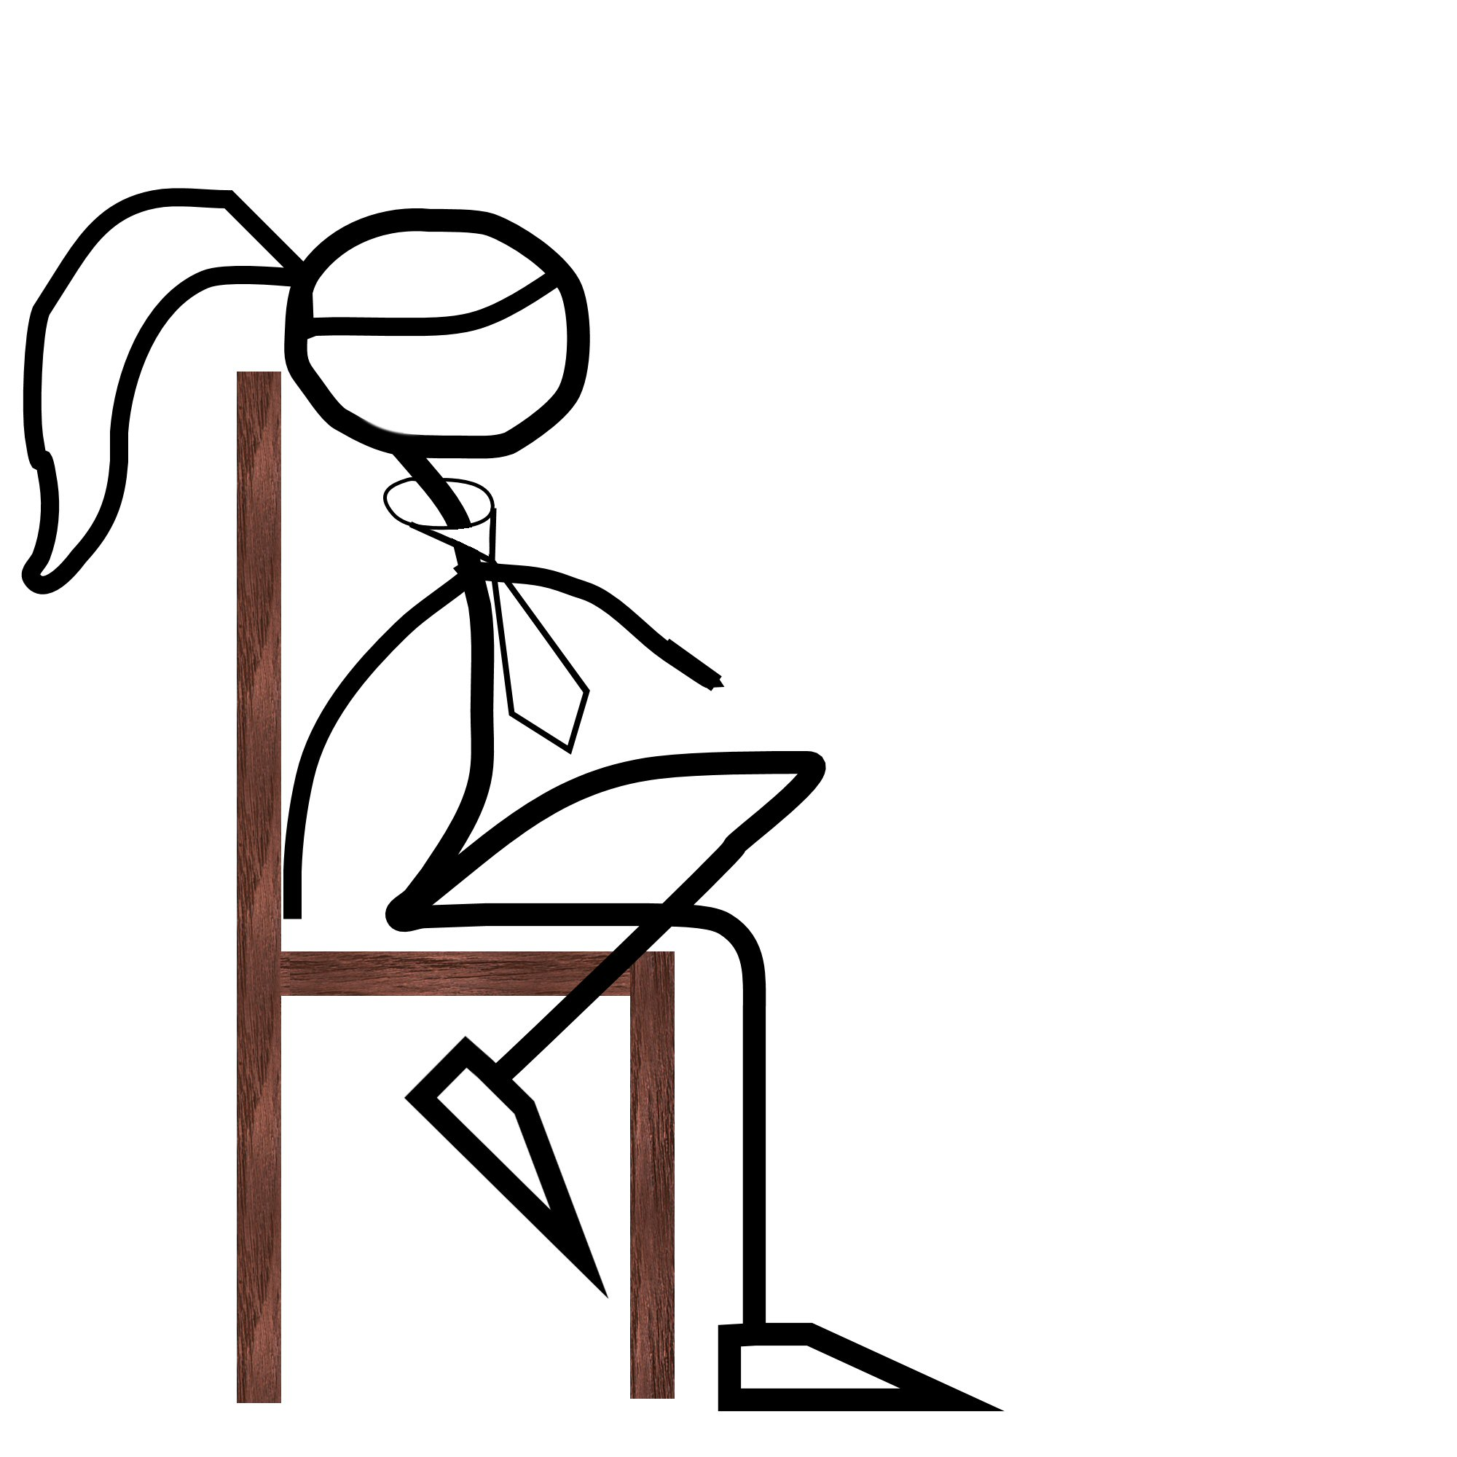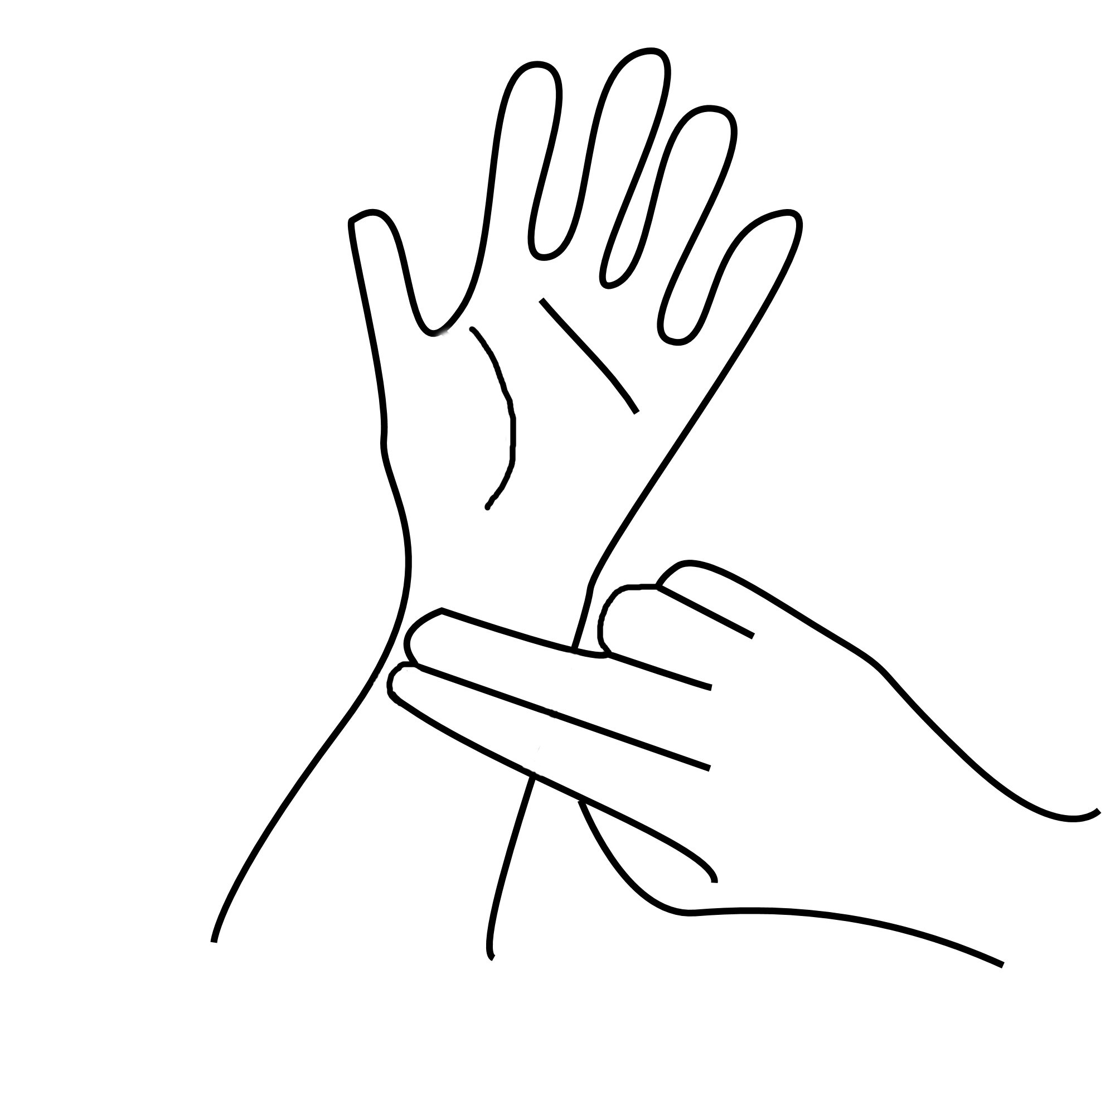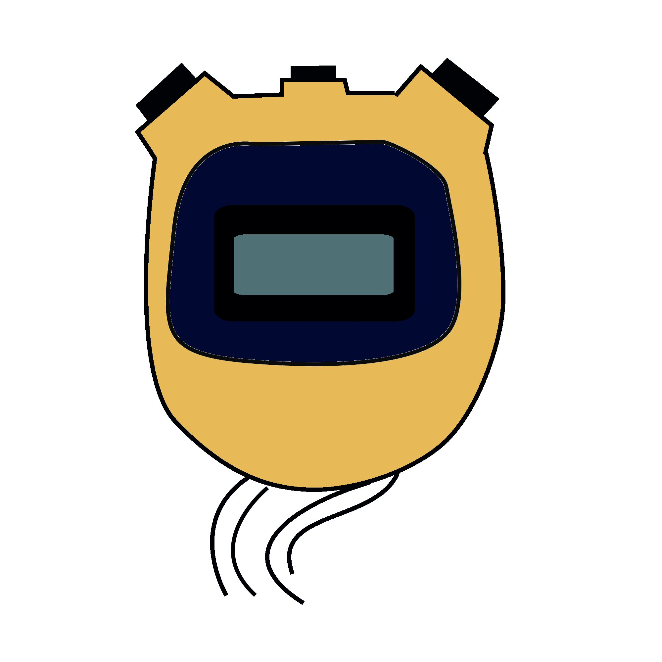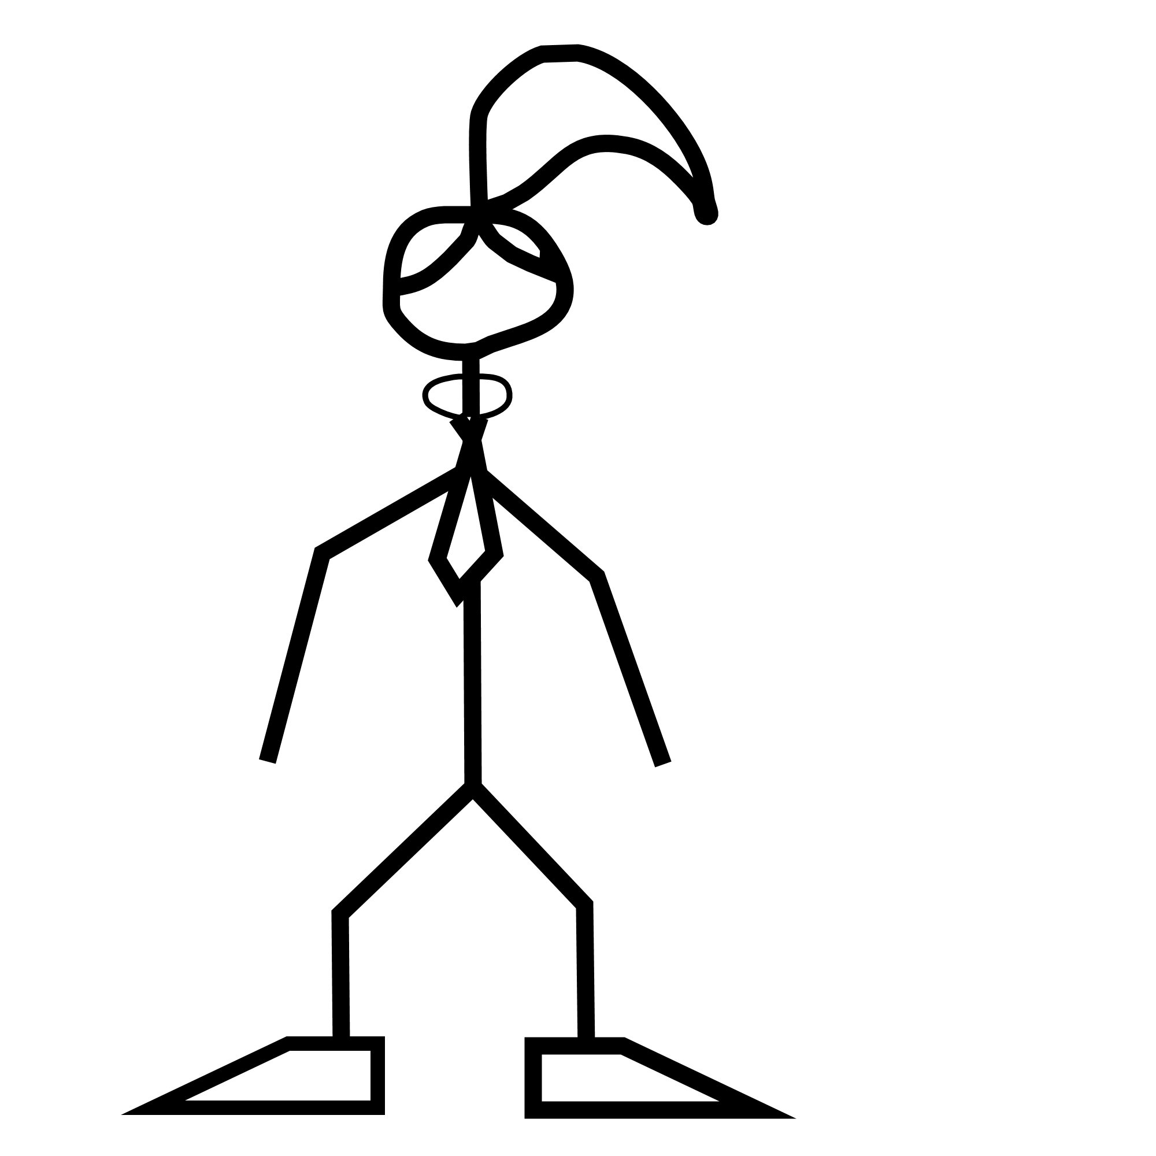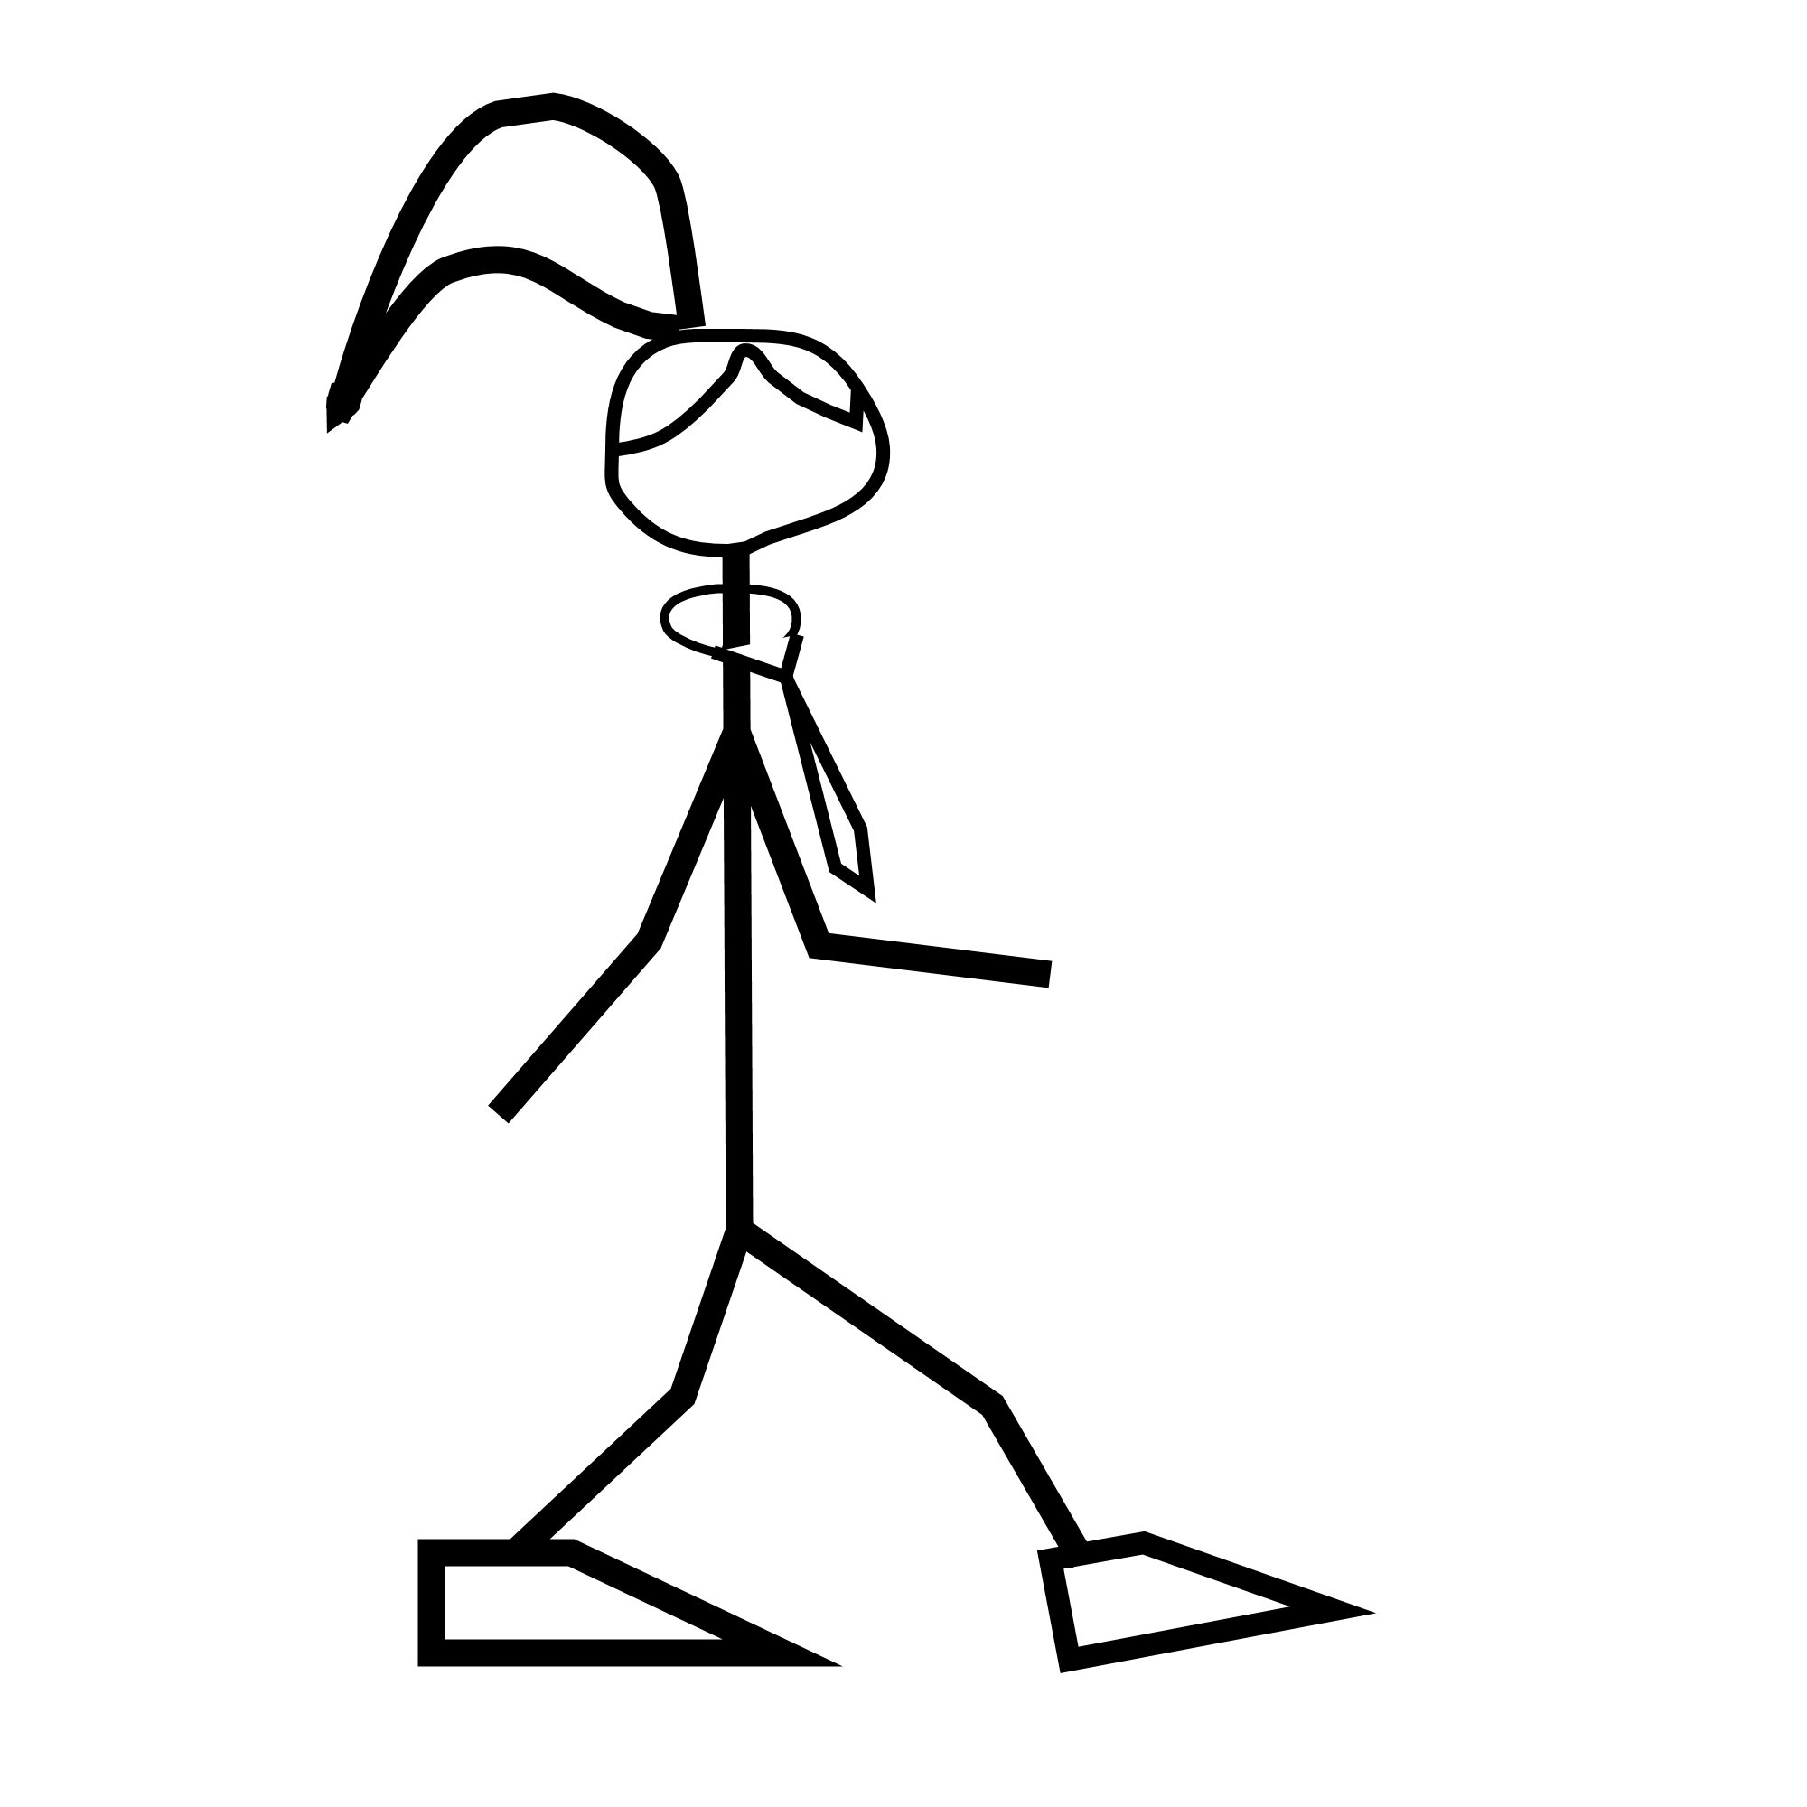
1.
2.
3.
5.

Always remember – Leave time to tidy up
This page can be printed in colour from the accompanying CD
Sit down on a chair and take 5 minutes to settle.
Locate the pulse on either the wrist or neck.
Count the number of pulses per minute and record.
4.
Repeat steps 2 and 3 twice and calculate an average.
Stand up.
Measure the pulse rate and record.

6.
Walk gently for 5 minutes.
Measure the pulse rate and record.

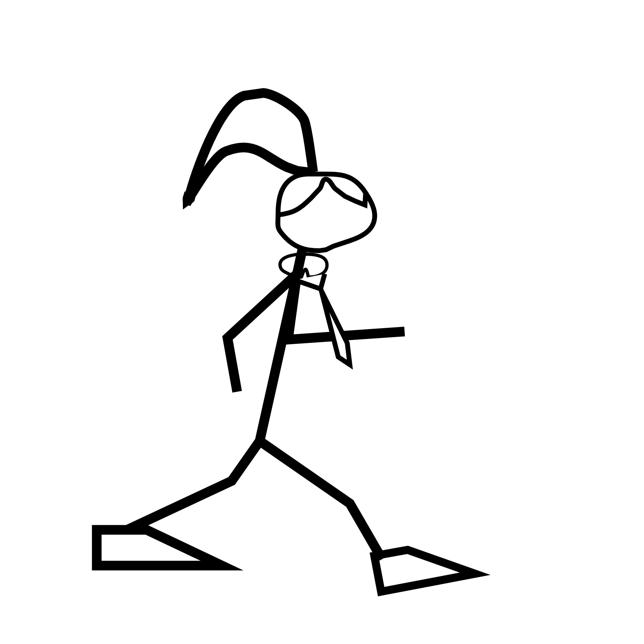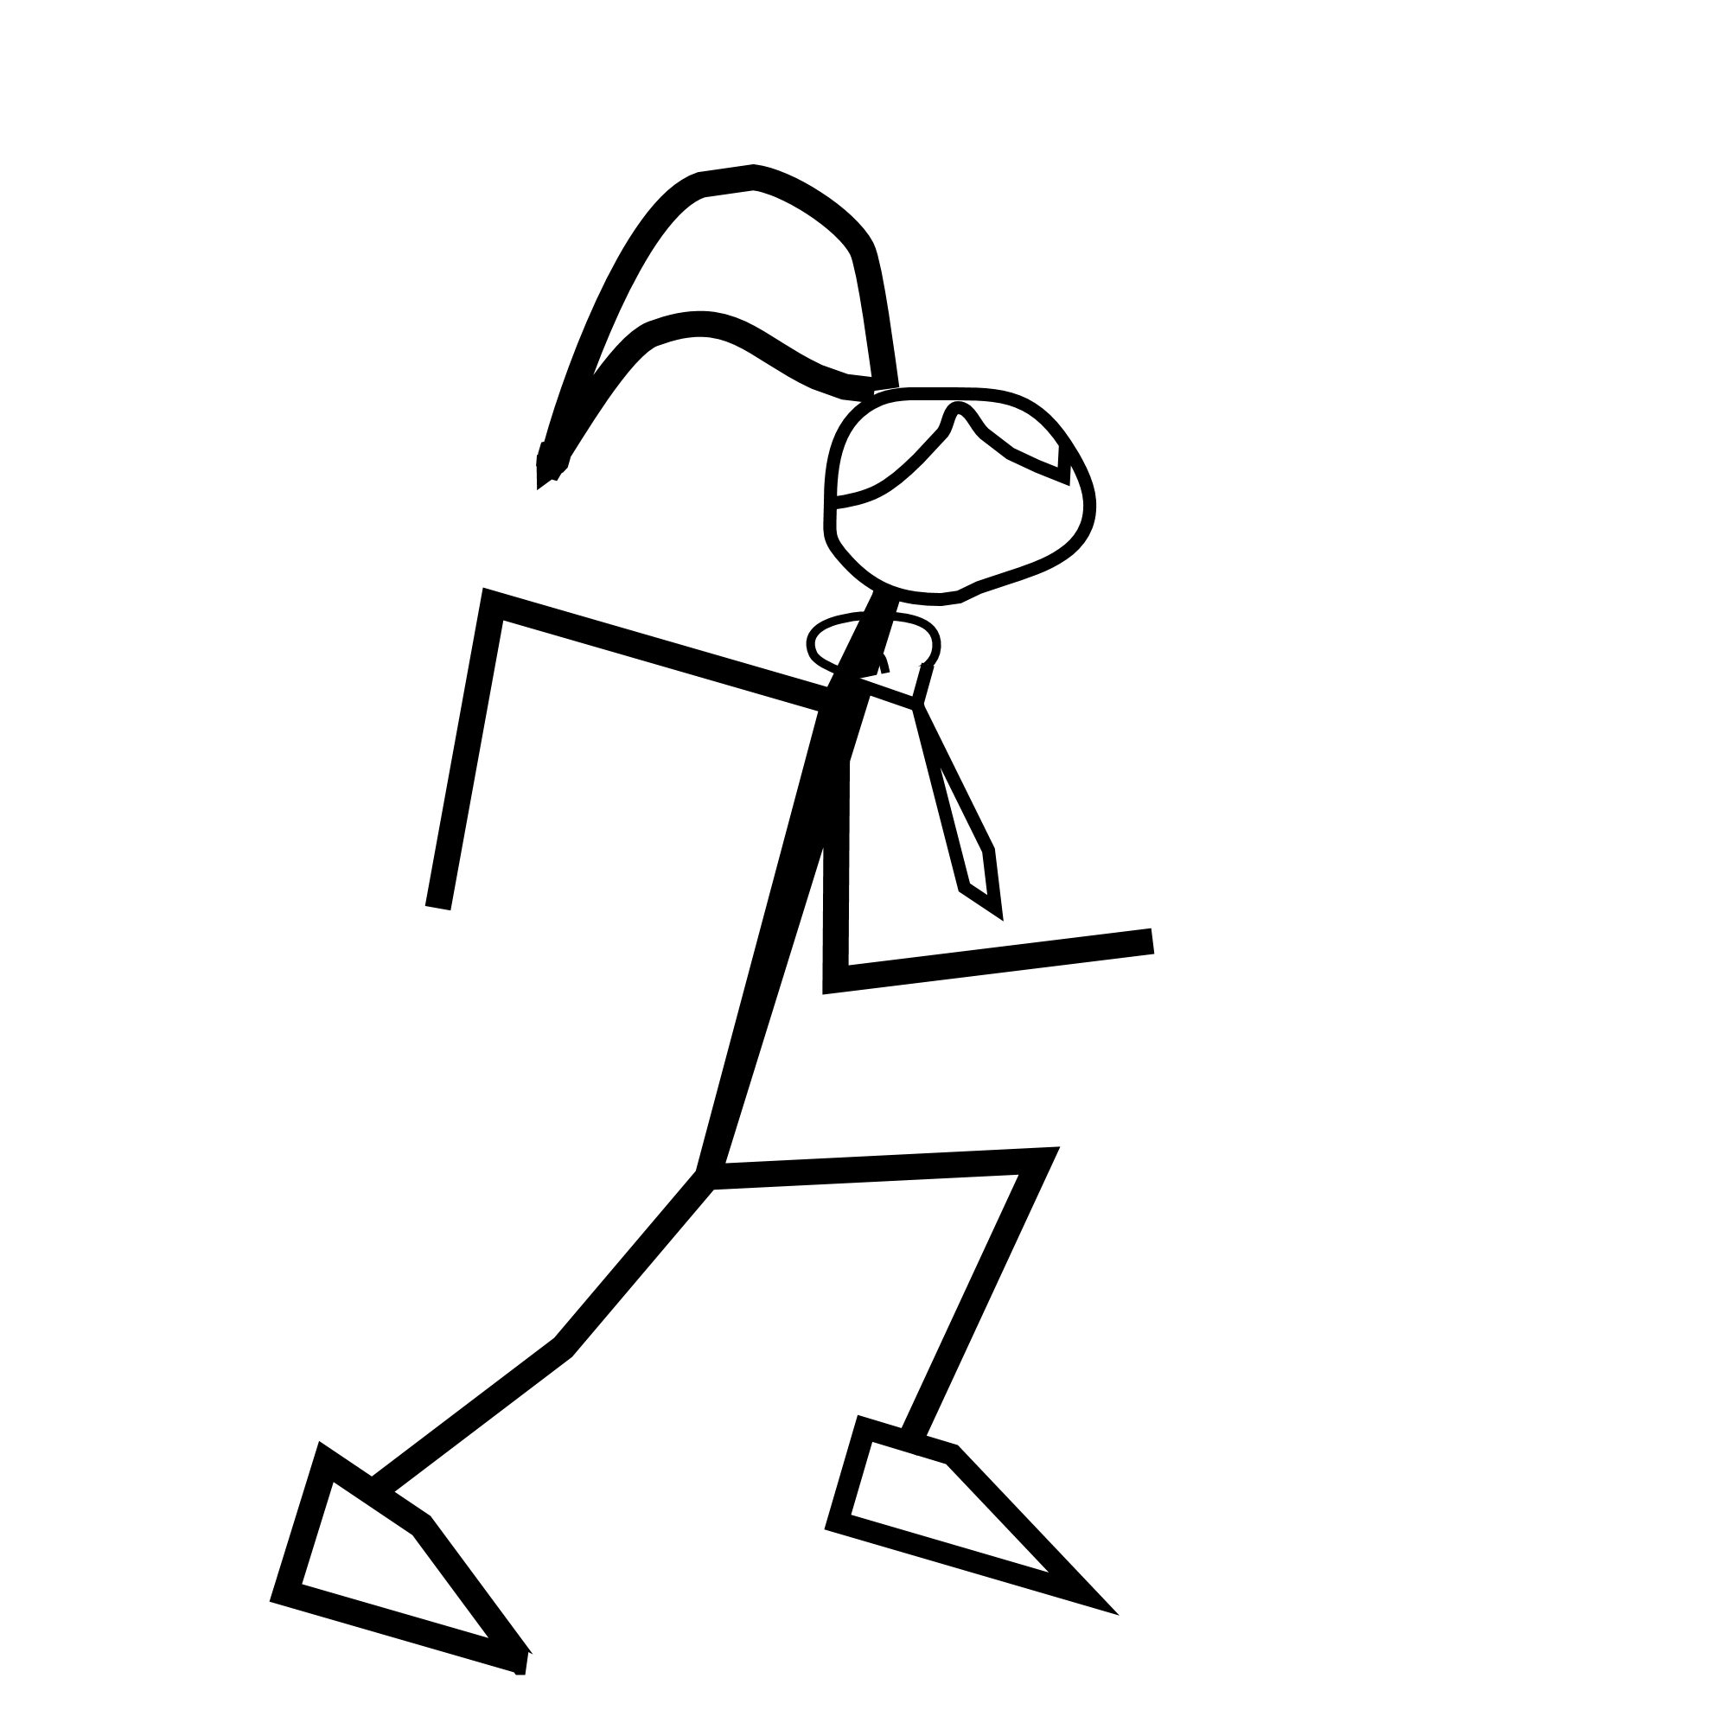
8.
Run for 5 minutes.
Measure the pulse rate and record.

9.
Continue to measure the pulse rate every minute until it has returned to normal.
7.
Walk briskly for 5 minutes.
Measure the pulse rate and record.

10.
Expected result

Sit Gentle walk Brisk walk Run
Pulse rate
(bpm)

Before exercise | Trial 1 | Trial 2 | Trial 3 | Total | Average
Resting pulse rate (bpm)

Activity | Standing | Gentle walking | Brisk walking | Running
Pulse rate (bpm)

Always remember – Leave time to tidy up
This page can be printed in colour from the accompanying CD

Always remember – Leave time to tidy up
This page can be printed in colour from the accompanying CD

