4.14 To investigate the effect of IAA growth regulator on plant tissue
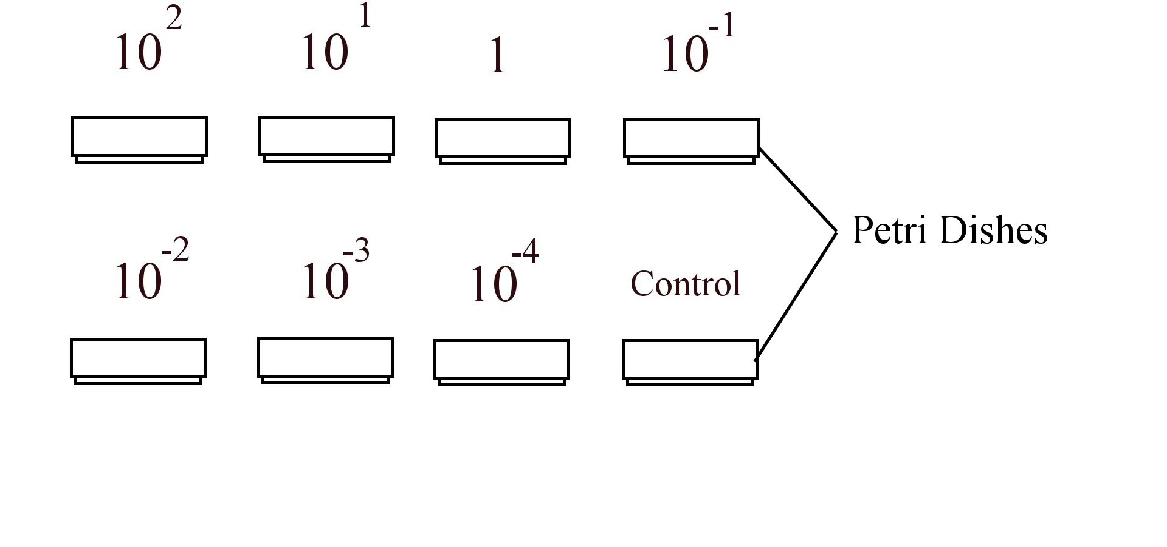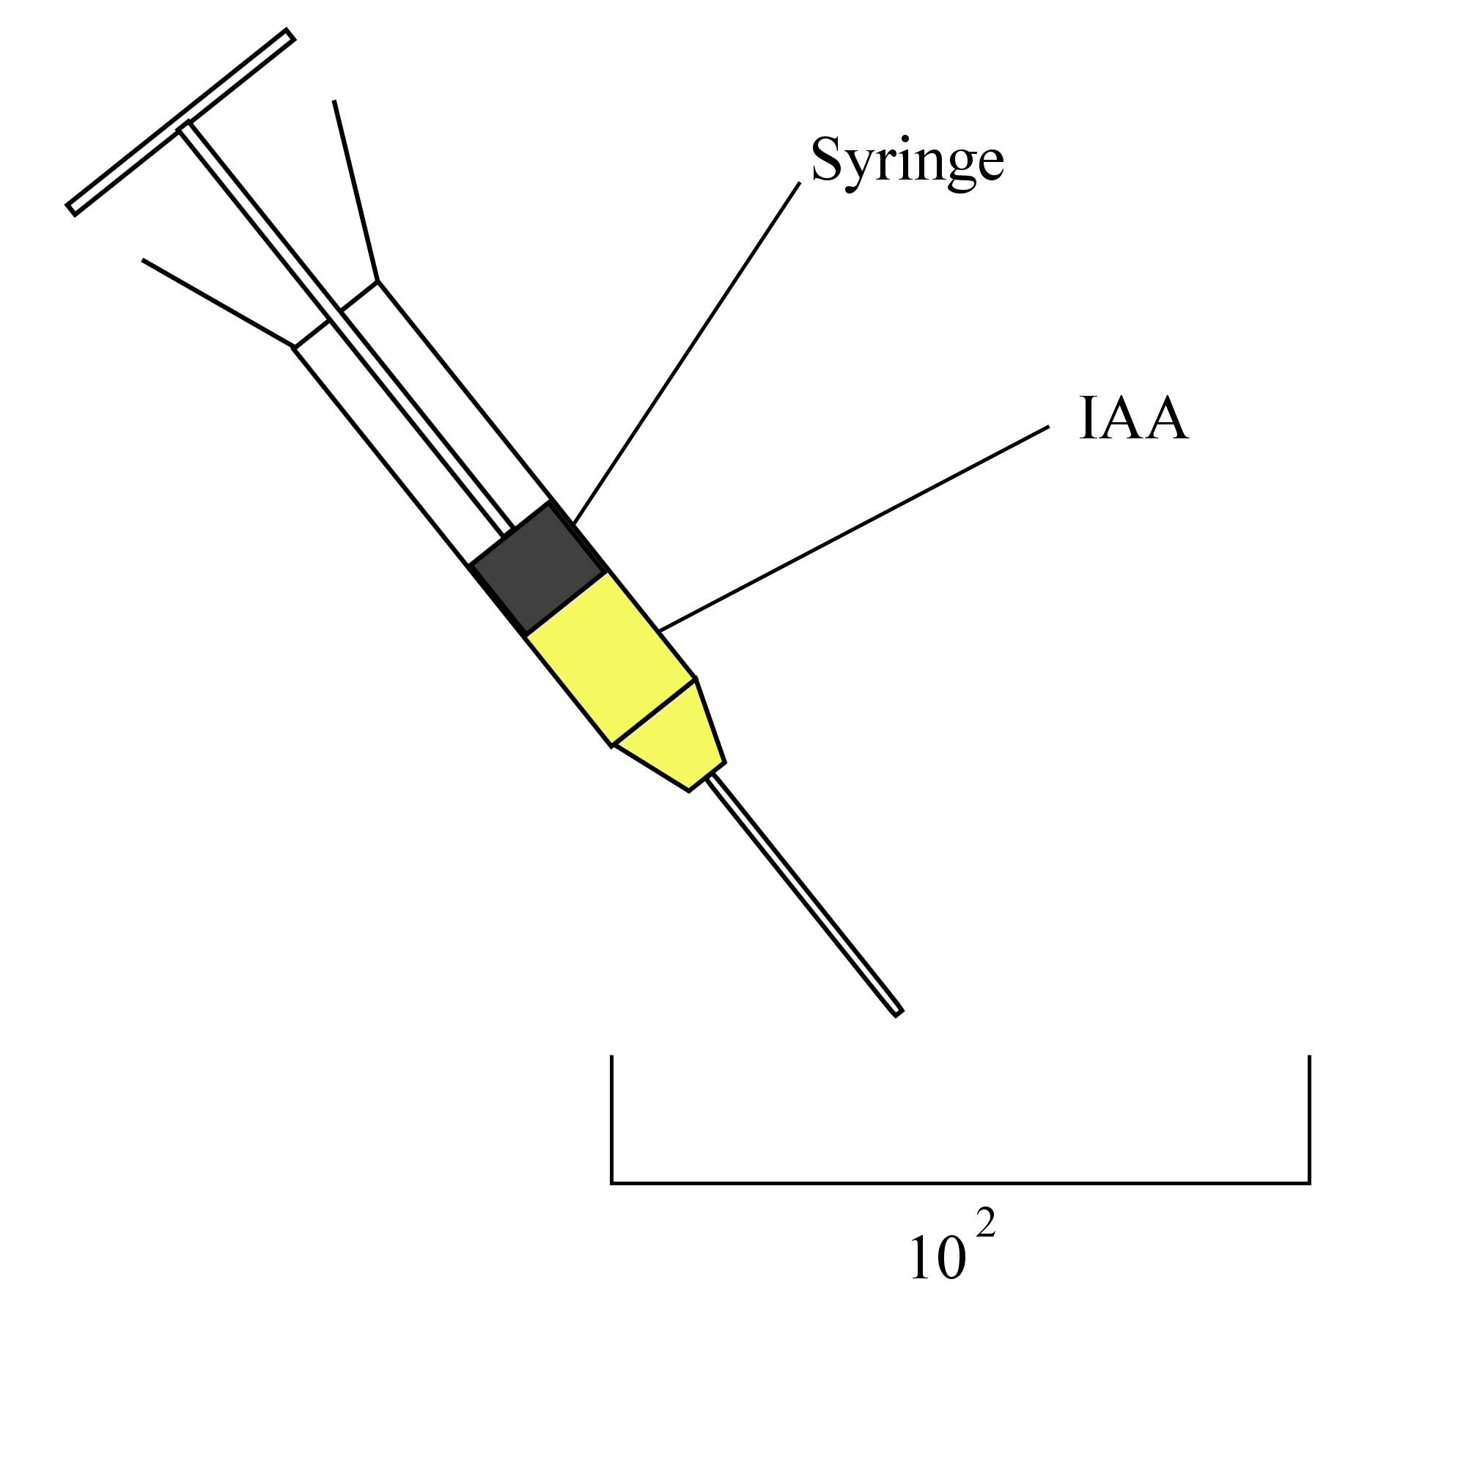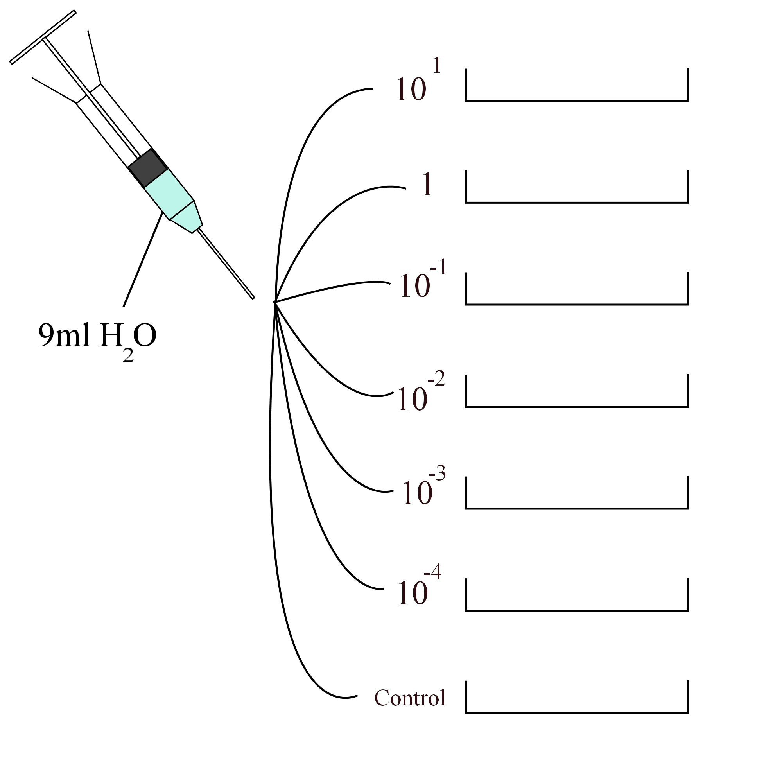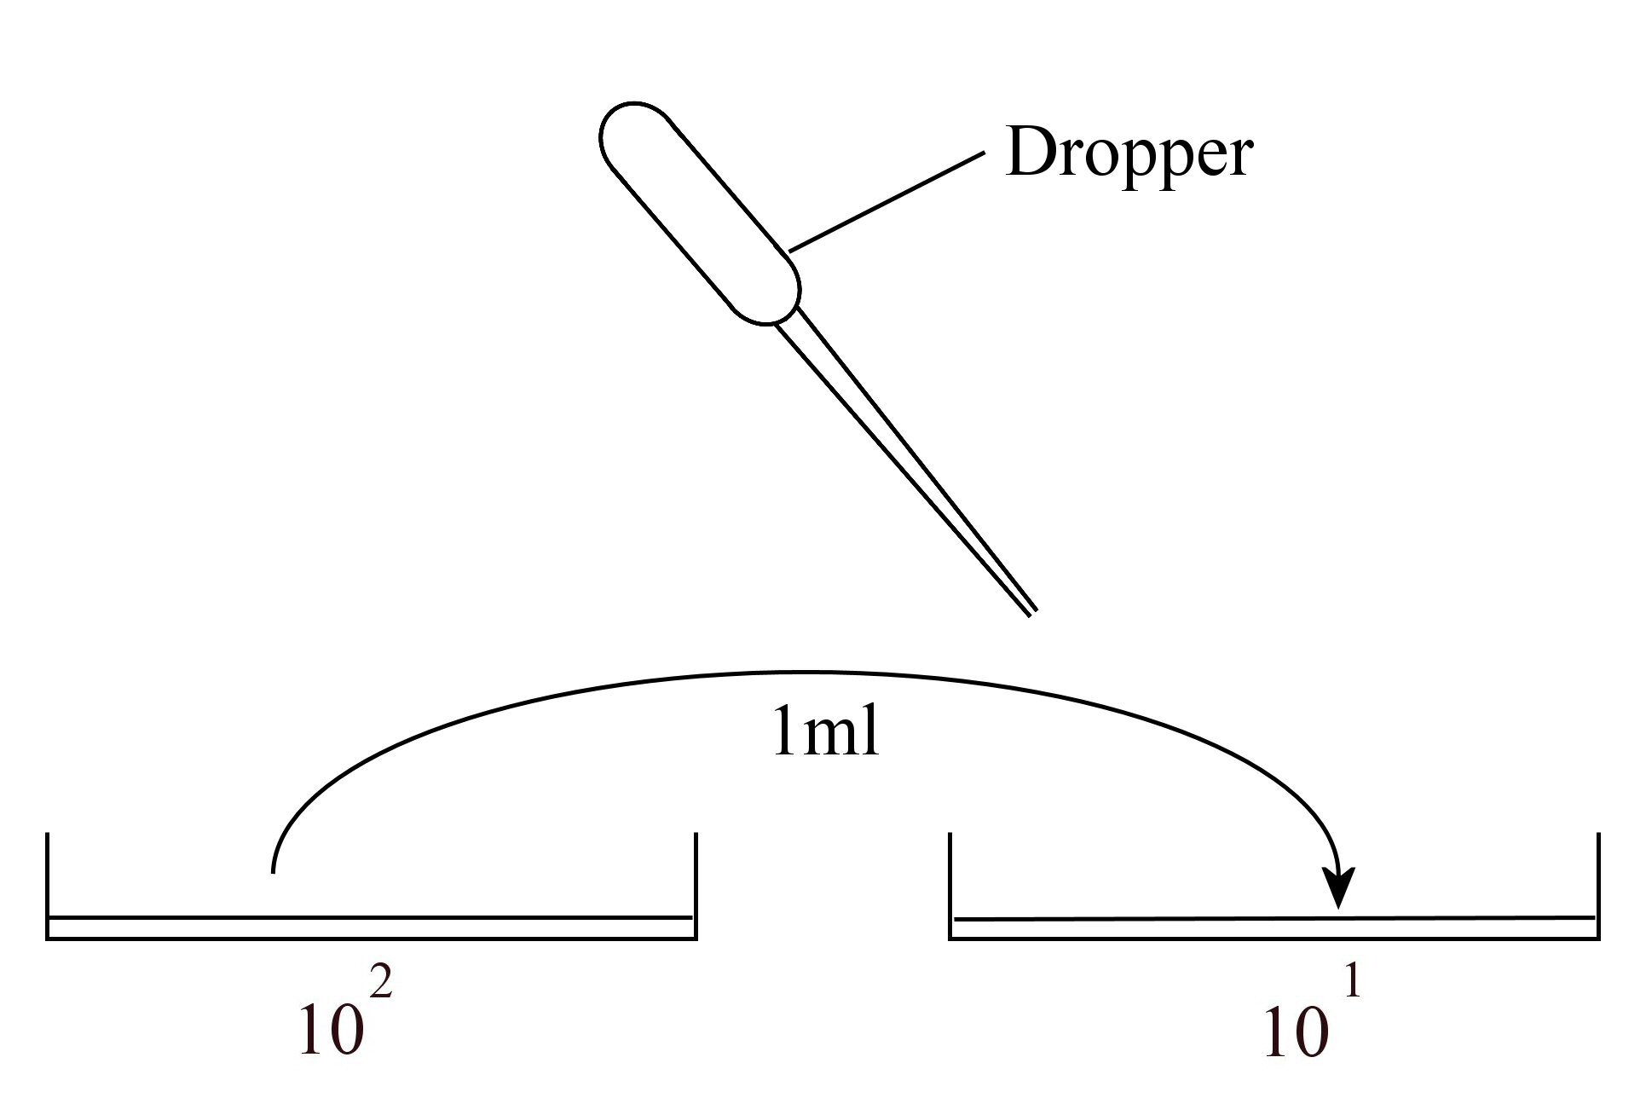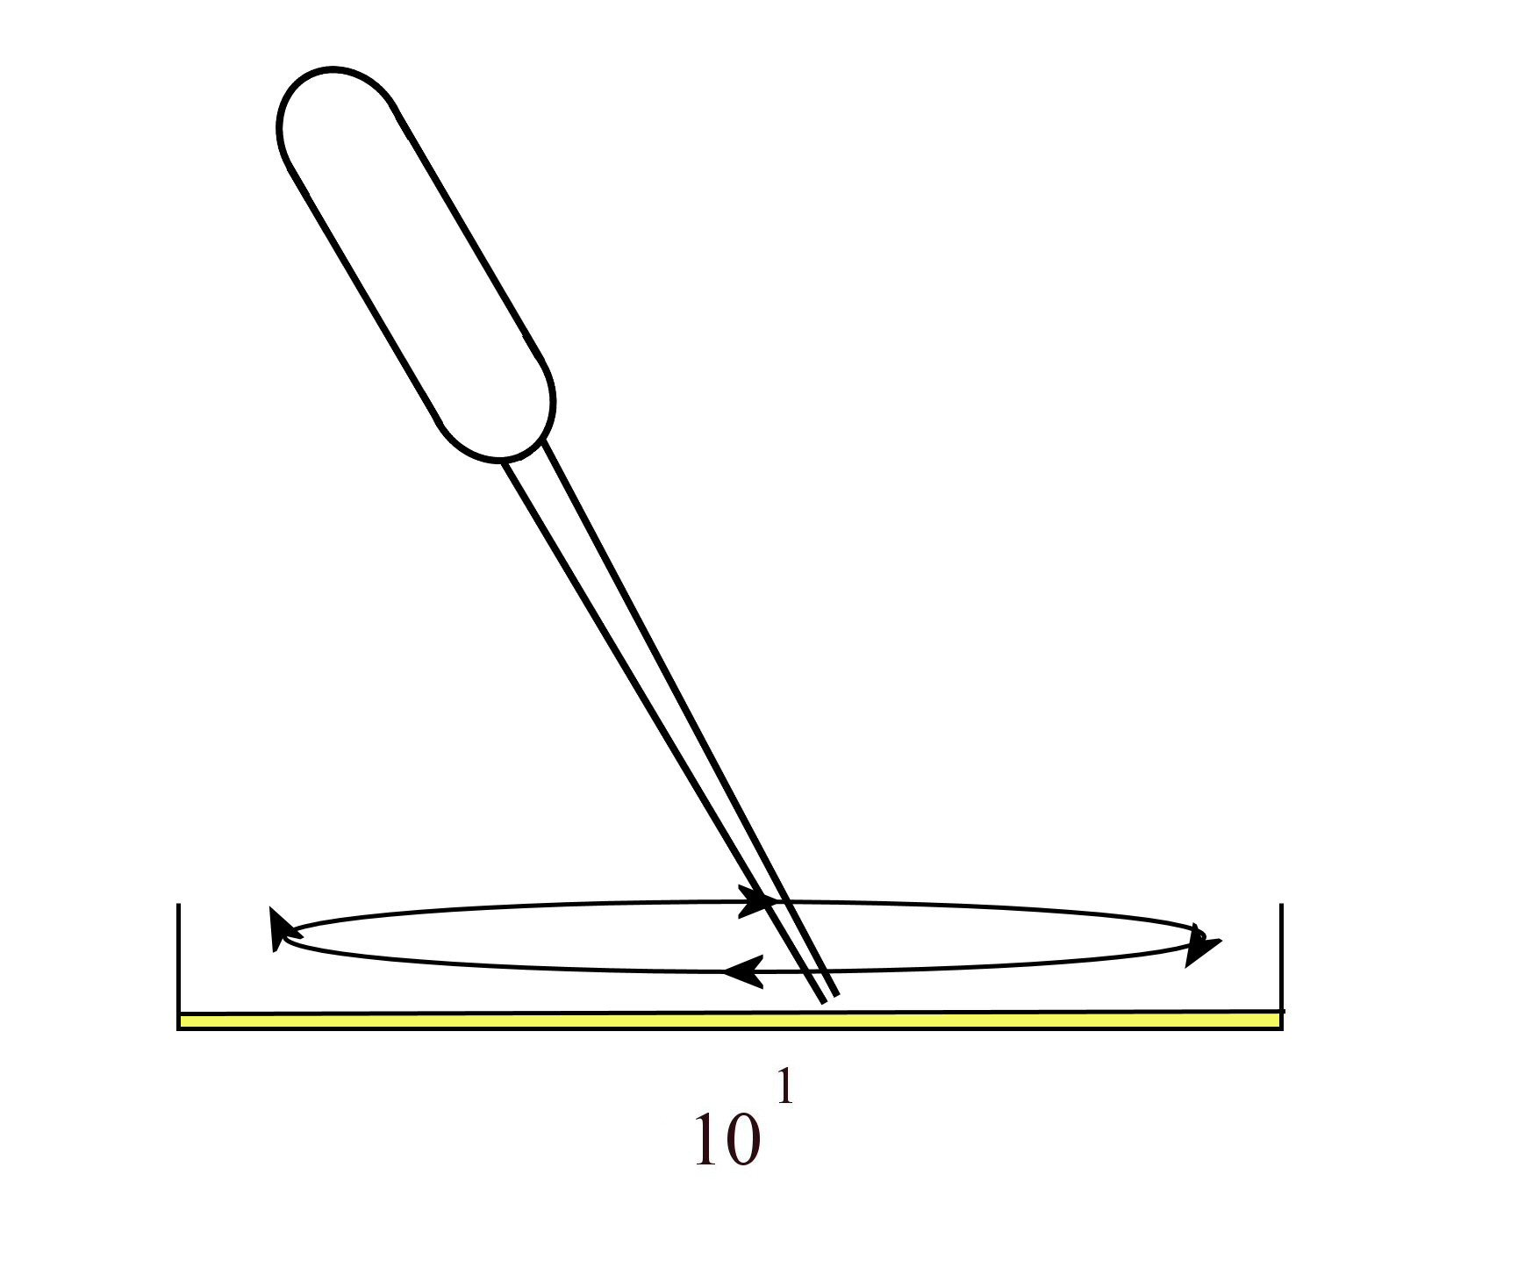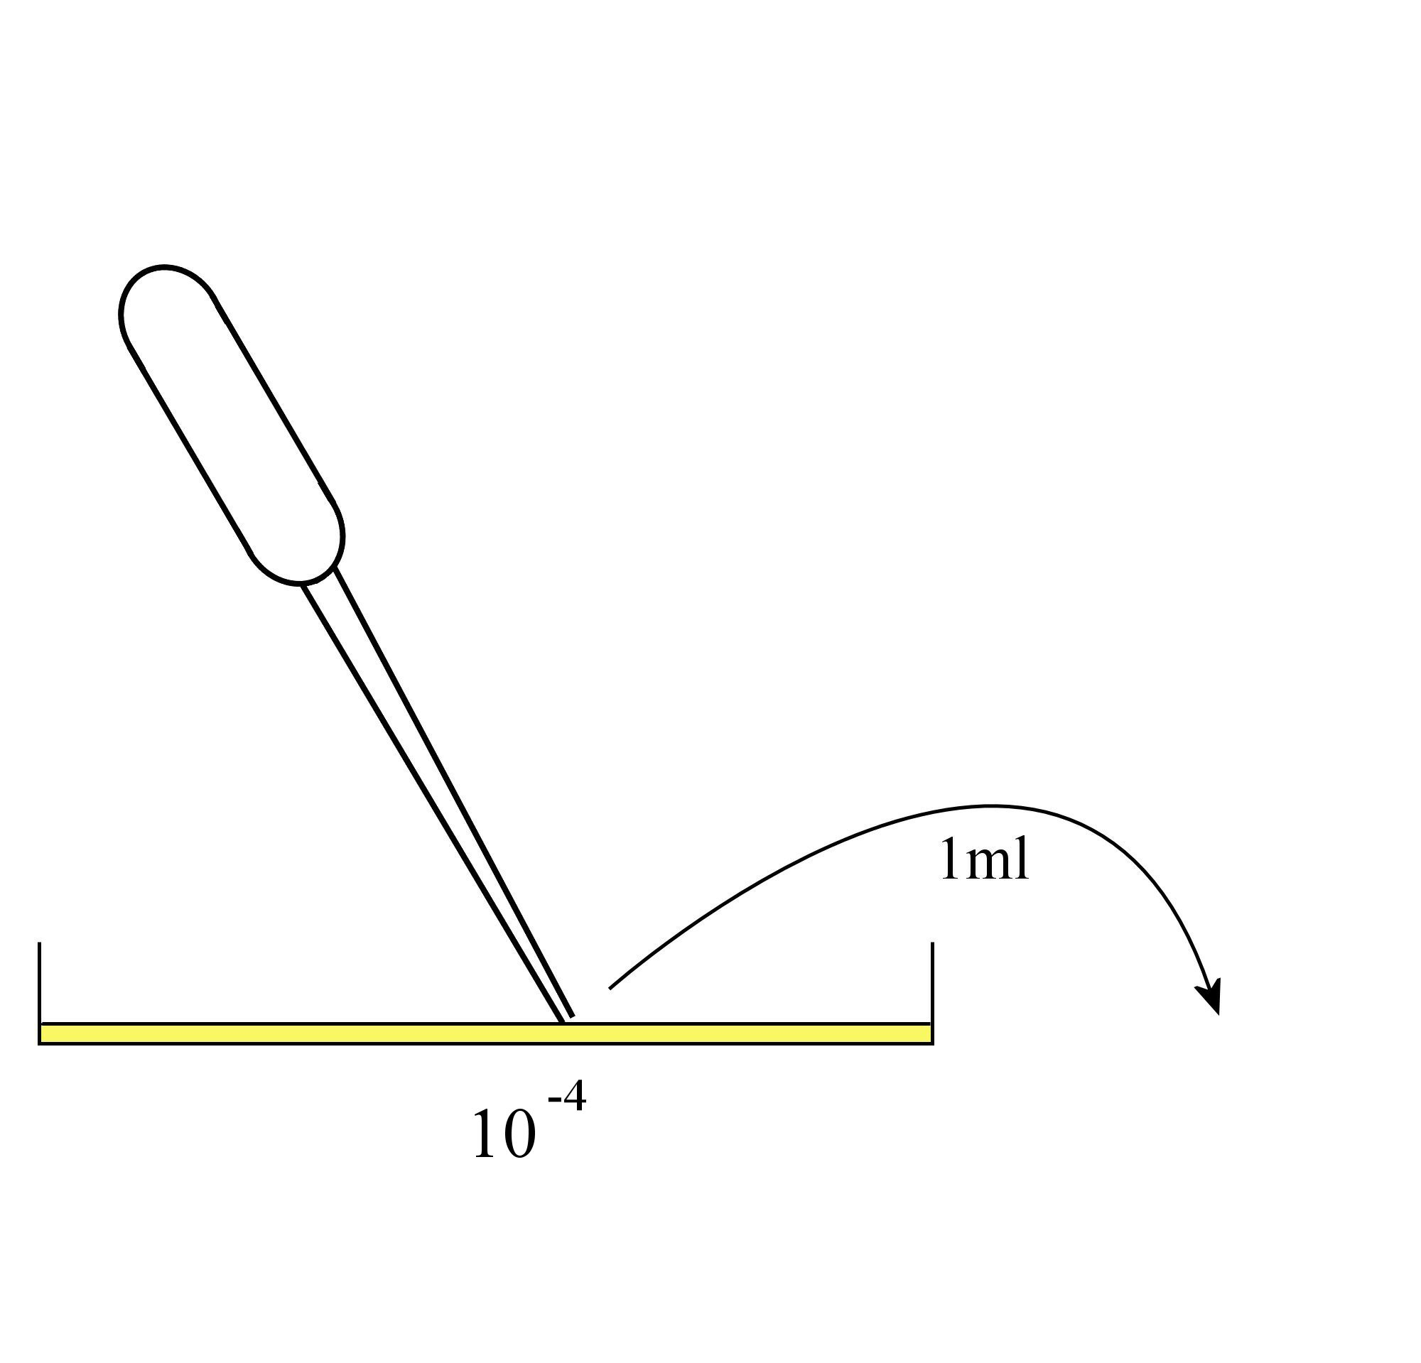
1.
2.
3.
5.

Always remember – Leave time to tidy up

This page can be printed in colour from the accompanying CD
Label eight petri dishes 10², 10¹, 1, 10⁻¹, 10⁻², 10⁻³, 10⁻⁴ and control.
Add 10 ml of the IAA solution to the dish labelled 10².
Using a different syringe, add 9 ml of water to each of the other dishes.
4.
Using a dropper, remove 1ml of solution from the 10² dish and add it to the 10¹ dish.
Stir the solution using the dropper. Repeat this procedure for the remainder of the dishes (1, 10⁻¹, 10⁻², 10⁻³ and 10⁻⁴), using a different dropper each time.

6.
Discard 1ml of liquid from the dish labelled
10⁻⁴.
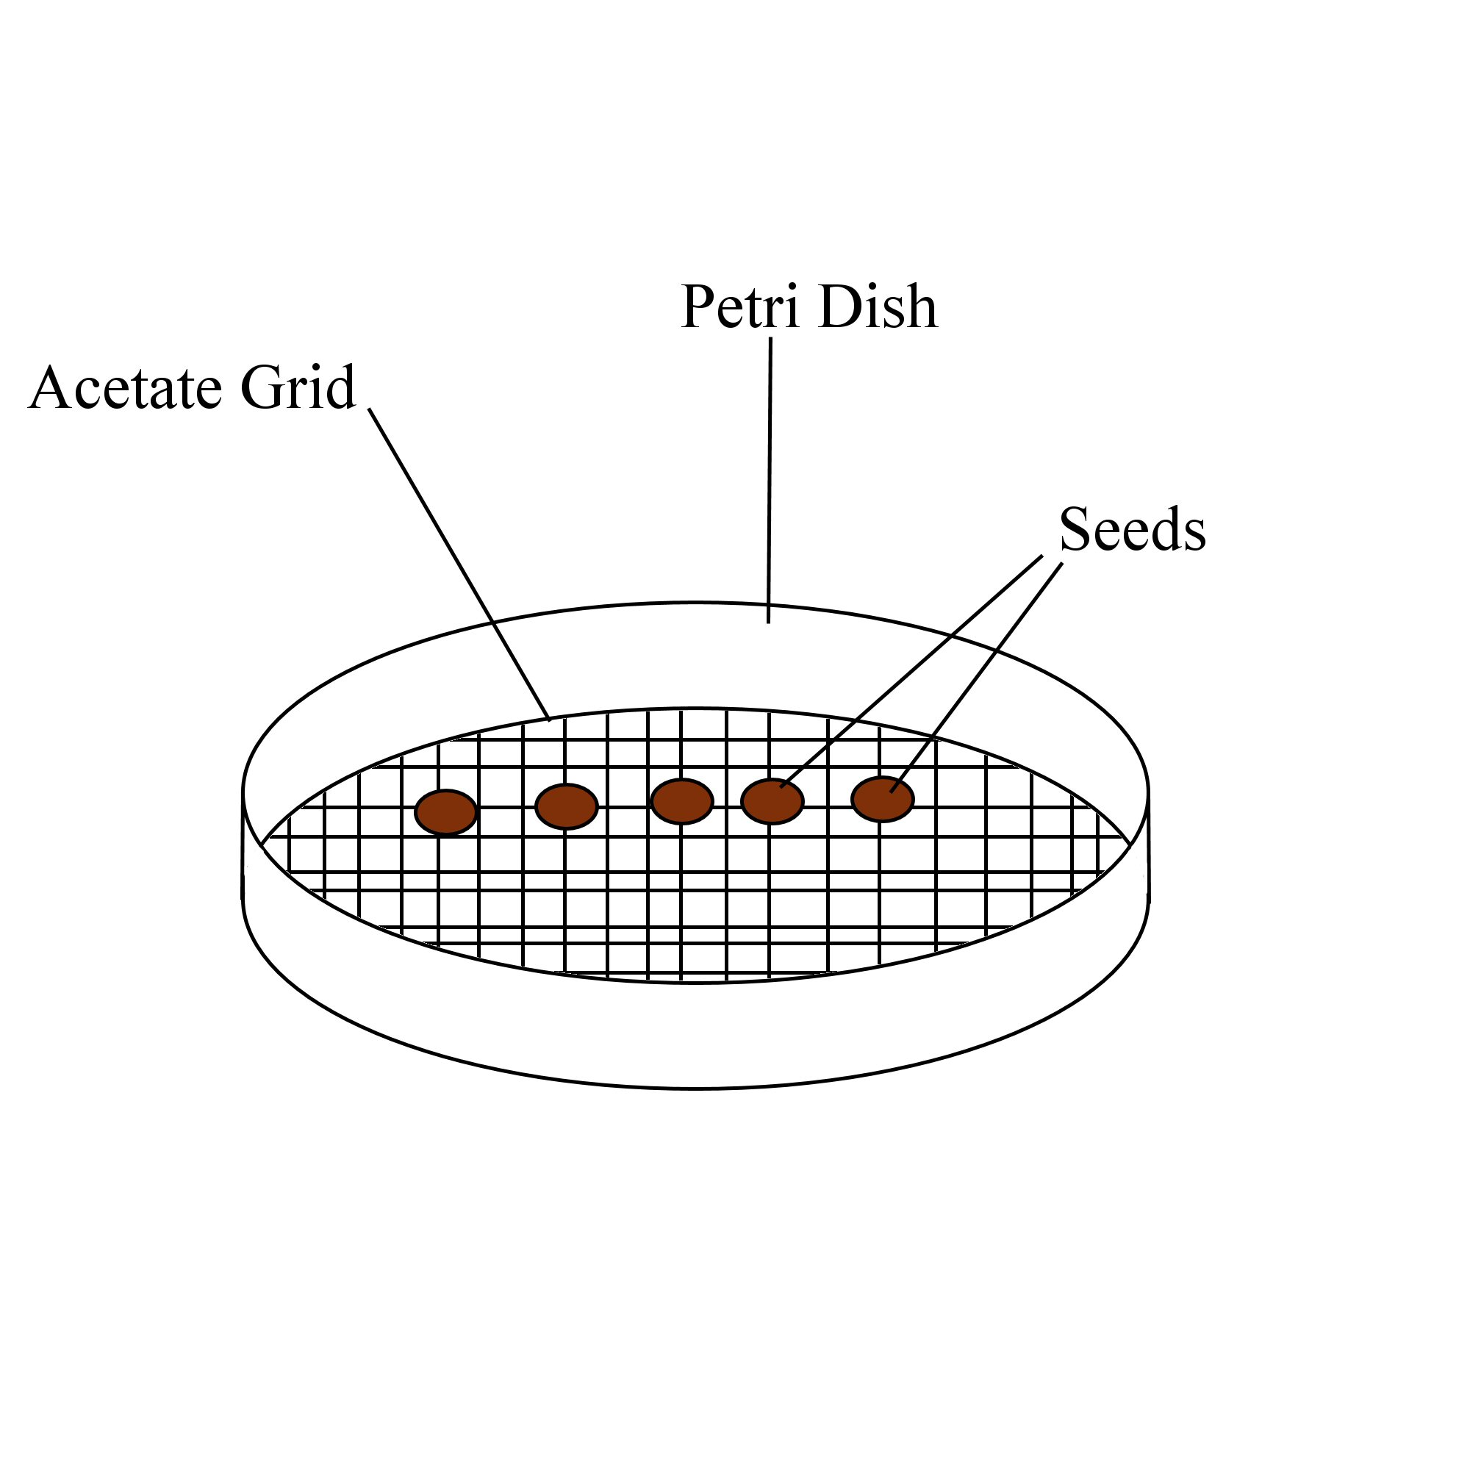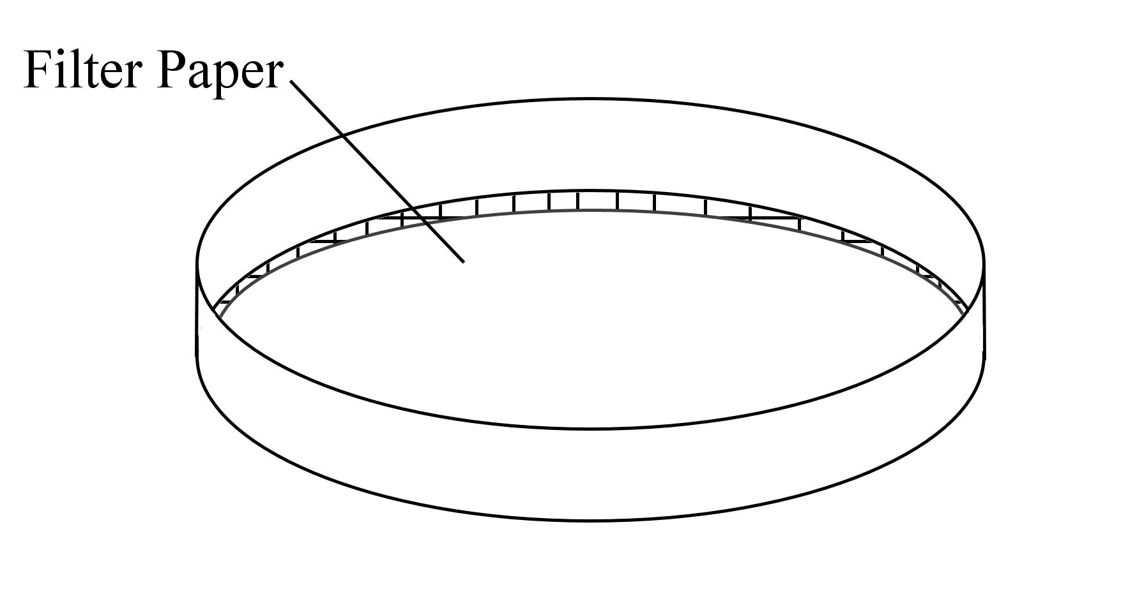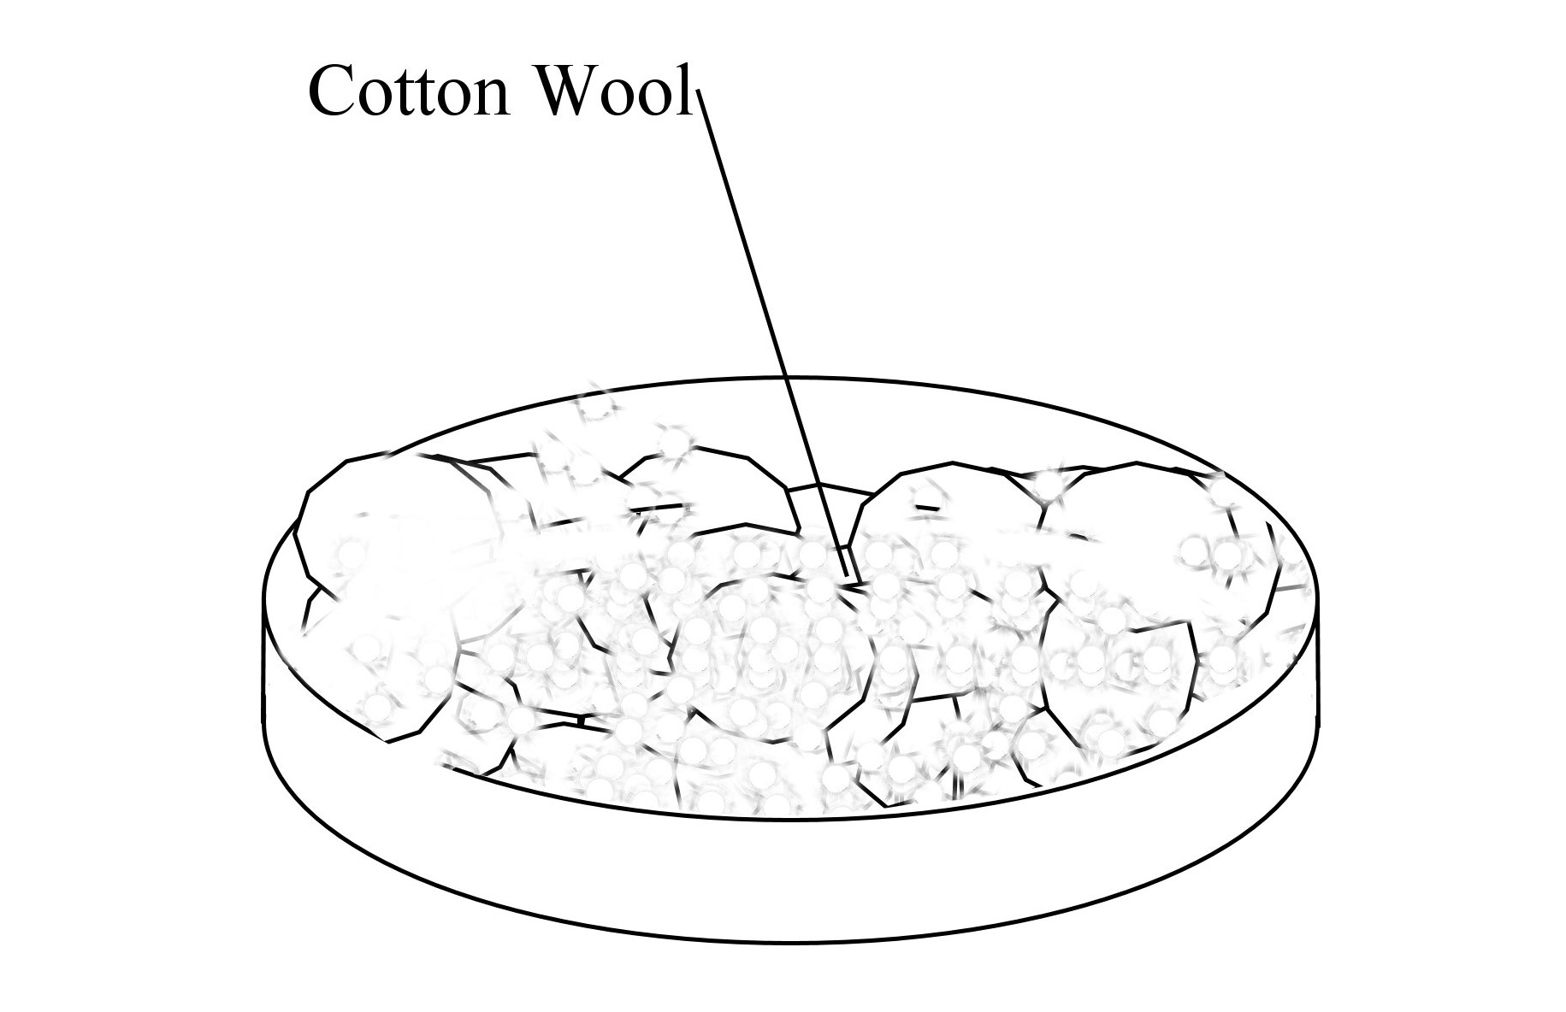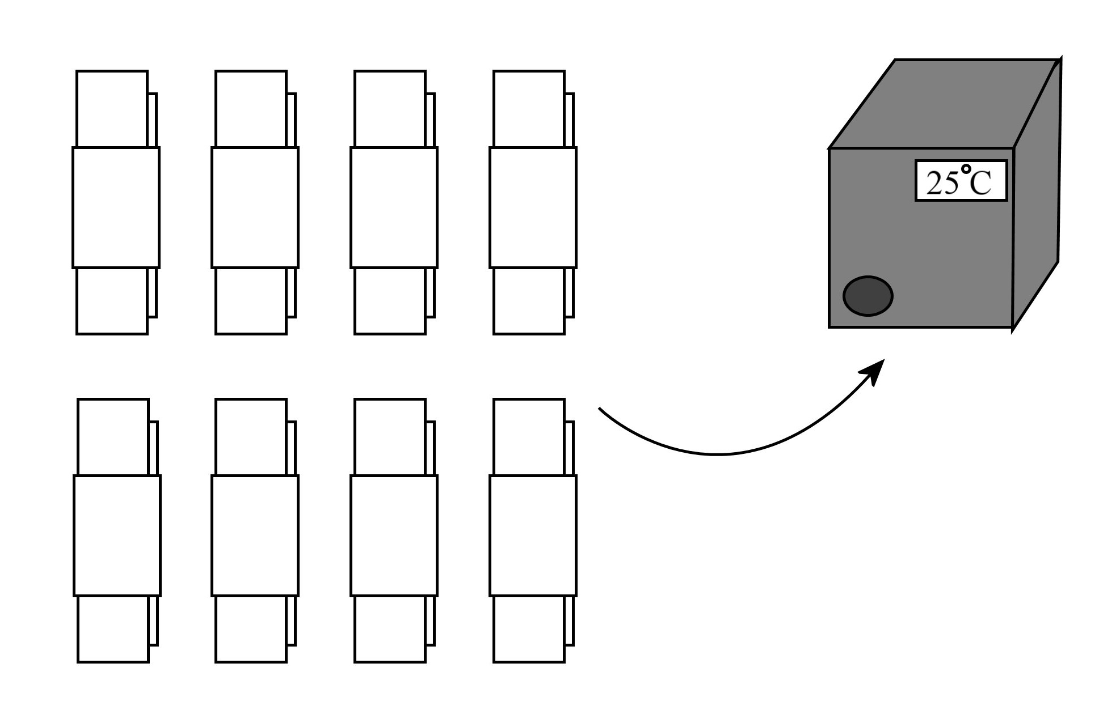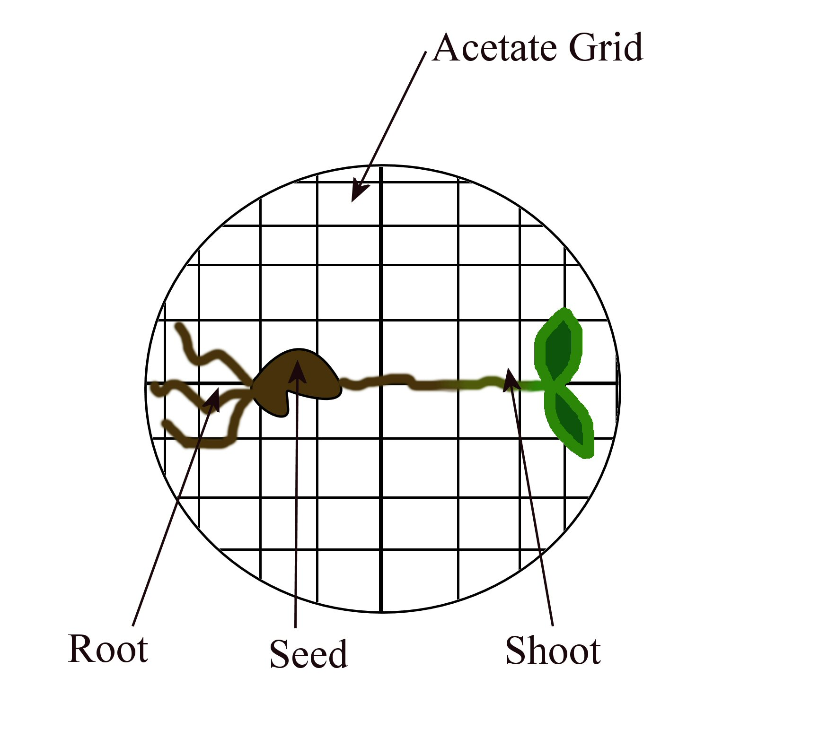
7.
8.
9.
Place an acetate grid on the lid of each petri dish. Place 5 radish seeds along the cross lines.
Place filter paper on top of the seeds.
Spread cotton wool on top of the filter paper.
Put the base of each petri dish on its lid. Secure the dishes and incubate vertically at 25^{O}C for 2-3 days.
10.
Measure the lengths of roots and shoots of each seed using the acetate grid.
11.
Calculate the average length of the stems at each concentration
and the percentage stimulation
or inhibition.

Always remember – Leave time to tidy up
This page can be printed in colour from the accompanying CD
Table of Results:
Concentration of IAA  (ppm) | Length of roots (mm) |  |  |  |  | Total Length (mm) | Average Length (mm) | Percentage stimulation or inhibition
Concentration of IAA  (ppm) | Seed 1 | Seed 2 | Seed 3 | Seed 4 | Seed 5 | Total Length (mm) | Average Length (mm) | Percentage stimulation or inhibition
0 (control)
10⁻⁴
10⁻³
10⁻²
10⁻¹
1
10¹
10²

Concentration of IAA  (ppm) | Length of shoots (mm) |  |  |  |  | Total Length (mm) | Average Length (mm) | Percentage stimulation or inhibition
Concentration of IAA  (ppm) | Seed 1 | Seed 2 | Seed 3 | Seed 4 | Seed 5 | Total Length (mm) | Average Length (mm) | Percentage stimulation or inhibition
0 (control)
10⁻⁴
10⁻³
10⁻²
10⁻¹
1
10¹
10²
This page can be printed in colour from the accompanying CD

Always remember – Leave time to tidy up

Always remember – Leave time to tidy up
This page can be printed in colour from the accompanying CD

