Contents
Biology Focus

Keywords,
Explanations &
Exam Question Revision

Declan Finlayson

Declan Finlayson

Introduction 3
1.1.3 Scientific Method and Experimentation 4
1.2.3 Characteristics of Life and Food 6
1.3.3 Biomolecules 9
Biomolecules 1 10
Biomolecules 2 11
1.3.4 Biomolecular Components 13
1.3.6 Role of Biomolecules 15
1.3.8 Biomolecules and Minerals 17
1.4.2 - 1.4.6 Ecology 19
1.4.8 + 9 Nutrient Recycling and Human Impact 24
Nutrient Recycling and Human Impact 1 25
Nutrient Recycling and Human Impact 2 26
Nutrient Recycling and Human Impact 1 + 2 27
1.4.11 Relationships and Population Dynamics 29
1.5.3 Ecosystem Study 31
2.1 Cell Structure and Microscopy 33
Cell Structure and Microscopy 1 34
Cell Structure and Microscopy 2 35
2.2.3 Enzymes 36
2.2.4 Photosynthesis 40
Photosynthesis 1 41
Photosynthesis 2 43
2.2.5 Respiration 45
Respiration 1 47
Respiration 2 49
Respiration 3 51
2.2.6 Movement through Membranes 53
2.2.7 Enzymes Higher Level 56
2.2.9 Photosynthesis Higher Level 58
2.2.10 Respiration Higher Level 61
2.3 Cell Continuity 63
Cell Continuity 1 66
Cell Continuity 2 67
Cell Continuity 1 and 2 68
2.4 Cell Diversity 70
2.5.1 - 2 Variation, Heredity, etc. 72
2.5.4 DNA, Replication, etc. 74
2.5.5+15 Protein synthesis 76
2.5.6 Genetic Inheritance 78
2.5.7 - 8 Variation and Evolution 81
2.5.9 - 13.H Genetic Engineering and Mendelian 83
2.5.14 DNA, Replication, etc. 87
3.1.3 Monera 89
3.1.4 Fungi 93
Fungi 1 94
Fungi 2 95
Fungi 1 and 2 96
3.1.5, 6, 10 Lab, Protista, Growth Curves 98
3.2.1 Plant Structure 101
Plant Structure 1 103
Plant Structure 2 104
3.2.2 Blood and Circulation 106
Blood and Circulation 1 108
Blood and Circulation 2 109
Blood and Circulation 3 110
Blood and Circulation 4 111
3.2.3 + 4 Blood Cells and Heartbeat 112
3.3.1 + 2 Nutrition and Storage in Plants 114
3.3.3 + 4 Human Nutrition and Digestion 117
Human Nutrition and Digestion 1 119
Human Nutrition and Digestion 2 120
Human Nutrition and Digestion 3 121
Human Nutrition and Digestion 4 122
3.3.5 Blood Transport of Nutrients 123
3.3.7 + 3.4.1 Cohesion-Tension and Homeostasis 125
3.4.3 Plant Exchange System 127
3.4.4 Breathing System 129
Breathing System 1 130
Breathing System 2 131
3.4.6 Excretory System 132
Excretory System 1 134
Excretory System 2 136
3.4.7 + 8 Excretion 138
3.5.2 Plant Responses 141
3.5.3 + 7 Defence System 144
3.5.3 Endocrine System 148
3.5.3 Eye and Ear 150
3.5.3 Musculoskeletal System 153
Musculoskeletal System 1 155
Musculoskeletal System 2 156
3.5.3 Nervous System 157
3.5.4 Viruses 161
3.6.1 Asexual Reproduction 163
3.6.1 + 3 Flower Structure and Gamete Formation 165
3.6.1 Pollination and Fertilisation 167
3.6.1 Fruit Formation and Dispersal 170
3.6.1 Dormancy and Germination 173
3.6.2 Reproductive Structures and Hormones 176
3.6.2 Pregnancy, Birth and Breastfeeding 179
3.6.2 Infertility and Birth Control 181
3.6.4 + 5 Embryo Development and Menstrual Cycle 183
INDEX 186
Answers 188

Introduction

Over 75 exercises with more than 1400 questions; all adapted from past Higher and Ordinary Level Leaving Certificate examination papers. The number of exercises per topic reflects the frequency at which the topic is asked and hence its importance.

If students are unsure of the correct answer they can research the answer themselves. This will help them engage with the subject and promote self-directed learning. Having a number of answers supplied also reduces the initial search of the topic to a minimum.

As opposed to being divided into ‘Chapters’ that cover numerous elements of the syllabus simultaneously, each section of the book relates to a single element of the syllabus. Each section is divided between KEYWORDS and EXPLANATIONS. Students are required to have a general understanding of the KEYWORDS listed at the beginning of each section. Detailed explanations of keywords are unlikely to be required in an exam context, but familiarity with the terms will contribute to the student’s comprehension of the topic at hand.

The EXPLANATIONS section lists words that previous exam papers have required students to explain in detail. Students should therefore familiarise themselves with the in-depth explanations provided.

Very often it is necessary to understand the meaning of terms in order to answer a question even if definitions are not required, e.g. Q10 (b) 2012 Higher Level (see below); it is necessary to know the meaning of the words in bold in order to answer the question.

(b) In the sweet pea plant the texture and colour of the testa (seed coat) are governed by two pairs of alleles, which are not linked. The allele for smooth (S) is dominant to the allele for wrinkled (s) and the allele for yellow (Y) is dominant to the allele for green (y).

(i) State the Law of Segregation and the Law of Independent Assortment.

(ii) Using the above symbols, and taking particular care to differentiate between upper case and lower case letters:
- give the genotype of a pea plant that is homozygous in respect of seed texture and heterozygous in respect of seed colour.
- state the phenotype that will result from the genotype referred to in 1.

The book highlights the brevity and detail of answers required in the examination.

The INDEX can be used to quickly find the explanations of the more important keywords. Solutions are available to all exercises.

1.1.3 Scientific Method and Experimentation

KEYWORDS

Biology
Control
Data
Double blind
Experiment
Hypothesis
Placebo
Principle or Law
Theory
Replicate
Scientific method
Standard

EXPLANATIONS

Biology: the study of living things.
Control: used in experiments as a standard against which your results can be compared.
Data: information, observations or measurements collected from the results of experiments.
Double-blind testing: e.g. during trials to examine the effectiveness of a new pill, two sample groups are taken. Neither the control group nor the group being tested knows which is taking the real pill and which is taking the placebo.
This ‘double-blind’ testing method avoids bias during the trials.
Hypothesis: groundless assumption (educated guess) taken from known facts or observation.
Placebo: dummy ‘pill’ used as a control in medical tests. It does not contain any ‘medicine’.
Principle or Law: this is a proven theory.
Replicate: make a duplicate of, repeat an experiment or procedure.
Theory: a proven hypothesis.

Insert the correct answer from the lower grid into the correct position in the right hand column
1 | What is an hypothesis?
2 | What an hypothesis may develop into
3 | Importance of a control in an experiment
4 | How the results of an experiment may be presented.
5 | Measurements, observations or information from an experiment
6 | Duplicate(s) of an experiment or procedure
7 | A proven hypothesis
8 | After formulating an hypothesis a scientist will devise...
9 | Where a scientist may publish the results of investigations
10 | Test of hypothesis or test of prediction
11 | Why repeat an experiment many times?
12 | Why is a control used when carrying out experiments?
13 | The process of science
14 | The value of the scientific method is limited by ...
15 | A good experiment examines ...

A | Data | F | Our ability to interpret results | K | Table / Graph
B | Educated guess based on observation | G | Replicate | L | Theory
C | Experiment | H | Scientific journal or Internet | M | Theory
D | Experiments | I | Scientific method | N | To compare (with experiment)
E | One variable at a time | J | Standard for comparison | O | To verify results or minimise error

1.2.3 Characteristics of Life and Food

KEYWORDS

Anabolism
Carbohydrates
Catabolism
Cell
Continuity of life
Disaccharide
Egestion
Excretion
Glucose
Lactose
Life [characteristics of]
Metabolism
Minerals
Nutrition
Organ System
Organisation
Reproduction
Response
Trace element
Sex cell

EXPLANATIONS

Anabolism: a chemical reaction which joins small molecules to make larger, more complex ones using enzymes, e.g. photosynthesis, protein synthesis, etc. Anabolic reactions require (need) energy.
Catabolism: a chemical reaction which breaks down a large molecule into simpler ones using enzymes, e.g. respiration, digestion. Catabolic reactions release (produce) energy.
Cell: basic/smallest structural unit of living things capable of functioning independently. Contains the living contents and organelles of the cell and is surrounded by a cell membrane.
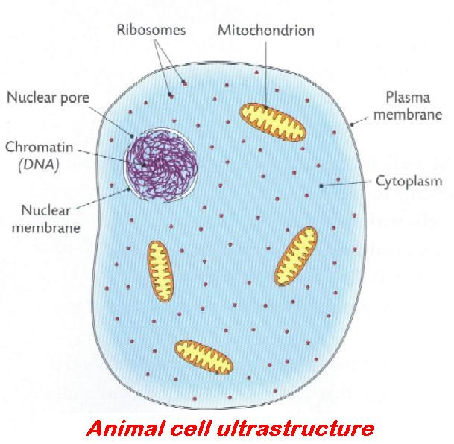 |  | 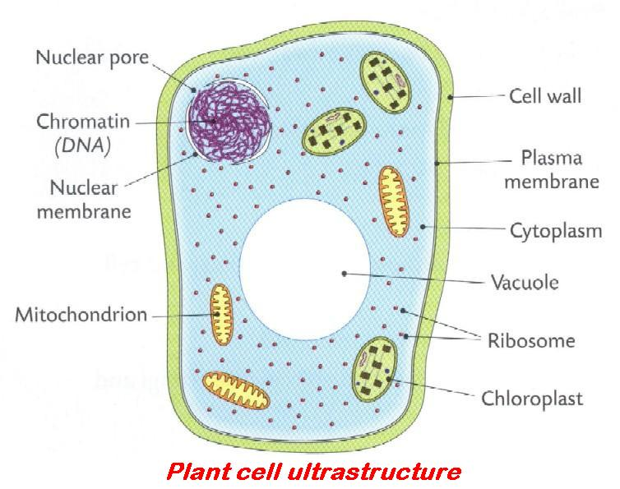
Continuity of life: the ability of organisms to exist from one generation to the next. This is achieved by cell division.
Egestion: elimination of faeces (unabsorbed material) from the body. This is not excretion.
Excretion: is the elimination of the waste products of metabolism from a cell, tissue or organ. | ORGAN EXCRETORY PRODUCTS  Skin Sweat = Water (95%), Salt (2%), Carbon dioxide (3%), Urea (tiny%)  Lungs Carbon dioxide and Water vapour  Kidneys Water, Urea, Uric acid, Na, Cl, K  Stomata (in plants) Oxygen, water vapour
Life (characteristics of): distinctive features or traits possessed or shared by all living organisms. These are Sensitivity (or responsiveness), Nutrition, Organisation, Reproduction and Excretion,
Metabolism: all chemical processes in living cells.
Enzymes catalyse metabolic reactions. Includes anabolism and catabolism.
Nutrition: the process involved in making or obtaining food (energy and materials) from the environment. |  | 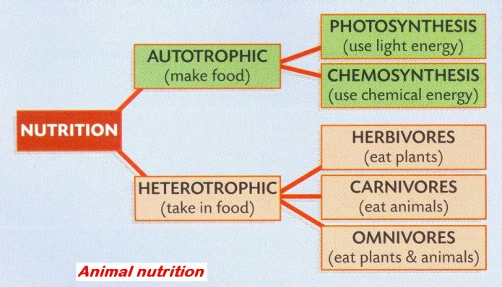
Organ systems: a group of organs working together to carry out a function, e.g. digestive system.
Organisation: organisms are composed of cells. These cells function together to form tissues, organs, organ systems, individuals (organisms) and populations. |  | 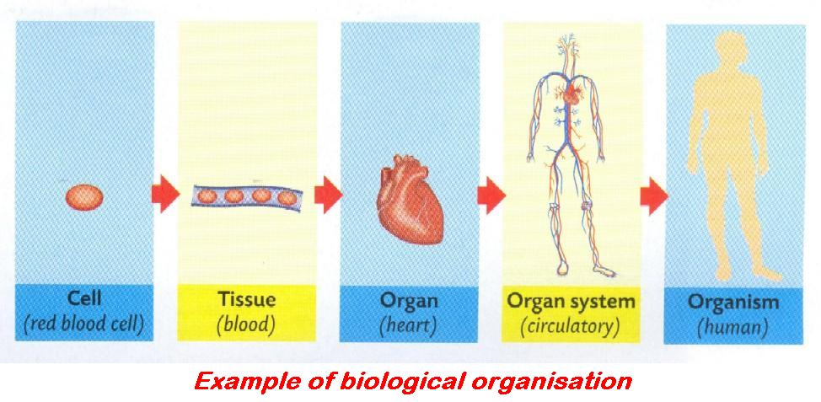
Reproduction: the ability of an organism to produce new individuals of its own kind by either sexual or asexual means.
Response: the ability of living organisms to react to changes in their internal and external environments.
It is a form of defence that allows the organisms survive.
Insert the correct answer from the lower grid into the correct position in the right hand column
1 | All chemical reactions in living organisms
2 | Catabolism + anabolism = ?
3 | Removal of the waste products of metabolism
4 | Gamete
5 | Needed for movement, heat, internal transport, etc.
6 | Zinc, iron and copper are examples of...
7 | What is meant by a trace element?
8 | True or False. Nitrogen is a trace element.
9 | A polysaccharide contains many sugar units. True or False
10 | True or False. Glucose is a monosaccharide.
11 | Ratio of hydrogen to oxygen atoms in a carbohydrate
12 | Biomolecules of the formula C_{x}(H₂0)_{y} are examples of...
13 | The chemical elements present in carbohydrates
14 | A monosaccharide
15 | Made of two sugar units or monosaccharides

A | 2:1 | F | Excretion | K | Minerals or trace elements
B | Carbohydrates | G | False | L | Sex cell
C | Carbon; Hydrogen; Oxygen | H | Glucose; Lactose | M | Mineral needed in small amount, e.g. < 0.01%
D | Disaccharide | I | Metabolism | N | True
E | Energy | J | Metabolism | O | True

1.3.3 Biomolecules

KEYWORDS

Amino acid
Benedict’s
Carbohydrates
Carbon
Cellulose
Chitin
Copper
CuSO₄
Disaccharide
Fehling’s
Glycerol
Glycogen
Hydrogen
Iodine
Iron
Maltose
Monosaccharide
Nitrogen
Oxygen
Phosphorous
Polysaccharide
Reducing sugar
Starch
Sulfur
Trace element
Vitamins
Zinc

EXPLANATIONS

Trace element: minerals required in very small amounts by organisms but essential for normal growth and development.

Biomolecules 1

Insert the correct answer from the lower grid into the correct position in the right hand column
1 | From what is cellulose formed?
2 | A polysaccharide with a different role to cellulose
3 | Chemical used to test for starch
4 | Reagent used when testing for a reducing sugar
5 | Reagent(s) used when testing for a protein
6 | Initial colour of reagent(s) used to test for a reducing sugar
7 | Does the test for reducing sugar require heat?
8 | Positive result in the test for reducing sugar
9 | Initial colour of reagent(s) used to test for a protein
10 | Does the test for protein require heat?
11 | Positive result in the test for protein
12 | Vitamins are either water-soluble or ... -soluble
13 | Fats are composed of oxygen, hydrogen and ...
14 | Two monosaccharides unite to form a ...
15 | Vitamin ... is an example of a water-soluble vitamin

A | Biuret or CuS0₄ and NaOH | F | Disaccharide | K | No
B | Blue | G | Fat | L | Starch; Glycogen
C | Blue | H | Fehling's or Benedict's | M | Violet
D | Brick red | I | Iodine | N | Vitamin B or C
E | Carbon | J | Monosaccharide units or Glucose | O | Yes

Biomolecules 2

Insert the correct answer from the lower grid into the correct position in the right hand column
1 | Biuret reagent (or CuS0₄ and NaOH) is (are) used to test for ...
2 | Benedict's (or Fehling's) is used to test for ...
3 | An example of a fat-soluble vitamin
4 | An example of a reducing sugar
5 | Example of a polysaccharide
6 | Made up of many sugar units
7 | A good source of Vitamin D in the diet
8 | Fats are composed of fatty acids and ...
9 | Fats that are liquid at room temperature
10 | Essential organic catalysts of metabolism
11 | Element found in proteins not found in carbohydrates
12 | Good sources of protein
13 | Proteins are composed of simpler substances called ...
14 | Elements found in carbohydrate
15 | Elements found in protein
16 | Elements found in fat
17 | An element associated with protein apart from C, H, O and N
18 | An example of a water-soluble vitamin
19 | Chemical used to show the presence of starch
20 | End product of protein digestion
21 | Is heat necessary to test for reducing sugar?

A | Amino acid | H | Glucose; Maltose | O | Protein
B | Amino acids | I | Glycerol | P | Reducing sugar
C | Carbon; Hydrogen; Oxygen | J | Iodine | Q | Sulfur
D | Carbon; Hydrogen; Oxygen | K | Lean meat; Fish; Eggs | R | Vitamin A or D or E or K
E | Carbon; Hydrogen; Oxygen; Nitrogen | L | Nitrogen | S | Vitamin B or C
F | Cellulose; Starch; Glycogen; Chitin | M | Oils | T | Vitamins
G | Dairy products | N | Polysaccharide | U | Yes

1.3.4 Biomolecular Components

KEYWORDS

Amino acids
Disaccharide
Fat-soluble
Fatty acids
Glycerol
Glycogen
Lipids
Polysaccharide
Proteins
Starch
Triglyceride
Vitamins
Water-soluble

EXPLANATIONS

Amino acid: structural unit of proteins, containing an amino group (-NH₂).  There are twenty common amino acids found in proteins. | 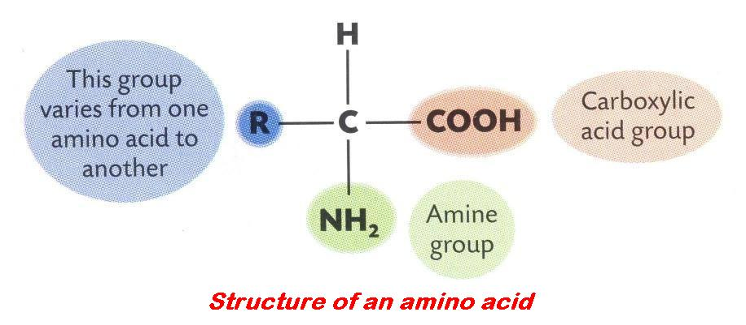
Fatty acid: Component of lipids. The smallest lipid is a triglyceride (see below). | 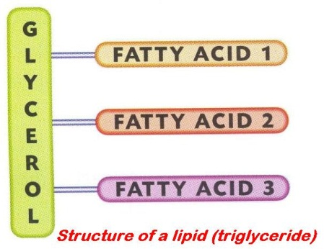
Glycogen: storage polysaccharide found in animal cells only, e.g. muscles, liver and brain.
Triglyceride: smallest lipid consisting of three fatty acid and one glycerol molecule.
Vitamin: An essential organic catalyst of metabolism.
- Needed in small amounts, cannot be produced in the body.
- Must be supplied continuously and in sufficient quantities.
- Some are water-soluble, e.g. vitamin B and vitamin C, and
- Some are fat-soluble, e.g. vitamin A, vitamin D, vitamin E and vitamin K.

Insert the correct answer from the lower grid into the correct position in the right hand column
1 | Food type identified using Sudan III or brown paper
2 | Elements found in both carbohydrates and fats
3 | One way in which carbohydrates differ from fats
4 | Difference between phospholipids and other lipids
5 | Difference between oil and fat
6 | How one fat may differ from another, in terms of composition
7 | Groups of Vitamins
8 | Glycerol and three fatty acids
9 | Lipids are made of amino acids. True or False
10 | All vitamins are fat soluble. True or False
11 | Eggs are a good source of fat in the diet. True or False
12 | Positive result of the Fehling's or Benedict's test
13 | Number of common amino acids found in proteins
14 | Use for a water bath in biological investigations
15 | Lipids are made up of fatty acids and ...
16 | Good source of protein in the human diet
17 | How amino acids differ from monosaccharides, in terms of composition
18 | What carbohydrates and fats have in common, in terms of composition

A | 20 | G | False | M | Lean Meat; Fish; Cheese; Eggs; Pulses
B | Amino acids contain Nitrogen | H | Fat (or oil or lipid) | N | Oil is liquid fat is solid at room temperature
C | Carbon; Hydrogen and Oxygen | I | Fat-soluble and Water-soluble | O | One fatty acid replaced with a phosphate group
D | Carbon; Hydrogen and Oxygen | J | Glycerol | P | Orange or Brick red
E | Different fatty acids | K | Hydrogen and Oxygen not in 2:1 ratio | Q | Triglyceride
F | False | L | Keep temperature constant or vary it | R | True

1.3.6 Role of Biomolecules

KEYWORDS

Anabolic
Anabolism
Catabolic
Catabolism
Cell membrane
Cellulose
Chitin
Collagen
Deamination
Digestion
Elastin
Enzymes
Glycogen
Immunity
Keratin
Lactose
Monosaccharide
Myosin
Photosynthesis
Replication
Respiration
Structural protein
Synthesis

EXPLANATIONS

Anabolism: a chemical reaction which joins small molecules to make larger, more complex ones using enzymes, e.g. photosynthesis, protein synthesis, etc. Anabolic reactions require (need) energy.
Catabolism: a chemical reaction which breaks down a large molecule into simpler ones using enzymes, e.g. respiration, digestion. Catabolic reactions release (produce) energy.
Cellulose: complex carbohydrate (polysaccharide) forming the cell walls of plant cells. It is made from chains of glucose molecules. | 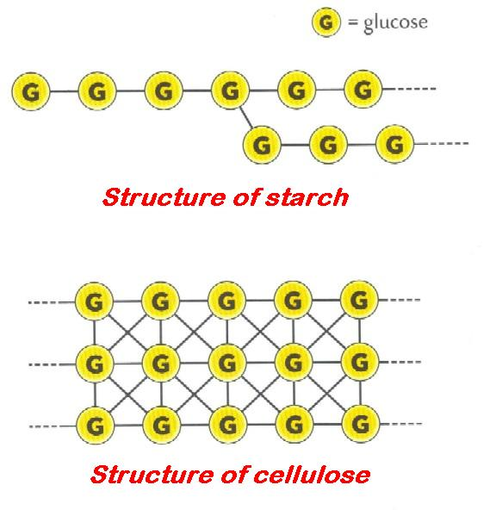

Insert the correct answer from the lower grid into the correct position in the right hand column
1 | A reaction in which large molecules are broken down to smaller ones
2 | Example of a catabolic reaction
3 | Example of an anabolic reaction in a plant
4 | Is energy release a feature of anabolic or catabolic reactions?
5 | Is the process of protein synthesis anabolic or catabolic?
6 | Is the process of converting ADP to ATP anabolic or catabolic?
7 | A monosaccharide
8 | Cellulose is a polysaccharide. What is it formed from?
9 | Name a polysaccharide that has a different role to cellulose
10 | A protein that has a structural role
11 | Cellulose is a structural ...
12 | A structural polysaccharide
13 | Precise location of cellulose
14 | Functions of fats
15 | Metabolic function of proteins
16 | Role of lipids in cells
17 | Cellulose
18 | Essential organic catalysts of metabolism

A | Anabolic | G | Cellulose; Chitin | M | Keratin; Myosin; Elastin; Collagen
B | Anabolic | H | Component of membranes; Storage; Energy | N | Photosynthesis; Protein synthesis; Replication
C | Carbohydrate or Polysaccharide | I | Enzymes or Immunity (antibodies) | O | Respiration; Digestion; Deamination
D | Catabolic | J | Glucose; Lactose; Ribose | P | Starch; Glycogen; Chitin
E | Catabolic | K | Glucose; Monosaccharide molecules | Q | Structural carbohydrate of plants
F | Cell wall | L | Insulation; Energy storage; Cell membrane | R | Vitamins

1.3.8 Biomolecules and Minerals

KEYWORDS

Antibodies
Amino acids
Calcium
Chitin
Enzyme
Glycogen
Iron
Magnesium
Mineral
Proteins
Rickets
RNA
Scurvy

EXPLANATIONS

Mineral (element): inorganic compound needed in small quantities for the correct functioning of the body, or an organism
Minerals are used by organisms in three ways:
- to form rigid body framework: calcium in bones and plant cell walls
- to form body tissues, e.g. iron used to make haemoglobin for blood (animal), magnesium used to make chlorophyll for photosynthetic cells (plant)
- to function in cellular and body fluids.

Insert the correct answer from the lower grid into the correct position in the right hand column
1 | Polysaccharide other than cellulose
2 | Colour change that indicates a positive result for protein
3 | Small molecules which are the building blocks for proteins
4 | Role of ribose
5 | Deficiency of Vitamin A
6 | Deficiency of Vitamin C
7 | Deficiency of Vitamin D
8 | Group of biomolecules to which enzymes belong
9 | Good source of Vitamin A
10 | Good source of Vitamin D
11 | Functions of fat in the body
12 | Role of carbohydrates other than structural
13 | Function of protein in the body
14 | Protein which changes reaction rates
15 | Minerals required by the human body
16 | Needed for haemoglobin formation
17 | Needed for bone and teeth development
18 | Needed for chlorophyll formation

A | Amino acids | G | Enzyme | M | Night blindness
B | Blue to Purple or violet | H | Growth; Repair; Muscles; Enzymes; Immunity (antibodies) | N | Proteins
C | Calcium | I | Insulation; Energy; Storage; Cell membrane | O | Rickets
D | Carrots | J | Iron | O | RNA
E | Dairy products | K | Iron; Calcium | Q | Scurvy
F | Energy store or release | L | Magnesium | R | Starch; Glycogen; Chitin

1.4.2 - 1.4.6 Ecology

KEYWORDS

Abiotic factors
Autotroph
Biosphere
Biotic factors
Carnivore
Chlorophyll
Climatic Factor
Consumer
Ecology
Ecosystem
Edaphic factor
Food chain
Food web
Grazing Food Chain
Habitat
Herbivore
Omnivore
pH
Photosynthesis
Phytoplankton
Plankton
Predator
Primary consumer
Primary producers
Producer
Pyramid of numbers
Secondary Consumer
Tertiary Consumer
Trophic level
Water

EXPLANATIONS

Abiotic factors: these are the non-living features of an ecosystem (i.e. the physical and chemical conditions) that affect the community.
They include: temperature, light intensity, air speed, water current, humidity, ¬pH, dissolved oxygen, salinity, nitrate, phosphate and other plant nutrients.
Biosphere: that part of the earth inhabited by living organisms, including land, ocean and the atmosphere in which life can exist.
Biotic factors: these are the living features of an ecosystem that affect the other members of the community.
They include: plants for food and shelter; predators; prey; parasites and pathogens; decomposers; competitors; and pollinators.
Carnivore: an animal or plant that feeds exclusively or mainly on animal flesh, e.g. fox, dog, ladybird, Venus fly-trap.
Climatic factors: features relating to long term weather conditions that influence the life and distribution of the organisms that live in a particular environment, e.g. rainfall, humidity, temperature, light intensity and day length.
Ecology: the study of how living things relate to and interact with each other and their environment.
Ecosystem: a community of living organisms interacting with one another and their non-living environment within a particular area, e.g. woodland, hedgerow, seashore, tree, etc.
Edaphic factors: the physical, chemical and biological characteristics of the soil that influence the distribution of organisms in a terrestrial ecosystem.
The major edaphic factors are: available (soil) water, mineral content, pH, humus, soil texture and structure.
Food chain: a list of species such that each is food for the next species in the list. It is a chain of organisms through which energy is transferred. Usually begins with green plants (producers), eaten by small animal (primary consumer), then a larger animal (secondary consumer), etc. The final member of the chain is the tertiary consumer. Usually represented as follows:

primary producer primary consumer secondary consumer tertiary consumer
e.g. rose greenfly ladybird thrush

The means ‘eaten by’. See grazing food chain.
Food web: a chart showing all the feeding connections in the habitat/ecosystem.  It is constructed by showing the links between all the interconnecting food chains in the habitat/ecosystem.  There is usually more than one species at each trophic level. | 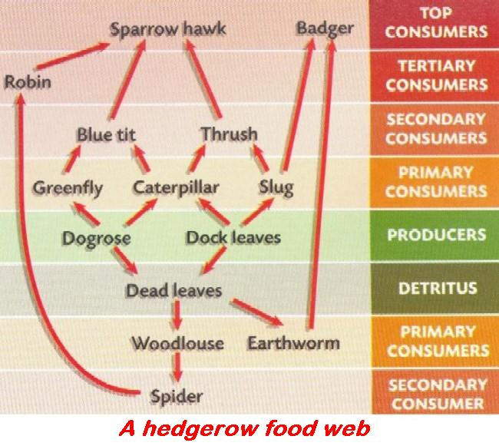
Grazing food chain: is a food chain where the initial plant is living, e.g.:
- grass grasshoppers frogs hawks
- rose bush aphids ladybirds thrushes
- seaweed winkles crabs herring gulls
- phytoplankton zooplankton copepod herring.
Habitat: the particular place within the ecosystem where a population of organisms live and to which they are adapted.
Herbivore: an animal that feeds exclusively or mainly on plants, e.g. rabbit.
Omnivore: an animal that feeds on plants and animal flesh, e.g. human.
Primary consumer: a herbivore which obtains its nutrition directly from plants; usually the second member of a food chain, e.g.
primary producer primary consumer secondary consumer tertiary consumer.
Producer: any organism capable of making its own food from inorganic materials, e.g. green plants.
Pyramid of numbers: a diagram that represents the numbers of organisms at each trophic level in a food chain; pyramid representing a food chain.

Bottom layer is the largest and represents a very large number of primary producers; next layer smaller and represents a smaller number of primary consumers; and so on to the uppermost layer where there may be only one tertiary consumer.
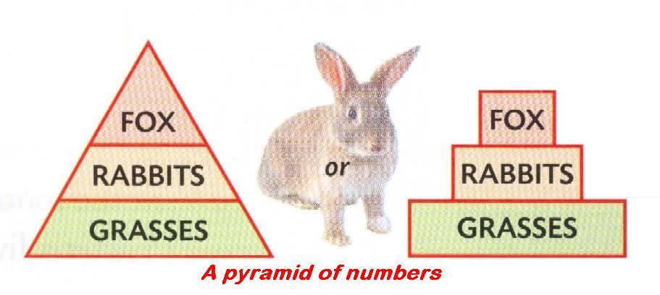 | 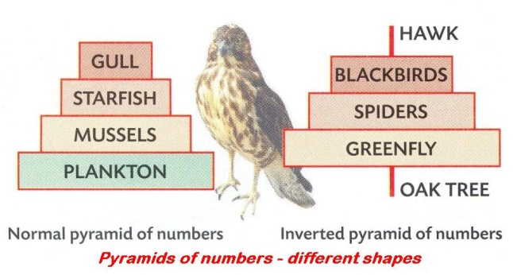
Secondary consumer: a carnivore which obtains its nutrition from animals, usually the third member of a food chain, e.g.
primary producer primary consumer secondary consumer tertiary consumer.
Tertiary consumer: a carnivore which obtains its nutrition from animals, usually the fourth member of a food chain, e.g.
primary producer primary consumer secondary consumer tertiary consumer.
Trophic level (T): feeding level: the position or energy level of a species in a food chain.
Organisms in a habitat/community which obtain their food through the same number of links in a food chain belong to the same trophic level; thus
- T₁ = primary producers
- T₂ = primary consumers = herbivores
- T₃ = secondary consumer = small carnivores
- T₄ = tertiary consumer = larger carnivores.
Sample food chains and their trophic levels
Trophic level | 1st = T₁ | 2nd = T₂ | 3rd =T₃ | 4th =T₄
Stage | Producer | Primary consumer (herbivore) | Secondary consumer  (small carnivore) | Tertiary consumer  (large carnivore)
Hedgerow examples | hawthorn | caterpillar | robin | hawk
Seashore examples | plankton | barnacle | whelk | crab

Insert the correct answer from the lower grid into the correct position in the right hand column
1 | The part of the planet where life occurs
2 | The place where an organism lives
3 | Living features
4 | Source of energy for the earth
5 | Interconnected food chains
6 | Factors relating to the soil
7 | Representation of the numbers of organisms at each trophic level
8 | The position of an organism in a food chain
9 | Any autotroph, i.e. organism that makes food, is a …
10 | Organism that eats another organism (heterotroph)
11 | Organism which feeds on a primary consumer
12 | Non-living features
13 | Abiotic factor example
14 | Biotic factor example
15 | Edaphic factor example
16 | Organisms that form the base of a pyramid of numbers
17 | Process that converts the sun's energy into a usable form
18 | Animal plankton (zooplankton) feeds on ...
19 | Substance needed by plants to photosynthesise
20 | Primary producers are found here in a pyramid of numbers
21 | Herbivores normally live long lives. True or False
22 | The remaining natural ecosystems are ones for which we have no use. True or False
23 | If tertiary consumers were removed what would happen to secondary consumers?
24 | Food chains are usually short. True or False

A | Abiotic | I | False | Q | Pyramid of numbers
B | Base or bottom | J | Food Web | R | Secondary consumers
C | Biosphere | K | Habitat | S | Soil type; pH of soil; Air, water or mineral content of soil
D | Biotic | L | Photosynthesis | T | The sun
E | Chlorophyll | M | Plant plankton (phytoplankton) | U | Their number would increase
F | Climatic; Edaphic; etc. | N | Predator (fox) influences distribution of rabbits | V | Trophic level
G | Consumer | O | Primary producer | W | True
H | Edaphic | P | Producers; Autotrophs | X | True

1.4.8 + 9 Nutrient Recycling and Human Impact

KEYWORDS

Acid rain
Aesthetic
Bacteria
Catalytic converter
Conservation
Crop rotation
Decomposer
Decomposition
Denitrification
Disease
Eutrophication
Extinction
Fertiliser run-off
Fossil fuel
Fungi
Landfill
Legumes
Lichen
Mineral depletion
Niche
Nitrification
Nitrogen fixation
Pollution
Recycle
Reduce
Reuse
Sewage
Scrubbers
Slurry
Sulfur dioxide
Toxin
Water pollution

EXPLANATIONS

Conservation: this is the protection, preservation and wise management of natural resources and the environment.
Decompose: rot, decay and break down into simpler reusable substances.
Denitrification: removal of nitrates and nitrites from the soil by converting them to ammonia and then nitrogen gas.
This is done by denitrifying bacteria, e.g. Thiobacillus denitrificans.
Niche: position or place occupied by an organism OR the functional role of an organism in an ecosystem, e.g. how it feeds, what it feeds on, what feeds on it, etc.
Nitrification: the conversion of ammonia to nitrites and/or nitrites to nitrates. | 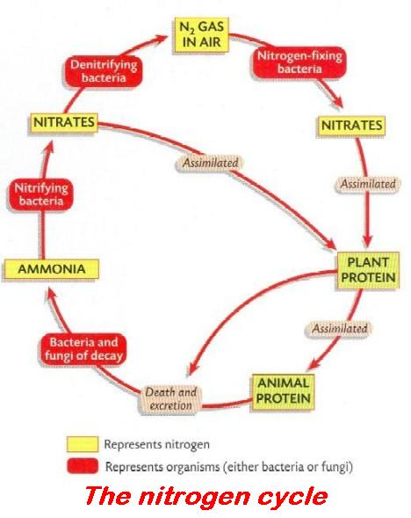
Nitrogen fixation: the conversion of atmospheric nitrogen into a form usable by plants i.e. nitrates.
Pollution: contamination or undesirable change in a habitat or environment, i.e. any human addition to the environment that leaves it less able to sustain life.
Nutrient Recycling and Human Impact 1

Insert the correct answer from the lower grid into the correct position in the right hand column
1 | Functional role of an organism
2 | Converting ammonia into nitrites and/or nitrites to nitrates
3 | Harmful addition to the environment (by humans)
4 | Conversion of atmospheric nitrogen to nitrates by bacteria
5 | Function of the nitrogen cycle
6 | Protection and wise management of endangered species
7 | Group of biomolecules that plants make from nitrates
8 | Group of organisms involved in nitrogen fixation
9 | Groups of soil microorganisms responsible for decomposition
10 | Why elements are recycled in nature
11 | Organisms that return nutrients to the environment by decay are ...
12 | Activity that results in the pollution of air
13 | Activity that results in the pollution of water
14 | Conservation practice from agriculture
15 | Conservation practice from fisheries

A | Bacteria and Fungi | F | Control of net mesh size | K | Niche
B | Bacteria; Legumes; Lichens | G | Decomposers | L | Nitrification
C | Burning fossil fuels | H | Fertiliser run-off | M | Nitrogen fixation
D | Conservation | I | Limited supply | N | Pollution
E | Control of fertiliser usage | J | Make Nitrogen available for use by organisms | O | Proteins

Nutrient Recycling and Human Impact 2

Insert the correct answer from the lower grid into the correct position in the right hand column
1 | Conservation practice from forestry
2 | Reasons for conserving wild species
3 | Effects of fertiliser run-off
4 | Problems associated with waste disposal
5 | Ways of minimising waste
6 | Decomposition is ...
7 | Use of micro-organisms in waste management
8 | Pollution caused by burning fossil fuels can be reduced by ...
9 | Conservation practice in agriculture
10 | Conservation practice in fisheries
11 | Conservation practice in forestry
12 | Example of domestic pollution
13 | Example of industrial pollution
14 | Example of agricultural pollution
15 | Role of microorganisms in waste management

A | Aesthetic; Possible sources of drugs; Prevent extinction | F | Eutrophication | K | Replanting
B | Catalytic converters; Scrubbers | G | Net size; Mesh size | L | Sewage treatment plants; Digesters; Compost heaps
C | Crop rotation; Prevent soil mineral depletion | H | Plant trees | M | Slurry and fertiliser washed from land
D | Decaying; Rotting | I | Plastic bags | N | Sulfur dioxide from burning fossil fuels
E | Disease; Toxins; Smell; Unsightly | J | Reduce; Recycle; Re-use | O | To consume waste

Nutrient Recycling and Human Impact 1 + 2

Insert the correct answer from the lower grid into the correct position in the right hand column
1 | Activity that results in the pollution of air
2 | Activity that results in the pollution of water
3 | Conservation practice in agriculture
4 | Conservation practice in fisheries
5 | Conservation practice in forestry
6 | Conversion of atmospheric nitrogen to nitrates by bacteria
7 | Converting ammonia into nitrites and/or nitrites to nitrates
8 | Decomposition is ...
9 | Effects of fertiliser run-off
10 | Example of agricultural pollution
11 | Example of domestic pollution
12 | Example of industrial pollution
13 | Function of the nitrogen cycle
14 | Functional role of an organism
15 | Group of biomolecules that plants make from nitrates
16 | Group of organisms involved in nitrogen fixation
17 | Groups of soil microorganisms responsible for decomposition
18 | Harmful addition to the environment (by humans)
19 | Organisms that return nutrients to the environment by decay are ...
20 | Pollution caused by burning fossil fuels can be reduced by ...
21 | Problems associated with waste disposal
22 | Protection and wise management of endangered species
23 | Reasons for conserving wild species
24 | Role of microorganisms in waste management
25 | Use of micro-organisms in waste management
26 | Ways of minimising waste
27 | Why elements are recycled in nature

A | Aesthetic; Possible sources of drugs; Prevent extinction | J | Disease; Toxins; Smell; Unsightly | S | Plastic bags
B | Bacteria and Fungi | K | Eutrophication | T | Pollution
C | Bacteria; Legumes; Lichens | L | Fertiliser run-off | U | Proteins
D | Burning fossil fuels | M | Limited supply | V | Reduce; Recycle; Re-use
E | Catalytic converters; Scrubbers | N | Make Nitrogen available for use by organisms | W | Replanting
F | Conservation | O | Control of net or mesh size | X | Sewage treatment plants; Digesters; Compost heaps
G | Crop rotation; Prevent soil mineral depletion; Control fertiliser usage | P | Niche | Y | Slurry and fertiliser washed from land
H | Decaying; Rotting | Q | Nitrification | Z | Sulfur dioxide from burning fossil fuels
I | Decomposers | R | Nitrogen fixation | A2 | To consume waste

1.4.11 Relationships and Population Dynamics

KEYWORDS

Adaptation
Birth control
Community
Competition
Contest competition
Contraception
Ecosystem
Migration
Mutualism
Parasitism
Pollution
Population
Predation
Predator
Prey
Reactant
Scramble competition
Social conditions
Solvent
Symbiosis

EXPLANATIONS

Adaptation: a process, change, method, characteristic or feature that an organism or species possesses, develops or evolves that suits/adjusts the organism to its environment to increase its chances of survival and reduce competition.
Competition: the struggle/rivalry/fight between organisms to obtain a sufficient supply of a resource of limited quantity.
Animals vie with each other for food, shelter and space, and plants vie for space, light, water and minerals.
Contest competition: involves an active physical confrontation between two organisms, e.g. two dogs fighting over a bone. One wins the bone.
Parasitism: a relationship between two organisms where one (parasite) benefits and the other (host) is harmed.
Population: a group of organisms of the one species living in part of an ecosystem.
Predation: the act, of some animals (predators), of capturing and killing other animals for food.
Predator: animal that hunts, captures and kills other animals (prey) for food.
Prey: an animal that is hunted and killed by another animal (predator) for food.
Scramble competition: a struggle between organisms where each organism tries to acquire as much of the resource as possible, e.g. an ivy plant and a pine tree may compete for light. The ivy uses adventitious roots to grip the pine tree and climb higher.
Symbiosis: a biological relationship between two organisms of different species living together, or one within the other, in such a way as to benefit one or both of the organisms.
There are different types of symbiotic relationships, e.g. mutualism, parasitism and commensalism.

Insert the correct answer from the lower grid into the correct position in the right hand column
1 | Functions of water in living organisms
2 | Relationship between two organisms where both benefit
3 | When two or more organisms fight for a resource in short supply
4 | Intraspecies competition is more intense than interspecies competition. True or False
5 | Relationship between two species where at least one benefits
6 | Competition where one organism loses the resource
7 | Competition where each organism gets some of the resource
8 | Factor that limits population growth
9 | Killing and eating another organism for food
10 | Consequences of population of prey declining
11 | Organism which kills and eats another organism
12 | Effect of contraception on human population
13 | Influences size of the human population
14 | Members of a species living in an area
15 | Community of organisms and their environment

A | Competition | F | Famine; Birth control; War; Disease | K | Scramble competition
B | Contest competition | G | Mutualism | L | Solvent; Transport; Support; Reaction medium; Reactant
C | Decrease in population; Improved social conditions | H | Population | M | Starvation; Migration; Decline in population; Change food source
D | Disease; Parasitism; Food availability; Pollution | I | Predation | N | Symbiosis
E | Ecosystem | J | Predator | O | True

1.5.3 Ecosystem Study

KEYWORDS

Abiotic
Adaptation
Anemometer
Bar chart
Beating tray
Camouflage
Cryptozoic trap
Fauna
Food chain
Food pyramid
Flora
Key (Ecology)
Pitfall trap
Pooter
Quadrat
Quadrat frame
Qualitative survey
Quantitative survey
Salinity
Slope
Sweep net
Transect
Trophic level
Tullgren funnel

EXPLANATIONS

Food pyramid: pyramid of five levels showing the correct number of servings of different foods to have a balanced diet.
Each level represents a different type of food. From the bottom up these are: cereals and starches (6+); fruit and vegetables (4+); dairy products (3); meat, fish, eggs, beans (2); sweets, chocolates, cakes (sparingly). The number in brackets represents the suggested minimum number of daily servings.
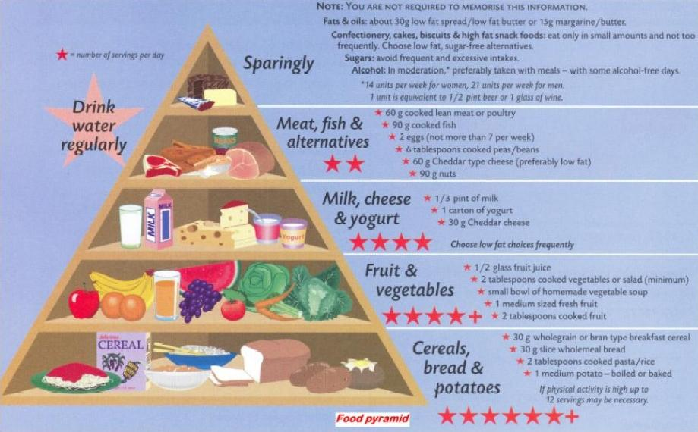

Qualitative study: a study determining the presence/absence of a substance or organism in a sample or habitat.
Quantitative study: a study determining the amount of a substance or number of an organism present in a sample or habitat.

Insert the correct answer from the lower grid into the correct position in the right hand column
1 | Non-living feature
2 | Survey indicating if a species is present or not
3 | Guide to identification
4 | Survey recording the numbers of a species
5 | Square frame used for sampling
6 | Fauna
7 | Adaptation feature
8 | Possible source of error in quantitative survey
9 | Way to present results of ecological survey
10 | Reason for using multiple quadrat samples
11 | An omnivore
12 | Flora
13 | Apparatus used to collect animals from an ecosystem
14 | Abiotic factors
15 | Position of an organism in a food chain

A | Abiotic factor | F | Key | K | Quadrat frame
B | Animals | G | More accurate; Reduce error | L | Qualitative
C | Bar chart; Table; Graph | H | Not enough samples taken | M | Quantitative
D | Colour for camouflage | I | Plants | N | Temperature; Water current; pH; Salinity
E | Human; Thrush; etc. | J | Pooter; Beating tray; Pitfall trap; Net | O | Trophic level

2.1 Cell Structure and Microscopy

KEYWORDS

Cell
Cell wall
Cellulose
Chloroplast
Electron microscope
Enzyme
Eukaryotic
Eyepiece lens
Mitochondrion
Nucleus
Photosynthesis
Prokaryotic
Prokaryotic [bacteria]
Prokaryotic Cell
Protein synthesis
Ribosome
Sap
Selectively Permeable
Vacuole

EXPLANATIONS

Cell: basic/smallest structural unit of living things capable of functioning independently. Contains the living contents and organelles of the cell and is surrounded by a cell membrane.
Eukaryotic cell: cell that has a membrane-bound (true) nucleus. It may also have other membrane-bound organelles, e.g. mitochondria and/or chloroplasts.
Prokaryotic cell: cell that does not have a membrane-bound (true) nucleus or membrane-bound organelles, e.g. bacteria. | 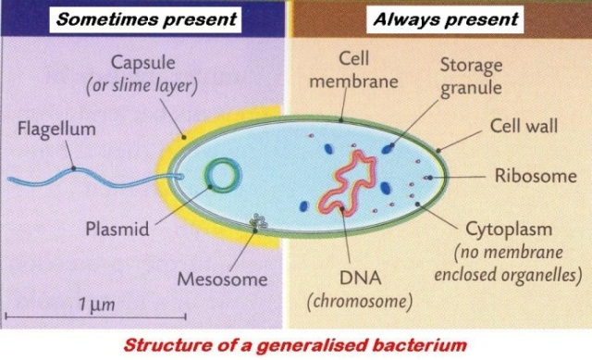
Selectively permeable membrane: also semi-permeable or partially permeable. This refers to the cell membrane. Allows certain molecules or ions to pass through but prevents others.
Note: the cell wall is fully permeable, i.e. it allows all molecules or ions to pass through.

Cell Structure and Microscopy 1

Insert the correct answer from the lower grid into the correct position in the right hand column
1 | A biological catalyst
2 | Microscope: eyepiece X 10; objective lens X 30; total magnification is ...
3 | Powerful microscope used to show cell ultrastructure
4 | Objective lenses 40X, 10X, and 4X. Which is used first?
5 | Purpose of a cover slip in microscopy
6 | Lenses closest to the stage are the eyepiece lenses. True or False
7 | Features of plant cells visible under a light microscope
8 | Vacuole contents
9 | Where phospholipids are found in cells
10 | Function of ribosome
11 | Function of cell membrane
12 | Amoeba - prokaryotic or eukaryotic?
13 | Selectively permeable (semi-permeable) membrane
14 | Features of plant cells not associated with animal cells
15 | Carbohydrate found in the cell wall

A | 300 | F | Cellulose | K | Membranes
B | 4X | G | Electron microscope | L | Protein synthesis
C | Allows some molecules through | H | Enzyme | M | Sap (water, glucose)
D | Cell wall; Chloroplasts; Large vacuoles | I | Eukaryotic | N | Selectively permeable
E | Cell wall; Vacuole; Chloroplast; Definite shape | J | False | O | To reduce evaporation; Hold specimen in place

Cell Structure and Microscopy 2

Insert the correct answer from the lower grid into the correct position in the right hand column
1 | The medium for chemical reactions in the cell is ...
2 | Plant cells have chloroplasts. True or False.
3 | Methylene blue is used to …
4 | Cell structures that indicates plant cells
5 | Cell membranes are semipermeable. True or False
6 | Location of cell membrane in plant cells
7 | Cells associated with membrane-bound organelles
8 | Chromosomes are found in the nucleus. True or False
9 | Feature that identifies a eukaryotic cell
10 | Cells similar to bacterial cells
11 | Chloroplasts contain DNA. True or False
12 | Animal cells do not have membranes. True or False
13 | Are fungi prokaryotic or eukaryotic?
14 | Iodine is used to ...
15 | Function of the chloroplast

A | Cell Wall; Chloroplast; Large Vacuole | F | Nucleus | K | True
B | Eukaryotic | G | Prokaryotic | L | True
C | Eukaryotic | H | Site of photosynthesis | M | True
D | False | I | Stain animal cells for microscopic examination | N | True
E | Immediately inside the cell wall | J | Stain plant cells for microscopic examination | O | Water

2.2.3 Enzymes

KEYWORDS

Amylase
Anabolism
ATP
Bioreactor
Buffer
Catabolism
Catalase
Enzyme
Hydrogen peroxide
Immobilisation
Immobilised Enzyme
Metabolism
Protease
Rate (of enzyme activity)
Sodium alginate
Specificity
Substrate
Water bath

EXPLANATIONS

Anabolism: a chemical reaction which joins small molecules to make larger, more complex ones using enzymes, e.g. photosynthesis, protein synthesis, etc. Anabolic reactions require (need) energy.
Bioreactor: a container in which a living thing/cells/enzymes are used in the production of something useful, e.g. during fermentation using yeast, yogurt production using bacteria, etc. | 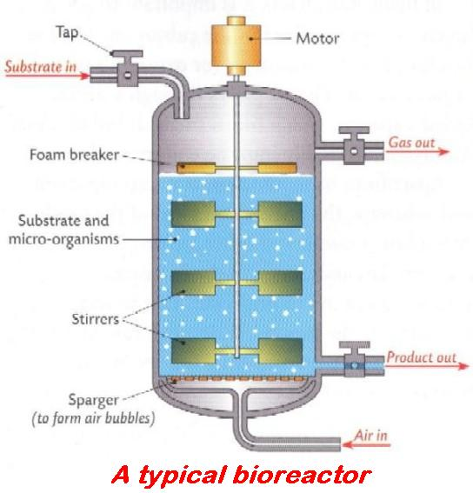
Catabolism: a chemical reaction which breaks down a large molecule into simpler ones using enzymes, e.g. respiration, digestion. Catabolic reactions release (produce) energy.
Enzymes: highly specific biological catalysts.
They are proteins with a definitive folded shape and are affected by heat (temperature), pH,. They control the rate of metabolic reactions such as respiration, photosynthesis, digestion and assimilation.
Immobilised enzyme: enzyme which is fixed to an inert material by chemical or physical means, e.g. trapped in beads or gel so that it will react with, but not mix with, its substrate.  This makes it easy to recover the enzyme from the product and it is reusable. | 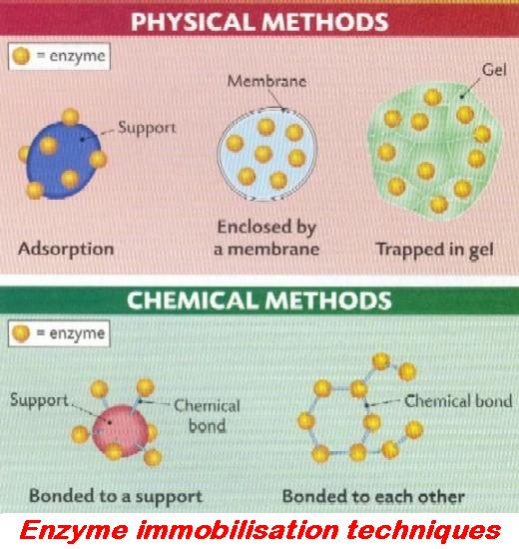
Metabolism: all chemical processes in living cells.
Enzymes catalyse metabolic reactions. Includes anabolism and catabolism.
Rate (of enzyme activity): the speed at which enzymes catalyse a reaction.

Insert the correct answer from the lower grid into the correct position in the right hand column
1 | All the chemical reactions in living cells
2 | Adenosine Triphosphate
3 | Group of molecules to which enzymes belong
4 | How to vary pH
5 | A vessel containing organisms producing useful products
6 | Advantage of an immobilised enzyme
7 | Biological protein catalyst
8 | Catalase substrate
9 | Influences the activity of an enzyme
10 | Enzyme attached or fixed or trapped
11 | Substance used to immobilise enzymes
12 | Advantages of using immobilised enzymes
13 | Joining small molecules to make larger ones
14 | Used to vary temperature in experiments
15 | Immobilised enzymes cannot act as catalysts. True or False
16 | Is an enzyme lipid, protein or carbohydrate?
17 | Substance acted upon by enzyme
18 | Breakdown of large molecules into smaller ones
19 | Iodine turns starch to a blue-black colour. True or False
20 | A measure of the acidity or alkalinity of a solution
21 | Enzymes are essential for metabolism. True or False
22 | All enzymes contain C, H, O and ...
24 | Enzyme, substrate and product
24 | Sources of energy

A | A bioreactor | I | False | Q | Proteins
B | Anabolism | J | Hydrogen peroxide | R | Solar and cellular
C | ATP | K | Immobilised | S | Substrate
D | Calcium (or sodium) alginate | L | It can be recovered | T | Temperature or pH
E | Can be reused; Pure product; Cost effective | M | Metabolism | U | True
F | Catabolic | N | Nitrogen | V | True
G | Catalase; hydrogen peroxide; oxygen | O | pH | W | Use buffers
H | Enzyme | P | Protein | X | Water bath or ice or thermostat

2.2.4 Photosynthesis

KEYWORD

Autotrophic
Chlorophyll
Chloroplast
Combustion
Data logger
Decomposition
Elodea
Light dependent stage
Light independent stage
Palisade layer
Photolysis
Photosynthesis
Reduction
Respiration
Stoma(ta)

EXPLANATION

Photosynthesis: the process in plants that makes food using light energy (carbon dioxide, water and chlorophyll).
_{light energy}
6CO₂ + 6H₂O C₆H₁₂O₆ + 6O₂
^{chlorophyll}
It occurs in the chloroplasts of green plants in which carbon dioxide and water, in the presence of light energy and chlorophyll, are converted into simple sugars and oxygen. The light energy is converted to chemical energy and is stored in the sugar molecule.

What happens to the products of photosynthesis? The simple sugars, e.g. glucose, are used in respiration, converted to starch and stored in the leaf, or transported in the phloem and stored elsewhere in the plant. The oxygen can be used in respiration or passed out to the atmosphere.

Chlorophyll (in chloroplasts) traps sunlight energy. This energy is used to split water (H₂O, from the soil) into protons (2 x H⁺), oxygen (O) and electrons (2 x e⁻). The electrons (e⁻) are passed to chlorophyll. The protons (H⁺) enter a pool of protons. Electrons from chlorophyll together with protons from the pool of protons are joined to carbon dioxide, from the atmosphere, (i.e. CO₂ is reduced) to form a carbohydrate C_{x}(H₂O)_{y}.

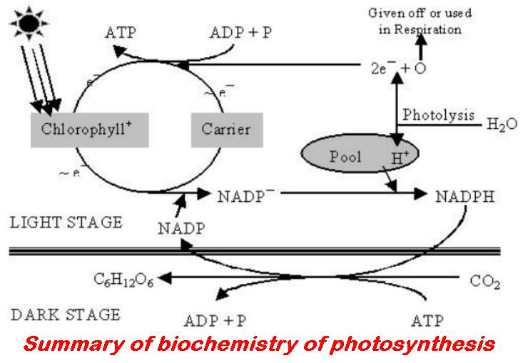

Photosynthesis 1

Insert the correct answer from the lower grid into the correct position in the right hand column
1 | Site of photosynthesis
2 | Sources of carbon dioxide in the atmosphere
3 | How to increase the rate of photosynthesis
4 | As light intensity increases, the rate of photosynthesis ...
5 | As light intensity decreases, the rate of photosynthesis ...
6 | How to vary light intensity in an experiment
7 | To measure the rate of photosynthesis
8 | Equation for photosynthesis
9 | Equation for aerobic respiration
10 | Fate of water molecules
11 | Sources of carbon dioxide in pond water
12 | Primary role of chlorophyll in photosynthesis
13 | During photosynthesis oxygen is produced from ...
14 | Oxygen produced during this stage of photosynthesis
15 | Fate of oxygen produced during photosynthesis
16 | Gas used (needed) for photosynthesis
17 | Gas produced during photosynthesis
18 | Energy source for photosynthesis

A | C₆H₁₂O₆ + 6O₂ Energy + 6CO₂ + 6H₂O | G | Decreases | M | Respiration (plant, animal, bacterial); Decomposition; From air
B | 6CO₂ + 6H₂O + Light + Chlorophyll C₆H₁₂O₆ + 6O₂ | H | Increase lighting, carbon dioxide or heating | N | Respiration; Combustion (burning)
C | Adjust lamp distance or bulb wattage | I | Increases | O | Respiration; Diffuses to atmosphere
D | Carbon dioxide | J | Light dependent stage | P | Sun or light
E | Chloroplast | K | Oxygen | Q | Trap or use light
F | Count no. of bubbles per minute or Use data logger | L | Photolysis or Split into Protons (H⁺), electrons and oxygen | R | Water

Photosynthesis 2

Insert the correct answer from the lower grid into the correct position in the right hand column
1 | Location of cells in leaf with most chlorophyll
2 | Term describing the nutrition of plants
3 | Organelle where chlorophyll is found
4 | Fate of Protons (H⁺) from splitting of water
5 | Fate of electrons from splitting of water
6 | Where carbon dioxide enters a leaf
7 | Part of the leaf where most photosynthesis occurs
8 | Needed for photosynthesis - carbon dioxide and ...
9 | Part of plant where most photosynthesis takes place
10 | Importance of photosynthesis
11 | Why cells in the palisade layer contain most chloroplasts
12 | As light intensity increases, the rate of photosynthesis ...
13 | As light intensity decreases, the rate of photosynthesis ...
14 | Method by which plants make their own food
15 | Role of chlorophyll in photosynthesis
16 | To measure the rate of photosynthesis
17 | Fate of water molecules
18 | Why use Elodea in photosynthesis experiment?

A | Autotrophic | G | Near upper surface | M | Released into pool and combine with CO₂ to form glucose
B | Chloroplast | H | Oxygen given off as bubbles; Elodea can survive under water | N | Stoma
C | Count no. of bubbles per minute; Use data logger | I | Palisade layer | O | Supplies O₂ and food for other organisms
D | Decreases | J | Passed to chlorophyll | P | To absorb light
E | Increases | K | Photolysis; Split into Protons (H⁺), electrons and oxygen | Q | Usually closer to the light
F | Leaf | L | Photosynthesis | R | Water

2.2.5 Respiration

KEYWORDS

Aerobic respiration
Alcohol
Anaerobic (conditions)
Anaerobic respiration
Cytoplasm
Cytosol
Ethanol
Fermentation
Glycolysis
Kreb’s cycle
Lactic acid
Lactate
Mitochondrion
Pyruvic acid
Pyruvate
Respiration

EXPLANATIONS

Aerobic respiration: the controlled release of energy from food within a cell using oxygen.
The process is controlled by enzymes and is very efficient, i.e. it releases a lot of energy.
C₆H₁₂O₆ + 6O₂ ENERGY + 6H₂O + 6CO₂
Anaerobic respiration: the controlled release of energy from food in a cell in the absence of oxygen.
The process is controlled by enzymes and is inefficient, i.e. it releases very little energy. Oxygen may be present but it will not be used, e.g.
(i) in yeast cells (fermentation)
C₆H₁₂O₆ Energy + 2C₂H₅OH + 2CO₂
ethyl alcohol + carbon dioxide
or ethanol + carbon dioxide
(ii) in human muscle (results in cramp)
C₆H₁₂O₆ Energy + 2CH₃CH(OH)COOH
lactic acid
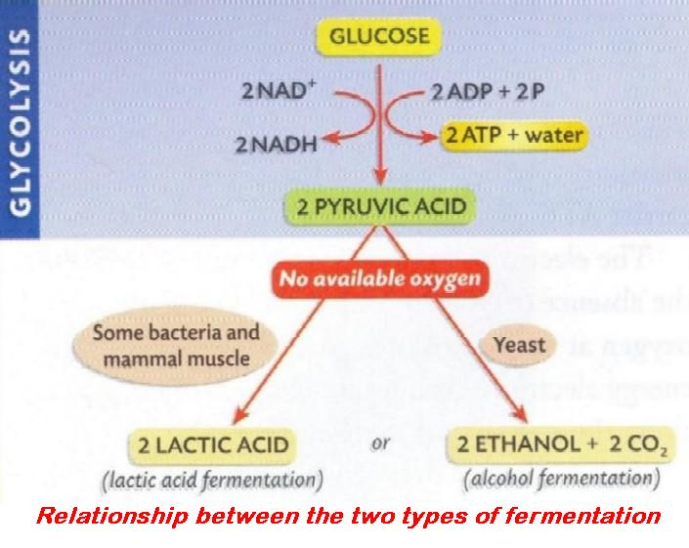

Fermentation: production of alcohol from starch and sugars contained in grain or fruit. (see anaerobic respiration above)
Respiration: the controlled release of energy from food, within the cell/cells of an organism.
It is a twenty-four hour process controlled by enzymes. It can occur with (aerobic respiration) or without (anaerobic respiration) the use of oxygen. It is also called internal respiration, tissue respiration or cellular respiration.

Aerobic respiration: C₆H₁₂O₆ + 6O₂ ENERGY + 6H₂O + 6CO₂

Anaerobic respiration: C₆H₁₂O₆ Energy + 2C₂H₅OH + 2CO₂

Respiration may occur as a one or a two-stage process. The first stage does not require oxygen, releases only a small amount of energy and occurs in the cytosol of the cell. The second stage does require oxygen, releases a large amount of energy and occurs in the mitochondrion. Anaerobic respiration is a first stage process. Aerobic respiration is a two-stage process.

Respiration 1

Insert the correct answer from the lower grid into the correct position in the right hand column
1 | Fermentation produces ...
2 | The first stage process of respiration is called ...
3 | In the first stage of respiration glucose is converted to ...
4 | In yeast pyruvic acid is converted to ...
5 | In anaerobic conditions in humans pyruvic acid is converted to ...
6 | Converting pyruvic acid to acetyl Co-enzyme A releases a molecule of...
7 | Acetyl co-enzyme A enters a cycle of reactions known as ...
8 | Site of Kreb's Cycle in cell
9 | Cytoplasm minus organelles or liquid part of cytoplasm
10 | Amount of energy released during first stage of respiration
11 | Respiration that produces alcohol
12 | Amount of energy released during second stage of respiration
13 | Site of second stage of aerobic respiration in cell
14 | Substance essential for aerobic respiration
15 | Lack of oxygen prevents which stage of respiration
16 | Is fermentation affected by temperature?
17 | Is oxygen required for the first stage of respiration?
18 | Substance produced during aerobic respiration and not during fermentation

A | Carbon dioxide | G | Kreb's Cycle | M | Oxygen
B | Cytosol | H | Lactic acid or lactate | N | Pyruvic acid or pyruvate
C | Ethanol | I | Large | O | Second stage
D | Ethanol and C0₂ | J | Mitochondrion | P | Small
E | Fermentation | K | Mitochondrion | Q | Water
F | Glycolysis | L | No | R | Yes

Respiration 2

Insert the correct answer from the lower grid into the correct position in the right hand column
1 | Substance that yeast can use to make ethanol
2 | Substance, other than ethanol, produced during fermentation
3 | Fermentation is finished
4 | Use for potassium iodide and sodium hypochlorite
5 | Substance produced during aerobic respiration and not during fermentation
6 | Purpose of Alkaline pyrogallol or an anaerobic jar
7 | Aerobic respiration
8 | Anaerobic respiration
9 | Site of the first stage of respiration
10 | Final product of the first stage of respiration
11 | Site of the second stage of respiration
12 | In anaerobic conditions in a human cell pyruvic acid converted to ...
13 | Is oxygen required for the first stage of respiration?
14 | In the absence of oxygen pyruvic acid may be converted to ...
15 | Industrial uses of anaerobic respiration of yeast
16 | Aerobic respiration is the release of energy in the absence of oxygen. True or False
17 | Acetyl co-enzyme A enters a cycle of reactions known as ...
18 | Does the second stage of aerobic respiration require oxygen?

A | Baking; Brewing | G | Lactic acid | M | Requires oxygen
B | Carbon dioxide | H | Lactic acid or Ethanol + C0₂ | N | Sugar; Starch
C | Cytoplasm or Cytosol | I | Mitochondrion | O | To remove oxygen
D | Does not require oxygen | J | No | P | To test for alcohol
E | False | K | No more gas given off (no more bubbles) | Q | Water
F | Kreb's Cycle | L | Pyruvic acid or Pyruvate | R | Yes

Respiration 3

Insert the correct answer from the lower grid into the correct position in the right hand column
1 | Controlled release of energy from food
2 | Energy release not requiring oxygen
3 | Why living organisms need to respire
4 | Type of respiration that releases most energy
5 | Industrial uses of anaerobic respiration of yeast
6 | Use of energy released in respiration
7 | Carbon dioxide is produced during respiration. True or False
8 | Some energy released in respiration is lost as heat. True or False
9 | Stage 1 of respiration requires oxygen. True or False
10 | Stage 1 of respiration takes place in the cytoplasm. True or False
11 | Stage 2 of respiration takes place in the cytoplasm. True or False
12 | Lactic acid is a product of anaerobic respiration. True or False
13 | Stage 1 or Stage 2. Takes place in the mitochondria
14 | Stage 1 or Stage 2. Large amount of energy produced
15 | Stage 1 or Stage 2. Takes place in the cytoplasm
16 | Stage 1 or Stage 2. Does not require oxygen.
17 | Respiration involving Stage 1 only
18 | Substance essential for aerobic respiration

A | Aerobic | G | Muscular activity; Respiration | M | Stage 2
B | Anaerobic or fermentation | H | Oxygen | N | To provide energy for metabolic activities
C | Anaerobic respiration | I | Respiration | O | True
D | Baking; brewing | J | Stage 1 | P | True
E | False | K | Stage 1 | Q | True
F | False | L | Stage 2 | R | True

2.2.6 Movement through Membranes

KEYWORDS

Active transport
Chloroplast
Diffusion
Hypertonic
Hypotonic
Isotonic
Mitochondrion
Nucleus
Osmosis
Passive transport
Permeable
Sap
Selectively Permeable
Semi/selectively permeable
Turgor
Vacuole

EXPLANATIONS

Diffusion: the movement of solute (gas or liquid molecules) from a region of high solute concentration to a region of lower solute concentration.
No permeable or semi-permeable membrane is necessary for diffusion to occur. No energy used by the cell in diffusion, i.e. it is a passive process.
Examples of diffusion: gaseous exchange in alveoli; absorption through villi of small intestine.
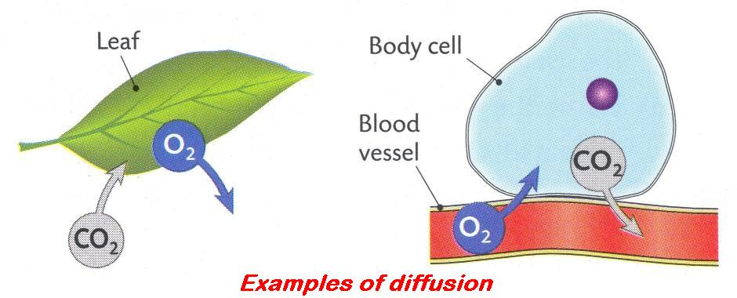

Osmosis: a special case of diffusion. It is the movement of solvent (always water) from a region of high solvent concentration to a region of lower solvent concentration through a semi-permeable membrane, until both concentrations are equal.  No energy used by the cell for osmosis to take place, i.e. it is a passive process.  Examples of osmosis: water entering root hair cell; water moving from cell to cell in transpiration. | 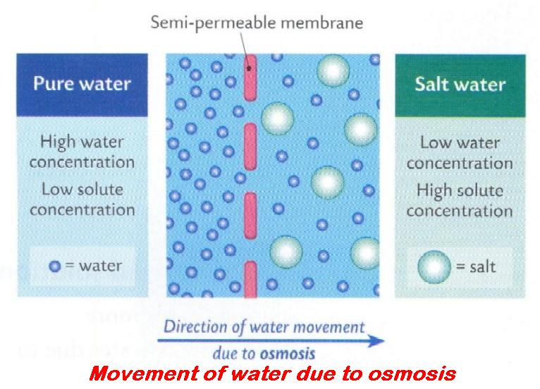
Selectively permeable membrane: also semi-permeable or partially permeable. This refers to the cell membrane. Allows certain molecules or ions to pass through but prevents others.
Note: the cell wall is fully permeable, i.e. it allows all molecules or ions to pass through.
Turgor: state of a plant cell due to pressure built up in the cell; exerted outwards and caused by the cell taking in water by osmosis. | 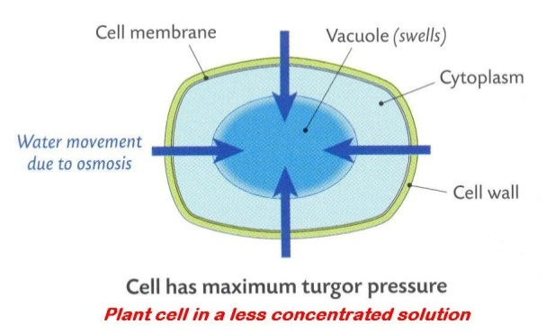
Insert the correct answer from the lower grid into the correct position in the right hand column
1 | Movement of water along a gradient through a selectively permeable membrane
2 | Allowing some substances to pass through
3 | Pressure built up in cell by taking in water by osmosis
4 | Locations in a cell with selectively permeable membranes
5 | Movement of molecules along a concentration gradient
6 | Having a lower solute concentration than the surrounding solution
7 | How high sugar or salt concentrations preserve food
8 | Water movement between cells or from soil to root
9 | Having a higher solute concentration than the surrounding solution
10 | Substance found in a plant cell vacuole
11 | No energy required for movement of substances
12 | Having the same solute concentration as another solution
13 | Example of passive transport
14 | Plant cell walls are fully permeable. True or False
15 | Movement of molecules against a concentration gradient

A | Active transport | F | Examples of osmosis in plants | K | Passive transport
B | Bacteria lose water by osmosis - inactivity or death | G | Hypertonic | L | Selectively permeable
C | Chloroplast; Mitochondrion; Nucleus; Vacuole | H | Hypotonic | M | True
D | Diffusion | I | Isotonic | N | Turgor
E | Diffusion | J | Osmosis | O | Water or Sugar or Sap or Salt(s)

2.2.7 Enzymes Higher Level

KEYWORDS

Agar plate
Bioreactor
Denatured enzyme
Denaturation
Enzyme
Hydrogen peroxide
Immobilised
Optimum Conditions
Optimum pH
Salinity
Sodium alginate
Specificity

EXPLANATIONS

Denaturation: changes in the shape of an enzyme (protein) due to extreme conditions, such as high temperature, unsuitable pH, or the presence of certain chemicals. If these changes are permanent they destroy the activity of the enzyme and the enzyme is denatured. | 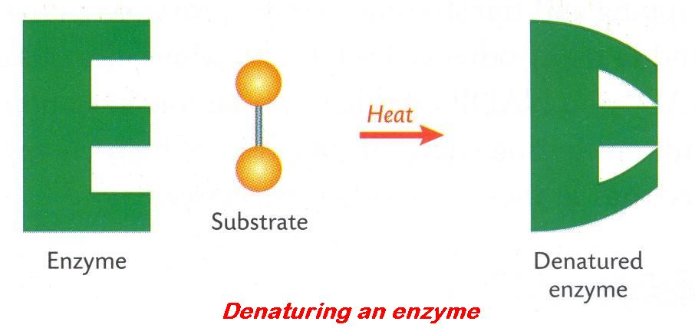
Optimum conditions: best or most favourable conditions for growth, reproduction, enzyme activity, etc.
Specificity: one enzyme will catalyse only one reaction.
The active site of an enzyme is not a fixed shape. It can change slightly to better fit the shape of the substrate when forming the enzyme-substrate complex.
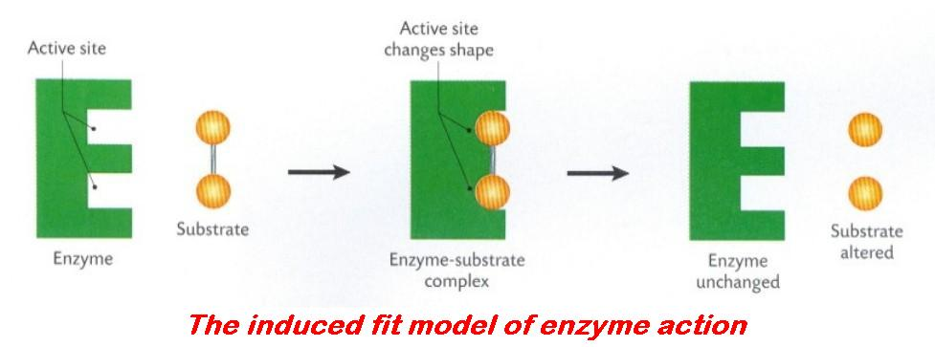

Insert the correct answer from the lower grid into the correct position in the right hand column
1 | A vessel containing organisms producing useful products
2 | Active Site
3 | Group of molecules to which enzymes belong
4 | Temperature at which human enzymes work best
5 | Enzymes are not essential for metabolism. True or False
6 | Shape of an enzyme
7 | Loss of enzyme function or activity
8 | Catalase
9 | Enzyme's optimum pH
10 | Enzyme attached or fixed or trapped
11 | Specificity of an enzyme
12 | Substance used to immobilise enzymes
13 | How an enzyme may be denatured
14 | Features of a denatured enzyme
15 | Immobilised enzymes can act as catalysts. True or False

A | 37 °C | F | Enzyme | K | Hydrogen peroxide
B | A bioreactor | G | Enzyme acts on only a particular substrate | L | Immobilised
C | Calcium (or sodium) alginate | H | False | M | pH at which enzyme works best
D | Changed structure; Loss of function | I | Folded | N | Proteins
E | Denatured enzyme | J | High temperature or Extreme pH or Agitation or High salinity | O | True

2.2.9 Photosynthesis Higher Level

KEYWORDS

ATP
Carbohydrates
Chlorophyll
Chloroplast
Dark stage
Decomposition
Glucose
Light dependent stage
Light independent stage
Metabolic reactions
NADP
Protons
Respiration

EXPLANATIONS

ATP: adenosine triphosphate. ATP is the source of energy in a cell – it traps and transfers energy for cell activities.  A compound composed of a molecule of adenine, one of ribose and three phosphate groups. The bonds between the phosphate groups are high-energy bonds.  When these bonds are broken, energy is released. ATP is formed in the mitochondria of a cell during respiration and in the chloroplast during photosynthesis. ATP converted to ADP with the release of energy and a phosphate group. | 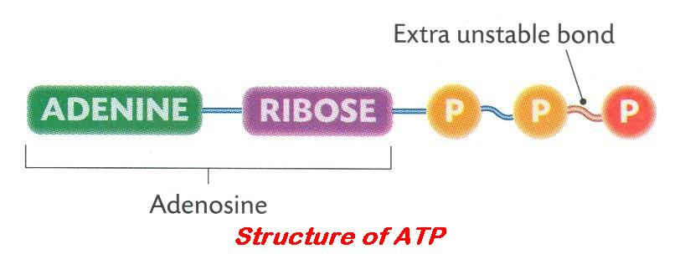
ATP significance: present in all cells and supplies energy (which has come from food or sunlight) for all processes that need it, e.g. protein synthesis, muscle contraction, nerve impulse transmission, etc.
NADP: nicotinamide adenine dinucleotide phosphate. NADP traps and transfers hydrogen ions (H⁺) in cell activities. It is necessary in photosynthesis.

Insert the correct answer from the lower grid into the correct position in the right hand column
1 | Sources of carbon dioxide in pond water
2 | Role of carbon dioxide in photosynthesis
3 | Role of water in photosynthesis
4 | Light stage
5 | Dark stage
6 | ATP = ?
7 | ATP formed during this stage of photosynthesis
8 | Energised electron
9 | Carbohydrate formed during this stage of photosynthesis
10 | P ~ P bond found here
11 | Fate of O₂ produced in light stage
12 | Fate of ATP produced in light stage
13 | Gas essential for the dark stage of photosynthesis
14 | Products of light stage vital for the dark stage
15 | Group of biomolecules to which the products of the dark stage belong
16 | From what substance is oxygen produced?
17 | Stage of photosynthesis in which oxygen is produced
18 | Location in plant cell where photosynthesis take place
19 | Where energised electrons come from
20 | Compound from which plant obtains the H used to make C_{x}(H₂0)_{y}
21 | Compound that supplies energy for the second stage reactions

A | Adenosine triphosphate | H | Dark stage | O | NADPH₍₂₎ and ATP
B | Adenosine triphosphate | I | Electron with extra energy from the sun | P | Respiration (plant, animal, bacterial); Decomposition; From air
C | ATP | J | For use in dark stage or Metabolic reactions | Q | Respired or Released (into atmosphere)
D | Carbohydrates | K | Light dependent stage (light necessary) | R | Supplies carbon for the formation of glucose
E | Carbon dioxide | L | Light (dependent) stage | S | Supplies protons (H⁺) and electrons or Photolysis
F | Chlorophyll | M | Light independent stage | T | Water
G | Chloroplast | N | Light stage | U | Water

2.2.10 Respiration Higher Level

KEYWORDS

Acetyl Co-enzyme A
Anaerobic
ATP
Electron transport chain
Ethanol
Fermentation
Glycolysis
Kreb’s cycle
Lactic acid
Protons
Pyruvic acid
Pyruvate

EXPLANATIONS

Glycolysis: the first stage of respiration that involves the conversion of glucose (6-carbon compound) to pyruvic acid (3-carbon compound) in the cytosol (cytoplasm) with the release of a small amount of energy.
Energy is also required to start this process.

Insert the correct answer from the lower grid into the correct position in the right hand column
1 | In glycolysis glucose is converted to ...
2 | Without oxygen yeast converts pyruvate to ...
3 | Without oxygen muscle cells convert pyruvate to ...
4 | Without oxygen Pyruvate converted to Acetyl Co-enzyme A with release of...
5 | With oxygen Acetyl Co-enzyme A enters a cycle of reactions called ...
6 | How oxygen debt is paid
7 | Name given to the first stage of respiration
8 | Respiration involving Stage 1 only
9 | Without oxygen pyruvic acid converted to ...
10 | Substance produced during aerobic respiration and not during fermentation
11 | Kreb's cycle produces energy in the form of...
12 | At the end of the transport chain electrons are given to ...
13 | End products of anaerobic respiration
14 | Molecule in which energy is stored in the cell
15 | In mitochondria pyruvate converted to CO₂ and a two-carbon compound called ...

A | Acetyl Co-enzyme A | F | Ethanol + CO₂ | K | Lactic acid
B | Anaerobic or Fermentation | G | Ethanol; Lactic acid; CO₂ | L | Lactic acid or Ethanol + CO₂
C | ATP | H | Glycolysis | M | Oxygen or Protons (to form water)
D | ATP | I | Increased breathing rate | N | Pyruvic acid or Pyruvate
E | Carbon dioxide | J | Krebs cycle | O | Water

2.3 Cell Continuity

KEYWORDS

Anaphase
Cancer
Carcinogen
Cell continuity
Cell cycle
Chromosome
Continuity of life
Diploid number
Egg
Gamete
Haploid number
Meiosis
Meristematic tissue
Metaphase
Mitosis
Mutation
Prophase
Radiation
Reproduction
Sperm
Spindle
Telophase

EXPLANATIONS

Cancer: a group of disorders caused by the abnormal and uncontrolled division of cells by mitosis.
This results from the loss of control over their rate of growth and cell division, and forms a tumour which then invades the surrounding tissues.
Cell continuity: cells surviving, growing and dividing and being passed from one generation to the next. Cells can only be made from pre-existing cells.
Chromosome: rod/thread-like structure composed of DNA and protein.
It contains the genetic information (genes) which is passed from one generation of cells or organisms to the next. Chromosomes occur in pairs (diploid) in most plant and animal cell nuclei.
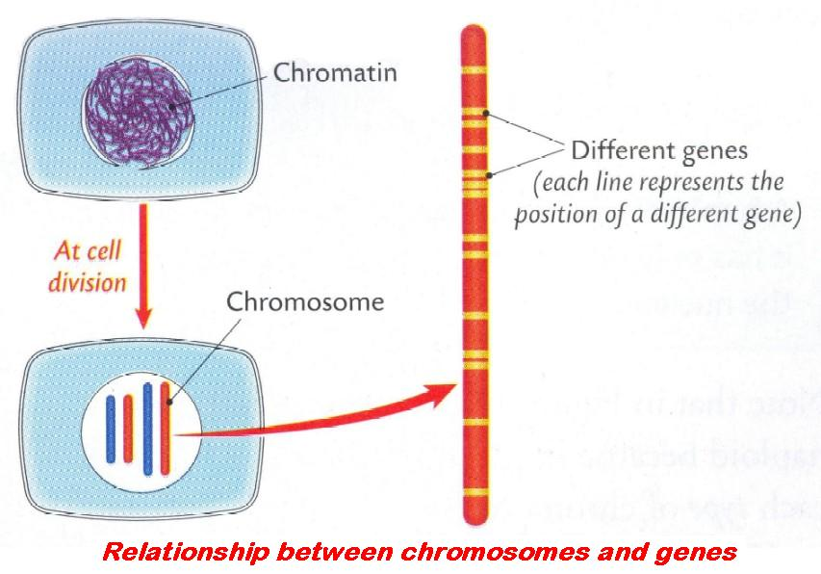 | 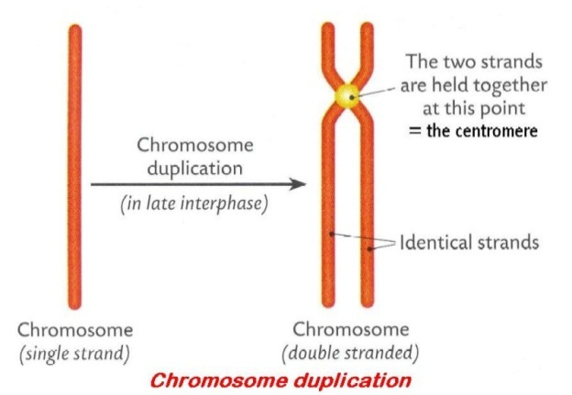
Continuity of life: the ability of organisms to exist from one generation to the next.
Diploid (2n): every organism has a fixed number of chromosomes. If they occur in pairs (homologous pairs) the organism is said to be diploid (2n), i.e. two sets of chromosomes – one set received from the father and one set from the mother at fertilisation, e.g. human 2n = 46, mouse 2n = 40, fruit fly 2n = 8. OR double the number of chromosomes found in gametes.
Gamete: any haploid sex cell which must fuse with another sex cell in order to produce a new individual.  A haploid reproductive cell, i.e. it contains half the required genetic information for the formation of a new individual or half the somatic number of chromosomes (in humans = 23), e.g. sperm cell, egg. | 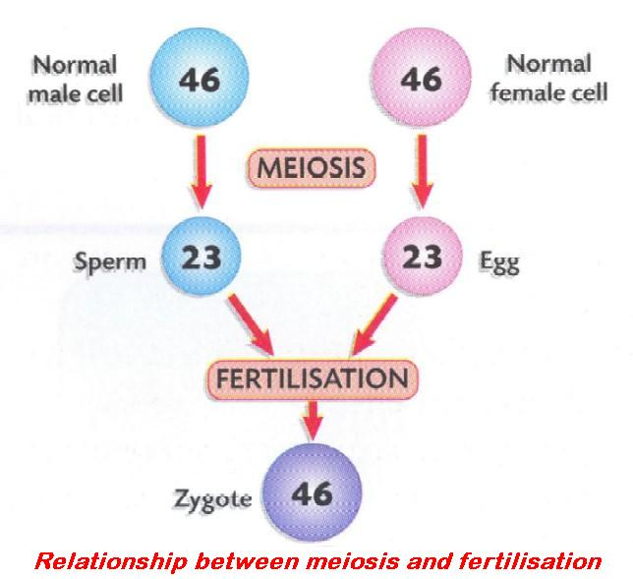
Haploid (n):
1. Having one of each of the pairs of chromosomes characteristic for a species. OR
2. Half the somatic number of chromosomes. OR
3. A single set of unpaired chromosomes.
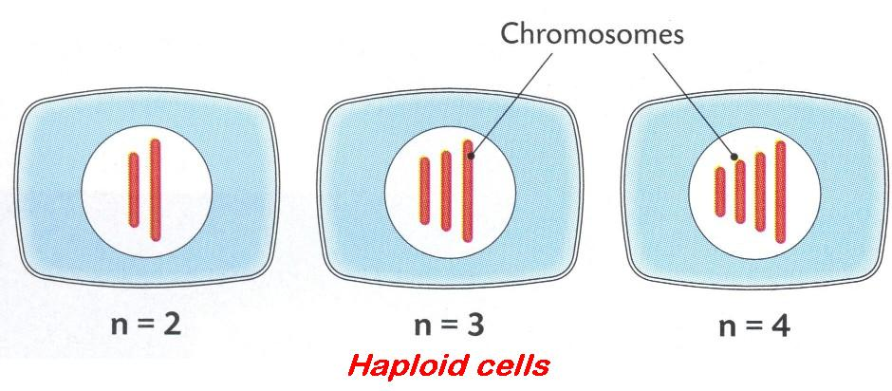

Meiosis: a cell division of gamete or spore producing cells. The diploid nucleus divides to form four different haploid daughter nuclei.

• Can take place in diploid cells only.
• Produces four cells that may all be different genetically.
• Daughter cells have half the number of chromosomes as the parent cell.
• Meiosis helps to maintain the chromosome number of the parent by producing haploid gametes in sexual reproduction.
• It also introduces variations into a species by mixing the genetic material that passes on to the next generation.
Mitosis: cell division where one nucleus (haploid or diploid) divides to form two identical daughter nuclei, similar to the parent cell.
It is the usual method of cell division by cells not involved in the formation of gametes (somatic cells). It occurs in a series of stages: prophase, metaphase, anaphase, telophase and a resting or preparatory stage – interphase.
- It takes place in haploid and diploid cells.
- Produces two daughter cells which are genetically identical and have the same number of chromosomes as the parent cell.
- Daughter cells are smaller in size than the parent cell.
- Is a method of reproduction in unicellular organisms but is mainly for growth and repair in multicellular organisms.

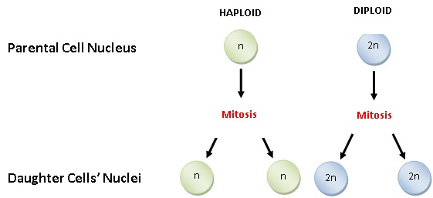

Cell Continuity 1

Insert the correct answer from the lower grid into the correct position in the right hand column
1 | Haploid human cell
2 | Function of mitosis in a single-celled organism
3 | Function of mitosis in a multicellular organism
4 | How mitosis differs from meiosis
5 | Function of meiosis
6 | Stages of mitosis
7 | Spindle fibres contract during ...
8 | Diploid number
9 | Group of disorders in which cells lose regulation of mitosis
10 | Location of mitosis in flowering plants
11 | Haploid number
12 | Number of new cells produced by mitosis
13 | Mitosis divides a nucleus into two identical nuclei. True or False
14 | A sperm contains the diploid number of chromosomes. True or False
15 | When chromosomes are located at the equator of the cell

A | Anaphase | F | Meristematic tissue | K | Reproduction
B | Cancer | G | Metaphase | L | Sperm or Egg
C | Chromosomes in pairs | H | No reduction in chromosome number | M | To produce gametes
D | False | I | One set of chromosomes | N | True
E | Growth; Repair | J | Prophase; Metaphase; Anaphase; Telophase | O | Two

Cell Continuity 2

Insert the correct answer from the lower grid into the correct position in the right hand column
1 | Number of new cells produced by meiosis
2 | If the diploid number in a cell is 46, the haploid number is ...
3 | The cells produced by meiosis are haploid.  True or False
4 | The cells produced by mitosis are identical. True or False
5 | Meiosis gives rise to variation. True or False
6 | Mitosis always produces four new cells. True or False
7 | Meiosis is never involved in gamete formation.  True or False
8 | Single-celled organisms use mitosis for reproduction. True or False
9 | Structures in nuclei responsible for biological inheritance
10 | Genes are found on structures in the nucleus called ...
11 | Function of spindle fibres during cell division
12 | Type of cell division by which tissues grow
13 | Possible causes of cancer
14 | During metaphase chromosomes are attached to the ...
15 | Type of cell in which a cell plate forms

A | 23 | F | False | K | To contract and separate chromosomes
B | Carcinogen; Mutation; Radiation | G | Four | L | True
C | Chromosomes | H | Mitosis | M | True
D | Chromosomes | I | Plant cell | N | True
E | False | J | Spindle | O | True

Cell Continuity 1 and 2

Insert the correct answer from the lower grid into the correct position in the right hand column
1 | A sperm contains the diploid number of chromosomes. True or False
2 | Diploid number
3 | During metaphase chromosomes are attached to the ...
4 | Function of meiosis
5 | Function of mitosis in a multicellular organism
6 | Function of mitosis in a single-celled organism
7 | Function of spindle fibres during cell division
8 | Genes are found on structures in the nucleus called ...
9 | Group of disorders in which cells lose regulation of mitosis
10 | Haploid human cell
11 | Haploid number
12 | How mitosis differs from meiosis
13 | If the diploid number in a cell is 46, the haploid number is ...
14 | Location of mitosis in flowering plants
15 | Meiosis gives rise to variation. True or False
16 | Meiosis is never involved in gamete formation. True or False
17 | Mitosis always produces four new cells. True or False
18 | Mitosis divides a nucleus into two identical nuclei. True or False
19 | Number of new cells produced by meiosis
20 | Number of new cells produced by mitosis
21 | Possible causes of cancer
22 | Single-celled organisms use mitosis for reproduction. True or False
23 | Spindle fibres contract during ...
24 | Stages of mitosis
25 | Structures in nuclei responsible for biological inheritance
26 | The cells produced by meiosis are haploid. True or False
27 | The cells produced by mitosis are identical. True or False
28 | Type of cell division by which tissues grow
29 | Type of cell in which a cell plate forms
30 | When chromosomes are located at the equator of the cell

A | 23 | K | Four | U | Sperm or Egg
B | Anaphase | L | Growth; Repair | V | Spindle
C | Cancer | M | Meristematic tissue | W | To contract and separate chromosomes
D | Carcinogen; Mutation; Radiation | N | Metaphase | X | To produce gametes
E | Chromosomes | O | Mitosis | Y | True
F | Chromosomes | P | No reduction in chromosome number | Z | True
G | Chromosomes in pairs | Q | One set of chromosomes | A2 | True
H | False | R | Plant cell | B2 | True
I | False | S | Prophase; Metaphase; Anaphase; Telophase | C2 | True
J | False | T | Reproduction | D2 | Two

2.4 Cell Diversity

KEYWORDS

Connective tissue
Conserve
Epithelial tissue
Mitosis
Organ
Organ System
Phloem
Tissue
Tissue culture
Vascular tissue
Xylem

EXPLANATIONS

Organ: a structure containing a group of tissues with a common function(s).  e.g. plant organs: leaf, root, stem, flower; animal organs: stomach, ear, testis, ovary, etc. | 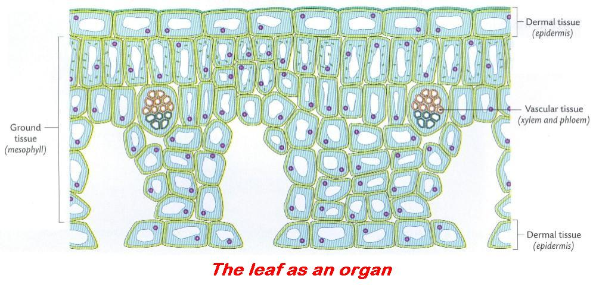
Organ systems: a group of organs working together to carry out a function, e.g. digestive system.
Tissue: group of cells with a similar function, e.g.
• plant tissues: meristematic tissue and vascular tissue;
• animal tissues: muscular tissue and nervous tissue.
Tissue culture: a method for growing individual cells (outside an organism) in a container of sterile nutrient medium to which hormones and growth substances may have been added.
This process is used in cancer research and plant propagation.

Insert the correct answer from the lower grid into the correct position in the right hand column
1 | Cells with common function
2 | Vascular (plant) tissue function
3 | Ground (plant) tissue function
4 | Dermal (plant) tissue function
5 | Animal tissue for movement
6 | Animal protective tissue
7 | Animal transport tissue
8 | Animal communication tissue
9 | Animal support tissue
10 | Cells grown on medium outside organism
11 | Application of tissue culture
12 | Vascular tissues found in flowering plants
13 | Gas needed to release energy to make a skin graft
14 | Suitable temperature to make skin cells grow
15 | Why sterile conditions are needed in tissue culture
16 | Type of cell division involved in tissue culture
17 | Group of tissues working together
18 | Plant organs

A | Body temperature | G | Nervous | M | Tissue culture
B | Connective | H | Organ | N | To conserve rare or Endangered plant species
C | Epithelial | I | Oxygen | O | To prevent bacterial growth
D | Leaf; Root; Stem; Bud; Tuber; Flower | J | Protection | P | Transport
E | Mitosis | K | Storage | Q | Vascular
F | Muscular | L | Tissue | R | Xylem; Phloem

2.5.1 - 2 Variation, Heredity, etc.

KEYWORDS

Chromosomes
Expression
Gene
Gene Expression
Genetics
Heredity
Inheritance
Meiosis
Mutation
Nucleus
Sexual reproduction
Species
Variation

EXPLANATIONS

Expression: (of gene) how the genetic information in the gene shows itself in the phenotype and how it is influenced by the environment.
Gene expression: the process of changing the information in a gene into a protein and the effect that protein has on the organism. | 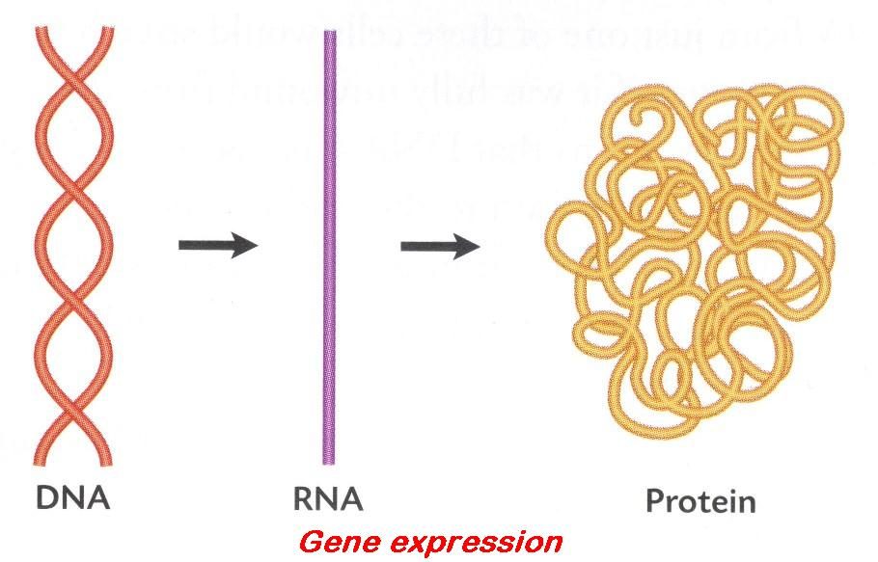
Heredity: offspring inherit various physical and mental traits of their parents or ancestors, i.e. certain traits, controlled by a genetic code within the chromosomes, are transmitted from one generation to the next.
Species: group of animals or plants that can interbreed and produce viable, fertile offspring.
Members of a species share the same characteristics and differ only in minor details. Each member of a species is unique.
Variation: differences between members of a species, group or population.
Only those variations (changes) that can be inherited or passed on are advantageous as they will accumulate over millions of years and give rise to new species. Variations are the 'functional units' of evolution.

Insert the correct answer from the lower grid into the correct position in the right hand column
1 | Differences between individuals within a population
2 | Interbreeding results in fertile offspring
3 | Cause of genetic variation
4 | Organisms of the same species usually produce fertile offspring. True or False
5 | Genetics is the study of...
6 | Chromosomes are made of DNA and lipid. True or False
7 | Unit of heredity or code for protein
8 | Where chromosomes are found in the cell
9 | Structures containing genes
10 | Part of DNA with information to make one protein
11 | Example of an inherited human characteristic
12 | Example of a non-inherited human characteristic
13 | Changing the information in a gene into a protein
14 | All individuals within a species are the same. True or False
15 | Cloned individuals are exactly the same. True or False

A | Ability to roller skate | F | Gene | K | Sexual reproduction; Meiosis; Mutation
B | Chromosomes | G | Gene | L | Species
C | Eye colour | H | Gene expression | M | True
D | False | I | In the nucleus | N | True
E | False | J | Inheritance | O | Variation

2.5.4 DNA, Replication, etc.

KEYWORDS

Amino acids
Coding DNA
Complementary
Cytoplasm
DNA profiling
Gene
Genetic screening
Junk DNA
mRNA
Nitrogenous base
Non-coding DNA
Nucleic acid
Paternity
Protease
Replication (DNA)
Ribosomes
rRNA
Thymine
Transcription
Translation
Triplet
tRNA
Uracil

EXPLANATIONS

Coding DNA: the part of a chromosome which contains information to make a protein.
DNA profile: a picture (auto radiograph) of the pieces of DNA produced when an organism’s DNA is broken up using specific enzymes and then sorted by size on a gel.  The stages involved are:  1. Cells are broken down to release DNA.  2. DNA strands are cut into fragments using restriction enzymes.  3. Fragments are separated on the basis of size using gel electrophoresis.  4. The pattern of fragment distribution is analysed. | 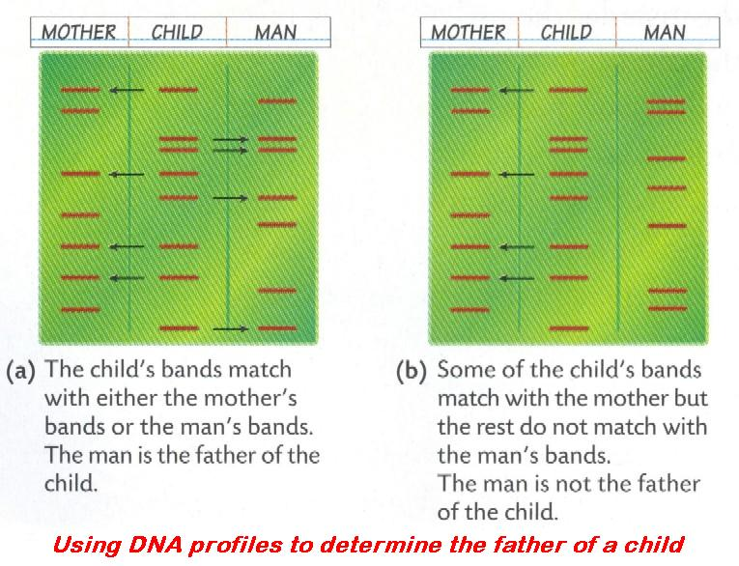
Gene: unit of heredity found on a chromosome, and is an instruction to the cell to make a particular substance, a protein, which helps regulate a trait (characteristic) of an organism. | 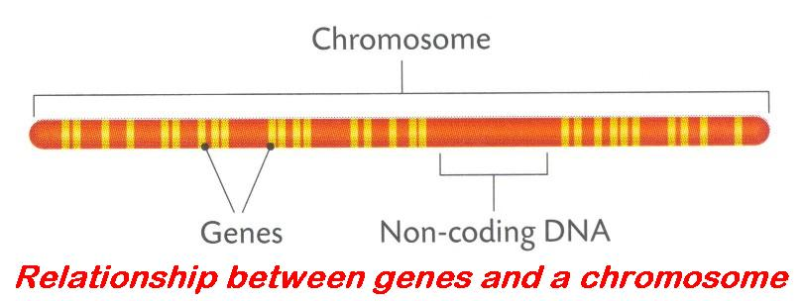
Genetic screening: tests to identify the presence of a specific gene or the presence or absence of changed or harmful genes possessed by an individual.
Non-coding DNA: the part of a chromosome which does not contain information to make a protein. See diagram above.

Insert the correct answer from the lower grid into the correct position in the right hand column
1 | Nitrogenous base of DNA
2 | Ribosome
3 | RNA
4 | RNA involved in protein synthesis
5 | Role of mRNA
6 | Role of rRNA
7 | Role of RNA
8 | Why use a blender when extracting DNA?
9 | Time the blender should be run when extracting DNA
10 | Why use washing-up liquid when extracting DNA?
11 | Why use salt when extracting DNA?
12 | Breaks down protein
13 | Why use a protease enzyme when extracting DNA?
14 | Type of alcohol (ethanol) used when separating DNA
15 | Genetic screening
16 | DNA profiling
17 | Applications of DNA profiling
18 | Genetic code in DNA

A | A few seconds | G | Ice cold | M | Three bases in sequence code for one amino acid
B | Break cell walls to release cytoplasm | H | mRNA; rRNA; tRNA | N | Thymine
C | Carry complementary amino acids to ribosomes | I | Protease | O | To break down membranes
D | Digest proteins associated with DNA | J | Protein | P | Transcription
E | Examining DNA for a pattern for comparison | K | Separates protein from DNA | Q | Translation
F | Forensic science; Paternity; Medical | L | Testing for the presence of a specific gene | R | Uracil

2.5.5+15 Protein synthesis

KEYWORDS

Amino acids
Codon
DNA
mRNA
Nucleus
Ribosomes
Transcription
Translation

EXPLANATIONS

Transcription: the making of mRNA from a single strand of DNA. | 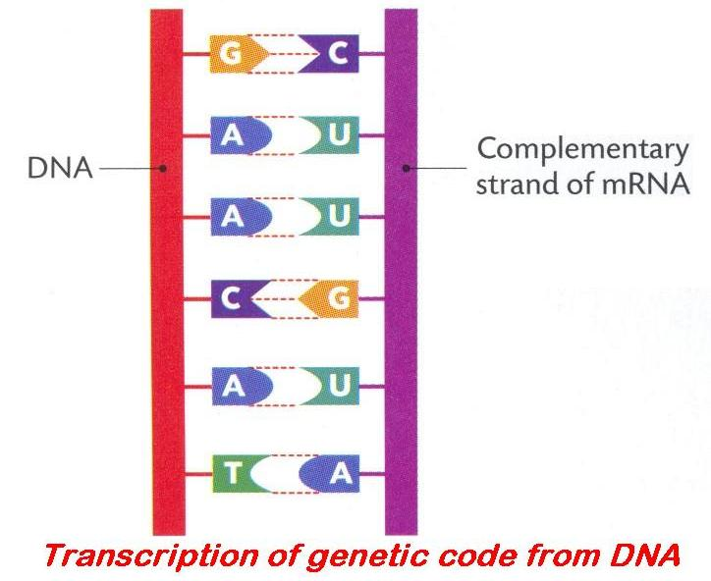
Translation: the making of a protein from an mRNA by translating the genetic information it contains to a sequence of amino acids. | 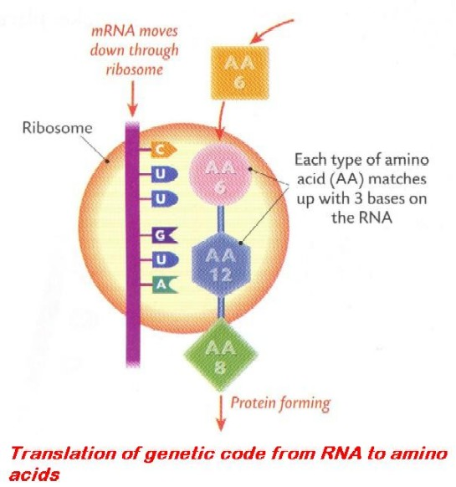

Insert the correct answer from the lower grid into the correct position in the right hand column
1 | Replication of DNA
2 | Transcription
3 | Role of rRNA
4 | The letter 't' in tRNA
5 | To make proteins, DNA is first transcribed as ...
6 | Where enzymes are produced in cells
7 | Where transcription occurs in a cell
8 | Type of RNA involved in transcription
9 | Where translation occurs in a cell
10 | Biomolecules that are joined together to make a protein
11 | A newly formed protein must ... before it can begin to work
12 | Triplet
13 | Role of a triplet
14 | Role of tRNA
15 | Translation
16 | Number of bases in a codon
17 | Types of mRNA codon
18 | During translation attached to a tRNA molecule

A | Amino acids | G | Making RNA from a single strand of DNA | M | Ribosome
B | Be folded into its functional shape | H | mRNA | N | Sequence of three nitrogenous bases of mRNA
C | Carry specific amino acids to the ribosomes | I | mRNA | O | Start; Add an amino acid; Stop
D | Codes for a specific amino acid | J | mRNA codon; An amino acid | P | Three
E | Making a copy | K | Nucleus | Q | Transfer
F | Making a protein using mRNA code | L | Ribosome | R | Translation

2.5.6 Genetic Inheritance

KEYWORDS

Alleles
Chromosome
Dominance
Dominant
Fertilisation
Gamete
Gene
Genotype
Heterozygous
Homozygous
Incomplete dominance
Non-coding
Phenotype
Recessive
X chromosome
XX
XY
Y chromosome

EXPLANATIONS

Allele: alternative forms of a gene or a pair of genes found at the same locus/position on homologous chromosomes controlling the same trait, e.g. T and t; T is an allele of t.
Dominance: (genetics) characteristic, trait or gene which expresses itself in offspring, even when the corresponding opposite one (recessive) is also inherited, e.g. Tt = tall, T is dominant or, simply, dominant gene = gene that is expressed in the heterozygous condition.
Fertilisation: the union of a haploid male gamete nucleus with a haploid female gamete nucleus resulting in the formation of a diploid zygote.  In the human female this occurs about halfway along the fallopian tube. | 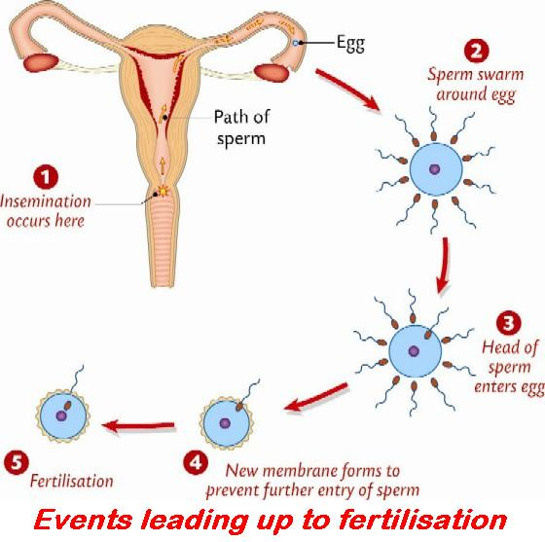
Gamete: any haploid sex cell which must fuse with another sex cell in order to produce a new individual.
A haploid reproductive cell, i.e. it contains half the required genetic information for the formation of a new individual or half the somatic number of chromosomes (in humans = 23), e.g. sperm cell, egg.
Genotype: genetic makeup of an individual or the genes that they inherit, e.g. Tt.
Heterozygous: possessing a pair of dissimilar genes (alleles) for a trait, e.g. Tt, i.e. the dominant and recessive genes.
Homozygous: an organism that breeds true (true-breeding) for a particular trait, because it possesses a pair of similar genes for the trait, e.g. TT or tt.
Incomplete dominance: in the heterozygous condition both alleles show complete dominance and an intermediate phenotype results, e.g. in shorthorn cattle red x white, F1 = Roan. It is also called co-dominance.
Phenotype: physical appearance of an individual as a result of the interaction of the genotype with the environment.
Recessive (allele): gene which can only be expressed when both alleles are the same, i.e. homozygous condition, e.g. tt = dwarf; t is recessive. OR The expression of the recessive allele is masked by a dominant allele.

Insert the correct answer from the lower grid into the correct position in the right hand column
1 | Individual's genetic make up
2 | Recessive
3 | Alleles
4 | Homozygous
5 | Phenotype
6 | Dominant
7 | Heterozygous
8 | If parent is Aa possible gametes that it can produce are ...
9 | Incomplete dominance
10 | If parent is AaBb possible gametes that it can produce are ...
11 | Human male sex chromosomes
12 | Human female sex chromosomes
13 | What is 'junk' DNA?
14 | When isolating DNA the first procedure was ...
15 | When isolating DNA why did you use wash-up liquid?
16 | Linkage
17 | Why is a protease necessary when isolating DNA?
18 | Sex-linkage

/A | A and a | G | Form of a gene | M | Non-coding
B | AB; Ab; aB; ab | H | Genes located on X or Y chromosome | N | Physical appearance of genotype
C | Allele that masks its recessive partner | I | Genes on the same chromosome | O | To disrupt membranes
D | Alleles different | J | Genotype | P | To separate DNA from protein
E | Chop | K | Identical alleles or genes | Q | XX
F | Expressed when homozygous only | L | Neither allele masks the expression of the other | R | XY

2.5.7 - 8 Variation and Evolution

KEYWORDS

Anatomy
Carcinogens
Chromosome
Darwin
Down’s syndrome
Enzyme
Evolution
Expression
Gene
Hormone
Isolation
Meiosis
Mutation
Natural selection
Radiation
Restriction
Transformation
Virus
Wallace

EXPLANATIONS

Evolution: a possible explanation how inheritable changes in species have occurred in response to environmental changes by natural selection over long periods of time.
It is the survival of the fittest by adaptation, variation and over-reproduction.
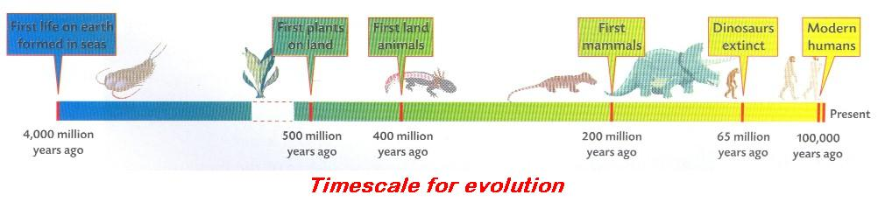

Mutation: a spontaneous change in the sequence of nitrogenous bases in a gene or a chromosome.

Insert the correct answer from the lower grid into the correct position in the right hand column
1 | Variation
2 | Factors responsible for the differences of heights in humans
3 | Mutation
4 | Cause of mutations
5 | Human condition resulting from a mutation
6 | Causes of variation
7 | Significance of inherited variation
8 | A change in the structure of DNA
9 | Types of mutation
10 | Scientist(s) responsible for the Theory of Natural Selection
11 | Evidence to support the theory of evolution
12 | Evolution
13 | Natural selection
14 | Application of genetic engineering using a microorganism
15 | Processes involved in genetic engineering

A | Darwin; Wallace | F | Genetic; Environment; Age | K | Production of hormones, enzymes
B | Descent of organisms from previous types by natural selection over time | G | Isolation; Restriction; Transformation; Expression | L | Radiation; Viruses; Carcinogens
C | Down's syndrome; Cancer | H | Mutation | M | Sexual reproduction; Mutation; Meiosis
D | Fossils; Embryos; Anatomy; Genetics | I | Mutation | N | Spontaneous change in genetic makeup
E | Gene; Chromosome | J | Produces new genotypes; Allows natural selection | O | Survival of the fittest; Best adapted survive

2.5.9 - 13.H Genetic Engineering and Mendelian

KEYWORDS

Chloroplast
Chromosome
Cutting (Restriction)
Diploid
Gamete
Gamete formation
Gene
Genetic engineering
Haemophilia
Herbicide
Independent assortment
Introduction of base sequence changes
Isolation
Law of Independent Assortment
Law of Segregation
Linkage
Mendel’s 1st Law [Segregation]
Mendel’s 2nd Law [Independent Assort]
Mitochondrion
Non-nuclear Inheritance
Red-green colour blindness
Segregation (Genetics)
Sex chromosome
Sex linkage
Transformation (ligation)
Transgenic animals
Variation

EXPLANATIONS

Cutting (Restriction): This is slicing up DNA using an enzyme that recognises specific nucleotide sequences on the DNA molecules. It then cuts the DNA strands at those sites. Some bacterial enzymes cut DNA at a specific nucleotide sequence. This is a defence mechanism used by bacteria against viral DNA and is now used as an important tool in biotechnology.
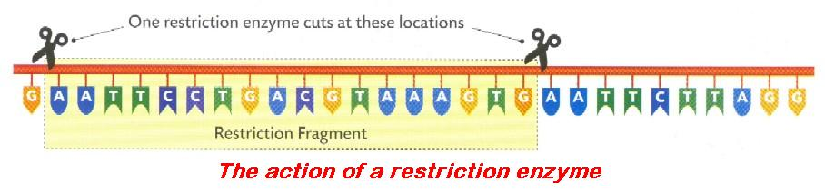

Genetic engineering: modern techniques or processes used to artificially alter the genetic information in the chromosome of an organism.
The process involves the following:
- isolation of gene
- cutting (restriction)
- transformation (ligation), introduction of base sequence changes
- expression.
Introduction of base sequence changes: this results in the order of bases in the host DNA being different
Isolation: the process of locating or identifying or removal of a gene (or a piece of DNA or a plasmid) from a chromosome.  Applications of genetic engineering:  - Tomato plants: gene for producing the enzyme needed to soften the fruit on ripening has been altered and no longer functions. Fruit remains hard, easier to harvest, used to make tomato ketchup.  - Sheep: have been given the human gene for factor VIII. Factor VIII is a substance needed for blood clotting. Persons with haemophilia (haemophiliacs) are missing this gene. It is hoped that the factor VIII can be extracted from the sheep’s milk.  - Micro-organisms: the production of human insulin by bacteria. | 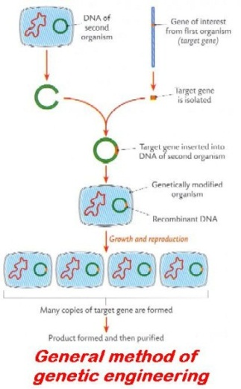
Law of independent assortment: (Mendel’s 2nd Law) states that during gamete formation each member of a pair of genes may combine randomly with either of another pair. | 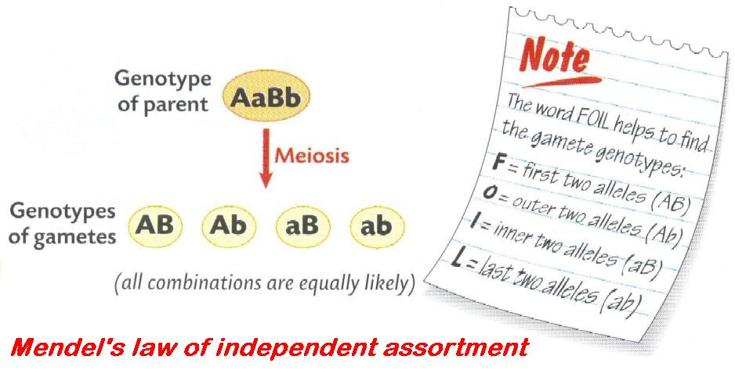
Law of Segregation: (Mendel’s 1st Law) states that characters (traits) are controlled by pairs of genes (e.g. Tt) that separate (segregate) at gamete formation. Each gamete carries only one gene for the trait.  At fertilisation the new organism will have two genes for each trait – one received from each parent. | 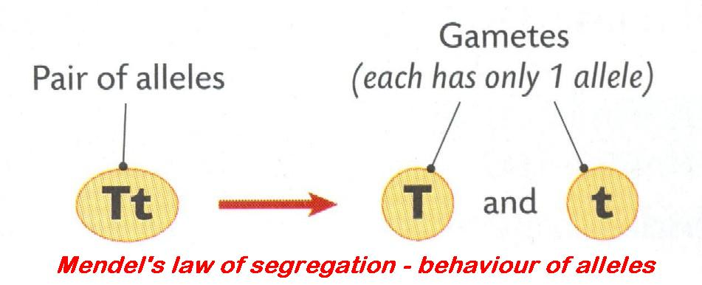
Linkage: genes located on the same chromosome that are not separated at gamete formation and are inherited together.  Complete linkage, i.e. genes never separating, seldom occurs. The closer the genes are on a chromosome the greater the degree of linkage; the further apart, the lesser the degree of linkage. In the diagram R and S are linked; as are r and s. | 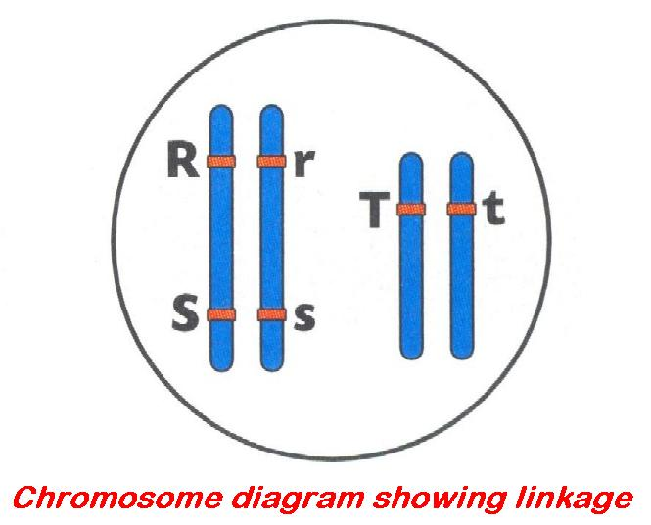
Non-nuclear inheritance: DNA is found in other organelles of the cell apart from the nucleus, e.g. mitochondrial DNA and chloroplast DNA that is passed on to the next generation.  These organelles play no part in sexual reproduction but are present in the female gametes (eggs). At fertilisation it is only the nucleus of the male gamete that fuses with the egg. All the mitochondrial DNA you possess you got from your mother, and she got hers from her mother, and so on. As a result there are very few different types of mitochondrial DNA. | 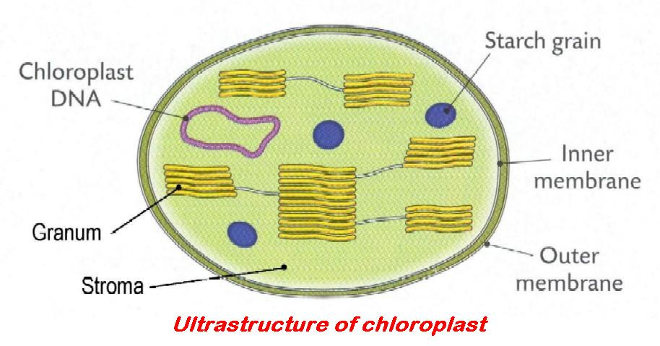
Sex-linkage: genes carried on the sex chromosomes (i.e. X and Y chromosomes) are sex-linked.
Genes are transmitted with the chromosome so the phenotype is related to the sex of the individual. The genes carried on the part of the X chromosome and have no corresponding part on the Y chromosome (i.e. non-homologous part of X chromosome) are X-linked. Examples of such genes are those controlling haemophilia and red/green colour-blindness in humans.
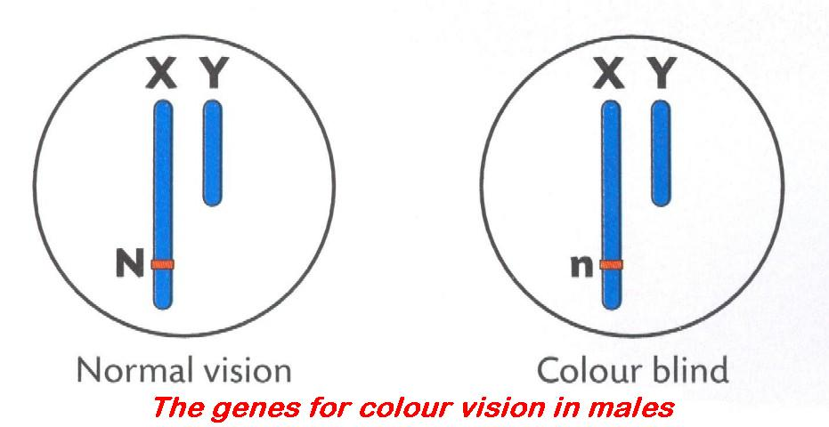 | 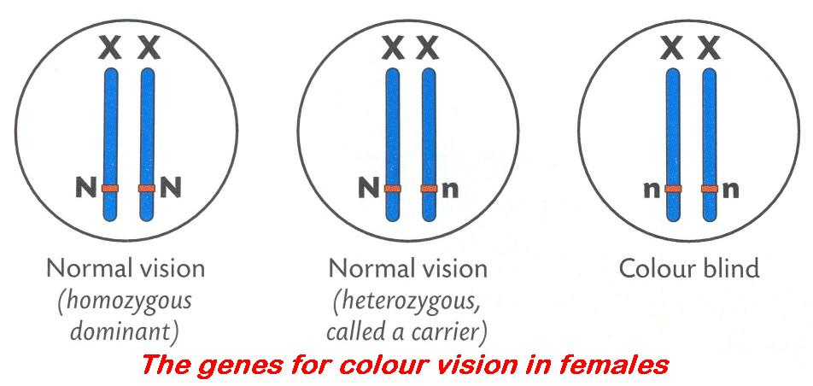
Transformation (Ligation): the joining or uptake of DNA to a plasmid or chromosome.

Insert the correct answer from the lower grid into the correct position in the right hand column
1 | Nucleus of a somatic (body) cell
2 | Advantage of genetically identical animals
3 | Disadvantage of genetically identical animals
4 | Genetic engineering
5 | Application of genetic engineering involving a plant
6 | Application of genetic engineering involving an animal
7 | Segregation
8 | Products of segregation of Aa
9 | Law of Independent Assortment
10 | Linkage, sex linkage
11 | Sex linked gene
12 | Why linked genes do not assort independently
13 | Example of a sex (X)-linked condition
14 | Organelles in which DNA is found
15 | Term used for alleles that lie on the same chromosome

A | A and a | F | Lack of variation; Prone to disease | K | Red-green colour blindness; Haemophilia
B | Diploid | G | Linked | L | Same quality wool, meat
C | During gamete formation any gene of a pair may combine with either of another pair | H | Manipulation of genes | M | Separation of a pair of genes so gametes get one of each
D | Gene on a sex (or X) chromosome | I | Mitochondrion; Chloroplast | N | Slow ripening tomatoes; Herbicide resistant plants
E | Genes on the same chromosome | J | Pharmaceuticals from transgenic animals | O | Transmitted together on the same chromosome

2.5.14 DNA, Replication, etc.

KEYWORDS

Adenine
Amino acids
Cytosine
DNA
Guanine
Hydrogen bonds
Nitrogenous base
Nucleotides
Nucleus
Purines
Pyrimidines
Ribosome
RNA
Thymine
Uracil

EXPLANATIONS

Nucleotide: one of four ‘building blocks’ of RNA and DNA.
A nucleotide is made up of:
1. a phosphate group
2. one five carbon sugar: deoxyribose (C₅H₁₀O₄) or ribose (C₅H₁₀O₅)
3. one nitrogen base: adenine (A), cytosine (C), guanine (G), thymine (T), uracil (U).
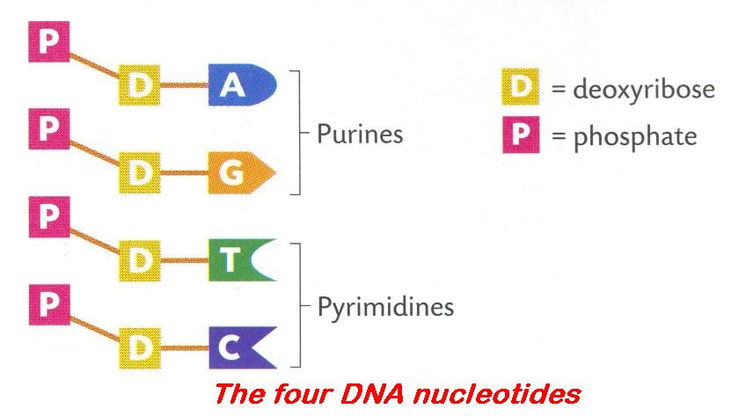

Insert the correct answer from the lower grid into the correct position in the right hand column
1 | Non-coding DNA
2 | Structural differences between DNA and RNA
3 | Two main events in the replication of DNA
4 | RNA is not found in ribosomes. True or False.
5 | Bases found in DNA
6 | Triplet code
7 | Transcription
8 | mRNA carries the code to the ...
9 | Cell organelle containing most DNA
10 | Instructions needed to make protein are called the ... code
11 | In DNA profiling fragments are separated on the basis of...
12 | Purpose of Freezer-cold alcohol
13 | DNA is a double helical shape. True or False.
14 | The base Uracil is found in DNA. True or False.
15 | In DNA this base can link only to thymine
16 | In DNA this base can link only to cytosine
17 | How the DNA strands held together
18 | Types of nitrogenous bases found in DNA

A | Adenine | G | False | M | Purines and pyrimidines
B | Adenine; Thymine; Guanine; Cytosine | H | Genetic | N | Ribosome
C | DNA contains thymine; RNA contains uracil | I | Guanine | O | Size
D | DNA unzips and new strands made | J | Hydrogen bonds | P | Three bases code for one amino acid
E | Does not code for a protein | K | Information (code) is copied to RNA molecule | Q | To bring DNA out of solution
F | False | L | Nucleus | R | True

3.1.3 Monera

KEYWORDS

Antibiotic
Antibiotic resistance
Autotroph
Autotrophic [bacteria]
Autotrophic nutrition
Bacteria
Binary fission
Biotechnology
Capsule
Chemosynthesis
Chemosynthetic bacteria
Coccus
Endospores
Flagellum
Heterotroph
Heterotrophic [organism]
Heterotrophic nutrition
Host
Kingdom
Monera
Mucilage
Parasite
Parasitic
Pathogen
Pathogenic
Peristalsis
Photosynthetic bacteria
Plasmid
Prokaryotae
Prokaryotic bacteria
Rod
Saprophytic
Saprophytic nutrition
Spiral
Spores
Virus

EXPLANATIONS

Antibiotic: substance naturally produced by living micro-organisms (e.g. Penicillium notatum) which destroys or inhibits the growth or reproduction of other micro-organisms, especially bacteria or fungi, e.g. penicillin, streptomycin, tetracycline, etc.
The ability to make this substance is controlled by a gene, which can be passed on to other bacteria of the same or different species. Note: antibiotics have no effect on viruses.
Antibiotic resistance: see antibiotic. If a patient is given an antibiotic it kills all bacteria (good and bad) except those that are naturally resistant to it – they may not be pathogens. These antibiotic resistant bacteria now flourish and increase in numbers. If a pathogen now attacks the patient it can pick up the resistance to the antibiotic from the non-pathogen, thus conferring resistance on itself.
The number of antibiotic resistant bacteria is on the increase, so the use of antibiotics should be minimised.
Autotrophic bacteria: bacteria that are self-nourishing, i.e. capable of making (synthesising) their own food from inorganic compounds.
Chemosynthetic bacteria: e.g. nitrifying bacteria. Autotrophic bacteria (organisms) make their food (get their energy) from the oxidation of inorganic compounds (e.g. nitrogen compounds) and not from light (photosynthesis).
Heterotrophic bacteria / organism: bacteria or organism that cannot make their own food.
Depend on other organisms as sources of food, e.g. all animals. They may be saprophytic or parasitic.
Parasitic: refers to an organism that lives in or on another organism (the host) from which it derives its nourishment and causes it harm.
Pathogen: an organism that causes a disease, e.g. pathogenic bacteria are capable of causing a disease, e.g. diphtheria, whooping cough and tetanus (3 in 1 vaccination).
Photosynthetic bacteria: e.g. autotrophic green sulfur bacteria get energy from sun. See summary chart. | 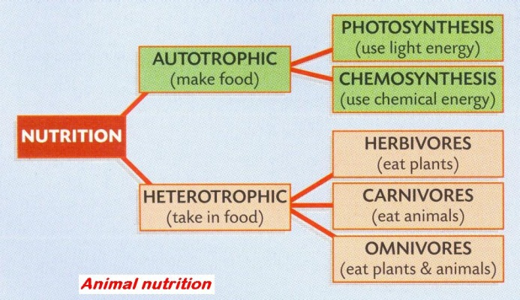
Prokaryotic cells: cells that do not have a membrane-bound (true) nucleus or membrane-bound organelles, e.g. bacteria. | 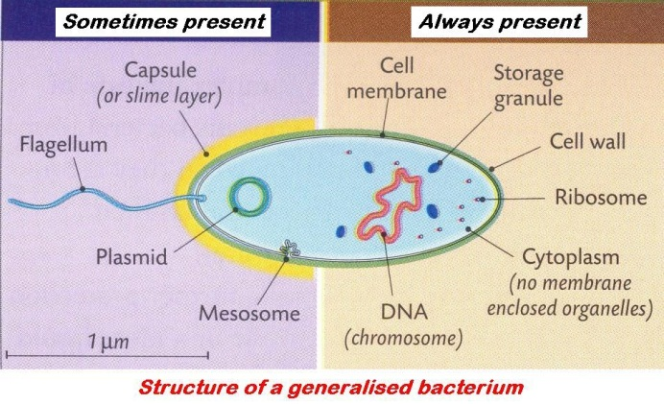
Saprophytic: a type of heterotrophic nutrition where an organism obtains its food from dead or decaying organic matter.

Insert the correct answer from the lower grid into the correct position in the right hand column
1 | Bacteria belong to this kingdom
2 | Ways in which bacterial cell differs from human cell
3 | Bacterial response to adverse environmental conditions
4 | Pathogenic bacteria
5 | Antibiotics
6 | Photosynthetic bacteria
7 | Chemosynthetic bacteria
8 | Forms of heterotrophic nutrition
9 | Antibiotic resistance
10 | Why antibiotics not prescribed for a viral infection
11 | Term for asexual reproduction in bacteria
12 | Layer outside cell wall of some bacteria
13 | Function of capsule
14 | Structure not found in all bacteria
15 | Autotrophic nutrition
16 | Heterotrophic nutrition
17 | Saprophytic nutrition
18 | Function of saprophytic bacteria
19 | Chemosynthesis
20 | Organism from which a parasite obtains its food
21 | Diseases caused by bacteria
22 | Function of flagella
23 | Bacterial types (shapes)
24 | Economic importance of bacteria

A | Bacteria not killed by antibiotic | I | Flagellum; Plasmid | Q | Parasitic; Saprophytic
B | Binary fission | J | Have no effect on viruses | R | Produce (endo)spores
C | Capsule; Slime layer; Mucilage | K | Host | S | Protection
D | Cause disease; Biotechnology | L | Make food using a chemical reaction | T | Rod; Coccus; Spiral
E | Cell wall; Capsule; Flagellum; Plasmid | M | Makes own food | U | Substances produced by micro-organisms which inhibit bacteria
F | Decompose dead organisms | N | Monera or Prokaryotae | V | TB; Syphilis; Cholera; Tetanus
G | Disease-causing | O | Movement | W | Use light to make food
H | Feeds on dead matter | P | Obtaining energy from chemical reactions | X | Uses food already made by other organisms

3.1.4 Fungi

KEYWORDS

Absorption
Asexual reproduction
Budding
Digestion
Filament
Fungi
Germination
Heterotrophic
Hypha
Meiosis
Mitosis
Mycelium
Natural selection
Rhizoids
Saprophytic
Sexual reproduction
Sporangium
Spores
Stolon
Yeast
Zygospore

EXPLANATIONS

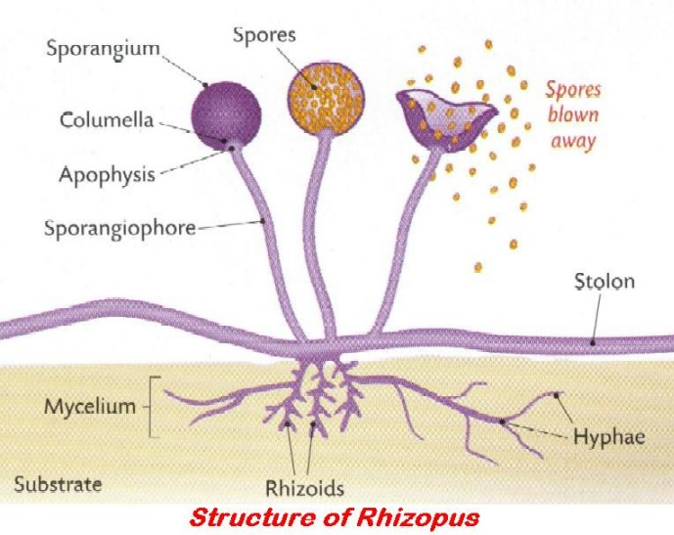

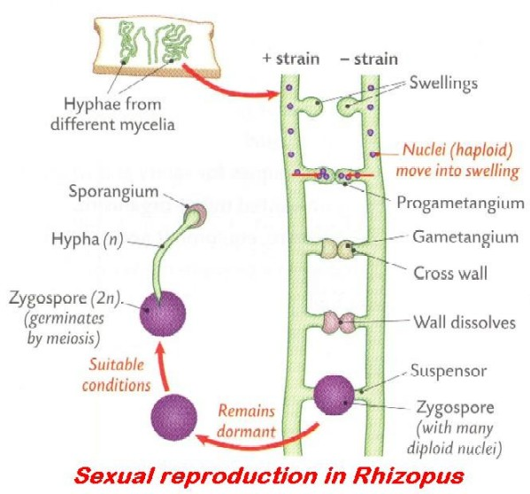

Fungi 1

Insert the correct answer from the lower grid into the correct position in the right hand column
1 | Kingdom to which yeasts belong
2 | Yeast beneficial to humans for ...
3 | The nutrient medium on which you grew leaf yeast
4 | Features of Rhizopus that shows it belongs to the kingdom Fungi
5 | What happens when zygospore germinates
6 | Eukaryotic organism
7 | Saprophytic fungi
8 | Role of saprophytic fungi
9 | Role of parasitic fungi
10 | Parasitic fungi
11 | Example of a beneficial fungus
12 | Example of a harmful fungus
13 | Function of rhizoid
14 | Function of sporangium
15 | Function of gametangium

A | Anchors; Digestion; Absorption | F | Living in or on another organism causing harm | K | Produces Spores; Stores spores; Asexual reproduction
B | Baking; Brewing | G | Malt agar | L | Recycling of nutrients; Decay
C | Fungi | H | Meiosis, hypha grows, sporangium, produces spores, released, germinate | M | Ringworm; Athlete's foot; Potato blight
D | Keep populations under control; Natural selection | I | Possess nucleus and membrane-bound organelles | N | Stolon; rhizoids; mycelium; hyphae; sporangium
E | Live on dead organisms (matter) | J | Produces gametes; Sexual reproduction | O | Yeast for brewing or baking

Fungi 2

Insert the correct answer from the lower grid into the correct position in the right hand column
1 | Function of zygospore
2 | Hypha
3 | Mycelium
4 | Role, other than anchorage, for rhizoids
5 | Mode of nutrition of athlete's foot
6 | Member of the Fungi kingdom that is of benefit to humans
7 | Member of the Fungi kingdom that is harmful to humans
8 | Type of nutrition in Rhizopus
9 | Type of cell division is involved in reproduction in yeast
10 | Anaerobic conditions
11 | In anaerobic conditions yeast produces alcohol (ethanol) and ...
12 | How Rhizopus gets its food
13 | Type of heterotrophic nutrition in Rhizopus
14 | Economically harmful members of the Fungi kingdom
15 | Process of asexual reproduction in yeast

A | Budding | F | Mass of hyphae | K | Parasitic
B | Carbon dioxide | G | Mitosis | L | Rhizopus; Mildew; Blight; Athlete's foot
C | Filament | H | Mushrooms – edible and medical | M | Saprophytic
D | Heterotrophic; Saprophytic | I | Mushrooms – poisonous | N | Secretes enzymes, onto bread, external digestion, absorbs products
E | Lack of oxygen or air | J | Nutritional – secretes enzymes, absorbs products | O | Survival; Dispersal

Fungi 1 and 2

Insert the correct answer from the lower grid into the correct position in the right hand column
1 | Anaerobic conditions
2 | Economically harmful members of the Fungi kingdom
3 | Eukaryotic organism
4 | Example of a beneficial fungus
5 | Example of a harmful fungus
6 | Features of Rhizopus that shows it belongs to the kingdom Fungi
7 | Function of gametangium
8 | Function of rhizoid
9 | Function of sporangium
10 | Function of zygospore
11 | How Rhizopus gets its food
12 | Hypha
13 | In anaerobic conditions yeast produces alcohol (ethanol) and ...
14 | Kingdom to which yeasts belong
15 | Member of the Fungi kingdom that is harmful to humans
16 | Member of the Fungi kingdom that is of benefit to humans
17 | Mode of nutrition of athlete’s foot
18 | Mycelium
19 | Parasitic fungi
20 | Process of asexual reproduction in yeast
21 | Role of parasitic fungi
22 | Role of saprophytic fungi
23 | Role, other than anchorage, for rhizoids
24 | Saprophytic fungi
25 | The nutrient medium on which you grew leaf yeast
26 | Type of cell division is involved in reproduction in yeast
27 | Type of heterotrophic nutrition in Rhizopus
28 | Type of nutrition in Rhizopus
29 | What happens when zygospore germinates
30 | Yeast beneficial to humans for ...

A | Anchors; Digestion; Absorption | K | Living in or on another organism causing harm | U | Produces gametes; Sexual reproduction
B | Baking; Brewing | L | Malt agar | V | Produces spores; Stores spores; Asexual reproduction
C | Budding | M | Mass of hyphae | W | Recycling of nutrients; Decay
D | Carbon dioxide | N | Meiosis, hypha grows, sporangium, produces spores, released, germinate | X | Rhizopus; Mildew; Blight; Athlete's foot
E | Filament | O | Mitosis | Y | Ringworm; Athlete's foot; Potato blight
F | Fungi | P | Mushrooms – edible and medical | Z | Saprophytic
G | Heterotrophic; Saprophytic | Q | Mushrooms – poisonous | A2 | Secretes enzymes, onto bread, external digestion, absorbs products
H | Keep populations under control; Natural selection | R | Nutritional - secretes enzymes, absorbs products | B2 | Stolon; Rhizoids; Mycelium; Hyphae; Sporangium
I | Lack of oxygen or air | S | Parasitic | C2 | Survival; Dispersal
J | Live on dead organisms (matter) | T | Possess nucleus and membrane-bound organelles | D2 | Yeast for brewing or baking

3.1.5, 6, 10 Lab, Protista, Growth Curves

KEYWORDS

Adapt
Amoebae
Asepsis
Autoclave
Batch (Flow) processing
Bioreactor
Chloroplast
Continuous (Flow) processing
Contractile vacuole
Exponential phase
Hypotonic
Lag phase
Log phase
Protista
Sterile
Sterility
Contractile vacuole
Pseudopod

EXPLANATIONS

Asepsis: or aseptic techniques. Methods used to prevent unwanted micro-organisms entering an area of an experiment.
Batch (bio) processing: is a method used to manufacture an exact quantity of product, and then the process is repeated for the next ‘batch’. The organisms being grown are in a five phase growth curve.
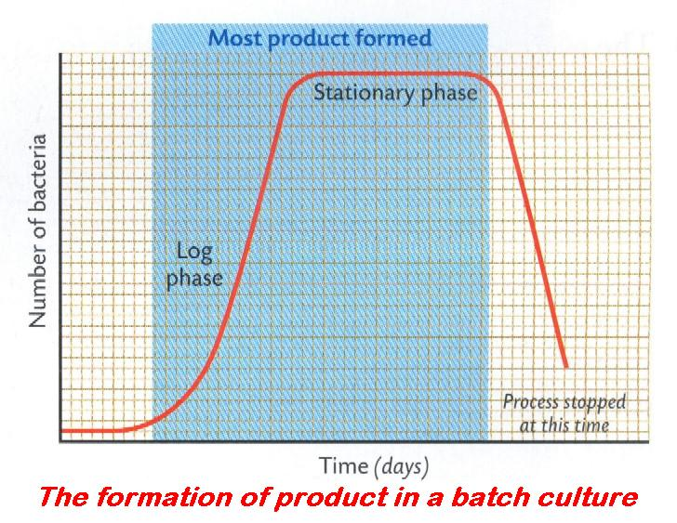 | 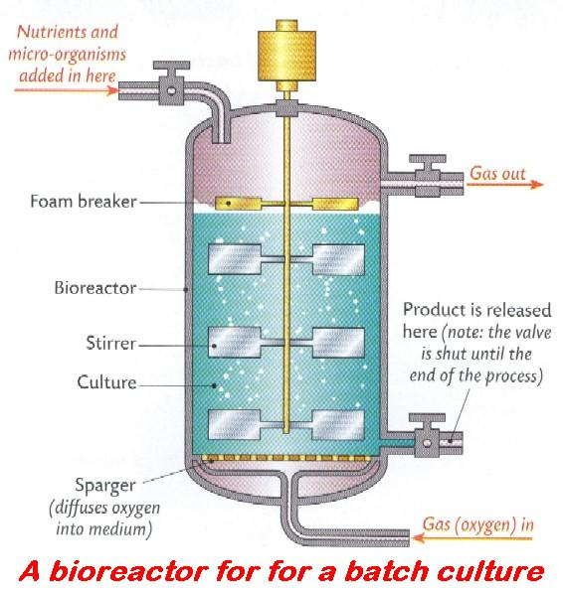
Continuous flow (bio) processing: is a method used to manufacture a product without interruption. The organisms being grown are maintained in a particular phase of the growth curve, i.e. the log phase.
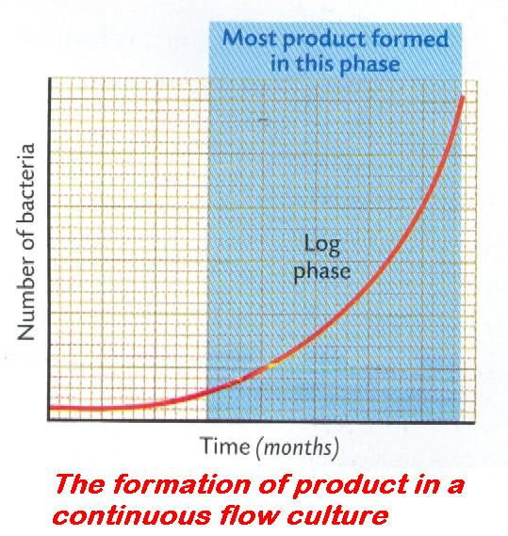 | 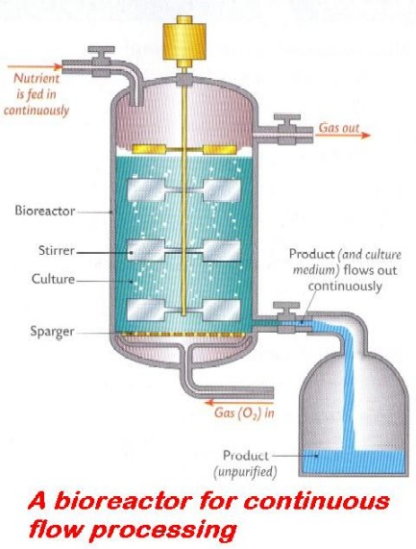
Sterility: the state of being sterile, i.e. free from all types of micro-organisms.

Insert the correct answer from the lower grid into the correct position in the right hand column
1 | How to dispose of used agar plates
2 | Sterile
3 | How to sterilise apparatus
4 | Purpose of agar when growing bacteria
5 | Kingdom to which Amoeba belongs
6 | Function of pseudopods in Amoeba
7 | First part of a growth curve
8 | Why contractile vacuole more active in freshwater amoebae
9 | What is happening during the lag phase?
10 | Second part of a growth curve
11 | Structure in Amoeba that gets rid of excess water
12 | Batch processing
13 | Found in plant cell but not in Amoeba
14 | What is happening during log or exponential phase?
15 | Continuous flow processing

A | Adapting to environment | F | Feeding; Movement | K | Log or Exponential phase
B | Autoclave at 121 °C for 15 minutes | G | Fixed amount of nutrients added at beginning | L | Nutrient medium
C | Autoclave in disposal bag | H | Free from (micro-) organisms | M | Nutrients constantly fed into bioreactor
D | Cell wall; Chloroplast | I | Freshwater Amoebae more hypotonic | N | Protista
E | Contractile vacuole | J | Lag phase | O | Reproducing rapidly

3.2.1 Plant Structure

KEYWORDS

Bud
Companion cells
Cotyledon
Dermal tissue
Dicotyledonous
Diffusion
Embryonic
Ground tissue
Lignin
Lumen
Meristem
Meristematic tissue
Mid-rib
Mitosis
Perennation
Phloem
Phloem sieve tube
Photosynthesis
Stomata
Transpiration
Transverse section
Vascular bundle
Vascular tissue
Vein
Xylem
Xylem tracheids
Xylem vessel

EXPLANATIONS

Companion cells: cells in phloem associated with sieve tube cells. The nucleus of the companion cell also controls the activities of the phloem sieve tube cells. | 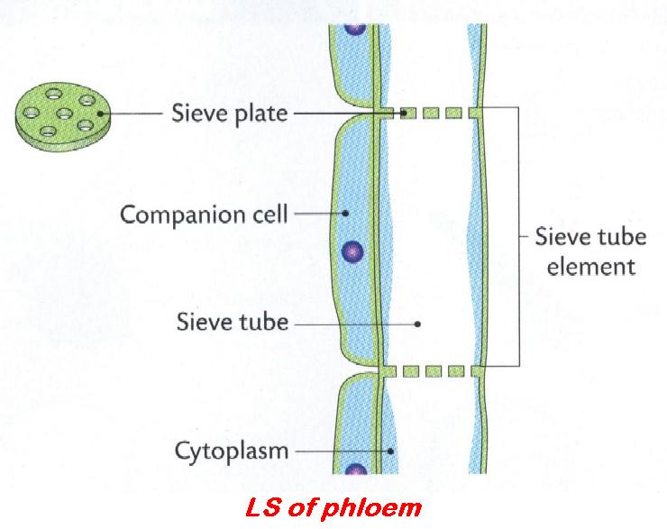
Phloem sieve tube: long cells, thin side walls, thick perforated end walls (sieve) allow passage of cytoplasm between cells. No nucleus when mature.
Meristem: tip of shoots and roots of plants. Area of active cell division (mitosis) which produces ‘simple’ cells.  These new cells will later undergo elongation and differentiation to give rise to the various plant tissues, e.g. xylem, phloem, etc. | 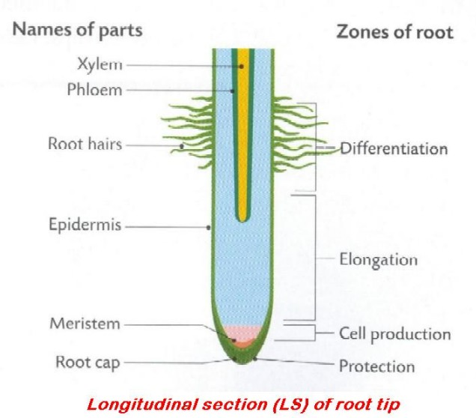
Xylem tracheids: long, relatively narrow, dead cells, containing lignin for support. Tapered at both ends, pits in the walls to allow sideways movement from cell to cell of water and minerals. | 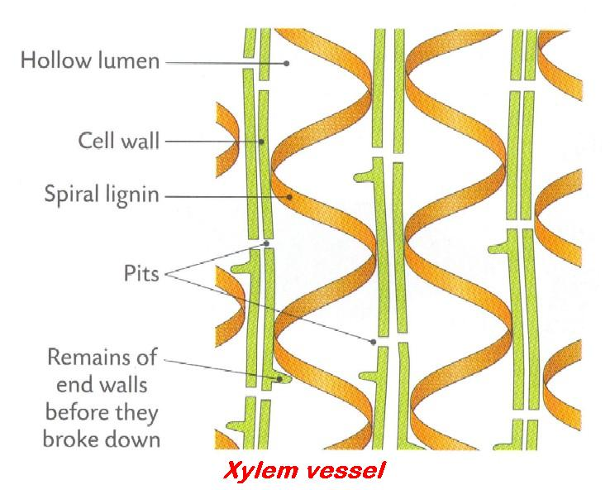
Xylem vessel: short, wide, dead cells arranged end to end, no end walls. Form continuous tube, larger diameter cells than xylem tracheids. Have lignin, in spiral bands for thickening, and numerous pits. They transport water and minerals upwards from root to stem.

Plant Structure 1

Insert the correct answer from the lower grid into the correct position in the right hand column
1 | Lenticels serve the same function as stomata. True or False
2 | The walls of xylem vessels are reinforced with ...
3 | Where xylem tissue is found in the stem of a dicotyledonous plant
4 | Vascular tissue in plants, other than xylem
5 | Location where mitosis occurs in flowering plants
6 | In a TS of a dicotyledonous stem, tissues that are not vascular tissues include ...
7 | Monocotyledonous plants have parallel leaf veins. True or False
8 | Function of phloem
9 | Function of xylem
10 | Why a dicotyledonous (dicot) plant is so called
11 | A dicotyledonous plant
12 | Phloem transports water in plants. True or False
13 | How xylem is adapted for water transport
14 | Vascular tissue in which sugars are mainly transported
15 | Function of dermal tissue

A | Dermal; Ground; Meristematic | F | Phloem | K | True
B | False | G | Phloem | L | True
C | Lignin | H | Protection against water loss, infection | M | Tubular lumen; Lignified walls; Narrow bore
D | Meristematic tissue | I | Transport of food, minerals, auxins | N | Two embryonic (seed) leaves
E | Oak; Ash; Elm; Horse chestnut | J | Transport of water, minerals; Support | O | Vascular bundle

Plant Structure 2

Insert the correct answer from the lower grid into the correct position in the right hand column
1 | How a TS through a monocot stem differs from a dicot
2 | Functions of a root
3 | Meristem in a root found here
4 | Function of vascular tissue
5 | Where xylem and phloem are found in a leaf
6 | Found in the walls of xylem cells but not in phloem cells
7 | Function of ground tissue
8 | Meristem
9 | Location of a meristem in a winter twig
10 | Functions of a stem
11 | Tissue type to which xylem and phloem belong
12 | Another function of xylem in addition to transport
13 | Where in a young root xylem and phloem tissues are found
14 | Main function of leaf
15 | How xylem is adapted for water transport
16 | Tube-like tissue in the stem through which water moves
17 | Ground tissue
18 | Function of guard cells
19 | Gases exchanged by the leaf
20 | Process by which the gases move in or out of the leaf
21 | Vascular tissue in plants, other than xylem
22 | Direction of water transport
23 | Monocotyledonous
24 | How veins arranged in the leaves of monocots

A | Anchorage; Absorption; Storage | I | Found between dermal and vascular tissue | Q | Transport; Support; Perennation
B | At the tip | J | Having one cotyledon and parallel venation | R | Transports substances
C | Bud; Stem tip | K | Lignin | S | Tubular lumen (Continuous; Hollow); Lignified walls; Narrow bore
D | Carbon dioxide; Oxygen | L | Phloem | T | Upwards
E | Centre | M | Photosynthesis; Transpiration; Gas exchange | U | Vascular
F | Control stomatal size and passage of gases | N | Region of mitosis in plants | V | Vascular bundles scattered
G | Diffusion | O | Scattered | W | Vein; Mid rib; Vascular bundle
H | Food storage; Support; Photosynthesis; Strength | P | Support | X | Xylem or vascular tissue

3.2.2 Blood and Circulation

KEYWORDS

Abdomen
ABO
Antibodies
Aorta
Artery
Atrium
Auricle
Bicuspid valve
Blood plasma
Blood pressure
Capillary
Cardiac
Closed circulatory system
Collagen
Coronary
Diaphragm
Diet
Endothelium
Foetus
Glucose
Hepatic portal vein
Hormones
Insulin
Long bones
Marrow
Mitral valve
Node
Non-elastic fibres
Open circulatory system
Plasma
Portal Blood System
Pulmonary
Pulmonary artery
Pulmonary vein
Pulse
Red blood cell
Renal
Rhesus
Semi-lunar valve
Systemic
Thoracic
Transfusion
Tricuspid valve
Vein
Ventricle
White blood cell

EXPLANATIONS

Artery: thick-walled blood vessel that carries blood away from heart rapidly at high pressure.  Blood flows in pulses. Arteries have no valves. They have a small lumen and a three-layered wall:  - outer layer: non-elastic fibres – collagen  - middle layer: elastic fibres and muscles (thick layer)  - inner layer: endothelium – one cell thick.. | 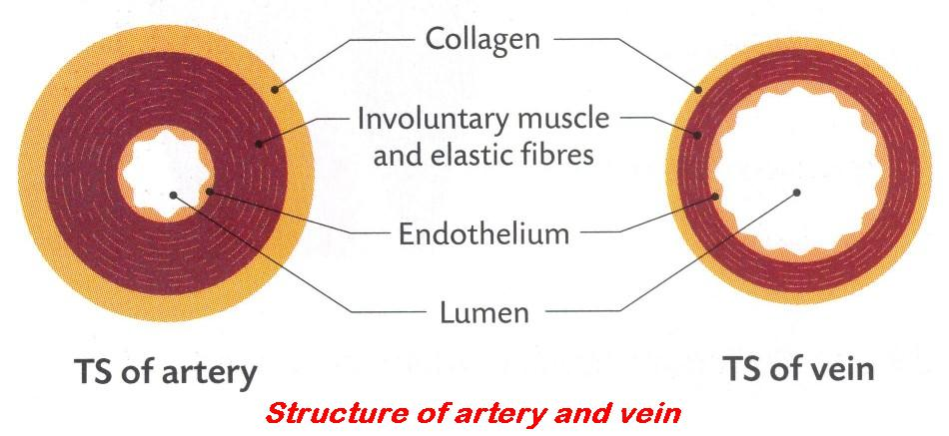
Capillary: blood vessel that link arterioles and venules.
Walls one cell thick (endothelium). Substances diffuse from the capillaries into the fluid in the spaces between the body cells (tissue fluid or extra-cellular fluid) and from there diffuse into the cells. Waste products in the cell diffuse in the reverse direction, i.e. into lymphatic vessels or blood capillaries.
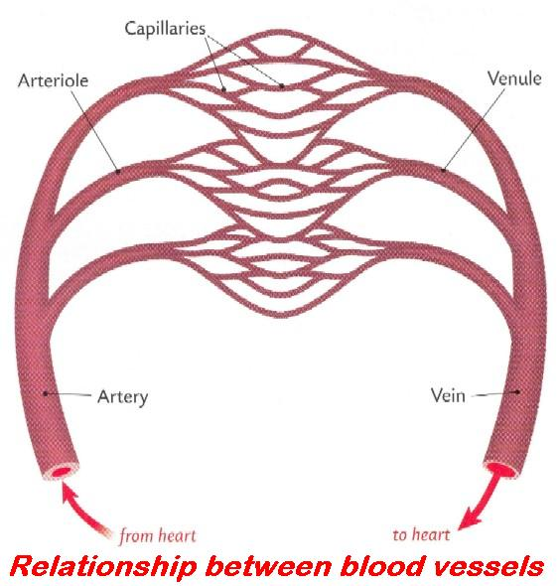 | 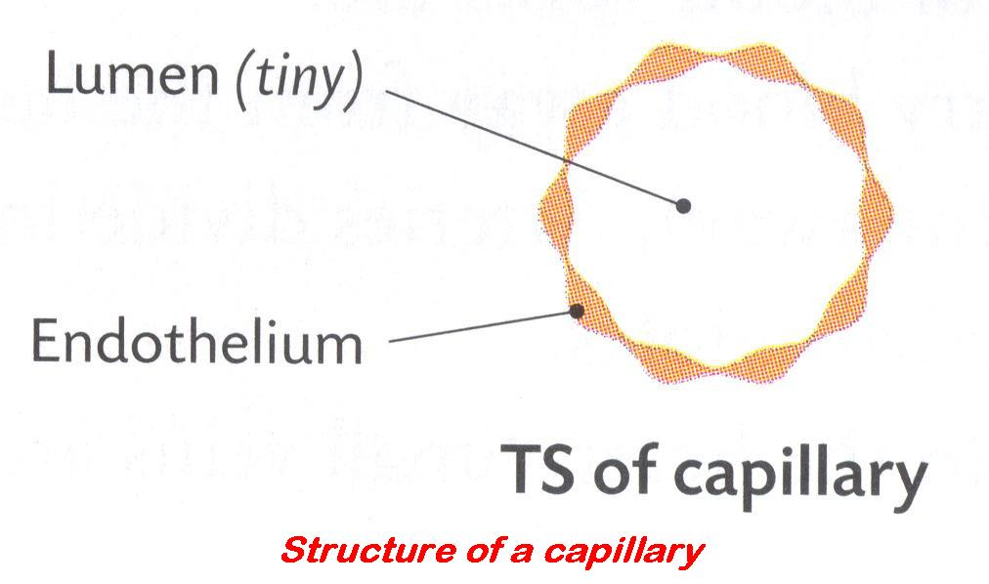
Closed circulation: refers to a transport system that confines the blood to, or maintains it in, a collection of tubules (blood vessels). | 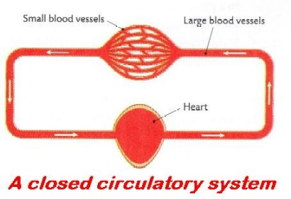
Open circulation: refers to a transport system that does not confine the blood to a collection of tubules, e.g. insects.  The blood leaves the tubules and flows among the body cells. | 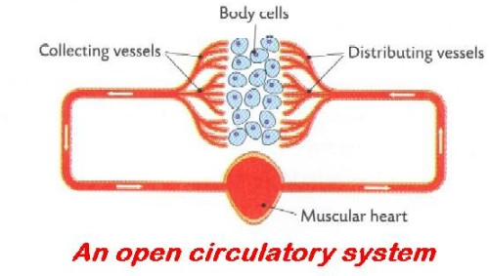
Portal blood system: circulatory system in which capillaries drain into a vein that opens into another capillary network, i.e. it begins and ends in capillaries, e.g. hepatic portal system
Vein: thin-walled blood vessel that carries blood to the heart slowly, at low pressure.
Has a large lumen. Also a three-layered wall:
- outer layer: non-elastic fibres
- middle layer: elastic fibres and muscles (thin layer)
- inner layer: endothelium, one cell thick.
- has valves, which prevent blood flowing backwards. Blood flows steadily. No pulse. See diagram above.

Blood and Circulation 1

Insert the correct answer from the lower grid into the correct position in the right hand column
1 | Tissues present in the walls of arteries and veins
2 | Function of collagen
3 | Function of muscles in arteries and veins
4 | Function of endothelium
5 | Function of the valves
6 | Heart chamber with the thickest muscular wall
7 | How to expose a semilunar valve
8 | Function of a semilunar valve
9 | Origin of the coronary artery
10 | Location of liver in the human body
11 | Where red blood cells are made
12 | Blood vessel that returns blood to the heart from the lungs
13 | Circuits of the circulatory system
14 | Left ventricle pumps blood into this circuit
15 | Expansion and contraction of artery wall

A | Aorta (near semilunar valve) | F | Lining of blood vessels | K | Pulmonary; Systemic
B | Collagen; Muscles; Endothelium | G | Marrow of long bones | L | Pulse
C | Cut aorta or Pulmonary artery | H | Non-elastic fibres prevent over expansion of vessel | M | Stops back flow of blood into ventricle from artery
D | Help in moving blood along vessels | I | Prevent backflow of blood | N | Systemic
E | Left ventricle | J | Pulmonary vein | O | Upper abdomen, under diaphragm

Blood and Circulation 2

Insert the correct answer from the lower grid into the correct position in the right hand column
1 | Force exerted by blood
2 | Body cavity in which the heart and lungs are located
3 | How heart muscle differs from other muscles
4 | Average resting rate of the human heart (bpm)
5 | Factor that decreases heart rate
6 | Factor that increases heart rate
7 | Pulmonary artery brings blood to ...
8 | Function of bicuspid valve
9 | Artery that supplies the heart muscle with blood
10 | Liquid part of blood
11 | Substances dissolved in plasma
12 | Function of the liquid part of blood
13 | Function of red cells
14 | Function of white cells
15 | Blood-grouping systems

A | 72 | F | Fear (fright); Exercise; Drugs; Infection | K | Prevent backflow of blood from left ventricle to auricle
B | ABO and Rhesus | G | Glucose; Carbon dioxide; Insulin; Antibodies | L | Protection against disease
C | Blood pressure | H | Hold 'cells' and dissolved substances | M | Sleep; Drugs (sedatives)
D | Coronary artery | I | Lungs | N | Thoracic or Chest
E | Doesn't tire | J | Plasma | O | Transport oxygen

Blood and Circulation 3

Insert the correct answer from the lower grid into the correct position in the right hand column
1 | The hepatic portal vein carries blood from the intestines to the ...
2 | Effect of smoking on the pulse resting rate
3 | Blood vessel that carries blood from the heart to the lungs
4 | Blood vessel that carries blood from the lungs to the heart
5 | Function of valves in veins
6 | Why valves are not needed in arteries
7 | Which has the bigger lumen, an artery or a vein?
8 | Advantage of capillary wall one cell thick
9 | How a portal vein differs from other veins
10 | Blood vessels from the aorta to the kidneys
11 | Blood vessels that supply the heart's muscle with blood
12 | Chamber of heart that receives blood from the lungs
13 | Substances dissolved in plasma
14 | Blood in the Aorta – oxygenated or deoxygenated?
15 | Why wall of left ventricle is thicker than wall of right ventricle

A | Blood is under pressure | F | Liver | K | Raises rate
B | Capillaries at both ends | G | Oxygenated | L | Renal arteries
C | Coronary or Cardiac arteries | H | Pulmonary artery | M | Substances can diffuse in and out of blood easily
D | Glucose; Carbon dioxide; Insulin; Antibodies | I | Pulmonary vein | N | To prevent back flow of blood
E | Left atrium (auricle) | J | Pumps blood further | O | Vein

Blood and Circulation 4

Insert the correct answer from the lower grid into the correct position in the right hand column
1 | Blood without cells, watery liquid part of blood
2 | Role for blood plasma
3 | Types of cell found in the blood
4 | The four ABO blood groups
5 | Importance of knowing a person's blood group
6 | The artery connected to the kidneys
7 | The vein that joins the intestine to the liver
8 | Location of heart in the human body
9 | Structure(s) protecting the heart
10 | Upper chambers of the heart
11 | Heart valve between chambers on the left-hand side
12 | Factors that affect the health of our circulatory system
13 | Blood vessel that brings blood from the heart to the body
14 | Lymphatic system composed of...
15 | Functions of the lymphatic system

A | A; B; AB; 0 | F | Diet; Exercise; Age | K | Renal artery
B | Aorta | G | Hepatic Portal vein | L | Rib cage
C | Atria or Auricles | H | Nodes and vessels | M | Thorax
D | Bicuspid (mitral) valve | I | Plasma | N | Transfusion; To prevent loss of foetus
E | Carries dissolved substances; Waste; Hormones; Antibodies | J | Red blood cell; white blood cell | O | Transport of fats; Nodes filter bacteria; Produce antibodies

3.2.3 + 4 Blood Cells and Heartbeat

KEYWORDS

Atrium
Deoxygenated
Haemoglobin
Lymphocytes
Marrow
Mitochondria
Monocytes
Plasma
Tricuspid valve
Ventricle

EXPLANATIONS

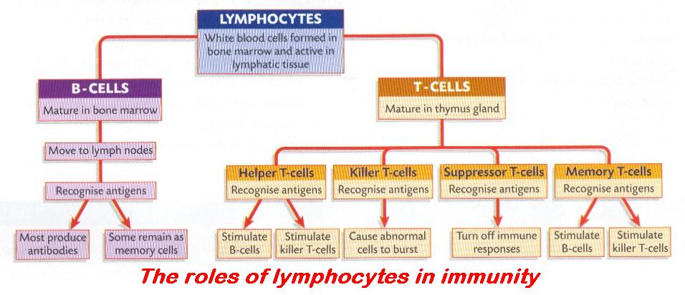

Insert the correct answer from the lower grid into the correct position in the right hand column
1 | How red blood cells differ from cheek cells
2 | Function of valves in veins
3 | Red blood cells have no nucleus. True or False
4 | Location in body where red blood cells are made
5 | White blood cells, other than lymphocytes
6 | Contractile tissue
7 | Blood in the Vena Cava – oxygenated or deoxygenated?
8 | The pacemaker is on the left side of the heart. True or False.
9 | Factor that decreases heart rate
10 | Role of the SA (sinoatrial) node
11 | Liquid part of blood
12 | Location of SA node in the heart
13 | Function of white cells
14 | Role of the AV (atrioventricular) node
15 | Location of AV node in the heart

A | Between atrium and ventricle; Near tricuspid valve | F | In wall of right atrium | K | Plasma
B | Deoxygenated | G | It can shorten | L | Protection against disease
C | False | H | Marrow of long bones | M | Sleep; Drugs (sedatives)
D | Impulse generation; Causing contraction (of heart muscle) | I | Monocytes | N | To prevent back flow of blood
E | Impulse generation; Causing contraction (of heart muscle) | J | No nucleus; Haemoglobin; No mitochondria | O | True

3.3.1 + 2 Nutrition and Storage in Plants

KEYWORDS

Active transport
Adhesion
Autotrophic (organism)
Bulb
Capillarity
Cohesion
Corm
Lenticels
Lignin
Modified leaf
Modified root
Modified stem
Osmosis
Photosynthesis
Rhizome
Root hairs
Root Pressure
Stoma(ta)
Transpiration
Tuber
Xylem

EXPLANATIONS

Autotrophic bacteria/organism: bacteria that are self-nourishing, i.e. capable of making (synthesising) their own food from inorganic compounds.
Root pressure: the force which can push water up a stem from the root and cause it to exude from a cut stump of a plant.
The movement of water into the xylem, by osmosis, causes this.
Transpiration: the loss of water vapour from the surface of a plant.

Insert the correct answer from the lower grid into the correct position in the right hand column
1 | Where water enters a plant
2 | Process responsible for water entry to plant
3 | Osmosis is responsible for uptake of minerals. True or False
4 | Water ascends through this plant tissue
5 | Adaptation of xylem for water transport
6 | Autotrophic organisms
7 | Function of stomata
8 | Factor that influences stomatal diameter
9 | Openings in stems equivalent to stomata
10 | Openings in the leaf which allow entry of CO₂
11 | How minerals (nitrates) enter the root of a plant
12 | Gas that exits the leaf at the stomata
13 | Processes that cause water to move upwards in a plant
14 | Why less water moves through plant at night
15 | Plant with leaves modified for food storage
16 | Carbohydrate found in modified leaves
17 | Modified stems for food storage
18 | Tuber
19 | Bulb
20 | A potato is a modified stem. True or False
21 | Root modified for food storage

A | Active transport | H | Modified leaf | O | Root hairs
B | Carrot; Turnip; Parsnip | I | Modified stem or Root | P | Root pressure; Cohesion; Adhesion; Capillarity; Transpiration
C | CO₂ concentration; Light intensity; K⁺ ions | J | No photosynthesis; Stomata closed; Night-time cooler | Q | Starch
D | False | K | Onion; Tulip; Daffodil; Cabbage | R | Stomata
E | Grass; Seaweed; Fern; Moss | L | Osmosis | S | To allow exchange of gases
F | Has lignin for strength and support | M | Oxygen; Water vapour; Carbon dioxide; Nitrogen | T | True
G | Lenticels | N | Rhizome; Corm; Tuber | U | Xylem

3.3.3 + 4 Human Nutrition and Digestion

KEYWORDS

Absorption
Amino acids
Amylase
Autotrophic nutrition
Bile
Bile salts
Carnivore
Chemical digestion
Colon
Constipation
Diffusion
Digestion
Duodenum
Egestion
Emulsification
Enzymes
Fatty acids
Fibre
Gall bladder
Glycerol
Herbivore
Heterotrophic (organism)
Hydrochloric acid
Ileum
Immune system
Ingestion
Insulin
Lipase
Liver
Lymph
Maltase
Maltose
Mechanical digestion
Molar teeth
NaHCO₃
Neutralisation
Omnivore
Pancreas
Pathogens
Peristalsis
Protein
Rectum
Stomach
Symbiotic bacteria
Villi
Vitamins

EXPLANATIONS

Absorption: the taking in of nutrients (small molecules) by a cell, through its membrane.
In digestion, the taking in, by the blood and lymph systems (lacteals), of the end products of digestion (monosaccharides, amino acids, fatty acids, glycerol, etc.).
Bile salts: Are chemicals produced by the liver and stored in the gall bladder.
Bile aids digestion by:
• changing the pH of the stomach contents from acid to alkaline,
• emulsifying fats to fat droplets,
• activating pancreatic lipase.
Carnivore: an animal or plant that feeds exclusively or mainly on animal flesh, e.g. fox, dog, ladybird, Venus fly-trap.
Chemical digestion: enzyme or acidic action breaking down food into simpler compounds.
- Carbohydrates are broken down to simple sugars, e.g. glucose
- Fats are broken down to fatty acids and glycerol
- Proteins are broken down to amino acids
Chemical digestion begins in the mouth where salivary amylase (ptyalin) begins digesting starch. Most chemical digestion takes place in the small intestine.
Digestion: the physical (chewing = mastication) and chemical process by which large particles and molecules of food are broken down into simpler, soluble, absorbable, usable forms.
Egestion: elimination of faeces (unabsorbed material) from the body.
This is not excretion.
Herbivore: an animal that feeds exclusively or mainly on plants, e.g. rabbit.
Heterotrophic bacteria / organism: bacteria or organism that cannot make their own food.
Depend on other organisms as sources of food, e.g. all animals. They may be saprophytic or parasitic.
Ingestion: the process of taking food into the body through the mouth
Mechanical digestion: the physical process of grinding or cutting or churning or chewing or emulsifying food.
The purpose of mechanical digestion is to make the ‘lumps’ of food smaller, thus increasing the surface area for chemical digestion by enzymes.
Omnivore: an animal that feeds on plants and animal flesh, e.g. human.
Peristalsis: method of moving substances (e.g. food) through tubes (e.g. intestines) by waves of rhythmic contractions and relaxations of muscles. | 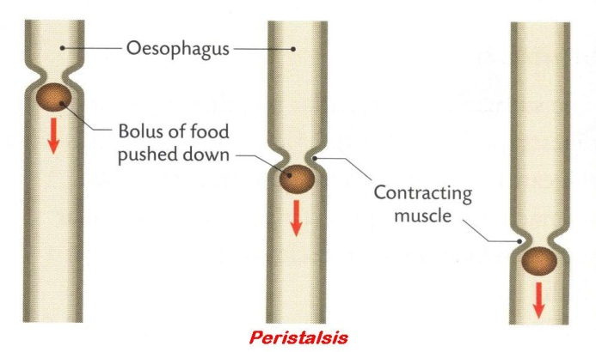

Human Nutrition and Digestion 1

Insert the correct answer from the lower grid into the correct position in the right hand column
1 | Herbivore
2 | Omnivore
3 | Carnivore
4 | Absorption
5 | Autotrophic nutrition
6 | Heterotrophic nutrition
7 | Digestion
8 | Peristalsis
9 | Why a low pH is important in the stomach
10 | Why fibre is important
11 | Enzyme involved in digestion of fat
12 | Products of fat digestion
13 | Role of bile in fat digestion
14 | Role of beneficial bacteria in alimentary canal
15 | How villi are adapted for absorption

A | An animal that eats both animals and plants | F | Fatty acids and glycerol | K | Movement across membrane into blood or lymph
B | Animal that feeds on animals only | G | Kills germs; Optimum pH for enzymes | L | Muscular contractions to move food
C | Animal that feeds on plants only | H | Large surface area; Rich blood supply; Thin-walled | M | Peristalsis; Prevent constipation
D | Breaking down food | I | Lipase | N | Production of vitamins; Inhibition of pathogens
E | Emulsification | J | Makes own food | O | Uses food already made by other organisms

Human Nutrition and Digestion 2

Insert the correct answer from the lower grid into the correct position in the right hand column
1 | Protease enzyme
2 | Products of protein digestion
3 | Carbohydrate-digesting enzyme
4 | Site of action of amylase
5 | Product(s) produced by amylase digestion
6 | Mechanical digestion
7 | Chemical digestion
8 | Structure, other than teeth, involved in mechanical digestion
9 | Functions of bile in digestive system
10 | Where lipase is secreted
11 | Site of action of lipase
12 | Optimum pH for lipase
13 | Activities of symbiotic bacteria in digestive system
14 | Optimum pH for amylase
15 | Where products of digestion are absorbed into the blood

A | Amino acids | F | Duodenum; Small intestine | K | Mouth; Small intestine
B | Amylase | G | Emulsification; Neutralisation | L | Pancreas
C | Between 7 and 9 | H | Enzyme action | M | Production of vitamins; Benefit immune system
D | Between 7 and 9 | I | Grinding; Cutting or Chewing | N | Stomach; Small intestine
E | Breaks down protein | J | Maltose | O | Villi or Ileum

Human Nutrition and Digestion 3

Insert the correct answer from the lower grid into the correct position in the right hand column
1 | Process involved in absorption of digested products
2 | Adaptations of ileum for the absorption
3 | How wholegrain cereal helps prevent constipation
4 | Human dental formula
5 | Function of incisor
6 | Function of canine
7 | Function of premolar
8 | Function of molar
9 | Symbiotic bacteria
10 | Part of digestive system where water is absorbed
11 | An organ for churning of food to chyme
12 | Waves of contractions passing through the gut
13 | An enzyme that turns fats to fatty acids and glycerol
14 | Emulsify fats
15 | Where bile is produced

A | Adds fibre; Absorbs water; Peristalsis encouraged; Faster movement | F | Cutting | K | Live in or on another organism, involving benefit
B | Bile salts | G | Diffusion | L | Liver
C | Colon; Stomach; Duodenum; Ileum | H | i 2/2; c 1/1; pm 2/2; m 3/3 | M | Peristalsis
D | Crushing | I | Large surface area; Good blood and lymph supply; Lining one cell thick; Long; Villi | N | Stomach
E | Crushing | J | Lipase | O | Tearing

Human Nutrition and Digestion 4

Insert the correct answer from the lower grid into the correct position in the right hand column
1 | Where bile is stored
2 | Where bile acts in the alimentary canal
3 | Role of peristalsis in digestion
4 | Are stomach contents acidic, neutral or alkaline?
5 | Are contents of small intestine acidic, neutral or alkaline?
6 | Substrate and product of amylase
7 | Egestion
8 | Egestion occurs from the ...
9 | pH of stomach contents
10 | On leaving the stomach food goes into the ...
11 | Role of the pancreas in digestion
12 | Why digestion is necessary
13 | Organ from which bile duct leaves
14 | Glands that secrete into the small intestine
15 | Non-digestive function of pancreas

A | Acidic | F | For solubility; For absorption; For transport | K | Makes enzymes; Makes NaHCO₃
B | Alkaline | G | Gall bladder | L | Produce insulin
C | Between 1 and 2 | H | Gall bladder | M | Push food along gut; Prevents constipation
D | Duodenum | I | Gall bladder and Pancreas | N | Rectum
E | Duodenum; Ileum | J | Getting rid of undigested food waste | O | Starch and maltose

3.3.5 Blood Transport of Nutrients

KEYWORDS

Amino acids
Bile
Chyme
Deamination
Diffusion
Emulsify
Fatty acids
Gall bladder
Glucose
Glycerol
Hepatic artery
Hepatic portal vein
Ileum
Lacteal
Liver
Minerals
Neutralise
Villus
Vitamins

EXPLANATIONS

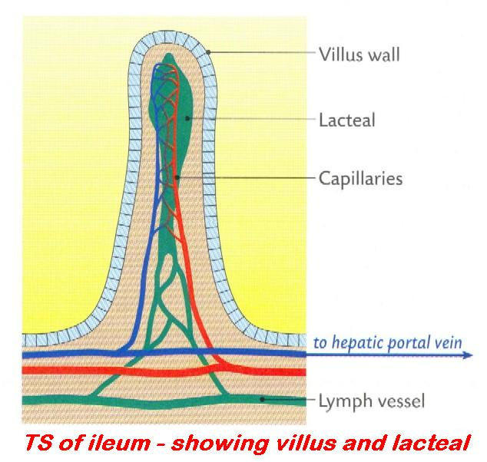

Insert the correct answer from the lower grid into the correct position in the right hand column
1 | Urea is formed in the kidneys. True or False
2 | Process by which digested foods are absorbed
3 | Type of food absorbed into lacteal of villi
4 | Role of liver in digestion
5 | Substance transported to liver in hepatic portal vein
6 | Blood vessel that brings oxygenated blood to the liver
7 | Where bile is stored after it has been made in the liver
8 | Role of bile salts in digestion
9 | Functions of the liver
10 | Bile is secreted by the ...
11 | Hepatic portal vein carries blood from intestines to ...
12 | Where products of digestion are absorbed
13 | Blood vessel that carries digested food to the liver
14 | The liver produces bile. True or False
15 | Balanced diet

A | Contains all the food types in correct proportions | F | Gall bladder | K | Liver
B | Diffusion | G | Glucose; Amino acids; Minerals; Vitamins | L | Make bile; Store vitamins; Deamination; Heat generation
C | Emulsify fats; Neutralise acidic chyme | H | Hepatic artery | M | Produces bile; Produces sodium hydrogen carbonate
D | False | I | Hepatic Portal Vein | N | Small intestine (ileum)
E | Fatty acids; Glycerol | J | Liver | O | True

3.3.7 + 3.4.1 Cohesion-Tension and Homeostasis

KEYWORDS

Adhesion
Amino acids
Balanced diet
Cohesion
Dixon and Joly
Food Pyramid
Homeostasis
Tension
Transpiration
Urea
Vascular tissue
Xylem

EXPLANATIONS

Adhesion: the ability of molecules of one substance to stick to (attract) a different substance, e.g. water molecules and the walls of the xylem vessels.
Balanced diet: one that contains the correct proportions of each of the following: carbohydrate, fat, protein, minerals, vitamins, water and roughage.
A balanced diet for an individual will depend on his/her sex, age and level of physical activity.
Cohesion: force with which molecules of the same substance stick to each other, e.g. force of attraction between water molecules.
Food pyramid: pyramid of five levels showing the correct number of servings of different foods to have a balanced diet.
Each level represents a different type of food. From the bottom up these are: cereals and starches (6+); fruit and vegetables (4+); dairy products (3); meat, fish, eggs, beans (2); sweets, chocolates, cakes (sparingly). The number in brackets represents the suggested minimum number of daily servings.
Homeostasis: the maintaining of a constant internal environment (i.e. concentrations of water, salt, turgidity, temperature, etc.) of a cell or organism or the processes involved with this.
Usually achieved by diffusion and the respiratory and excretory systems.
Tension: being stretched OR the pressure exerted by a gas expanding.

Insert the correct answer from the lower grid into the correct position in the right hand column
1 | Forces of attraction between water molecules
2 | Cohesion-tension model explains water movement against ...
3 | Ability of water molecules to stick to surfaces (xylem)
4 | Scientists associated with cohesion-tension model of transport
5 | Homeostasis
6 | Cause of tension
7 | Why homeostasis is important
8 | How liver contributes to homeostasis
9 | How lungs contribute to homeostasis
10 | How nephrons of kidneys contribute to homeostasis
11 | Water conducting vascular tissue
12 | Pulling force exerted by upward moving water

A | Adhesion | E | Gravity | I | Prevent a build-up of urea
B | Cohesion | F | Keeps temperature suitable for enzyme reactions | J | Tension
C | Convert excess amino acids to urea | G | Maintain levels of O₂ and CO₂ | K | Transpiration
D | Dixon and Joly | H | Maintaining a constant internal environment | L | Xylem

3.4.3 Plant Exchange System

KEYWORDS

Chloroplasts
Diffusion
Guard cells
Lenticels
Mitochondria
Stomata
Transpiration

EXPLANATIONS

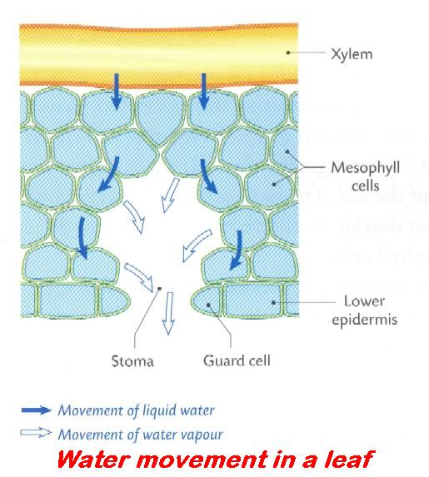

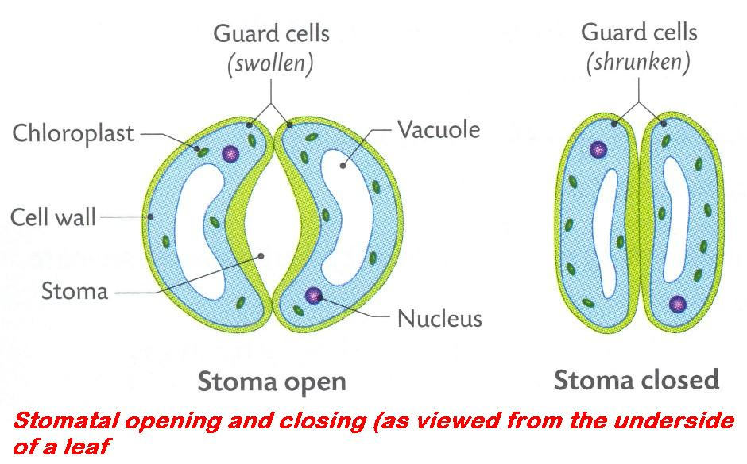

Insert the correct answer from the lower grid into the correct position in the right hand column
1 | Function of stomata of leaf
2 | Factor that influences stomatal diameter
3 | Apertures in stems equivalent to stomata
4 | Gas that exits the leaf at the stoma
5 | Structures in plant cells in which photosynthesis occurs
6 | Structures in plant cells in which aerobic respiration occurs
7 | Function of guard cells
8 | Gases that enter the leaf at the stoma
9 | Process by which gases move in or out of leaf
10 | Gas that diffuses throughout mesophyll of leaf
11 | Cells responsible for controlling size of stomatal opening
12 | Openings in leaf that allow gaseous exchange

A | Carbon dioxide | E | Diffusion | I | Mitochondria
B | Carbon dioxide; Oxygen; Nitrogen; Water vapour | F | Exchange of gases and transpiration | J | Oxygen; Water vapour; Carbon dioxide; Nitrogen
C | Chloroplasts | G | Guard cells | K | Stomata
D | Control stomatal size | H | Lenticels | L | Water vapour; Oxygen; Nitrogen; Carbon dioxide

3.4.4 Breathing System

KEYWORDS

Allergic response
Alveoli
Antibiotic
Bacteria
Breathing
Bronchioles
Capillary
Diaphragm
Infection
Intercostals
Oesophagus
Oxyhaemoglobin
Steroids
Trachea
Thorax

EXPLANATIONS

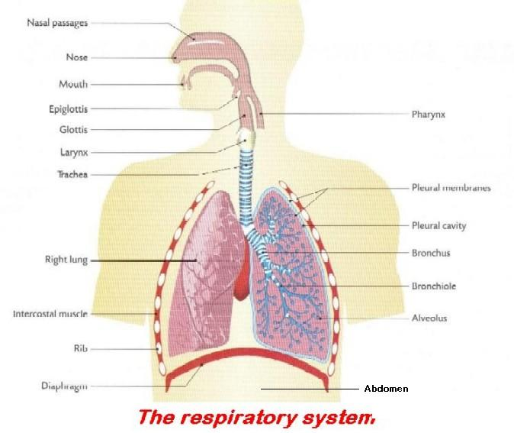

Breathing System 1

Insert the correct answer from the lower grid into the correct position in the right hand column
1 | Average breathing rate at rest
2 | Effect of smoking on resting breathing rate
3 | Where cilia occur in the breathing system
4 | Function of cilia
5 | Takes place in the alveoli
6 | How alveoli are adapted for their purpose
7 | Effect of exercise on the breathing rate
8 | Possible cause of asthma
9 | Possible cause of bronchitis
10 | Treatment for asthma
11 | Treatment for bronchitis
12 | Gas transported in pulmonary vein

A | 16 bpm | E | Carry dirt particles and bacteria upwards | I | Infection; Narrowing of bronchi
B | Allergic response; Smoking; Narrowing of bronchioles; Infection; Anxiety | F | Exchange of gases | J | Oxygen
C | Antibiotics | G | Increases | K | Trachea
D | Capillary network; Moist surface; Thin walled; Large surface area; One cell thick | H | Increases | L | Use of inhaler; Steroids

Breathing System 2

Insert the correct answer from the lower grid into the correct position in the right hand column
1 | How oxygen is transported in the blood
2 | Function of epiglottis
3 | Function of larynx
4 | Role of the diaphragm muscles in inhalation
5 | Role of the intercostal muscles in inhalation
6 | Process involved in passage of gas between alveolus and blood
7 | Function of cartilage in trachea
8 | Where is the epiglottis?
9 | Muscles used in breathing
10 | Humans receive oxygen from air they inhale. True or False
11 | Role of alveoli in the lungs
12 | Location of diaphragm
13 | Location of intercostal muscles
14 | How water is lost from the body
15 | Structures in lungs in which gaseous exchange takes place

A | Alveoli | F | Diaphragm; Intercostal | K | To close off trachea
B | As oxyhaemoglobin | G | Diffusion | L | To keep it open
C | Between ribs | H | Dividing the thorax and abdomen | M | To make sound
D | Contract; Raise rib cage | I | Exchange gases | N | Top of oesophagus
E | Contracts; Lowers | J | Sweating; Breathing out water vapour | O | True

3.4.6 Excretory System

KEYWORDS

Abdomen
Adipose tissue
Amino acids
Aorta
Bile
Bladder
Bowman’s capsule
Carbohydrate
Constrict
Cortex
Dialysis
Diffusion
Dilate
Ectotherm
Endotherm
Excretion
Fat
Fatty acids
Glucose
Hormone
Kidney
Loop of Henle
Medulla
Metabolism
Nephron
Osmoregulation
Piloerection
Plasma
Protein
Reabsorption
Renal artery
Respiration
Transpiration
Ureter
Urethra
Urine
Vasoconstriction
Vasodilation

EXPLANATIONS

Ectotherm: animal whose temperature changes with that of its surroundings, i.e. a cold-blooded animal, e.g. fish, frog, reptile.
It gains heat by moving into a warmer area and loses heat by moving into a colder area.
Endotherm: animal whose body temperature is maintained usually at a higher level than that of its surroundings, i.e. a warm-blooded animal, e.g. human.
The source of this heat is from its own metabolism.
Excretion: is the elimination of the waste products of metabolism from a cell, tissue or organ. | ORGAN EXCRETORY PRODUCTS  Skin Sweat = Water (95%), Salt (2%), Carbon dioxide (3%), Urea (tiny%)  Lungs Carbon dioxide and Water vapour  Kidneys Water, Urea, Uric acid, Na, Cl, K  Stomata (in plants) Oxygen, water vapour
Reabsorption: taking in again, e.g. in the nephron of the kidney: glucose, amino acids, etc. are taken back into the blood in the proximal convoluted tubule after being removed from it in the glomerulus | 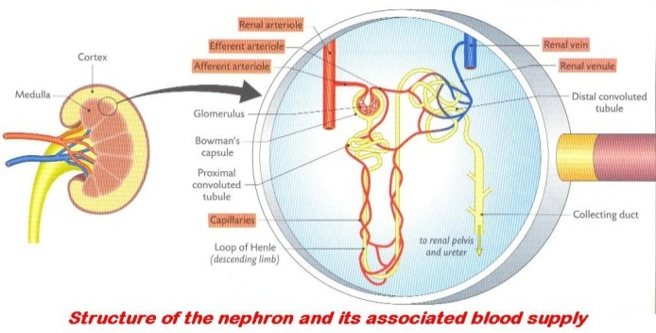
Ureter: duct (tube) that brings urine from the kidney to the bladder. | 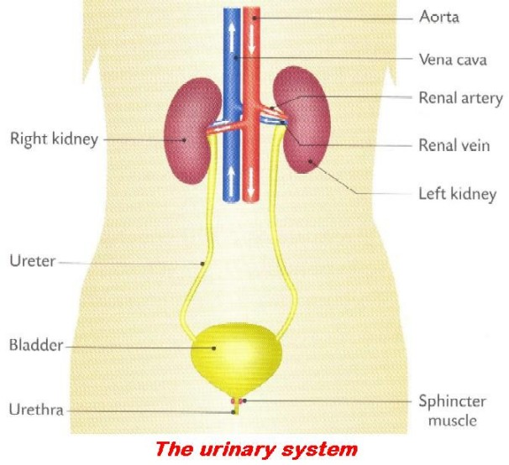
Urethra: duct (tube) which delivers urine from the bladder to the outside; also, in the male it deposits sperm in the vagina.

Excretory System 1

Insert the correct answer from the lower grid into the correct position in the right hand column
1 | Excretion
2 | Method of excretion in flowering plants
3 | Role of the kidneys in homeostasis
4 | Ureter
5 | Urethra
6 | Plasma
7 | Glomerular filtrate
8 | Why red blood cells are absent from glomerular filtrate
9 | Concentration of glucose in plasma same as glomerular filtrate. Why?
10 | Why glucose is normally absent from urine
11 | Substance from which urea is derived
12 | Substance from which carbon dioxide is derived
13 | The ureter links kidney to ...
14 | Where filtration occurs in the kidney
15 | Substances not lost from the body during urine formation
16 | Treatment for a person whose kidneys are malfunctioning
17 | Organs of excretion other than kidney
18 | Where reabsorption occurs in the kidney

A | Bladder | G | Elimination of waste products of metabolism | M | Maintaining salt and water balance; Osmoregulation
B | Carbohydrate; Fat; Fatty acids | H | From bladder to outside | N | Plasma that has entered Bowman's capsule
C | Cortex; Bowman's capsule | I | From kidney to bladder | O | Protein; Amino acid
D | Cortex; Medulla; Nephron; Loop of Henle | J | Glucose small, can pass into Bowman's capsule | P | Proteins; Glucose
E | Dialysis | K | It is reabsorbed | Q | Skin; Lungs; Liver
F | Diffusion; transpiration | L | Liquid part of blood | R | Too big to pass into Bowman's capsule

Excretory System 2

Insert the correct answer from the lower grid into the correct position in the right hand column
1 | Excretory substance present in urine
2 | Endotherm
3 | Main source of body heat in endotherms
4 | Arterioles in the skin ... when external temperature drops
5 | Products excreted by human
6 | Osmoregulation
7 | Arterioles in the skin ... when external temperature rises
8 | Main blood vessel to which renal artery links the kidney
9 | Fluid present in ureter
10 | Occurs in the proximal convoluted tubule
11 | Blood vessel that supplies blood to a kidney
12 | Cavity of the body where kidneys are located
13 | Feature of kidney which indicates it is an exocrine gland
14 | Substance excreted by the skin
15 | Functions of the skin other than excretion
16 | Responses when body temperature begins to drop
17 | How the body is insulated against loss of heat
18 | Responses when body temperature begins to rise
19 | Substances found in sweat
20 | Animals which are not endotherms
21 | Advantage of being an endotherm

A | Abdomen | H | Ectotherms | O | Temperature always suitable for enzyme activity
B | Adipose tissue; Hair | I | Has constant body temperature | P | Temperature regulation; Protection
C | Aorta | J | Has ducts; Does not produce hormones | Q | Urea; Water; Salt
D | Balancing salt/water concentration | K | Piloerection; Increased metabolic rate; Vasoconstriction | R | Urine
E | Carbon dioxide; Urine; Water; Sweat; Bile; Salt | L | Reabsorption | S | Vasodilation; Sweat; Hairs lie flat
F | Constrict | M | Renal artery | T | Water; Salt
G | Dilate | N | Respiration | U | Water; Urea; Salt

3.4.7 + 8 Excretion

KEYWORDS

Absorption
Active transport
ADH
Bowman’s capsule
Cortex
Distal convoluted tubule
Glomerular filtrate
Permeable
Perspiration
Pituitary
Plasma
Protein
Proximal convoluted tubule
Renal artery
Respiration
Vasopressin

EXPLANATIONS

Active transport: the movement of substances (solutes or ions) from a region of low concentration (hypotonic) to a region of higher concentration (hypertonic) against the concentration gradient through a semi-permeable membrane (cell membrane).
It requires the use of energy (in the form of ATP) by the cell. ATP is a product of respiration. Respiration usually requires oxygen and occurs in the mitochondria.

Insert the correct answer from the lower grid into the correct position in the right hand column
1 | Breathing
2 | Respiration
3 | Breathing rate controlled by concentration of... in the blood
4 | Factor that influences the diameter of the stoma(ta)
5 | Gas in blood that triggers deeper or faster breathing
6 | Plasma
7 | Glomerular filtrate
8 | Why red blood cells are absent from glomerular filtrate
9 | Blood vessel from which afferent arteriole is derived
10 | Where Bowman's capsule is located in kidney
11 | Where filtration takes place in kidney
12 | Where reabsorption of amino acids takes place in kidney
13 | Features of nephron that aid filtration
14 | Biomolecules too large to pass into the glomerular filtrate
15 | Situations which result in a drop in water content of blood
16 | Hormone released when water content of blood drops
17 | Endocrine gland which secretes ADH (vasopressin)
18 | Target area for ADH (vasopressin)
19 | How ADH (vasopressin) reaches its target area
20 | Role of ADH when water content of blood is low
21 | Hormone which changes permeability of collecting ducts
22 | Is it normal for urine to contain protein?
23 | Is it normal for urine to contain glucose?
24 | Is it normal for urine to contain salts?

A | ADH (vasopressin) | I | Distal convoluted tubule; Collecting duct | Q | Pituitary
B | Anti-diuretic hormone; Vasopressin | J | In the blood | R | Plasma that has entered Bowman's capsule
C | Bowman's capsule or glomerulus | K | Infection; Perspiration; High salt intake; Low water intake | S | Process of taking in 0₂ and giving out of CO₂ and H₂O vapour to the air
D | Carbon dioxide | L | Large surface area; Porous capillary walls; Lining one cell thick | T | Proteins
E | Carbon dioxide | M | Liquid part of blood | U | Proximal convoluted tubule
F | CO₂; Light; K⁺ ions; Water | N | Makes walls more permeable; More absorption of water | V | Renal artery (arteriole)
G | Controlled release of energy from food, within the cell(s) of an organism | O | No | W | Too big to pass into Bowman's capsule
H | Cortex | P | No | X | Yes

3.5.2 Plant Responses

KEYWORDS

Abscisic acid
Adverse environmental stimulus
Adverse external environment
Apical meristems
Auxin
Chemotropism
Ethylene (ethene)
Geotropism
Growth Regulator
Hydrotropism
IAA
NAA
Phloem
Phototropism
Photosynthesis
Plant growth regulator
Positively phototropic
Serial dilution
Thigmotropism
Tropism
Vascular

EXPLANATIONS

Chemotropism: the growth response of a plant to chemicals, e.g. fertilisers.
Responsible for roots growing downwards.
Geotropism: the growth response of a plant to gravity.
Growth regulators: chemicals produced in the meristematic regions and transported through the vascular system of plants. They affect the rate of growth (cell division) or development of plants when they are in very low concentrations.
Some external factors also regulate the growth of plants, e.g. light intensity, amount of daylight, temperature and gravity.
Hydrotropism: the growth response of a plant to water.
Phototropism: the growth response of a plant to light.  Caused by the higher concentration of the plant growth regulator IAA (indoleacetic acid, an auxin) on the darker side of the plant shoot. This promotes cell elongation on that side and the shoot grows towards the light as a result. | 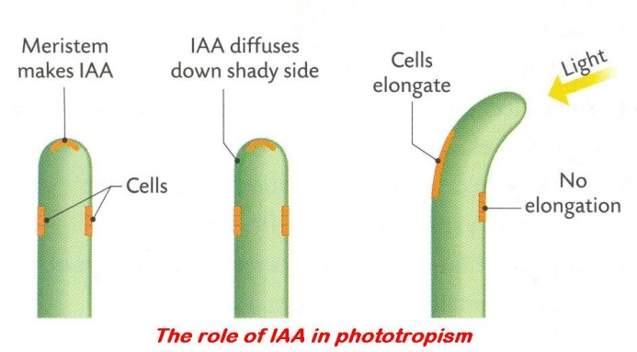
Thigmotropism: the growth response of a plant to touch, e.g. tendrils.
Tropism: the growth response of part of a plant to an external unidirectional stimulus.
- positive tropism: plant grows towards stimulus
- negative tropism: plant grows away from stimulus

Insert the correct answer from the lower grid into the correct position in the right hand column
1 | Where in flowering plants growth regulator is secreted
2 | Uses of synthetic growth regulator
3 | Making solutions of different concentrations from a stock solution
4 | Auxin
5 | A site of auxin secretion
6 | Similarity between auxin and hormone action
7 | Tropism
8 | Types of tropism
9 | Methods used by plants to protect themselves
10 | Role of auxin in phototropism
11 | Thigmotropism
12 | Chemotropism
13 | Growth regulator that promotes growth
14 | Growth regulator that inhibits growth
15 | Growth response of roots growing towards water
16 | Growth response of shoots growing towards light
17 | Benefit to a plant of phototropism
18 | Phototropism is the growth response of a plant to ...
19 | Substances that control tropic responses
20 | Tissue through which growth regulators are transported
21 | The growth response of a plant to chemicals is geotropism. True or False
22 | Adverse external environment
23 | The growth response of a plant to light is phototropism. True or False
24 | Growth regulator used when investigating plant growth

A | Apical meristems of shoots | I | Hydrotropism | Q | Rooting powder; Weed killer; Ripening of fruit; Seedless fruits
B | Causes response; Slow acting; Long lasting | J | IAA | R | Serial dilution
C | False | K | IAA; NAA; Abscisic acid; Ethylene (ethene) | S | Surroundings that are harmful to organism(s)
D | Growth regulator in plants | L | IAA; NAA; Ethylene (ethene) | T | Thigmo-; Photo-; Geo-; Hydro-; Chemo-
E | Growth regulators | M | Light | U | Thorns; Stings; Bad taste; Poison
F | Growth response of plant to a stimulus | N | Phloem; Vascular | V | Tip of shoot; Buds; Meristem
G | Growth response to chemicals | O | Photosynthesis | W | True
H | Growth response to touch | P | Phototropism | X | Unequal distribution, caused by light, unequal growth, results in bending

3.5.3 + 7 Defence System

KEYWORDS

Active immunity
Antibody
Antigen
B–cells
Bactericidal agent
Helper T-cells
Immunity
Induced Immunity
Killer T-cells
Lymph node
Memory T-cells
Passive immunity
Pathogen
Serum
Spleen
Suppressor T-cells
T-cells
Thymus
Vaccination
Vaccine
Virus

EXPLANATIONS

Active immunity: long-term immunity resulting from the production of antibodies.
This can be achieved by:
- inoculation (the injection) of vaccine containing a weakened strain of a pathogen or its toxin, or
- an infection by a pathogen.

The body produces an antibody in response to the presence of either of these and retains the ability to produce it again if attacked by the pathogen at some later stage, i.e. it is long-term immunity.
Antibody: protein substances produced by lymphocytes (white blood cells) to attack and destroy or counteract specific antigens (micro-organisms or their products).
Antigen: a substance (micro-organism or it’s waste products) that the immune system of the body recognises as ‘foreign’.
As a result the immune system will produce antibodies that will react with the antigen and neutralise or destroy it.
Immunity: the ability of the body to resist infection.
Induced immunity: to give the body the ability to fight infections using antibodies that are produced by (a) suffering the illness or (b) by vaccination.  Induced immunity can be active or passive. | 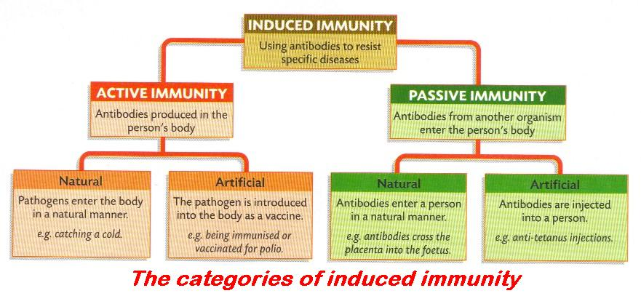
Passive immunity: recipient receives antiserum, containing antibodies, from an already immunised individual. This confers short-term immunity on that individual, e.g. tetanus and new-born babies.
Vaccination: process of injecting a vaccine (which acts as an antigen) into a person in order to induce immunity. This results in the production of antibodies against the antigen.
Vaccine: a suspension of living, dead or attenuated pathogens which act as an antigen causing the body to produce antibodies that render the body immune to infection by the specific pathogens.
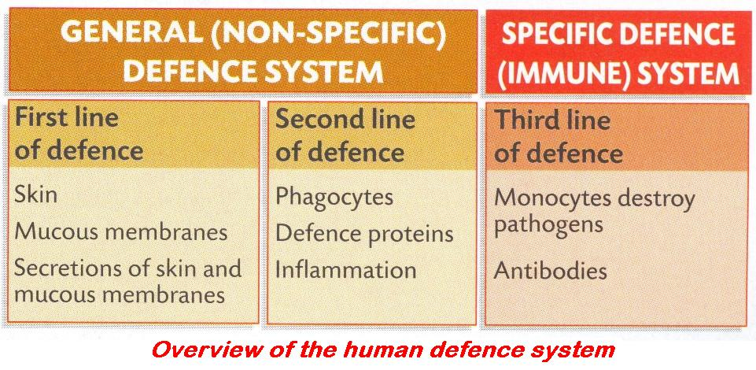

Insert the correct answer from the lower grid into the correct position in the right hand column
1 | Immunity
2 | Active immunity
3 | Passive immunity
4 | How skin defends body against pathogens
5 | Specific defence system
6 | Purpose of vaccination
7 | Antigen
8 | Antibody
9 | Vaccination gives rise to active immunity. True or False
10 | Vaccination
11 | Antibiotic
12 | Long-term immunity
13 | Short-term immunity
14 | General defence system
15 | Phagocytic white blood cells
16 | Group of blood cells to which lymphocytes belong
17 | Types of lymphocyte
18 | Role of B-cells
19 | Role of T-cells
20 | Role of Helper T-cells
21 | Role of Killer T-cells
22 | Role of Suppressor T-cells
23 | Role of Memory T-cells
24 | Lymphocytes and monocytes respond to ...

A | Ability of body to resist infection | I | Memorise antigen | Q | Spleen; Thymus and Lymph nodes
B | Act as Helper; Killer; Suppressor or Memory cells | J | Passive immunity | R | Stimulate B cells or Killer T cells; Recognise antigens
C | Active immunity | K | Produce antibodies | S | Substance produced one micro-organisms that kills another
D | Antigens | L | Produced in response to antigen, destroys antigen | T | Switch off immune system
E | Continuous unbroken covering; Contains bactericidal agent | M | Production of antibodies | U | T-cells; B-cells
F | Destroy infected or damaged cells | N | Receives serum from immune individual | V | To induce immunity
G | Engulf bacteria and viruses | O | 'Safe dose' of a pathogen, causing antibody production | W | True
H | Foreign substance, causes antibody production | P | Skin and mucous linings of Respiratory, Digestive and Reproductive tracts | X | White blood cells

3.5.3 Endocrine System

KEYWORDS

Adrenaline
Contraception
Diabetes
Diabetes Mellitus
Ductless gland
Endocrine
Endocrine gland
Exocrine
Exocrine gland
Feedback
Glucagon
Hormone
Insulin
Pancreas
Pituitary

EXPLANATIONS

Endocrine gland: ductless gland. Secretions (hormones) delivered directly into bloodstream by the following glands.  e.g. pituitary, thyroid, parathyroid, pancreas, adrenal, ovary and testis. | 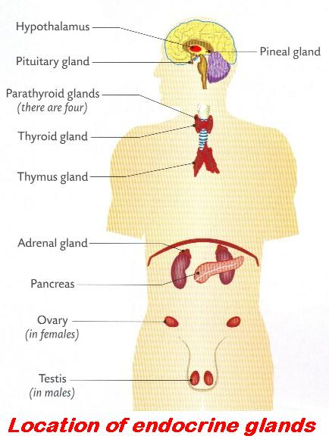
Exocrine gland: a gland which delivers its secretion through a tube or duct.
Does not depend on bloodstream, e.g. liver, pancreas, sweat glands and salivary glands.
Hormone: a substance (chemical message) produced by an endocrine gland secreted directly into and transported by the bloodstream to other parts (target organs) of the body where it brings about a response.
Hormones regulate metabolic activity. A hormonal response generally works slowly over a longer period of time compared with a nervous response.

Insert the correct answer from the lower grid into the correct position in the right hand column
1 | Hormone
2 | Gland producing growth hormone
3 | Function of growth hormone
4 | Growth hormone deficiency symptom
5 | How hormone action differs from nerve action
6 | Exocrine gland
7 | How endocrine gland differs from exocrine gland
8 | Endocrine gland
9 | Product of the endocrine portion of the pancreas
10 | Function of insulin or glucagon
11 | Fight or flight hormone
12 | Symptom of insulin deficiency
13 | Glands that secrete hormones
14 | Where Islets of Langerhans are found
15 | Hormone secreted by Islets of Langerhans
16 | Hormone that controls the rate of metabolism
17 | Use of hormone supplements
18 | How hormones are similar to plant growth regulators

A | Adrenaline | G | Gland with a duct | M | Produced in one location, acts in different location; Prolonged effect
B | Chemical secreted by ductless gland causing a response | H | Insulin | N | Regulates blood sugar level
C | Control rate of growth | I | Insulin or Glucagon | O | Secretes into blood stream
D | Diabetes mellitus | J | Pancreas | P | Slower to act; More sustained; Chemical
E | Ductless or Hormone producing gland | K | Pituitary | Q | Thyroxine
F | Endocrine or Ductless | L | Pituitary dwarfism | R | Treatment of diabetes; Contraception

3.5.3 Eye and Ear

KEYWORDS

Cochlea
Cones
Eustachian tube
Hammer
Iris
Lens
Optic nerve
Pharynx (throat)
Pupil
Retina
Rods
Semi-circular canals
Suspensory ligaments

EXPLANATIONS

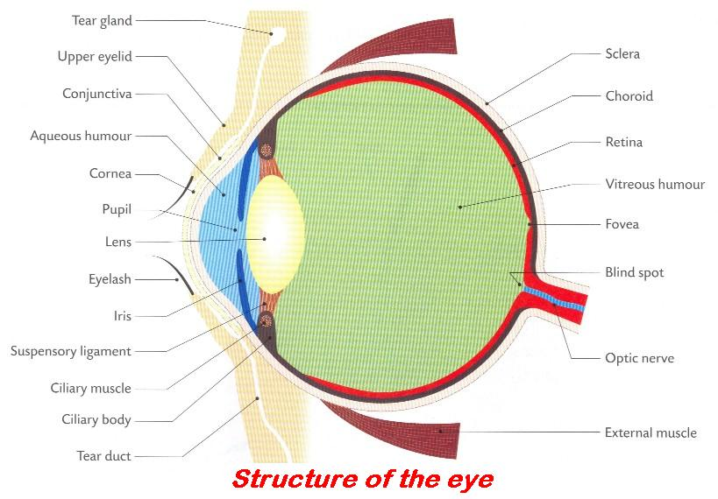

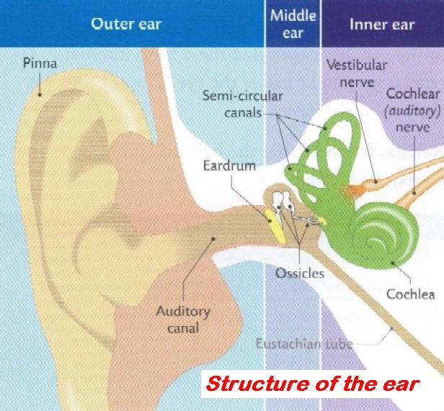

Insert the correct answer from the lower grid into the correct position in the right hand column
1 | Function of lens
2 | Function of retina
3 | Role of suspensory ligaments in vision
4 | Role of cones in vision
5 | Role of optic nerve in vision
6 | Role of brain in vision
7 | Function of iris
8 | Why two eyes are better than one
9 | The hammer is a very small bone located in the ...
10 | Connected to the middle ear by the Eustachian tube
11 | Present in the middle ear
12 | Function of cochlea
13 | Part of eye where rods and cones are found
14 | Function of rods
15 | Where in the eye is the retina located?
16 | Types of cells that receive light in the retina
17 | Function of the Eustachian tube
18 | Function of semi-circular canals
19 | Part of the ear where nerve impulses are generated
20 | Coloured part of the eye
21 | Function of pupil

A | Back of the eye | H | Equalise pressure on the eardrum | O | Pharynx (throat)
B | Black and white vision; Vision in poor light | I | Gas/Air | P | Posture; Balance
C | Brings impulses from retina to brain | J | Hearing | Q | Retina
D | Cochlea or Semi-circular canals | K | Holds lens in place | R | Rods; Cones
E | Controls amount of light entering eye | L | Increased visual field; To judge distance | S | To allow light in
F | Detects colour | M | Interprets information received from retina | T | To convert light into nerve impulses
G | Ear | N | Iris | U | To focus light onto the retina

3.5.3 Musculoskeletal System

KEYWORDS

Antagonistic muscle pair
Appendicular skeleton
Arthritis
Axial skeleton
Ball and socket
Biceps
Cartilage
Cervical
Compact bone
Contractile (tissue)
Femur
Hinge
Humerus
Joint
Ligament
Lumbar
Medullary cavity
Osteoblast
Osteoporosis
Radius
Spinal cord
Spongy bone
Tendon
Triceps
Ulna
Vertebrae
Vertebral column

EXPLANATIONS

Appendicular skeleton: all bones in the skeleton excluding the axial skeleton (skull, vertebral column, sternum and ribs).  These include wings, legs, and arms or fins and the pelvic girdle and pectoral girdle that join the appendages to the rest of the skeleton. | 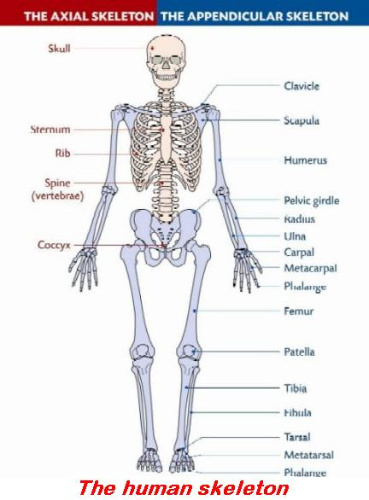
Axial skeleton: this is composed of the skull, vertebral column, sternum and ribs.
Joint: the place where two bones meet.  The function of joints is to allow movement. Types of joints include immovable joints, slightly movable joints, freely moving and synovial joints. | 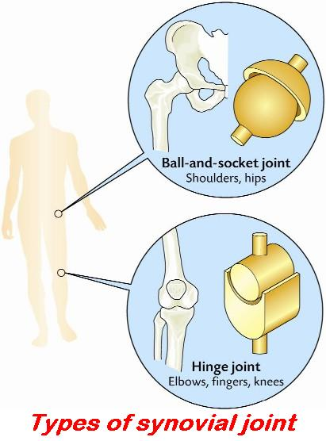
Ligament: an elastic connective tissue that joins bone to bone. | 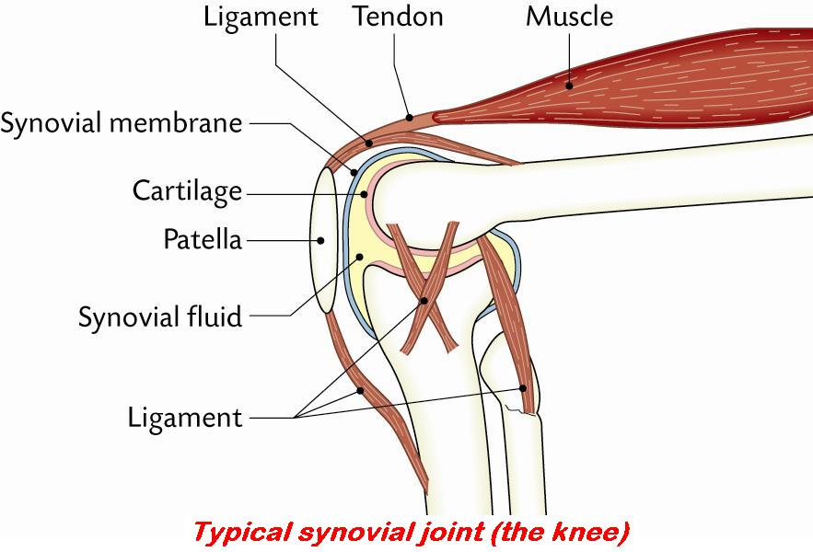
Tendon: a non-elastic connective tissue that joins muscle to bone.
Osteoblast: bone-forming cell found lining the outer surface of all bones.
Also present inside most bone cavities. These cells secrete a very strong bone matrix made mainly of collagen fibres, which provide bone with its strength. They replace cartilage with bone when the body is growing.

Musculoskeletal System 1

Insert the correct answer from the lower grid into the correct position in the right hand column
1 | Disorders of the musculoskeletal system
2 | Function of cartilage
3 | Function of synovial fluid
4 | Function of ligament
5 | Roles of the skeleton
6 | Axial skeleton
7 | Function of red marrow
8 | Function of tendon
9 | Antagonistic muscle pair
10 | Where are the discs in human backbone?
11 | Function of intervertebral discs
12 | Role of yellow bone marrow
13 | Bones are joined to other bones by ...
14 | Vertebrae found in the neck
15 | Vertebrae found in small of back

A | Absorbs shock; Reduces wear and friction; Protection | F | Formation of blood cells | K | Lumbar
B | Arthritis; osteoporosis | G | Friction-free movement; Absorbs shock | L | Pair of muscles that have opposite effects
C | Between the vertebrae | H | Hold bones together | M | Shock absorption; Friction-free movement
D | Cervical | I | Joins muscle to bone | N | Support; Movement; Protection
E | Fat storage | J | Ligaments | O | Vertebral column, skull and rib cage

Musculoskeletal System 2

Insert the correct answer from the lower grid into the correct position in the right hand column
1 | Vertebrae found in the neck
2 | Function of synovial fluid
3 | Bones are joined to other bones by ligaments. True or False
4 | Part of CNS that runs through the vertebrae
5 | Bones that form human arm
6 | Structures that attach muscle to bone
7 | Upper arm muscle that contracts to raise arm
8 | Upper arm muscle that contracts to lower arm
9 | Type of joint at the elbow
10 | Type of joint at the hip
11 | Why the bones of birds are almost hollow
12 | Tendons attach bone to bone. True or False
13 | A long bone
14 | State a function of spongy bone.
15 | State a function of compact bone.

A | Ball and socket | F | Hinge | K | Red blood cell formation
B | Biceps | G | Humerus; Femur | L | Spinal cord
C | Cervical | H | Humerus; Radius; Ulna | M | Tendons
D | False | I | Light for flight | N | Triceps
E | Friction-free movement; Absorbs shock | J | Protection; Support | O | True

3.5.3 Nervous System

KEYWORDS

Axon
Central nervous system (CNS)
Cerebellum
Cerebrum
Dendrites
Grey matter
Homeostasis
Hypothalamus
Impulse
Inter-(Association) neurons
Interneuron
Involuntary muscle activity
Medulla oblongata
Motor neuron
Myelin sheath
Neuron
Neurotransmitter
Osmoregulation
Paralysis
Parkinson's disease
Peripheral nervous system (PNS)
Reflex action
Response
Sensory neuron
Spinal cord
Stimulus
Synapse
Synaptic cleft
Voluntary muscle activity
White matter

EXPLANATIONS

Interneurons: neurons that carry messages from one or more sensory neurons to motor neurons.
They are found within the central nervous system.
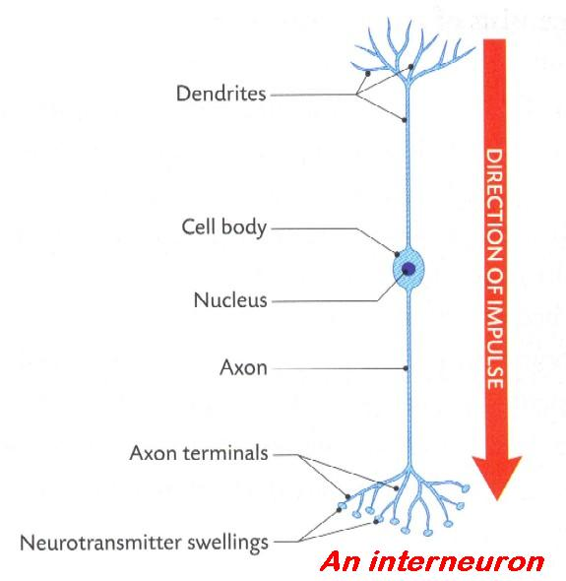 | 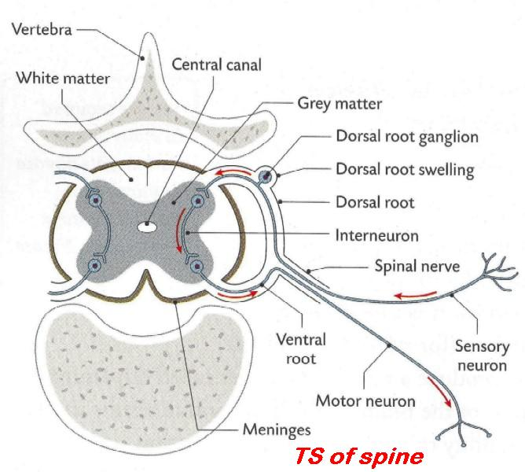

Motor neuron: efferent neuron. Carries messages from the central nervous system (CNS) to an effector.  Cell body located at end of axon, inside CNS. | 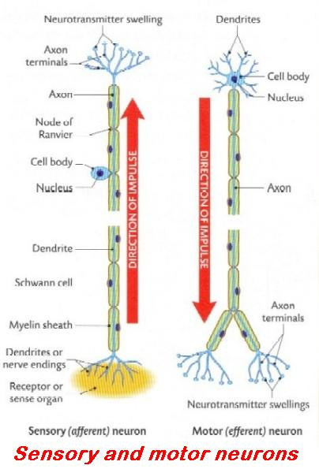
Sensory neuron: afferent neuron. Pick up and carry messages from sense organs (receptors) to the central nervous system (CNS).
Cell body at end of a short branch to one side of the axon, outside CNS.
Response: the ability of living organisms to react to changes in their internal and external environments.
It is a form of defence that allows the organisms survive.

Insert the correct answer from the lower grid into the correct position in the right hand column
1 | Motor neurons conduct impulses away from the CNS. True or False
2 | A neuron is a ...
3 | Sensory neurons
4 | Motor neurons
5 | Interneurons (association neurons)
6 | Role of neurotransmitter substances
7 | Function of Schwann cells
8 | Function of Myelin sheath
9 | Function of dendrites
10 | Small gaps between neurons
11 | Reflex action
12 | Importance of reflex actions
13 | A motor neuron carries impulses to the brain. True or False
14 | Central nervous system is made up of...
15 | Disorders of the nervous system
16 | Peripheral nervous system is made up of...
17 | Function of Cerebrum
18 | Function of Hypothalamus
19 | Function of Cerebellum
20 | Function of Medulla oblongata
21 | Grey matter
22 | White matter
23 | Area where one neuron ends and another begins
24 | Chemical that carries messages between two neurons

A | All nerves except brain and spinal cord | I | Co-ordinates voluntary muscle activity; Balance | Q | Rapid response; Defence against injury
B | Automatic response to a stimulus | J | False | R | Receive impulse and carry it to cell body
C | Brain and spinal cord | K | Insulation; Speeds up impulse | S | Responsible for involuntary muscle activities
D | Carry impulse across synaptic cleft; Trigger impulse in next neuron | L | Link two neurons | T | Responsible for movement; Memory; Intelligence; Emotions
E | Carry impulses from CNS to effector | M | Nerve cell | U | Responsible for Osmoregulation; Body temperature; Homeostasis
F | Carry impulses towards CNS from receptor | N | Neurotransmitter | V | Synaptic cleft or Synapse
G | Consists of axons of neurons | O | Parkinson's; Paralysis | W | Synaptic cleft or Synapse
H | Consists of nerve cell bodies and dendrites | P | Produces myelin sheath | X | True

3.5.4 Viruses

KEYWORDS

Antigen
Disease
DNA
Host
Immune system
Non-cellular
Nucleic acid
Protein
RNA
Specific
Virus

EXPLANATIONS

Virus: (plural = viruses) non-cellular micro-organisms, made up of a protein coat and one type of nucleic acid (DNA or RNA).
They are obligate parasites, i.e. they can only multiply (reproduce) inside a living cell. Three types of virus: spheres, rods and bacteriophages. Cause disease, e.g. foot and mouth, rabies, polio, influenza, common cold, AIDS, etc.

Insert the correct answer from the lower grid into the correct position in the right hand column
1 | Virus
2 | Main chemical components of virus
3 | How is HIV transmitted
4 | How HIV affects the human body
5 | How spread of HIV controlled
6 | Human diseases caused by viruses
7 | Beneficial application of a virus
8 | Antibiotic
9 | Antibiotics not prescribed for viral infections. Why?
10 | Advantage of biological control
11 | Disadvantage of biological control
12 | Economic importance of viruses
13 | Medical importance of viruses
14 | HIV/AIDS has orphaned many children in sub-Saharan Africa. True or False
15 | Antibody

A | Crop damage; Animal and human disease | F | Human disease cost; Used in medical research | K | Smallpox; Chicken pox; Measles; Mumps; Rubella; Polio; 'Flu; Common cold
B | Destroys the immune system | G | Non-cellular, one nucleic acid, reproduce in host cell | L | Substance produced one micro-organisms that kills another
C | DNA or RNA; Protein | H | One faithful sexual partner; Not sharing needles | M | True
D | Environmentally friendly; specific | I | Produced in response to antigen; Destroys antigen | N | Upsets balance of nature
E | Have no effect on viruses | J | Sexual contact | O | Used in genetic engineering; vaccine production

3.6.1 Asexual Reproduction

KEYWORDS

Asexual reproduction
Budding
Bulb
Clone
Corm
Cutting
Grafting
Layering
Pollination
Rhizome
Runner
Seed
Sexual reproduction
Tissue culturing
Tuber
Variation
Vegetative propagation

EXPLANATIONS

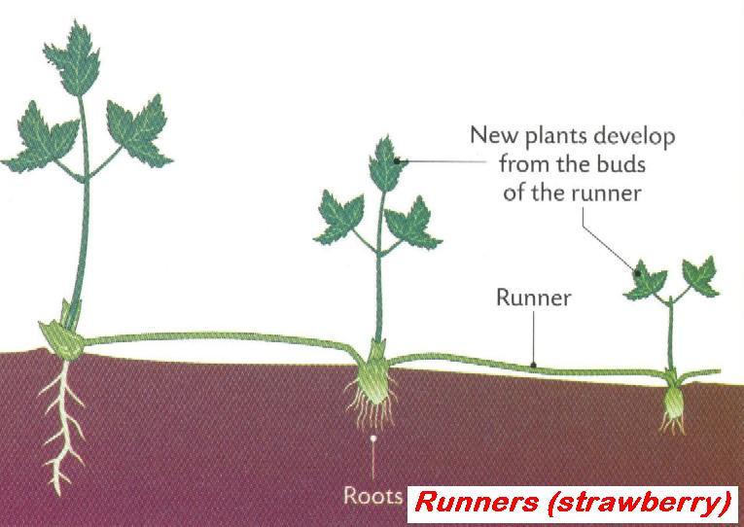 | 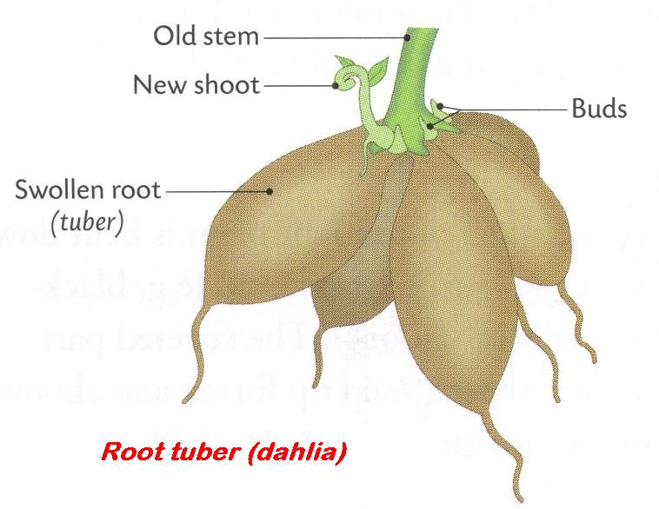
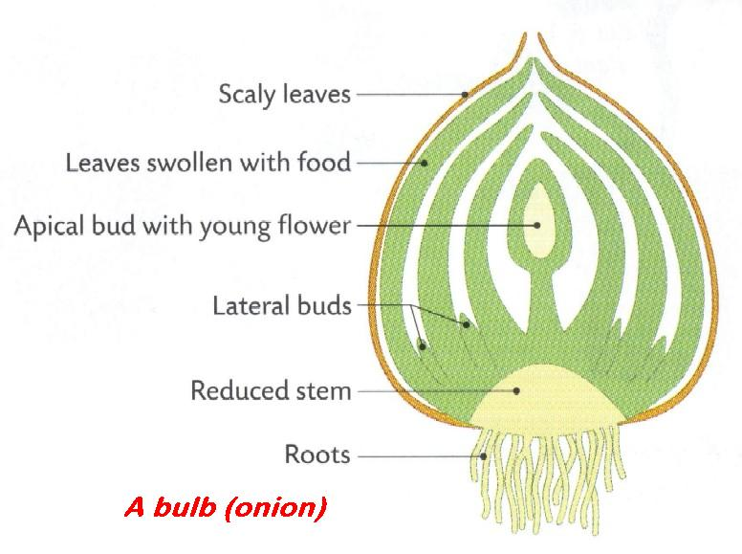 | 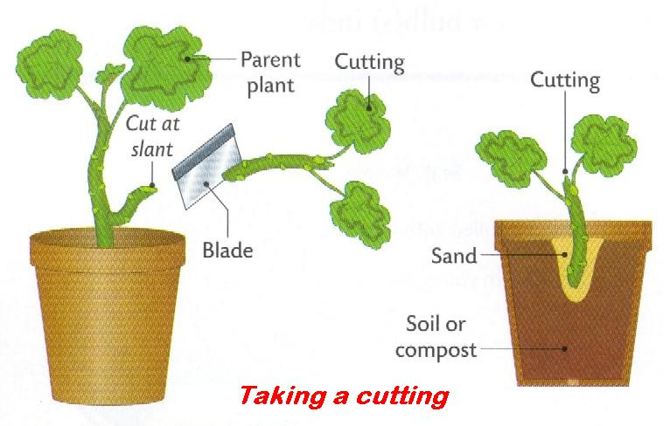

Insert the correct answer from the lower grid into the correct position in the right hand column
1 | Vegetative propagation
2 | Genetically identical individuals
3 | Examples of natural vegetative propagation involving a stem
4 | The products of vegetative propagation are clones. True or False
5 | Examples of natural vegetative propagation involving a root
6 | Benefit of artificial propagation
7 | Examples of natural vegetative propagation involving a bud
8 | Techniques of artificial vegetative propagation used for flowering plants
9 | How vegetative propagation differs from sexual reproduction
10 | Disadvantage of artificial propagation
11 | Main types of reproduction
12 | Strawberries reproduce asexually using …

A | Bulbs | E | Offspring identical; Fast; Preserves desirable features | I | Runners
B | Clones | F | One parent; Less variation; No pollination | J | Sexual; Asexual
C | Cuttings; Layering; Grafting; Budding; Tissue culturing | G | Reproduction that does not involve seed production | K | True
D | Lack of variation; Disease susceptibility | H | Rhizomes; Corms; Tubers | L | Tubers

3.6.1 + 3 Flower Structure and Gamete Formation

KEYWORDS

Anther
Embryo
Embryo sac
Endosperm nucleus
Fertilised egg
Fruit
Gametes
Haploid
Meiosis
Mitosis
Ovary
Petal
Photosynthesis
Polar nuclei
Pollen
Stamen
Stigma
Triploid
Tube nucleus

EXPLANATIONS

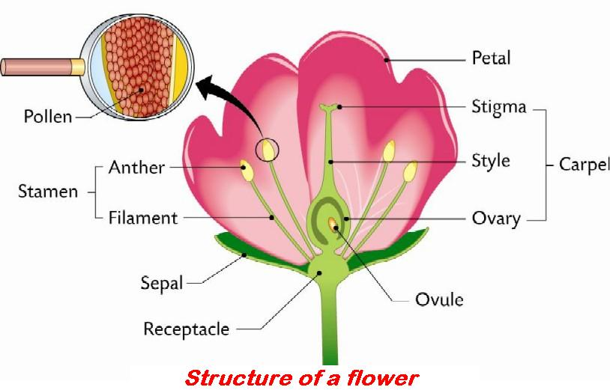 | 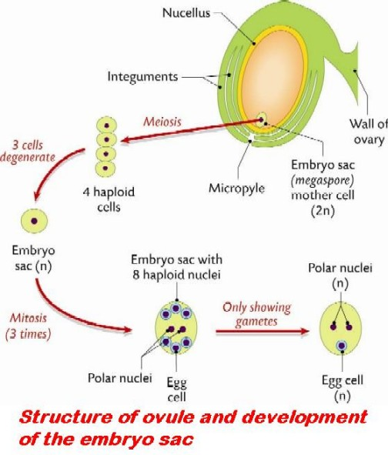
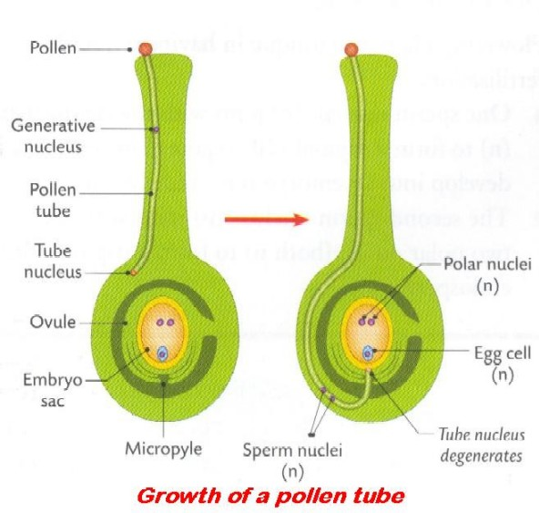 | 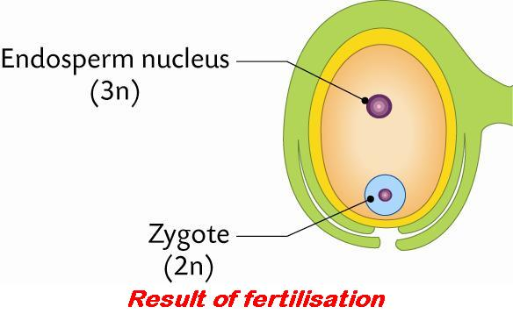

Insert the correct answer from the lower grid into the correct position in the right hand column
1 | Role of sepal
2 | Role of anther
3 | Role of stigma
4 | Role of ovary
5 | Generative nucleus divides by ... to form male gametes.
6 | Part of flower where pollen is produced
7 | Function of petal
8 | Part of flower from which fruit develops
9 | Where pollen is produced in the stamen
10 | Adaptations of petal for its function
11 | Pollen mother cells divide by ...
12 | With what does each male gamete fuse in the embryo sac?
13 | Male gamete fuses with egg cell to form ...
14 | Male gamete fuses with polar nuclei to form ...
15 | Mature pollen grain

A | Anther | F | Fertilised egg | K | Produces female gametes; Becomes fruit
B | Anther of the stamen | G | Meiosis | L | Protection; Photosynthesis
C | Attract insects | H | Mitosis | M | Receives pollen
D | Colour; Scent; Size; Shape | I | Ovary | N | Triploid endosperm nucleus
E | Egg cell; Polar nuclei | J | Pollen production | O | Tube nucleus and two haploid male gamete nuclei

3.6.1 Pollination and Fertilisation

KEYWORDS

Anther
Carpel
Cotyledon
Cross-pollination
Embryo sac
Endosperm
Endosperm nucleus
Endospermic seed
Fertilisation
Fruit
Fusion
Gamete
Generative nucleus
Monocotyledonous
Nectary
Non-endospermic seed
Ovule
Petals
Polar nuclei
Pollen tube
Pollination
Radicle
Seed
Self-pollination
Stamen
Stigma
Style
Triploid
Variations
Zygote

EXPLANATIONS

Fertilisation: the union of a haploid male gamete nucleus with a haploid female gamete nucleus resulting in the formation of a diploid zygote.
In the human female this occurs about halfway along the fallopian tube.
Pollination: the transfer of pollen from the anther of the stamen of one flower, to the stigma of the carpel of (a) the same flower or another flower on the same plant (self-pollination) or (b) another flower on a different plant of the same species (cross- pollination).
Wind and insects are agents of pollination.

Insert the correct answer from the lower grid into the correct position in the right hand column
1 | What happens to the two polar nuclei?
2 | What happens to the ovary after fertilisation?
3 | Endosperm is a food reserve in some seeds. True or False
4 | Pollination
5 | Structure in seed from which root develops
6 | Adaptations of wind-pollinated flowers
7 | What happens to the ovule after fertilisation?
8 | Fertilisation
9 | How are flowers with nectaries pollinated?
10 | Why cross-pollination is preferable to self-pollination
11 | To which part of a flower is pollen carried?
12 | Cross-pollination
13 | Location in seed in which food is stored
14 | Methods of cross-pollination
15 | Carbohydrate present in food store of a seed
16 | Forms in the ovary after pollination and fertilization
17 | Adaptations of an insect-pollinated flower
18 | Process that follows pollination in plant life cycle
19 | Part of the flower where fertilisation occurs
20 | Structure through which pollen tube grows in order to reach the embryo sac
21 | Where pollen is produced in the stamen

A | Anther | H | Fertilisation | O | Starch
B | Becomes the fruit | I | Fuse with male gamete to form triploid endosperm nucleus | P | Stigma of the carpel
C | Becomes the seed | J | Fusion of gametes; Formation of zygote | Q | Style
D | Brightly coloured petals; Anthers within petals; Nectaries | K | Increases variation | R | Transfer of pollen from anther to carpel
E | By insects | L | Long stamens; Feathery stigmas; Large numbers of smooth light pollen grains | S | Transfer of pollen from one flower to another on a different plant of same species
F | Embryo sac; Ovule | M | Radicle | T | True
G | Endosperm; Cotyledon | N | Seed; Zygote | U | Wind; Animal

3.6.1 Fruit Formation and Dispersal

KEYWORDS

Colonisation
Competition
Cotyledon
Dicotyledon
Dispersal
Embryo
Endosperm
Endospermic seed
Fruit
Growth regulator
Monocotyledon
Non-endospermic seed
Ovary
Ovule
Plumule
Radicle
Seedless fruit
Shoot

EXPLANATIONS

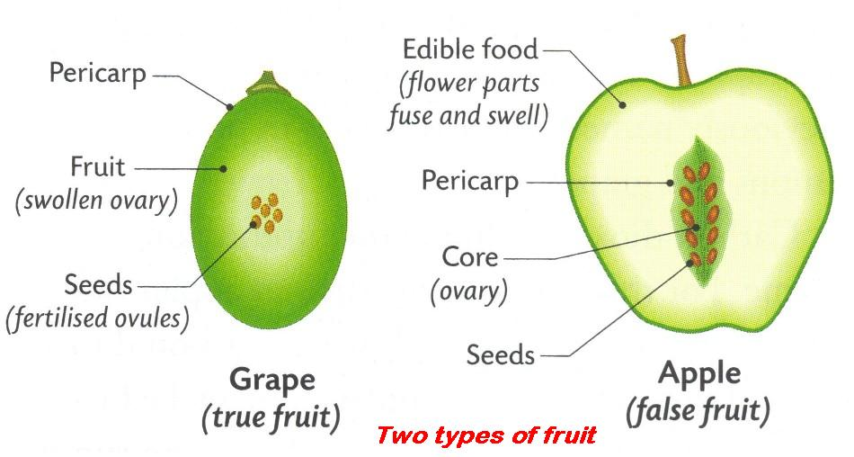 | 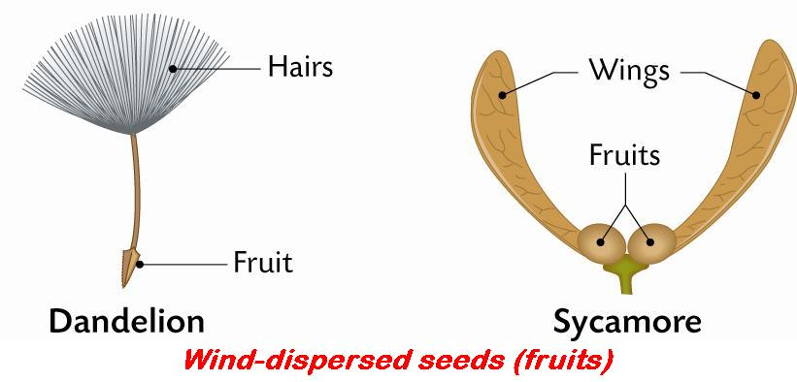

Insert the correct answer from the lower grid into the correct position in the right hand column
1 | Role of fruit
2 | From what a seed develops
3 | Endospermic seed
4 | Non-endospermic seed
5 | Method used to produce seedless fruits
6 | Locations in seed where food may be stored
7 | Parts of embryo plant in seed
8 | Role of radicle
9 | Role of plumule
10 | Methods of seed dispersal
11 | Advantages of dispersal to the plant
12 | What is a cotyledon?
13 | Name a monocotyledon
14 | Name a dicotyledon
15 | Part of flower that develops into a fruit
16 | Plant that uses wind to disperse seed
17 | Plant that uses animals to disperse seed
18 | What is an embryo?
19 | What is dispersal?
20 | How are the seeds of blackberries dispersed?
21 | By which method are Sycamore fruits dispersed?

A | Blackberry; Burdock | H | Develops into shoot | O | Ovule
B | Broad bean; Pea | I | First leaf that develops in embryo; A food store | P | Part of seed that becomes the new plant
C | By animals | J | Grass; Maize | Q | Radicle; Plumule
D | Colonisation; Reduces competition | K | Growth regulator; Selective propagation | R | Reproduction; seed dispersal
E | Cotyledon; Endosperm | L | Main food store in cotyledons | S | Spreading of seeds
F | Dandelion; Sycamore | M | Main food store in endosperm | T | Wind
G | Develops into root | N | Ovary | U | Wind; Animal; Self; Water

3.6.1 Dormancy and Germination

KEYWORDS

Anaerobic jar
Dormancy
Embryo
Enzyme
Germination
Metabolism
Optimum enzyme activity
Plumule
Radicle
Respiration
Substrate
Testa
Water bath

EXPLANATIONS

Dormancy: a period of rest, inactivity or non-vegetative state before growth, during which the rate of metabolism is reduced, e.g. in buds, seeds and spores.
Seeds will not germinate during this time, even if given ideal conditions, because other requirements may be necessary before germination can occur. For example:
- seed coat (testa) too hard, must wait for it to be softened by nature
- cold conditions necessary. Ensures springtime germination and maximises the growing season for the new seedling
- desert plants have chemical inhibitors in seed that must be washed out by heavy rain. Ensures water for further growth
- embryo not mature. Seed not 'ripe' so must wait.
Germination: is the beginning of the growth of seeds, spores or pollen grains after a period of dormancy.
Certain conditions must be available, i.e. Water, Oxygen and a suitable temperature (Warmth) – WOW.

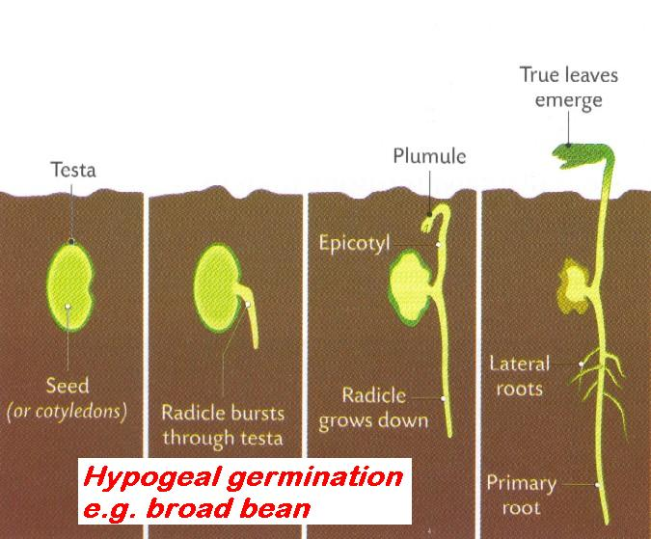 | 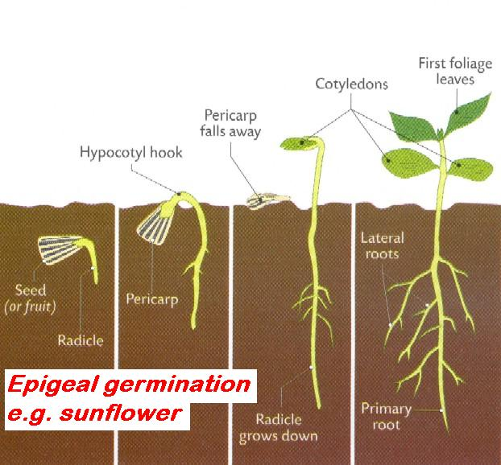

Insert the correct answer from the lower grid into the correct position in the right hand column
1 | Light is essential for the germination of seeds. True or False
2 | Experiment you used starch or skimmed milk agar plates
3 | Purpose for use of starch or skimmed milk agar plates
4 | What is dormancy?
5 | Advantages of dormancy
6 | Germination
7 | Part of seed from which shoot develops
8 | Why digestion is needed in a germinating seed
9 | How dormancy is useful to farmers and gardeners
10 | Needed for the germination of seeds
11 | Function of water in germination
12 | Function of oxygen in germination
13 | Necessity of suitable temperature for germination
14 | Seeds remain inactive for a period before germination
15 | Stage in the plant's life cycle that follows dormancy
16 | Use for a water bath in experiments
17 | Purpose of an anaerobic jar in experiments
18 | Part of seed from which root develops

A | Aerobic respiration | G | Germination or Growth | M | Period of reduced metabolism; No growth
B | Dormancy | H | Growth of seed or embryo | N | Plumule
C | Enzyme action; Solvent; Bursting testa | I | Keep temperature constant | O | Radicle
D | Enzyme digestive activity | J | Makes food soluble and transportable | P | Substrate or Nutrient medium
E | False | K | Optimum enzyme activity | Q | To see if oxygen is necessary for germination
F | Germination at suitable time; Survival of unfavourable conditions | L | Optimum sowing, ploughing time; Maximise growing season | R | Water; Oxygen; Suitable temperature

3.6.2 Reproductive Structures and Hormones

KEYWORDS

Chromosome
Cowper’s gland
Epididymis
Meiosis
Menstrual cycle
Ova (eggs)
Ovary
Ovulation
Primary sexual characteristics
Penis
Primary sexual characteristics
Prostate
Puberty
Secondary sexual characteristics
Semen
Seminal fluid
Seminal vesicles
Sperm
Sperm duct
Testis
Testosterone
Urethra

EXPLANATIONS

Primary sexual characteristics: physical characteristics or features that distinguish males and females at their birth, i.e. the sex organs.
Secondary sexual characteristics: the physical characteristics that appear during puberty and adolescence.
In the male they include the broadening of the shoulders, growth and enlargement of the penis, deepening of the voice, body and facial hair, etc. In the female they include enlargement and growth of the breasts, growth of body hair under arms and pubic regions.

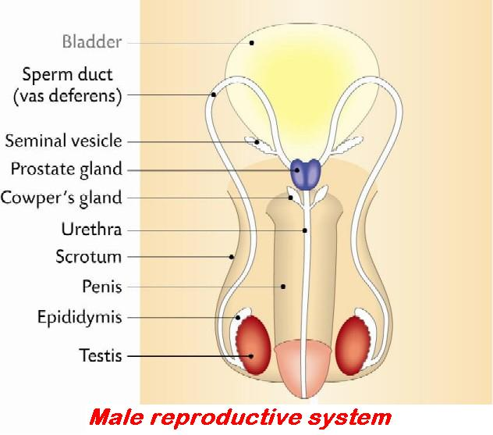 | 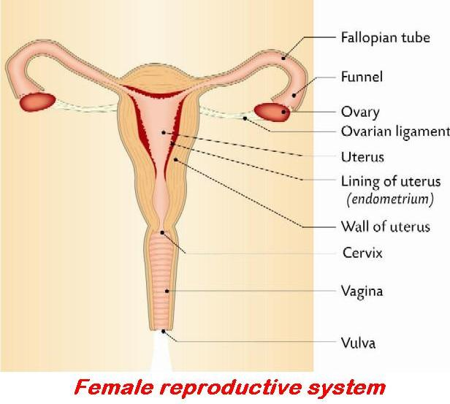

Insert the correct answer from the lower grid into the correct position in the right hand column
1 | Where testosterone is secreted
2 | Role of testosterone
3 | Where sperm are produced
4 | Glands that secrete seminal fluid
5 | Function of seminal fluid
6 | Where meiosis occurs in male reproductive system
7 | Where sperm are stored in male reproductive system
8 | What is semen?
9 | Where maturing of sperm cells occurs
10 | Where mixing of fluid with sperm cells occurs
11 | Part of male reproductive system that transports semen
12 | Male secondary sexual characteristics
13 | Function of prostate gland
14 | Function of sperm duct
15 | Function of midpiece of sperm
16 | How sperm differs from ova (eggs)
17 | What are secondary sexual characteristics?
18 | Female secondary sexual characteristics
19 | What is the menstrual cycle?
20 | Where is the ovum (egg) formed?
21 | Ovulation

A | Allows sperm to swim; Provides nutrients | H | Epididymis | O | Sperm cells and seminal fluid
B | Body hair; Breast development; Hips widen | I | Features developing at puberty for sexual attraction | P | Sperm duct or Prostate gland
C | Broken voice; body hair; Enlargement of testes and penis | J | Monthly cycle in female | Q | Supply energy for movement
D | Carry sperm | K | Ovary | R | Testis
E | Cowper's; Seminal vesicles; Prostate | L | Release of egg from ovary | S | Testis
F | Develop secondary sexual characteristics | M | Seminal fluid production; Nutrition of sperm | T | Testis
G | Epididymis | N | Size; Shape; Motile; Chromosomal difference | U | Urethra; Sperm duct

3.6.2 Pregnancy, Birth and Breastfeeding

KEYWORDS

Embryo
Fallopian tube
Fertilisation
Gametes
Haploid
Hormones
Immunity
Ovary
Ovulation
Placenta
Plasma proteins
Progesterone
Uterus

EXPLANATIONS

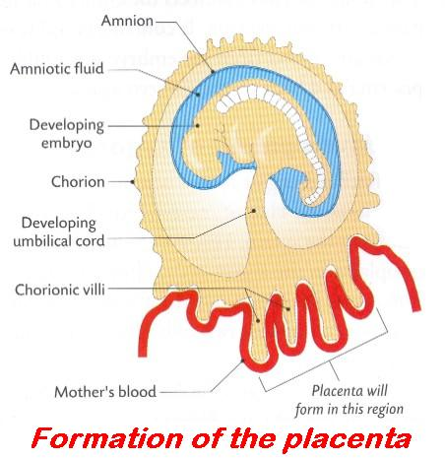 | 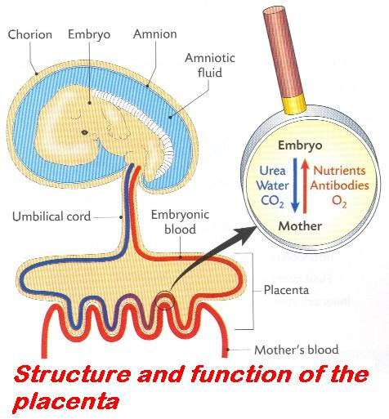
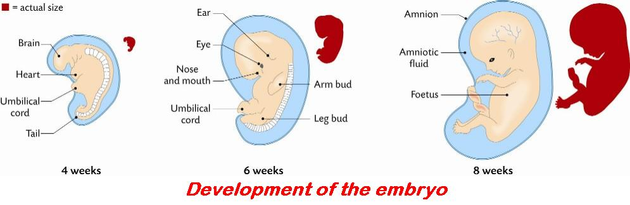

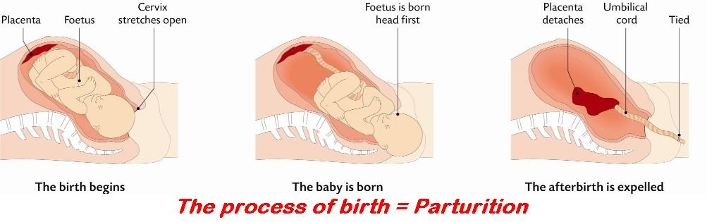

Insert the correct answer from the lower grid into the correct position in the right hand column
1 | The process of fertilisation is complete when ...
2 | Where fertilisation occurs
3 | Role of ATP in cells
4 | What is fertilisation?
5 | Hormone associated with maintenance of the placenta
6 | Example of gene mutation
7 | Biological benefits of breastfeeding
8 | Survival time for sperm
9 | Chromosome mutation
10 | The placenta is formed from ...
11 | Functions of the placenta
12 | Nucleus of an egg cell
13 | Where meiosis occurs in female reproductive system
14 | Where implantation occurs in female reproductive system
15 | Survival times for ova

A | Change in the number of chromosomes of an organism | F | Immunity; Correct nutrients; Easier to digest; Delayed ovulation | K | Store or provides energy
B | Embryonic and uterine tissues | G | Ovary | L | The male and female nuclei have fused
C | Fusion of gametes | H | Produces hormones; Transfers material; Barrier for plasma proteins | M | Up to 2 days
D | Half way along Fallopian tube | I | Progesterone | N | Up to 7 days
E | Haploid | J | Sickle-cell anaemia | O | Uterus

3.6.2 Infertility and Birth Control

KEYWORDS

Birth control
Conceive
Conception
Condom
Contraception
Copulation
Diaphragm
Fertilisation
Gametes
Implantation
Implants
Intercourse
In vitro fertilisation
In vivo
Infertility
IUD
Ovulation
Pill
Pregnancy
Rhythm method
Sperm count
Spermicide
STIs
Uterus
Vasectomy

EXPLANATIONS

Birth control: limiting the number of children born.
Contraception: the act of preventing the fertilisation of an egg or implantation or pregnancy.
Different methods of birth control include:
- natural: abstaining from sexual intercourse during the fertile period
- mechanical: use of a barrier, e.g. condom, to prevent sperm and egg meeting or use of an IUD to prevent implantation
- chemical: use of the pill to prevent ovulation
- surgical: tubal ligation in females and vasectomy in males.
Copulation: a process of introducing sperm into the female’s reproductive system.
Implantation: process by which the blastocyst attaches itself to, and becomes embedded in, the lining of the uterus (endometrium).
This process may be attempted artificially as part of in-vitro fertilisation for the treatment of infertility.
In-vitro fertilisation: a method used to treat infertility and help a woman conceive. It involves the union of the male gamete nucleus with the female gamete nucleus outside the woman’s body (in a ‘test tube’ or other laboratory environment).
In-vivo: an event or process occurring inside a living organism, e.g. fertilisation.
Infertility: the inability to produce sufficient gametes and conceive or produce children.
May be caused by a low sperm count or low sperm mobility in males, blocked fallopian tubes in females or endocrine gland failure in either or both.

Insert the correct answer from the lower grid into the correct position in the right hand column
1 | Cause of infertility in female
2 | Cause of infertility in male
3 | 'In vitro' fertilisation
4 | Contraception
5 | How surgical methods of contraception work
6 | Surgical method of male contraception
7 | Advantage of vasectomy
8 | Disadvantage of vasectomy
9 | Where implantation occurs in female reproductive system
10 | Non-surgical methods of contraception
11 | Infertility
12 | How mechanical methods of contraception work
13 | How chemical methods of contraception work
14 | How natural methods of contraception work
15 | The next step for an embryo developed from in vitro fertilisation?

A | Condom; Pill; IUD; Diaphragm; Spermicide; Rhythm; Implants | F | Intercourse takes place avoiding ovulation | K | Prevents contact between sperm and egg
B | Fertilisation outside the body | G | Low sperm count; Hormonal | L | Prevents ovulation; Normone levels changed
C | Hormonal; Blockage; Failure to ovulate | H | Not easily reversed; No protection against STIs | M | Simple operation; Effective; Single procedure
D | Implantation or Frozen | I | Prevention of fertilisation, implantation or pregnancy | N | Uterus
E | Inability to produce or fertilise gametes; Inability to conceive | J | Prevents contact between sperm and egg | O | Vasectomy

3.6.4 + 5 Embryo Development and Menstrual Cycle

KEYWORDS

Amnion
Blastocyst
Blastula
Ectoderm
Embryo
Endoderm
Endometrium
Fertilisation
Follicle
FSH
Germ layer(s)
LH
Mesoderm
Morula
Oestrogen
Organ system
Ovary
Pituitary
Testis
Tissue

EXPLANATIONS

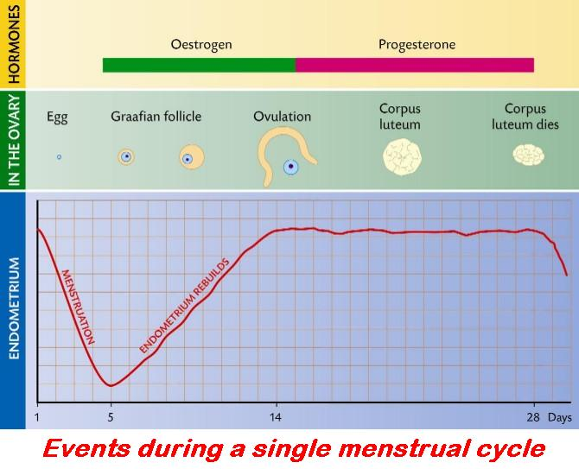

Insert the correct answer from the lower grid into the correct position in the right hand column
1 | What is meant by germ layers?
2 | Name the germ layers
3 | Tissue that develops from ectoderm
4 | Tissue that develops from endoderm
5 | Tissue that develops from mesoderm
6 | What is a placenta?
7 | Functions of the placenta
8 | What is the amnion?
9 | Role of amnion
10 | Morula
11 | Blastocyst
12 | Menstruation
13 | Where is FSH produced?
14 | Function of FSH
15 | Part of female reproductive system influenced by FSH and LH
16 | Role of oestrogen in menstrual cycle
17 | Role of progesterone in menstrual cycle
18 | Where testosterone is secreted

A | Ectoderm; Endoderm; Mesoderm | G | Ovary or Follicle | M | Shedding of endometrium in absence of fertilisation
B | Fluid-filled, hollow ball of cells | H | Pituitary | N | Skin; Nails; Hair; Nervous system
C | Holds or Produces fluid; Protects embryo | I | Produces hormones; Allows passage of material; Acts as a barrier | O | Solid ball of cells
D | Layer of cells in the blastula; Potential to give rise to tissues | J | Production of follicle; Stimulate oestrogen production | P | Structure in womb of pregnant mammals; Helps nourish foetus and discharge waste
E | Lining of gut; Liver; Pancreas | K | Repairs endometrium; Inhibits FSH; Stimulates LH | Q | Testis
F | Muscles; Skeleton; Excretory; Respiratory and Circulatory systems | L | Sac or Membrane surrounding embryo | R | Thickening endometrium; Inhibits FSH and LH production

INDEX

Abiotic factors 19
Absorption 117
Active immunity 144
Active transport 138
Adaptation 29
Adhesion 125
Aerobic respiration 45
Allele 78
Amino acid 13
Anabolism 6, 15, 36
Anaerobic respiration 45
Antibiotic 89
Antibiotic resistance 89
Antibody 144
Antigen 144
Appendicular skeleton 153
Artery 106
Asepsis 98
ATP 58
ATP significance 58
Autotrophic bacteria 89
Autotrophic bacteria/organism 114
Axial skeleton 153
Balanced diet 125
Batch (bio) processing 98
Bile salts 117
Biology 4
Bioreactor 36
Biosphere 19
Biotic factors 19
Birth control 181
Cancer 63
Capillary 106
Carnivore 19, 117
Catabolism 6, 15, 36
Cell 6, 33
Cell continuity 63
Cellulose 15
Chemical digestion 117
Chemosynthetic bacteria 89
Chemotropism 141
Chromosome 63
Climatic factors 19
Closed circulation 107
Coding DNA 74
Cohesion 125
Companion cells 101
Competition 29
Conservation 24
Contest competition 29
Continuity of life 6, 63
Continuous flow (bio) processing 98
Contraception 181
Control 4
Copulation 181
Cutting 83
Data 4
Decompose 24
Denaturation 56
Denitrification 24
Diffusion 53
Digestion 118
Diploid (2n) 63
DNA profile 74
Dominance 78
Dormancy 173
Double-blind testing 4
Ecology 19
Ecosystem 19
Ectotherm 132
Edaphic factors 19
Egestion 6, 118
Endocrine gland 148
Endotherm 132
Enzymes 36
Eukaryotic cell 33
Evolution 81
Excretion 7, 132
Exocrine gland 148
Expression 72
Fatty acid 13
Fermentation 45
Fertilisation 78, 167
Food chain 20
Food pyramid 31, 125
Food web 20
Gamete 64, 79
Gene 74
Gene expression 72
Genetic engineering 83
Genetic screening 74
Genotype 79
Geotropism 141
Germination 173
Glycogen 13
Glycolysis 61
Grazing food chain 20
Growth regulators 141
Habitat 20
Haploid (n) 64
Herbivore 20, 118
Heredity 72
Heterotrophic bacteria / organism 89, 118
Heterozygous 79
Homeostasis 125
Homozygous 79
Hormone 148
Hydrotropism 141
Hypothesis 4
Immobilised enzyme 37
Immunity 144
Implantation 181
Incomplete dominance 79
Induced immunity 144
Infertility 181
information 4
Ingestion 118
Interneurons 157
Introduction of base sequence changes 83
In-vitro fertilisation 181
In-vivo 181
Isolation 84
Joint 154
Law 4
Law of independent assortment 84
Law of Segregation 84
Life (characteristics of) 7
Ligament 154
Ligation 85
Linkage 85
Mechanical digestion 118
Meiosis 64
Mendel’s 1st Law 84
Mendel’s 2nd Law 84
Meristem 101
Metabolism 7, 37
Mineral 17
Mitosis 65
Motor neuron 158
Mutation 81
NADP 58
Niche 24
Nitrification 24
Nitrogen fixation 24
Non-coding DNA 74
Non-nuclear inheritance 85
Nucleotide 87
Nutrition 7
Omnivore 20, 118
Open circulation 107
Optimum conditions 56
Organ 70
Organ systems 7, 70
Organisation 7
Osmosis 53
Osteoblast 154
Parasitic 90
Parasitism 29
Passive immunity 145
Pathogen 90
Peristalsis 118
Phenotype 79
Phloem sieve tube 101
Photosynthesis 40
Photosynthetic bacteria 90
Phototropism 141
Placebo 4
Pollination 167
Pollution 24
Population 29
Portal blood system 107
Predation 29
Predator 29
Prey 29
Primary consumer 20
Primary sexual characteristics 176
Principle 4
Producer 20
Prokaryotic cell 33
Prokaryotic cells 90
Pyramid of numbers 21
Qualitative study 31
Quantitative study 31
Rate (of enzyme activity) 37
Reabsorption 133
Recessive 79
Replicate 4
Reproduction 7
Respiration 46
Response 7, 158
Restriction 83
Root pressure 114
Saprophytic 90
Scramble competition 29
Secondary consumer 21
Secondary sexual characteristics 176
Selectively permeable membrane 33, 53
Sensory neuron 158
Sex-linkage 85
Species 72
Specificity 56
Sterility 99
Symbiosis 29
Tendon 154
Tension 125
Tertiary consumer 21
Theory 4
Thigmotropism 141
Tissue 70
Tissue culture 70
Trace element 9
Transcription 76
Transformation 85
Translation 76
Transpiration 114
Triglyceride 13
Trophic level (T) 21
Tropism 141
Turgor 54
Ureter 133
Urethra 133
Vaccination 145
Vaccine 145
Variation 72
Vein 107
Virus 161
Vitamin 13
Xylem tracheids 102
Xylem vessel 102

Answers

Page 5 1.1.3 Scientific Method and Experimentation
1 | 2 | 3 | 4 | 5 | 6 | 7 | 8 | 9 | 10 | 11 | 12 | 13 | 14 | 15
B | L | J | K | A | G | M | D | H | C | O | N | I | F | E

Page 8 1.2.3 Characteristics of Life and Food
1 | 2 | 3 | 4 | 5 | 6 | 7 | 8 | 9 | 10 | 11 | 12 | 13 | 14 | 15
I | J | F | L | E | K | M | G | N | O | A | B | C | H | D

Page 10 1.3.3 Biomolecules 1
1 | 2 | 3 | 4 | 5 | 6 | 7 | 8 | 9 | 10 | 11 | 12 | 13 | 14 | 15
j | l | i | h | a | b | o | d | c | k | m | g | e | f | n

Page 11 1.3.3 Biomolecules 2
1 | 2 | 3 | 4 | 5 | 6 | 7 | 8 | 9 | 10 | 11 | 12
R | S | U | I | G | Q | F | H | P | M | J | O
13 | 14 | 15 | 16 | 17 | 18 | 19 | 20 | 21 | 22 | 23 | 24
W | N | L | B | C | E | D | T | V | K | A | X

Page 14 1.3.4 Biomolecular Components
1 | 2 | 3 | 4 | 5 | 6 | 7 | 8 | 9 | 10 | 11 | 12 | 13 | 14 | 15 | 16 | 17 | 18
G | C | J | N | M | E | H | P | Q | F | R | O | A | K | I | L | B | D

Page 16 1.3.6 Role of Biomolecules
1 | 2 | 3 | 4 | 5 | 6 | 7 | 8 | 9 | 10 | 11 | 12 | 13 | 14 | 15 | 16 | 17 | 18
D | O | N | E | A | B | J | K | P | M | C | G | F | L | I | H | Q | R

Page 18 1.3.8 Biomolecules and Minerals
1 | 2 | 3 | 4 | 5 | 6 | 7 | 8 | 9 | 10 | 11 | 12 | 13 | 14 | 15 | 16 | 17 | 18
R | B | A | P | M | Q | O | N | D | E | I | F | H | G | K | J | C | L

Page 22 1.4.2 - 1.4.6 Ecology
1 | 2 | 3 | 4 | 5 | 6 | 7 | 8 | 9 | 10 | 11 | 12
C | K | D | T | J | H | Q | V | O | G | R | A
13 | 14 | 15 | 16 | 17 | 18 | 19 | 20 | 21 | 22 | 23 | 24
F | N | S | P | L | M | E | B | I | W | U | X

Page 25 1.4.8 + 9 Nutrient Recycling and Human Impact 1
1 | 2 | 3 | 4 | 5 | 6 | 7 | 8 | 9 | 10 | 11 | 12 | 13 | 14 | 15
K | L | N | M | J | D | O | B | A | I | G | C | H | E | F

Page 26 1.4.8 + 9 Nutrient Recycling and Human Impact 2
1 | 2 | 3 | 4 | 5 | 6 | 7 | 8 | 9 | 10 | 11 | 12 | 13 | 14 | 15
H | A | F | E | J | D | L | B | C | G | K | I | N | M | O

Page 27 1.4.8 + 9 Nutrient Recycling and Human Impact 1 + 2
1 | 2 | 3 | 4 | 5 | 6 | 7 | 8 | 9 | 10 | 11 | 12 | 13 | 14 | 15
D | N | G | H | U | I | Q | Z | T | S | J | M | B2 | V | C2
16 | 17 | 18 | 19 | 20 | 21 | 22 | 23 | 24 | 25 | 26 | 27 | 28 | 29 | 30
P | R | X | C | B | W | K | E | L | F | A | D2 | A2 | Y | O

Page 30 1.4.11 Relationships and Population Dynamics
1 | 2 | 3 | 4 | 5 | 6 | 7 | 8 | 9 | 10 | 11 | 12 | 13 | 14 | 15
L | G | A | O | N | B | K | D | I | M | J | C | F | H | E

Page 32 1.5.3 Ecosystem Study
1 | 2 | 3 | 4 | 5 | 6 | 7 | 8 | 9 | 10 | 11 | 12 | 13 | 14 | 15
a | l | f | m | k | b | d | h | c | g | e | i | j | n | o

Page 34 2.1 Cell Structure and Microscopy 1
1 | 2 | 3 | 4 | 5 | 6 | 7 | 8 | 9 | 10 | 11 | 12 | 13 | 14 | 15
H | A | G | B | O | J | D | M | K | L | N | I | C | E | F

Page 35 2.1 Cell Structure and Microscopy 2
1 | 2 | 3 | 4 | 5 | 6 | 7 | 8 | 9 | 10 | 11 | 12 | 13 | 14 | 15
o | k | i | a | l | e | b | m | f | g | n | d | c | j | h

Page 38 2.2.3 Enzymes
1 | 2 | 3 | 4 | 5 | 6 | 7 | 8 | 9 | 10 | 11 | 12
M | C | Q | W | A | L | H | J | T | K | D | E
13 | 14 | 15 | 16 | 17 | 18 | 19 | 20 | 21 | 22 | 23 | 24
B | X | I | P | S | F | U | O | V | N | G | R

Page 41 2.2.4 Photosynthesis 1
1 | 2 | 3 | 4 | 5 | 6 | 7 | 8 | 9 | 10 | 11 | 12 | 13 | 14 | 15 | 16 | 17 | 18
E | N | H | I | G | C | F | B | A | L | M | Q | R | J | O | D | K | P

Page 43 2.2.4 Photosynthesis 2
1 | 2 | 3 | 4 | 5 | 6 | 7 | 8 | 9 | 10 | 11 | 12 | 13 | 14 | 15 | 16 | 17 | 18
G | A | B | M | J | N | I | R | F | O | Q | E | D | L | P | C | K | H

Page 47 2.2.5 Respiration 1
1 | 2 | 3 | 4 | 5 | 6 | 7 | 8 | 9 | 10 | 11 | 12 | 13 | 14 | 15 | 16 | 17 | 18
C | F | N | D | H | A | G | J | B | P | E | I | K | M | O | R | L | Q

Page 49 2.2.5 Respiration 2
1 | 2 | 3 | 4 | 5 | 6 | 7 | 8 | 9 | 10 | 11 | 12 | 13 | 14 | 15 | 16 | 17 | 18
N | B | K | P | Q | O | M | D | C | L | I | G | J | H | A | E | F | R

Page 51 2.2.5 Respiration 3
1 | 2 | 3 | 4 | 5 | 6 | 7 | 8 | 9 | 10 | 11 | 12 | 13 | 14 | 15 | 16 | 17 | 18
I | C | N | A | D | G | O | P | E | Q | F | R | L | M | J | K | B | H

Page 55 2.2.6 Movement through Membranes
1 | 2 | 3 | 4 | 5 | 6 | 7 | 8 | 9 | 10 | 11 | 12 | 13 | 14 | 15
J | L | N | C | D | H | B | F | G | O | K | I | E | M | A

Page 57 2.2.7 Enzymes Higher Level
1 | 2 | 3 | 4 | 5 | 6 | 7 | 8 | 9 | 10 | 11 | 12 | 13 | 14 | 15
B | F | N | A | H | I | E | K | M | L | G | C | J | D | O

Page 59 2.2.9 Photosynthesis Higher Level
1 | 2 | 3 | 4 | 5 | 6 | 7 | 8 | 9 | 10 | 11 | 12 | 13 | 14 | 15 | 16 | 17 | 18 | 19 | 20 | 21
P | R | S | K | M | A | N | I | H | B | Q | J | E | O | D | T | L | G | F | U | C

Page 62 2.2.10 Respiration Higher Level
1 | 2 | 3 | 4 | 5 | 6 | 7 | 8 | 9 | 10 | 11 | 12 | 13 | 14 | 15
n | f | k | e | j | i | h | b | l | o | c | m | g | d | A

Page 66 2.3 Cell Continuity 1
1 | 2 | 3 | 4 | 5 | 6 | 7 | 8 | 9 | 10 | 11 | 12 | 13 | 14 | 15
L | K | E | H | M | J | A | C | B | F | I | O | N | D | G

Page 67 2.3 Cell Continuity 2
1 | 2 | 3 | 4 | 5 | 6 | 7 | 8 | 9 | 10 | 11 | 12 | 13 | 14 | 15
g | a | l | m | n | e | f | o | c | d | k | h | b | j | i

Page 68 2.3 Cell Continuity 1 and 2
1 | 2 | 3 | 4 | 5 | 6 | 7 | 8 | 9 | 10 | 11 | 12 | 13 | 14 | 15
h | g | v | x | l | T | W | F | C | U | Q | P | A | M | B2
16 | 17 | 18 | 19 | 20 | 21 | 22 | 23 | 24 | 25 | 26 | 27 | 28 | 29 | 30
J | I | Y | K | D2 | D | C2 | B | S | E | Z | A2 | O | R | N

Page 71 2.4 Cell Diversity
1 | 2 | 3 | 4 | 5 | 6 | 7 | 8 | 9 | 10 | 11 | 12 | 13 | 14 | 15 | 16 | 17 | 18
l | p | k | j | f | c | q | g | b | m | n | r | i | a | o | e | h | d

Page 73 2.5.1 - 2 Variation, Heredity, etc.
1 | 2 | 3 | 4 | 5 | 6 | 7 | 8 | 9 | 10 | 11 | 12 | 13 | 14 | 15
o | l | k | m | j | d | f | i | b | g | c | a | h | e | N

Page 75 2.5.4 DNA, Replication, etc.
1 | 2 | 3 | 4 | 5 | 6 | 7 | 8 | 9 | 10 | 11 | 12 | 13 | 14 | 15 | 16 | 17 | 18
N | J | R | H | P | Q | C | B | A | O | K | I | D | G | L | E | F | M

Page 77 2.5.5+15 Protein synthesis
1 | 2 | 3 | 4 | 5 | 6 | 7 | 8 | 9 | 10 | 11 | 12 | 13 | 14 | 15 | 16 | 17 | 18
E | G | R | Q | H | L | K | I | M | A | B | N | D | C | F | P | O | J

Page 80 2.5.6 Genetic Inheritance
1 | 2 | 3 | 4 | 5 | 6 | 7 | 8 | 9 | 10 | 11 | 12 | 13 | 14 | 15 | 16 | 17 | 18
j | f | G | K | N | C | D | A | L | B | R | Q | M | E | O | I | P | H

Page 82 2.5.7 - 8 Variation and Evolution
1 | 2 | 3 | 4 | 5 | 6 | 7 | 8 | 9 | 10 | 11 | 12 | 13 | 14 | 15
H | F | N | L | C | M | J | I | E | A | D | B | O | K | G

Page 86 2.5.9 - 13.H Genetic Engineering and Mendelian
1 | 2 | 3 | 4 | 5 | 6 | 7 | 8 | 9 | 10 | 11 | 12 | 13 | 14 | 15
B | L | F | H | N | J | M | A | C | E | D | O | K | I | G

Page 88 2.5.14 DNA, Replication, etc.
1 | 2 | 3 | 4 | 5 | 6 | 7 | 8 | 9 | 10 | 11 | 12 | 13 | 14 | 15 | 16 | 17 | 18
E | C | D | F | B | P | K | N | L | H | O | Q | R | G | A | I | J | M

Page 91 3.1.3 Monera
1 | 2 | 3 | 4 | 5 | 6 | 7 | 8 | 9 | 10 | 11 | 12
N | E | R | G | U | W | L | Q | A | J | B | C
13 | 14 | 15 | 16 | 17 | 18 | 19 | 20 | 21 | 22 | 23 | 24
S | I | M | X | H | F | P | K | V | O | T | D

Page 94 3.1.4 Fungi 1
1 | 2 | 3 | 4 | 5 | 6 | 7 | 8 | 9 | 10 | 11 | 12 | 13 | 14 | 15
C | B | G | N | H | I | E | L | D | F | O | M | A | K | J

Page 95 3.1.4 Fungi 2
1 | 2 | 3 | 4 | 5 | 6 | 7 | 8 | 9 | 10 | 11 | 12 | 13 | 14 | 15
O | C | F | J | K | H | I | D | G | E | B | N | M | L | A

Page 96 3.1.4 Fungi 1 and 2
1 | 2 | 3 | 4 | 5 | 6 | 7 | 8 | 9 | 10 | 11 | 12 | 13 | 14 | 15
I | X | T | D2 | Y | B2 | U | A | V | C2 | A2 | E | D | F | Q
16 | 17 | 18 | 19 | 20 | 21 | 22 | 23 | 24 | 25 | 26 | 27 | 28 | 29 | 30
P | S | M | K | C | H | W | R | J | L | O | Z | G | N | B

Page 100 3.1.5, 6, 10 Lab, Protista, Growth Curves
1 | 2 | 3 | 4 | 5 | 6 | 7 | 8 | 9 | 10 | 11 | 12 | 13 | 14 | 15
C | H | B | L | N | F | J | I | A | K | E | G | D | O | M

Page 103 3.2.1 Plant Structure 1
1 | 2 | 3 | 4 | 5 | 6 | 7 | 8 | 9 | 10 | 11 | 12 | 13 | 14 | 15
K | C | O | F | D | A | L | I | J | N | E | B | M | G | H

Page 104 3.2.1 Plant Structure 2
1 | 2 | 3 | 4 | 5 | 6 | 7 | 8 | 9 | 10 | 11 | 12
V | A | B | R | W | K | H | N | C | Q | U | P
13 | 14 | 15 | 16 | 17 | 18 | 19 | 20 | 21 | 22 | 23 | 24
E | M | S | X | I | F | D | G | L | T | J | O

Page 108 3.2.2 Blood and Circulation 1
1 | 2 | 3 | 4 | 5 | 6 | 7 | 8 | 9 | 10 | 11 | 12 | 13 | 14 | 15
B | H | D | F | I | E | C | M | A | O | G | J | K | N | L

Page 109 3.2.2 Blood and Circulation 2
1 | 2 | 3 | 4 | 5 | 6 | 7 | 8 | 9 | 10 | 11 | 12 | 13 | 14 | 15
C | N | E | A | M | F | I | K | D | J | G | H | O | L | B

Page 110 3.2.2 Blood and Circulation 3
1 | 2 | 3 | 4 | 5 | 6 | 7 | 8 | 9 | 10 | 11 | 12 | 13 | 14 | 15
F | K | H | I | N | A | O | M | B | L | C | E | D | G | J

Page 111 3.2.2 Blood and Circulation 4
1 | 2 | 3 | 4 | 5 | 6 | 7 | 8 | 9 | 10 | 11 | 12 | 13 | 14 | 15
I | E | J | A | N | K | G | M | L | C | D | F | B | H | O

Page 113 3.2.3 + 4 Blood Cells and Heartbeat
1 | 2 | 3 | 4 | 5 | 6 | 7 | 8 | 9 | 10 | 11 | 12 | 13 | 14 | 15
J | N | C | H | I | G | B | O | M | D | K | F | L | E | A

Page 115 3.3.1 + 2 Nutrition and Storage in Plants
1 | 2 | 3 | 4 | 5 | 6 | 7 | 8 | 9 | 10 | 11 | 12 | 13 | 14 | 15 | 16 | 17 | 18 | 19 | 20 | 21
O | L | D | U | F | E | S | C | G | R | A | M | P | J | K | Q | N | I | H | T | B

Page 119 3.3.3 + 4 Human Nutrition and Digestion 1
1 | 2 | 3 | 4 | 5 | 6 | 7 | 8 | 9 | 10 | 11 | 12 | 13 | 14 | 15
C | A | B | K | J | O | D | L | G | M | I | F | E | N | H

Page 120 3.3.3 + 4 Human Nutrition and Digestion 2
1 | 2 | 3 | 4 | 5 | 6 | 7 | 8 | 9 | 10 | 11 | 12 | 13 | 14 | 15
E | A | B | K | J | I | H | N | G | L | F | C | M | D | O

Page 121 3.3.3 + 4 Human Nutrition and Digestion 3
1 | 2 | 3 | 4 | 5 | 6 | 7 | 8 | 9 | 10 | 11 | 12 | 13 | 14 | 15
G | I | A | H | F | O | D | E | K | C | N | M | J | B | L

Page 122 3.3.3 + 4 Human Nutrition and Digestion 4
1 | 2 | 3 | 4 | 5 | 6 | 7 | 8 | 9 | 10 | 11 | 12 | 13 | 14 | 15
G | E | M | A | B | O | J | N | C | D | K | F | H | I | L

Page 124 3.3.5 Blood Transport of Nutrients
1 | 2 | 3 | 4 | 5 | 6 | 7 | 8 | 9 | 10 | 11 | 12 | 13 | 14 | 15
D | B | E | M | G | H | F | C | L | J | K | N | I | O | A

Page 126 3.3.7 + 3.4.1 Cohesion-Tension and Homeostasis
1 | 2 | 3 | 4 | 5 | 6 | 7 | 8 | 9 | 10 | 11 | 12
B | E | A | D | H | K | F | C | G | I | L | J

Page 128 3.4.3 Plant Exchange System
1 | 2 | 3 | 4 | 5 | 6 | 7 | 8 | 9 | 10 | 11 | 12
F | A | H | J | C | I | D | B | E | L | G | K

Page 130 3.4.4 Breathing System 1
1 | 2 | 3 | 4 | 5 | 6 | 7 | 8 | 9 | 10 | 11 | 12
A | G | K | E | F | D | H | B | I | L | C | J

Page 131 3.4.4 Breathing System 2
1 | 2 | 3 | 4 | 5 | 6 | 7 | 8 | 9 | 10 | 11 | 12 | 13 | 14 | 15
B | K | M | E | D | G | L | N | F | O | I | H | C | J | A

Page 134 3.4.6 Excretory System 1
1 | 2 | 3 | 4 | 5 | 6 | 7 | 8 | 9 | 10 | 11 | 12 | 13 | 14 | 15 | 16 | 17 | 18
G | F | M | I | H | L | N | R | J | K | O | B | A | C | P | E | Q | D

Page 136 3.4.6 Excretory System 2
1 | 2 | 3 | 4 | 5 | 6 | 7 | 8 | 9 | 10 | 11 | 12 | 13 | 14 | 15 | 16 | 17 | 18 | 19 | 20 | 21
Q | I | N | F | E | D | G | C | R | L | M | A | J | T | P | K | B | S | U | H | O

Page 139 3.4.7 + 8 Excretion
1 | 2 | 3 | 4 | 5 | 6 | 7 | 8 | 9 | 10 | 11 | 12
S | G | D | F | E | M | R | W | V | H | C | U
13 | 14 | 15 | 16 | 17 | 18 | 19 | 20 | 21 | 22 | 23 | 24
L | T | K | A | Q | I | J | N | B | O | P | X

Page 142 3.5.2 Plant Responses
1 | 2 | 3 | 4 | 5 | 6 | 7 | 8 | 9 | 10 | 11 | 12
A | Q | R | D | V | B | F | T | U | X | H | G
13 | 14 | 15 | 16 | 17 | 18 | 19 | 20 | 21 | 22 | 23 | 24
L | K | I | P | O | M | E | N | C | S | W | J

Page 146 3.5.3 + 7 Defence System
1 | 2 | 3 | 4 | 5 | 6 | 7 | 8 | 9 | 10 | 11 | 12
A | M | N | E | Q | V | H | L | W | O | S | C
13 | 14 | 15 | 16 | 17 | 18 | 19 | 20 | 21 | 22 | 23 | 24
J | P | G | X | U | K | B | R | F | T | I | D

Page 149 3.5.3 Endocrine System
1 | 2 | 3 | 4 | 5 | 6 | 7 | 8 | 9 | 10 | 11 | 12 | 13 | 14 | 15 | 16 | 17 | 18
B | K | C | L | P | G | O | E | I | N | A | D | F | J | H | Q | R | M

Page 151 3.5.3 Eye and Ear
1 | 2 | 3 | 4 | 5 | 6 | 7 | 8 | 9 | 10 | 11 | 12 | 13 | 14 | 15 | 16 | 17 | 18 | 19 | 20 | 21
U | T | K | F | C | M | E | L | G | O | I | J | Q | B | A | R | H | P | D | N | S

Page 155 3.5.3 Musculoskeletal System 1
1 | 2 | 3 | 4 | 5 | 6 | 7 | 8 | 9 | 10 | 11 | 12 | 13 | 14 | 15
B | A | G | H | N | O | F | I | L | C | M | E | J | D | K

Page 156 3.5.3 Musculoskeletal System 2
1 | 2 | 3 | 4 | 5 | 6 | 7 | 8 | 9 | 10 | 11 | 12 | 13 | 14 | 15
C | E | O | L | H | M | B | N | F | A | I | D | G | K | J

Page 159 3.5.3 Nervous System
1 | 2 | 3 | 4 | 5 | 6 | 7 | 8 | 9 | 10 | 11 | 12
X | M | F | E | L | D | P | K | R | V | B | Q
13 | 14 | 15 | 16 | 17 | 18 | 19 | 20 | 21 | 22 | 23 | 24
J | C | O | A | T | U | I | S | H | G | W | N

Page 162 3.5.4 Viruses
1 | 2 | 3 | 4 | 5 | 6 | 7 | 8 | 9 | 10 | 11 | 12 | 13 | 14 | 15
G | C | J | B | H | K | O | L | E | D | N | A | F | M | I

Page 164 3.6.1 Asexual Reproduction
1 | 2 | 3 | 4 | 5 | 6 | 7 | 8 | 9 | 10 | 11 | 12
G | B | H | K | L | E | A | C | F | D | J | I

Page 166 3.6.1 + 3 Flower Structure and Gamete Formation
1 | 2 | 3 | 4 | 5 | 6 | 7 | 8 | 9 | 10 | 11 | 12 | 13 | 14 | 15
L | J | M | K | H | B | C | I | A | D | G | E | F | N | O

Page 168 3.6.1 Pollination and Fertilisation
1 | 2 | 3 | 4 | 5 | 6 | 7 | 8 | 9 | 10 | 11 | 12 | 13 | 14 | 15 | 16 | 17 | 18 | 19 | 20 | 21
I | B | T | R | M | L | C | J | E | K | P | S | G | U | O | N | D | H | F | Q | A

Page 171 3.6.1 Fruit Formation and Dispersal
1 | 2 | 3 | 4 | 5 | 6 | 7 | 8 | 9 | 10 | 11 | 12 | 13 | 14 | 15 | 16 | 17 | 18 | 19 | 20 | 21
R | O | M | L | K | E | Q | G | H | U | D | I | J | B | N | F | A | P | S | C | T

Page 174 3.6.1 Dormancy and Germination
1 | 2 | 3 | 4 | 5 | 6 | 7 | 8 | 9 | 10 | 11 | 12 | 13 | 14 | 15 | 16 | 17 | 18
E | D | P | M | F | H | N | J | L | R | C | A | K | B | G | I | Q | O

Page 177 3.6.2 Reproductive Structures and Hormones
1 | 2 | 3 | 4 | 5 | 6 | 7 | 8 | 9 | 10 | 11 | 12 | 13 | 14 | 15 | 16 | 17 | 18 | 19 | 20 | 21
R | F | S | E | A | T | G | O | H | P | U | C | M | D | Q | N | I | B | J | K | L

Page 180 3.6.2 Pregnancy, Birth and Breastfeeding
1 | 2 | 3 | 4 | 5 | 6 | 7 | 8 | 9 | 10 | 11 | 12 | 13 | 14 | 15
L | D | K | C | I | J | F | N | A | B | H | E | G | O | M

Page 182 3.6.2 Infertility and Birth Control
1 | 2 | 3 | 4 | 5 | 6 | 7 | 8 | 9 | 10 | 11 | 12 | 13 | 14 | 15
C | G | B | I | J | O | M | H | N | A | E | K | L | F | D

Page 184 3.6.4 + 5 Embryo Development and Menstrual Cycle
1 | 2 | 3 | 4 | 5 | 6 | 7 | 8 | 9 | 10 | 11 | 12 | 13 | 14 | 15 | 16 | 17 | 18
D | A | N | E | F | P | I | L | C | O | B | M | H | J | G | K | R | Q

